National Technical University of Athens
Department of Electrical and Computer Engineering
Modeling Smart Electric Vehicle Charging
A Multi-Level Intelligence Approach with Renewable Energy Integration
Diploma Thesis
by
Christos Kontomitros
Supervisor: Prof. Alexandros Flamos
Co-supervisor: Dr. Dimitris Fotopoulos
Piraeus, April 2026

Περίληψη
Η παρούσα διπλωματική εργασία αναλύει την έξυπνη φόρτιση ηλεκτρικών οχημάτων σε γραφειακούς χώρους που περιλαμβάνουν φωτοβολταϊκά συστήματα. Ο στόχος είναι να αξιολογηθεί η επίδραση διαφορετικών βαθμών ευφυΐας στο κόστος, στην εκμετάλλευση της τοπικής ανανεώσιμης ενέργειας και στην τήρηση των λειτουργικών περιορισμών του δικτύου. Η φόρτιση στον επαγγελματικό χώρο γίνεται ολοένα και πιο σημαντική, καθώς η αύξηση των ηλεκτρικών οχημάτων προκαλεί πίεση στα κτιριακά και δικτυακά συστήματα. Αυτό ισχύει ιδιαίτερα όταν η φόρτιση δεν συνοδεύεται από αυτοματισμούς. Τα κτίρια γραφείων είναι ιδανικοί χώροι εφαρμογής, καθώς προσφέρουν σταθερά ωράρια εργασίας, εκτεταμένα διαστήματα στάθμευσης και την ευκαιρία να αξιοποιηθούν πηγές ενέργειας από φωτοβολταϊκά συστήματα. Για αυτόν τον λόγο, δημιουργήθηκε ένα μοντέλο που ενσωματώνει το ηλεκτρικό φορτίο του κτιρίου, την παραγωγή ενέργειας από φωτοβολταϊκά συστήματα, την αποθήκευση ενέργειας, μια στόλο ηλεκτρικών αυτοκινήτων και τους περιορισμούς του δικτύου. Η προσέγγιση στηρίζεται σε μια μελέτη περίπτωσης που χρησιμοποιεί ρεαλιστικά στοιχεία σχετικά με την κατανάλωση, την ηλιακή ακτινοβολία και τις τιμές του ηλεκτρικού ρεύματος. Μελετώνται μια βασισμένη σε κανόνες απλή στρατηγική και μια στρατηγική ενισχυτικής μάθησης χρησιμοποιώντας Q-learning. Επιπλέον, εξετάζεται η δυνατότητα επέκτασης σε λειτουργία Vehicle-to-Grid, που επιτρέπει στα οχήματα να επιστρέφουν ενέργεια στο κτίριο ή το δίκτυο. Η αξιολόγηση γίνεται με βάση οικονομικά, ενεργειακά, λειτουργικά και υπολογιστικά κριτήρια.
Τα αποτελέσματα αποκαλύπτουν ότι η οργανωμένη φόρτιση ενισχύει την απόδοση του συστήματος σε σύγκριση με μια βασική ανελαστική στρατηγική. Η χρήση απλών κανόνων εξασφαλίζει αξιόπιστη λειτουργία με χαμηλή πολυπλοκότητα και πλήρη τήρηση των βασικών περιορισμών. Η μέθοδος Q-learning παρέχει επιπλέον βελτίωση στα οικονομικά αποτελέσματα και μια πιο αποδοτική διαχείριση ενέργειας από το δίκτυο, ωστόσο προϋποθέτει περισσότερη υπολογιστική ισχύ και μια εκτενή διαδικασία εκπαίδευσης. Η συμβολή των φωτοβολταϊκών είναι θετική, αφού μειώνει την εξάρτηση από το δημόσιο δίκτυο και προάγει τη χρήση ανανεώσιμων πηγών ενέργειας σε τοπικό επίπεδο. Ωστόσο, το συνολικό όφελος που προσφέρουν εξαρτάται από τις διαστάσεις του συστήματος σε σύγκριση με τις ανάγκες φόρτισης. Η μελέτη του Vehicle-to-Grid αποκαλύπτει ότι η τεχνική ικανότητα δεν πάντα οδηγεί σε οικονομικό όφελος υπό όλες τις συνθήκες της αγοράς. Όταν η διαφορά ανάμεσα στις τιμές αγοράς και πώλησης είναι μικρή, τότε η διαδικασία αποφόρτισης γίνεται λιγότερο ελκυστική και τα οφέλη από το V2G παραμένουν περιορισμένα. Συνολικά, η εργασία καταλήγει στο συμπέρασμα ότι η έξυπνη φόρτιση με τη χρήση φωτοβολταϊκών είναι μια ρεαλιστική και αποδοτική λύση για τα κτίρια γραφείων. Επιπλέον, οι πιο εξελιγμένες στρατηγικές ελέγχου και το V2G αποκτούν σημασία κυρίως όταν υποστηρίζονται από κατάλληλες πολιτικές. ληλές τιμολόγια και συνθήκες λειτουργίας.
Λέξεις κλειδιά: Ηλεκτρικά οχήματα, έξυπνη φόρτιση, ανανεώσιμες πηγές ενέργειας, βελτιστοποίηση, Vehicle-to-Grid, γραφειακά κτίρια.

Abstract
The research presented in this thesis examines the intelligent charging of electric vehicles at workplaces that have incorporated photovoltaic power plants into their design. The objective is to investigate how varying levels of "intelligence" influence both the cost associated with charging and the use of locally generated renewable energy as well as the degree to which the building’s electrical loads conform to the grid operating requirements. With regard to workplace charging, there has been increasing interest in recent years due to the rapid proliferation of electric vehicles and its impact on both the infrastructure of individual buildings and grid operations when charging takes place in an uncontrolled manner. The reason why office buildings represent such an ideal area of investigation is due to the fact that these locations combine three factors that are ideally suited for the implementation of smart charging; namely, the predictability of work schedules, the relatively long duration of vehicle parking and the opportunity to incorporate energy generated through rooftop-mounted solar arrays.
In order to accomplish this, a mathematical model has been developed to simulate the behavior of an electric vehicle fleet that charges in a building equipped with energy storage, a PV system and subject to grid-related constraints. This model uses real-world data regarding energy usage and solar radiation as well as historical price data related to the purchase and sale of electricity. In addition, two types of control algorithms were evaluated: one type is a straightforward, rule-based algorithm and the other utilizes Q-learning as a means of developing an optimal control strategy. Finally, the ability of the vehicles to act as distributed generators and return excess energy to either the building or the grid (i.e., Vehicle-to-Grid operation) was investigated. From a financial perspective, this represents a potentially significant source of additional revenue that could help offset some portion of the total costs associated with owning and maintaining an electric vehicle. However, the extent to which Vehicle-to-Grid operation will provide a net benefit under various market conditions remains unclear.
For example, if the difference in price between purchasing electricity and selling electricity back to the utility company is not sufficient to cover the incremental cost associated with the development of V2G capabilities, then it may prove difficult to justify the expense of implementing such technology. Therefore, the remainder of this chapter evaluates each of these aspects of smart charging using a combination of economic, energetic, operational and computational metrics.
The findings reported in this thesis clearly demonstrate that cooperative charging significantly improves system-wide performance relative to a simple inelastic strategy. The results further show that a rule-based approach provides reliable operation with minimal complexity and full compliance with most constraints. Additionally, the results show that a Q-learning approach provides improvements over the rule-based approach with respect to both economic efficiency and efficient management of grid energy. However, a major drawback of this method is that it requires substantially greater amounts of computational resources than do rule-based approaches and must undergo a training phase prior to operation. Furthermore, the analyses of photovoltaic contribution demonstrated that photovoltaic contribution is beneficial since it allows for a reduction in reliance upon grid-supplied electricity and increased utilization of locally-generated renewable energy; however, whether or not overall benefits derived from PV contribution are substantial ultimately depend upon relative sizes of the PV system(s) installed versus total peak-charging demand.

Introduction

Background and Motivation
Recent climate regulations have led to a rise in the adoption of electric vehicles. More and more people are opting for an electric vehicle for their daily commute. According to studies, most of the time spent in commute is on the way to and from the office. Also, most people spend a third of their time in offices, and with them their cars, which can be charged during the workday. The car batteries can also be used in times of peak consumption to give electricity back to the building or to the grid. Since the charging will happen throughout the day, it is logical to create smart charging algorithms that can utilise information from solar power generation, pricing spreads throughout the day, and grid capacity limits in order to optimise the charging schedule. Office buildings also offer a huge rooftop space for the installation of solar panels; the energy produced by these panels can be used both for the building’s consumption as well as for the charging of the electric vehicles. The cost of electricity produced is zero, and this helps reduce the overall cost. As such, the utilization of renewable energy is the most important aspect of the charging algorithm.

Literature Review
Currently, there are many different algorithms that are used for the smart scheduling of the EV fleet. Early studies, such as Richardson , used linear programming in order to decide which vehicle will be charged and when in 15-minute intervals, taking into account network limitations. Further studies included the use of reinforcement learning to increase grid stability, and optimize for pricing and renewables utilization; several studies are included in this review .

Smart Charging Levels
The algorithms developed in this thesis are separated by their intelligence levels. Level 0 is a simple rule-based algorithm that prioritises solar renewable energy, respecting grid constraints and the target charging SOC of the EV battery; it charges without respecting future price levels. Level 1 is a Q-learning algorithm that uses a reward function to include information about price levels and also the availability of solar energy. Level 2 is a Q-learning algorithm that also includes the action of discharging energy back to the grid. The remaining chapters focus on different parts of the algorithms.

Thesis Structure
Chapter 2 focuses more on the models that describe the office, the EVs, the grid, and the solar panels. Chapter 3 focuses on the data for the office building consumption, electricity pricing, and solar generation. Chapter 4 focuses on the simulation using each algorithm, collecting and comparing the results. Chapter 5 focuses on the conclusion of the results and recommendations for future work.

Methodology
This chapter describes the methodology used to simulate a real environment. It includes the models and equations used to describe the different components. The different algorithms are also described in this chapter in order of intelligence levels.

System Components

Office Building Model
The office building is modeled first by its energy consumption. The stationary battery of the building is also represented by a battery model. The solar panels are represented by a solar panel model, and the grid is represented by a grid model.

Energy Consumption
For the building’s energy consumption $C_{b}(t)$, we utilize the ELMAS dataset (European Load Model for Aggregated Sectors), specifically the Office cluster (#5). Unfortunately, the dataset only contains mean data for the classes of the cluster, so we calculated a sample building’s annual energy. We then extracted this data into the Time_series_18_clusters.csv file. The following processing steps were followed:
Let $L_{t}$ be the mean hourly energy load of the different classes of the Office cluster ($T=8,736$ hours for the year 2018) with yearly energy:
$$E_{cluster}=\sum_{t=1}^{T}{L_{t}}$$
To be able to represent a single office building, we calculate the per-customer annual energy for each class $c$ belonging to the Office cluster column:
$$e_{c}=\frac{E_{c}}{N_{c}}$$
where $E_{c}$ is the annual energy and $N_{c}$ the number of customers in class $c$. The 75th percentile is used to scale the energy to represent a medium to big office.
$$\begin{equation}
E_{target} = Q_{0.75}\!\left(\{e_c\}\right) = 58{,}831 \; \text{\text{kWh}}
\end{equation}$$
The energy profile $L_{t}$ is then scaled using the energy target of the single building:
$$L_{t}^{scaled}=L_{t}⋅\frac{E_{target}}{E_{cluster}}$$
To simulate a more realistic scenario, we also introduce noise to the energy profile. We use a daily factor $α_{d}$ (constant within each day) and an hourly factor $β_{t}$:
$$\begin{aligned}α_{d}&∼N(1,σ_{d}^{2}), σ_{d}=0.08, α_{d}∈[0.7,1.3] \\ β_{t}&∼N(1,σ_{h}^{2}), σ_{h}=0.03, β_{t}∈[0.9,1.1]\end{aligned}$$
The synthetic series before re-normalization:
$$L_{t}^{syn}=L_{t}^{scaled}⋅α_{d}(t)⋅β_{t}$$
Finally, as we did in the previous step, we re-scale the series to preserve the target annual energy:
$$C_{b}(t)=L_{t}^{syn}⋅\frac{E_{target}}{\sum_{t=1}^{T}{L_{t}^{syn}}}.$$
The single-office profile has a mean load of 6.73 and a peak load of 11.92 .

Solar Photovoltaic System
The solar PV system is modeled by the following equation:
$$P_{solar}(t)=A_{panel}⋅η_{panel}⋅I(t),$$
where:
- $A_{panel}$ = solar panel area (m²)
- $η_{panel}$ = panel efficiency
- $I(t)$ = solar irradiance at hour $t$ (W/m²)

Building Battery Storage
The building’s battery is modeled as follows:
$$P_{dis,t}=min​\left(P_{max}, ({\text{SoC}}_{t−1}−{\text{SoC}}_{min})⋅η\right)$$
$$P_{ch,t}=min​\left(P_{max}, C−{\text{SoC}}_{t−1}\right)$$
$${\text{SoC}}_{t}={\text{SoC}}_{t−1}+min​\left(P_{ch,t}, E_{excess}(t)\right)$$
$${\text{SoC}}_{t}={\text{SoC}}_{t−1}−min​\left(\frac{P_{dis,t}}{η}, \frac{E_{missing}(t)}{η}\right)$$
where:
- $P_{max}$ = maximum charge/discharge power []
- $C$ = battery capacity []
- ${\text{SoC}}_{min}$ = minimum allowable state of charge
- $η$ = round-trip efficiency
- $E_{excess}(t)=max(0, P_{solar}(t)−C_{b}(t))$ = surplus solar energy
- $E_{missing}(t)=max(0, C_{b}(t)−P_{solar}(t))$ = energy deficit
Constraints:
$$\begin{aligned}{\text{SoC}}_{min}&≤{\text{SoC}}_{t}≤C \\ 0&≤P_{ch,t}≤P_{max} \\ 0&≤P_{dis,t}≤P_{max}\end{aligned}$$

Net Energy Demand
The building’s net energy demand (positive = needs grid, negative = surplus):
$$E_{net}^{building}(t)=C_{b}(t)−P_{solar}(t)−E_{discharge}^{b}(t)+E_{charge}^{b}(t).$$

Electric Vehicle Fleet Model

Individual EV Characteristics
Each EV $i$ in the fleet has the following information:
- Battery capacity: $B_{cap}^{i}$ []
- State of charge: ${\text{SoC}}^{i}(t)$ [dimensionless, 0–1]
- Maximum charge rate: $P_{max,charge}^{i}$ []
- Maximum discharge rate: $P_{max,discharge}^{i}$ [] (for V2G)
- Arrival time: $t_{arrival}^{i}$ [hour]
- Departure time: $t_{target}^{i}$ [hour]
- Desired SoC: ${\text{SoC}}_{desired}^{i}$ [dimensionless]

EV Battery Dynamics
The state of charge evolves for EV $i$ following the equation:
$${\text{SoC}}^{i}(t+1)={\text{SoC}}^{i}(t)+\frac{η_{charge}⋅E_{charge}^{i}(t)−E_{discharge}^{i}(t)/η_{discharge}}{B_{cap}^{i}}$$
where $η_{charge}$ and $η_{discharge}$ are charging and discharging efficiencies (typically 0.95).

Constraints
Each EV must satisfy:
$$\begin{aligned}{\text{SoC}}_{min}&≤{\text{SoC}}^{i}(t)≤1.0 ∀t \\ {\text{SoC}}^{i}(t_{target}^{i})&≥{\text{SoC}}_{desired}^{i} \\ E_{charge}^{i}(t)&=0 \text{if }t<t_{arrival}^{i}\text{ or }t≥t_{target}^{i}\end{aligned}$$
Constraint [eq:target_constraint] ensures that each EV reaches its desired charge level before departure.

Grid Model

Dynamic Pricing
For the simulations, we use dynamic pricing with a different price for each hour:
$$\begin{equation}
\pi_{buy}(t) = \text{price\_profile}[t \bmod 24] \quad [\text{€/\text{kWh}}].
\end{equation}$$
For V2G scenarios, the selling prices are 80% of the buying prices:
$$\begin{equation}
\pi_{sell}(t) = \text{sell\_price\_profile}[t \bmod 24] \quad [\text{€/\text{kWh}}].
\end{equation}$$
Typically, $π_{sell}(t)≤π_{buy}(t)$ (80-90% of purchase price).

Grid Capacity Constraint
The grid provides a certain capacity that can be used by the building for charging:
$$E_{grid}^{building}(t)+\sum_{i=1}^{N_{EV}}{E_{grid}^{i}}(t)≤P_{grid,max}(t),$$
where $P_{grid,max}(t)$ represents the hourly grid capacity limit.

Optimization Problem Formulation

Objective Function
The goal is to minimize the total electricity cost:
$$min\sum_{t=0}^{T−1}{\left[π_{buy}(t)⋅E_{grid}^{total}(t)−π_{sell}(t)⋅E_{V2G}^{total}(t)\right]},$$
where:
- $E_{grid}^{total}(t)$ = total energy purchased from grid at hour $t$
- $E_{V2G}^{total}(t)$ = total energy sold back to grid (V2G only)
- $T$ = simulation duration (24 hours)

Energy Balance
For each hour $t$, the energy equation must be satisfied:
$$C_{b}(t)+\sum_{i=1}^{N_{EV}}{E_{charge}^{i}}(t)=P_{solar}(t)+E_{grid}^{total}(t)+\sum_{i=1}^{N_{EV}}{E_{discharge}^{i}}(t)$$

Level 0: Baseline (Uncontrolled Charging)

Algorithm Description
The simple algorithm prioritizes the remaining solar energy and respects grid capacity; each car charges at the maximum rate upon arrival until its desired state of charge is reached:
Calculate building surplus: $E_{surplus}(t)=max(0,P_{solar}(t)−C_{b}(t))$ Calculate available grid capacity: $P_{available}(t)=P_{grid,max}(t)−max(0,C_{b}(t)−P_{solar}(t))$ $E_{remaining}←E_{surplus}(t)$ $E_{needed}^{i}=min(P_{max,charge}^{i},({\text{SoC}}_{desired}^{i}−{\text{SoC}}^{i}(t))⋅B_{cap}^{i})$ $E_{from_surplus}=min(E_{needed}^{i},E_{remaining})$ $E_{from_grid}=min(E_{needed}^{i}−E_{from_surplus},P_{available}(t))$ $E_{total}=E_{from_surplus}+E_{from_grid}$ Charge EV $i$ with $E_{total}$ Update $E_{remaining}$ and $P_{available}(t)$.

Mathematical Formulation
Energy for EV $i$ at hour $t$:
$$E_{charge}^{i}(t)=min\left(P_{max,charge}^{i}, ({\text{SoC}}_{desired}^{i}−{\text{SoC}}^{i}(t))⋅B_{cap}^{i}, E_{available}(t)\right)$$
where $E_{available}(t)$ contains both the building’s surplus energy and the remaining grid capacity.

Level 2: Intelligent Optimization Algorithms

Reinforcement Learning (Q-Learning)

State Space
The state for EV $i$ at hour $t$ is represented by the following vector:
$$s^{i}(t)=(\text{EV_id}, {\text{SoC}}_{bin}^{i}(t), t, \text{grid_availability}),$$
where ${\text{SoC}}_{bin}^{i}(t)$ is the discretized SoC (bins of 0.1).

Action Space
For charge-only systems:
$$A=\{\text{charge},\text{standby}\}.$$
For V2G-enabled systems:
$$A_{V2G}=\{\text{charge},\text{discharge},\text{standby}\}.$$

Reward Function
The reward function is as follows:
$$\begin{aligned}R(s,a,s^{′})=& −α_{1}⋅E_{grid}^{i}(t)⋅π_{buy}(t) \text{(minimize grid cost)} \\ & +α_{2}⋅E_{solar}^{i}(t) \text{(maximize solar usage)} \\ & +α_{3}⋅1[{\text{SoC}}^{i}(t_{target}^{i})≥{\text{SoC}}_{desired}^{i}] \text{(target achievement)} \\ & −α_{4}⋅max(0,{\text{SoC}}_{desired}^{i}−{\text{SoC}}^{i}(t_{target}^{i})) \text{(penalty for shortfall)} \\ & −α_{5}⋅1[{\text{SoC}}^{i}(t)<{\text{SoC}}_{min}] \text{(constraint violation)}\end{aligned}$$
where $α_{1},…,α_{5}$ are weights.

Q-Learning Update Rule
The Q-value is updated using the temporal difference method:
$$Q(s,a)←Q(s,a)+α\left[R(s,a,s^{′})+γ\max_{a^{′}}Q(s^{′},a^{′})−Q(s,a)\right],$$
where:
- $α$ = learning rate (0.1-0.15)
- $γ$ = discount factor (0.95-1.0)
- $s^{′}$ = next state after taking action $a$ in state $s$

Policy Execution
After training, the policy selects actions greedily:
$$a^{*}(s)=arg\max_{a∈A}Q(s,a).$$

Level 2: Vehicle-to-Grid (V2G)

Bidirectional Energy Flow
V2G expands the optimization to include discharge decisions:
$$E_{net}^{i}(t)=E_{charge}^{i}(t)−E_{discharge}^{i}(t).$$

V2G Constraints
Additional constraints for V2G are as follows:
$$\begin{aligned}E_{discharge}^{i}(t)&≤({\text{SoC}}^{i}(t)−{\text{SoC}}_{desired}^{i})⋅B_{cap}^{i} \text{(preserve target SoC)} \\ E_{charge}^{i}(t)⋅E_{discharge}^{i}(t)&=0 \text{(no simultaneous charge/discharge)}.\end{aligned}$$

Revenue Calculation
Total benefit with V2G:
$${\text{Benefit}}_{V2G}=−\sum_{t=0}^{T−1}{\left[π_{buy}(t)⋅E_{grid}^{total}(t)−π_{sell}(t)⋅\sum_{i=1}^{N_{EV}}{E_{discharge}^{i}}(t)\right]}.$$
Positive benefit indicates revenue or cost saving.

V2G Integration with Algorithms
The Q-Learning algorithm is extended to handle V2G by adding the action of discharging and by adding the selling reward to the reward function; additionally, discharge constraints are included.

Case Study: Office Building Scenario
The case study models a single office building with solar panels installed in the rooftop, 15 electric vehicles charging at the building, a stationary battery storage system, and a grid connection with capacity limits. The simulation window is one day.

Building Energy Profile

Energy Consumption Data

Data Source
The energy consumption profile as stated in the previous chapter was derived from ELMAS dataset. A new timeseries was created with synthetic data.

Profile Characteristics
Figure 3.1 shows the hourly consumption pattern:
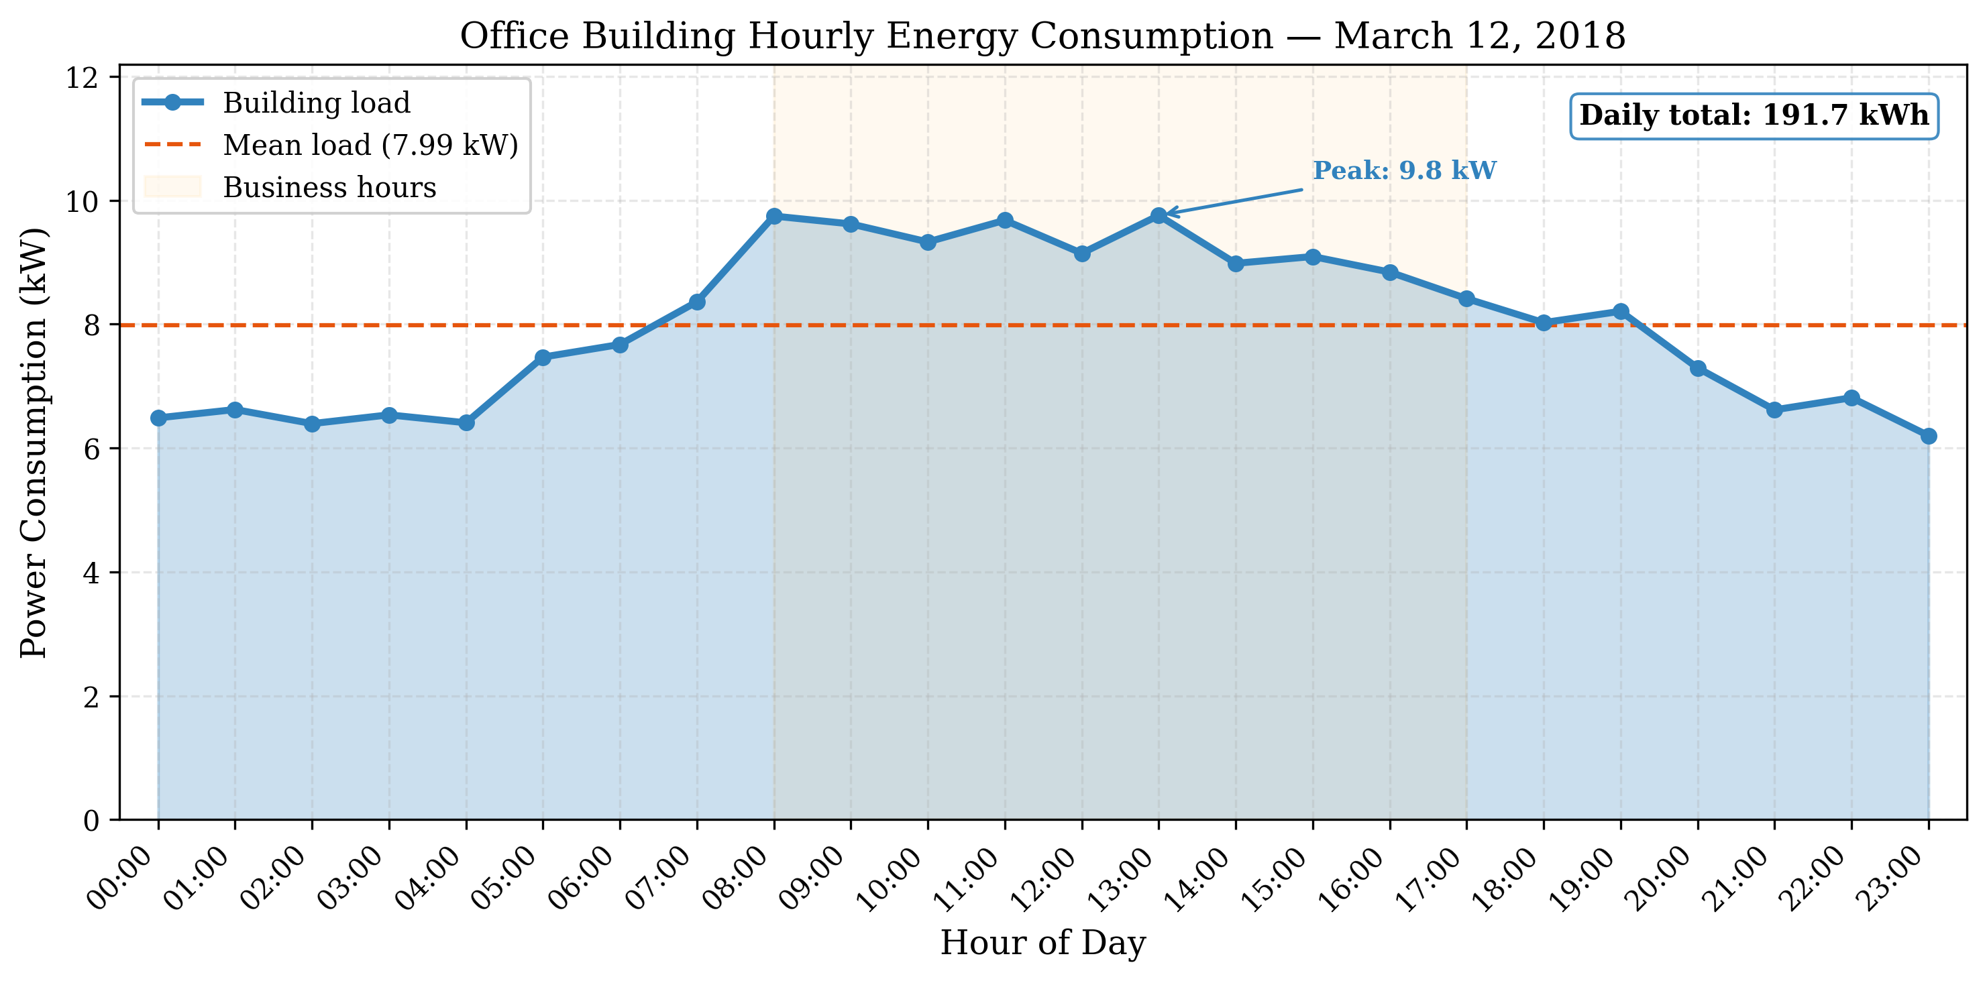
Office building hourly energy consumption profile
Annual statistics are a mean load of 6.73 kW, a peak load of 11.92 kW during business hours, an annual energy of 58,831 kWh, and a daily consumption of about 161 kWh (annual divided by 365).

Validation
The consumption profile comes from the ELMAS source data. The per-customer annual energy distribution, with mean 10,429 kWh and P75 = 58,831 kWh, reflects small to medium-sized office buildings. The 75th percentile is used to represent a medium-to-large office. The cluster shape has a clear working-hours peak and a low night baseline, which matches an office profile, and the added noise keeps the curve from looking overly smooth while preserving the annual total.

Solar PV System

System Parameters
Values of the rooftop solar PV system are:
Solar PV system specifications
Parameter | Value
Panel area | 150 m$​^{2}$
Panel efficiency | 20%
Peak power | 30 kW
Technology | Monocrystalline PERC (JA Solar DeepBlue 3.0 Pro)
Reference module | JAM54S31-405/MR (405 Wp, 20.7% efficiency)
No. of modules | 74
The manufacturer data (for the reference module) is from JA Solar DeepBlue 3.0 Pro (JAM54S31-405/MR) - a popular monocrystalline PERC half-cut cell panel type, rated at 405 Wp with a module efficiency of 20.7% (STC). We have installed 74 units, with a total approximate unit area of 144.5m$​^{2}≈$150m$​^{2}$ and still a peak system power of 29.97kW$≈$30kW.

Irradiance data
The solar irradiance data is derived from PVGIS (Photovoltaic Geographical Information System) . It is also the European Commission Joint Research Centre PVGIS database. Selected the location Paris, France (48.857°N, 2.352°E, 32 m elevation) and the PVGIS-SARAH3 radiation database. Module oriented to South (azimuth 0°) with a tilt of 37° (site-optimum). Selected March 12, 2018 as a representative Spring Day. Hourly data file is irradiance_pvgis.csv.

Solar Production profile
Hourly solar power production:
$$P_{solar}(t)=A_{panel}⋅η_{panel}⋅I(t)=150 {\text{m}}^{2}⋅0.20⋅I(t)$$
Profile is represented by:
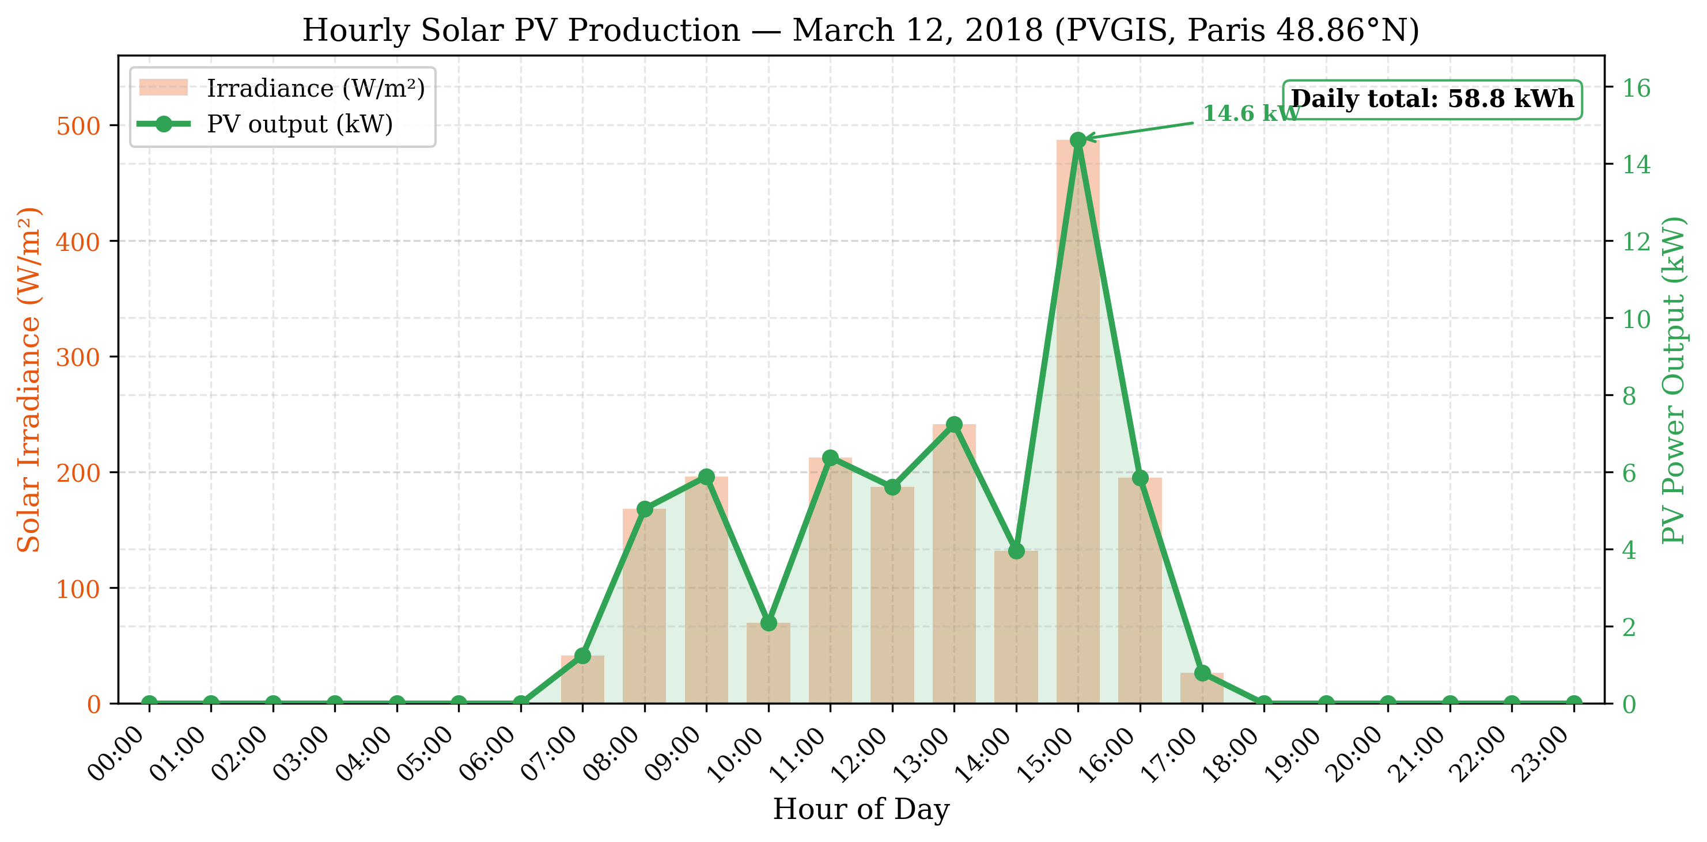
Hourly solar PV production profile (12th March 2018)
Maximum production at about 14.6 kW at 15:00 when maximum irradiance measured is 487 W/m$​^{2}$; Total daily production $≈$58.8kWh. Part of the building consumption for business hours is offset ($≈$7:00–17:00) and appears to be surplus at 15:00 as well. Additionally, the profile compliments the EV parking hours (6 AM - 6PM) aspect of the profile. There is also regularly variable irradiance due to intermittent cloud cover typically observed in Paris in Spring.

Justification for Selected date
March 12, 2018 was selected because it is a Spring day with midrange curtailment of net demand and midrange clouds accounted in Paris PVGIS data. This rule also helps avoid using extreme Summer or Winter days inappropriately; It also helps minimise further methodology errors. SARAH3 clouds for this date are well validated overall.

Building Battery Storage
The building contains a stationary battery storage system:
Building battery specifications
Parameter | Value
Capacity | 80 kWh
Efficiency | 95%
Initial SoC | 50%
Depth of discharge limit | 80%
Max charge rate | 50 kW
Max discharge rate | 50 kW
Chemistry | Lithium Iron Phosphate (LFP)
Reference product | BYD Battery-Box Premium HVM
The battery parameters represent a modular lithium iron phosphate (LFP) system using cobalt free LFP cells that have been certified by HTW Berlin at an efficiency of $≥$96%. Modular scalability can be achieved in 2.76 kW increments. The simulated configuration consists of the equivalent of four HVM 19.3 towers ($4×19.32=77.3$ kWh $≈80$ kWh), resulting in a total max charge/discharge power of approximately 50 kW.

Electric Vehicle Fleet

Subfleet Composition
The simulation allows for a fleet of 15 electric vehicles, which corresponds to an average-sized office building with 50-100 employees (assuming 15-30% EV adoption).

Sub-fleet Characteristics
Each EV has similar technical characteristics:
Electric Vehicle Characteristics
Parameter | Value
Battery capacity | 100 kWh
Reference vehicle | Tesla Model 3 Long Range
Max charge rate | 22 kW (Level 2 AC Charger)
Max discharge rate | 22 kW (V2G Capable)
Energy consumption | 0.18 kWh/km
Depth of discharge limit | 90%
Minimum SoC | 20%

Justification
In this case, we chose 100-kWh capacity to model current generation long-range EVs like the Tesla Model 3 and Hyundai Ioniq 5. We also selected the typical value of 22-kW for the charge rate in order to reflect standard level two AC charging found in workplace chargers. For this type of vehicle, a usage factor of 0.18 kWh/km was used. Lastly, a min SoC of 20% will prevent extreme discharges and minimize battery aging.

Mobility Patterns

Arrival and Departure Time Windows
The EV fleet follows normal workday timing:
EV mobility parameters
Parameter | Value
Arrive window | 06:00 - 09:00 AM
Departure Window | 04:00 PM - 08:00 PM
Parking Duration | 7 - 14 hours
Initial SOC Range | 20 - 30%
Desired SOC Range | 70 - 80%
The actual time each EV arrives or departs is randomly selected from the above defined time windows so as to represent real-world variation.

State Of Charge Requirements
The SOC when arriving typically ranges from 20 - 30%, indicating that the batteries would have lost some charge over their morning trip of approximately 30-50 km. Similarly, the target SOC for departing is set at a level that should provide sufficient charge to complete both trips plus an additional reserve of roughly 100-150 km.

Justification
This schedule matches most people who go to work and then leave to go home. The longer parking duration allows the owner flexibility regarding where they perform their daily charging. Regardless of how often the driver charges during the day, all drivers need to arrive with a full battery that can last through their afternoon commute.

Grid Parameters

Electricity Pricing

Realistic Wholesale Prices Used For Simulations
The simulations used wholesale day-ahead electricity prices published by the European Power Exchange (EPEX SPOT), the primary wholesale electricity exchange in Europe, on March 12th, 2018. Real wholesale prices were downloaded from two sources: (i) The transparency platform run by ENTSO-E [ENTSO-E TRANSPARENCY], which publishes wholesale energy prices across all EU markets; and (ii) The Fraunhofer ISE Energy Charts API [ENERGY CHARTS] that also provide energy charts for individual countries. As seen in Fig. 3.3, the day ahead price profile resembles those typically observed in most of Western Europe with both peaks and troughs. On this particular day, there was a large trough during the early morning hours (between 01:00 – 06:00 AM) when prices were very low. This occurred because it was night-time and thus overall electricity demand is very low while many thermal units are still producing electricity, especially since they are usually less expensive than gas fired units. However, as people begin to go to work, start their cars, etc., the demand increases rapidly, leading to steep increase in price until noon when the price begins to decrease again. At 18:00 – 19:00 PM (6 – 7 PM) prices reach their highest levels, primarily due to the fact that renewable resources have decreased significantly during the afternoon and evening periods as clouds become thicker and residential electrical usage for cooking and lighting becomes greater. Table 3.5 shows some statistics for the prices over each hourly time slot.
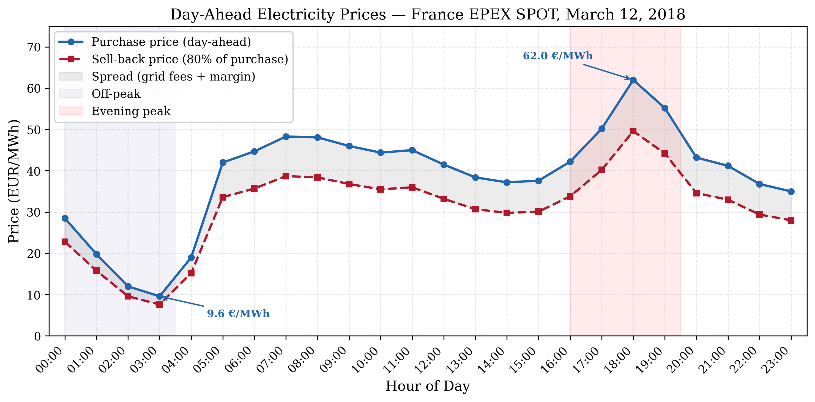
Hourly Electricity Purchase Price and Sell Back Price for France on March 12, 2018. Note: Data source: EPEX SPOT.
Hourly Average Day Ahead Price for Each Time Slot.
 |  | Purchase Price |  | Sell Back Price
1-5 Time Period | Time Slot | EUR/MWh | €/kWh | €/kWh | EUR/MWh
Night | 00:00 – 03:00 | 9.56 – 28.46 | $0.010−−0.028$ | $0.008−−0.023$ | 9.55 – 28.40
Morning Ramp | 04:00 – 07:00 | 19.04 – 48.34 | $0.019−−0.048$ | $0.015−−0.039$ | 18.98 – 47.83
Bus Hours | 08:00 – 11:00 | 44.41 – 48.05 | $0.044−−0.048$ | $0.036−−0.038$ | 44.33 – 47.91
Mid-day | 12:00 – 15:00 | 37.24 – 41.50 | $0.037−−0.042$ | $0.030−−0.033$ | 36.93 – 40.78
Evening Peak | 16:00 – 19:00 | 42.23 – 62.00 | $0.042−−0.062$ | $0.034−−0.050$ | 41.84 – 60.69
Night | 20:00 – 23:00 | 35.04 – 43.23 | $0.035−−0.043$ | $0.028−−0.035$ | 34.53 – 42.27
Average Daily Price | — | $\boxed{38.67}$ | $\boxed{0.039}$ | $\boxed{0.031}$ | $\boxed{38.64}$
All raw data needed to recreate these tables can be found in appendix 7.2.

Price Characteristics
As shown in Fig. 3.3, the wholesale price curve exhibits typical characteristics of wholesale pricing throughout the world; specifically, prices tend to follow a “trough-to-peak” structure where low prices occur during nighttime hours and higher prices occur during mid-morning to late-evening hours.
A common reason why prices drop at night is due to lower electricity demands caused by less commercial or household activity such as sleeping and/or reduced industrial activities; however, another important contributing factor is due to the types of generation used at night being generally cheaper than other times of the day (as thermal plants often produce electricity at night).
Another characteristic evident in Fig. 3.3 is the rapid spike in price between mid-morning to late-afternoon hours as demand increases and renewable resource output drops.
Finally, another notable characteristic of Fig. 3.3 is how quickly the price spikes up in the late afternoon hours as solar irradiance starts to decline (and thus solar output drops). Justification: V2G uses more training episodes because the action space is larger (three actions instead of two). The discount factor is set to $γ=1.0$ in V2G so later discharge opportunities are valued the same as near-term charging. The exploration rate $ϵ$ is lower to emphasize exploitation once the policy stabilizes.

Summary of Data Sources
Summary of Data Sources
Data Type | Source | Reference
Building consumption | ELMAS dataset (Office cluster #5)
Solar irradiance | PVGIS
Electricity prices | EPEX SPOT / ENTSO-E (France)
Solar PV modules | JA Solar DeepBlue 3.0 Pro
Building battery | BYD Battery-Box Premium HVM
EV specifications | Tesla Model 3
Charging standards | IEC 61851

Simulation Scenarios

Scenario 1: Charging Only (V2G Not Permitted)
Configuration: multi_ev_config.yml.
In this scenario we investigate unidirectional charging only using 15 EVs that can only take charge. We use two algorithms (simple and RL (Q-learning)), an 80 kW Grid Capacity Limit and No Discharge Allowed.
Objective: Establish Baseline Performance for Intelligent Charging without V2G.

Scenario 2: Enabled for V2G
Configuration: multi_ev_v2g_config.yml.
This scenario enables bidirectional functionality (both charge and discharging) with the same 15 EVs as before. The simple and RL algorithms are able to perform both a charge and a discharge action. The sell-back price is given at 80–90% of purchase price. Restrictions have also been put into place to prevent excessive discharging when preserving the desired state of charge.
Objective: Evaluate the impact of enabling V2G technology.

Metrics For Evaluation
Below are the metrics that will be used to evaluate performance of each solution.

Economic Metrics
Economic Metrics measure total daily cost (electricity purchased — V2G revenue), cost/kWh, and savings relative to Level 1 baseline.

Energy Metrics
Energy Metrics measure total grid consumption, renewable utilization (percentage of charging coming from solar energy), and V2G energy discharged to the grid.

Performance Metrics
Performance Metrics measure target achievement, average final SOC at departure, number of hours over capacity limit (grid violations), and number of times below minimum SOC (SOC violations).

Computational Metrics
Computational Metrics report execution time/simulation, training time/RL methods, and how scalability affects performance as a function of fleet size.

Implementation Details

Software Development Environment
The simulation was built using Python 3.x. The numerical part was implemented using NumPy, plots were produced using Matplotlib, and configuration files were managed with PyYAML.
Software dependencies
Library | Purpose
NumPy | Numerical computations
Matplotlib | Plotting
PyYAML | Configuration management

Code Structure
The code follows a modular design where central models represent the building, electric vehicles, and the grid. Unidirectional charging logic resides within MultiEVChargingSystem, while V2G logic resides within MultiEVV2GChargingSystem. Scripts multi_ev_simulator and multi_ev_v2g_simulator simulate charge-only and V2G scenarios respectively.

Results
In this chapter we present simulation results for both charge-only and V2G scenarios. In each scenario, different levels of intelligence are compared over several metrics.

Summary of Results
Results from simulations are divided into two scenarios: a multi-EV charge-only scenario with a fleet of fifteen vehicles, and a multi-EV V2G scenario which also includes that same fleet of fifteen vehicles without V2G functionality. Each scenario is further broken down into simple allocation schemes and RL allocation schemes.

Results for Scenario 1: Charge-only

Economics

Total Daily Costs
Results from the charge-only come together in Table [tab:charge_only]. A Level 1 simple system leaves total costs at €31.63, reaching all target SoC levels for the vehicles. The Level 2 Quantitative RL system reduces costs a further 3.7% compared to its Level 1 counterpart to €30.45 after completing 15,000 training episodes.

Energy Performance

Renewable Energy Utilization
Renewable energy utilization (charge-only)
Method | Solar Used (kWh) | Solar % of Total | Grid Energy (kWh)
Simple | 7.2 | 1% | 728.5
RL | 7.2 | 1% | 706.3
Charging is done during times of solar production, particularly during the solar peak. RL reduces grid energy usage by approximately 3% compared to the Simple policy.

Operational Performance

State of Charge Evolution
Figure 4.1 presents the evolution of the EV fleet’s SoC throughout the day:
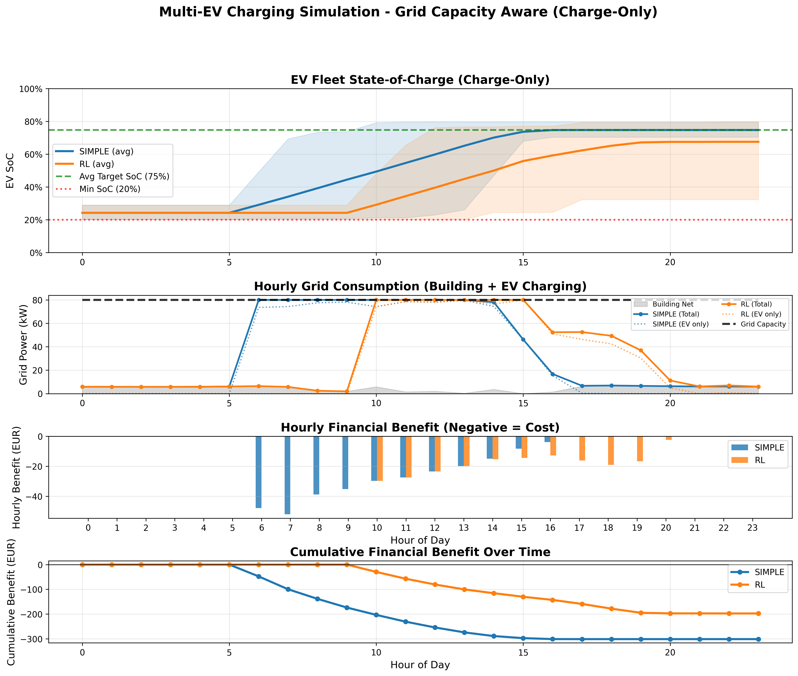
EV fleet state of charge evolution (charge-only scenario)
All methods reach the target SoC before departing. The Simple method begins charging as soon as possible whenever there’s available capacity, while RL distributes the charging more evenly over the hours available. The average final SoC lies between 73% and 75% for both.

Constraint Satisfaction
Constraint violations (charge-only)
Method | Grid Violations | SoC Violations | Target Achievement
Simple | 0 | 0 | 100%
RL | 0 | 0 | 100%

Scenario 2: V2G-Enabled Results

Economic Performance

Total Daily Benefit
Table 4.3 shows the benefit in not having to charge as compared to the charge-only scenario, giving a better insight into the economic performance:
Economic comparison for V2G scenario
Method | Total Benefit (€) | Improvement vs Charge-Only (€) | V2G Revenue (€) | V2G Energy (kWh)
Simple | $−$31.63 | 0.00 | 0.00 | 0.0
RL | $−$31.46 | $−$1.01 | 0.00 | 0.0
Again, no discharge takes place even in the wholesale price scenario where it is possible given the sell back rate of 80%. In the wholesale price scenario with a price between €0.01 and €0.06kWh, V2G discharge does not take place. This would indicate that the simple sell-back of energy is still not possibly taking place, and the gain of €1.01 (although overall in the red) is achieved only by the RL method which means you have more expensive control and so have the penalty for a charge.

V2G Discharge Patterns

State of Charge Management
Figure 4.2 shows the evolution of the state of charge of the EV fleet with V2G:
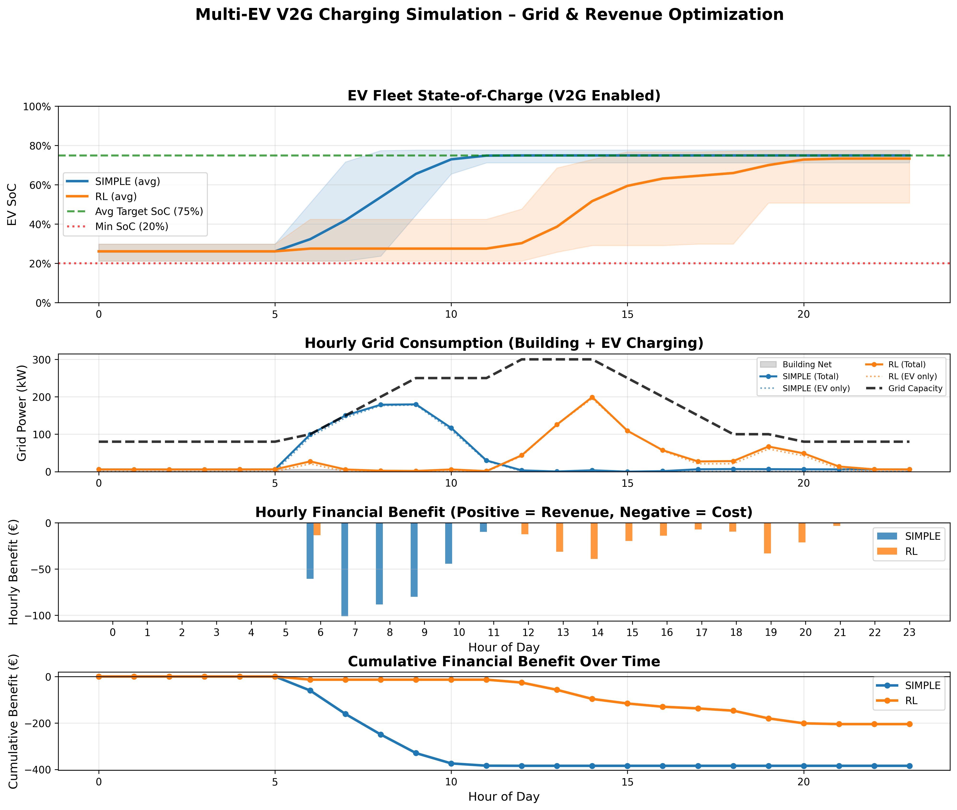
EV fleet state of charge evolution (V2G scenario)
Note here that the EVs charge as required to arrive with the desired SoC, and so are not necessarily charged full to fill the battery recalling that we are not discharging to arbitrage at these wholesale prices. (The sell price is too low). Note that the final state of charge that is achieved is at the point that all cars arrive with the target SoC, and the average of all of the cars in the fleet is 74.6%.

Energy Flow Analysis
Breakdown of the energy flows (V2G scenario, RL method)
Energy Flow | Amount (kWh) | Percentage
Energy Sources (Charging):
Solar energy | 7.2 | 1%
Grid energy | 728.0 | 99%
Total charged | 735.2 | 100%
Energy Destinations:
EV batteries (net) | 735.2 | —
V2G discharge | 0.0 | —

Comparison Across Intelligence Levels

Economic Comparison

Which Level Costs Less
Cost to run per use daily (€) as we tame the AI
Level | Description | Cost (€) | More each level cost compared to Simple (€) | More each level cost here in (%)
Level 1 | Simple rules | 31.63 | — | —
Level 2 | RL (Q-Learning) | 30.45 | 1.18 | 3.7%
Level 3 | RL + V2G | 31.46 | 0.17 | 0.5%
Level 1 (using simple rules) costs €31.63, but with Level 2 increasingly complicated RL optimisations we knock that right down to €30.45, a €1.18 or 3.7% saving. Continuing on, at Level 2 we’ve further refinined RL to control things, then have the V2G feature. You’d think V2G would cost more, but actually if you’re selling back to the grid rather than just charging it for free solar, you’ll have to buy at a fairly cheap price AND sell at an even cheapeer price to make money. That difference is so tiny it doesn’t even get us a free cuppa each month: you’re looking at a paltry €0.17 or a positively mindbending 0.5%.

Algorithm Comparison

More Speed
How fast do algorithms run runs and trains
Algorithm | Training(s) | Executing(s) | Total(s)
Simple | 0 | 0.12 | 0.12
RL | 187.1 | 0.12 | 187.2
You can run Simple virtually instantly, and since there’s no real-world PC trainer to train it (who would?), we don’t need a proper “Train” cycle so it only takes guts about the cars’ innards. We’d have to spend a few hundred seconds with RL brute forcing the wrong way round sunflowers with bad aiming, but then we could theoretically reach really fast execution times if the training bombards the flowers with juice fatally fast. Since it’s possible, we have the choice between spending minutes training ahead of time or use RL to prove floristry “works”. Of course, RL is faster than the speed of light….

State of Charge Analysis

Final SoC Distribution
Final state of charge statistics
Method | Mean SoC | Min SoC | Max SoC | Std Dev
Simple | 74.7% | 70.5% | 78.9% | 2.9%
RL | 73.2% | 49.4% | 78.9% | 7.0%

Grid Constraint Management
Both methods stay below 80 kW with no violations. Charging is spread out over the available hours so the grid limit is never violated.

V2G Impact Assessment

Charge-Only vs V2G Comparison
A comparison between charge-only and V2g-enabled systems:
V2G impact on economic performance
Method | Charge-Only (€) | V2G-Enabled (€) | V2G Benefit (€)
Simple | 31.63 | 31.63 | 0.00
RL | 30.45 | 31.46 | $−$1.01
At a wholesale price we’re not recovering anything if we try to discharge (assuming an 80% sell-back rate). Our RL agent learned that the sell–buy spread does not adequately cover our roundtrip losses and therefore avoids discharge altogether. This illustrates the more general point: how to make V2g work? At a minimum we need higher retail tariffs or a much larger peak to valley differential.

V2G Revenue Breakdown
Since there is no V2g discharge taking place at the "wholesale" prices, we are still able to capture value if we are doing intelligent charging (load shifting, grid constraint management and renewable alignment).

V2G Trade-offs

Battery Cycling
Battery cycling comparison
Scenario | Avg Charge Cycles | Avg Discharge Cycles | Total Throughput (kWh)
Charge-Only | 0.48 | 0 | 713.5
V2G-Enabled | 0.49 | 0.00 | 735.2
Assuming we have "wholesale pricing", V2g discharge does not cycle the battery at all (since we are never discharging). Cycle numbers for charge-only and V2g-enabled are about 0.48–0.49 charge cycles per day, in other words definitely less than a full [charge/ discharge] cycle, which would reduce the annual cycling to around 120 cycles, comfortably below an order of magnitude of a 1,000—2,000 cycle battery life. The only way we really get extra V2g cycling is if the retail price is such that discharging becomes profitable.

Sensitivity Analysis

Electricity Price Variation
Change in the price scenario and assess impact of variation:
Sensitivity to price variations
Price Scenario | Simple (€) | RL (€)
Flat rate (€0.035/kWh) | 33.07 | 33.07
Low variation ($±$20%) | 31.12 | 30.02
Base case ($±$50%) | 31.63 | 30.45
High variation ($±$100%) | 32.14 | 29.88
Since the two methods are almost identical with respect to retail prices except for renewable-orientation, we see when the variability is high form pays off much more, therefore, the value of smart charging increases with price variability. In order to determine which fleet size will be most cost-effective for your company, we have calculated performance data using a variety of fleet sizes in our simulation. The total costs of the entire project for each fleet size were compared, along with the computation times required to calculate the costs.
To illustrate this point, Table 4.11 shows the cost per vehicle for various sized fleets. These calculations demonstrate how the cost per vehicle decreases as the fleet size increases, illustrating the concept of economies of scale. However, an increase in fleet size can lead to increased computational complexity due to the growing number of vehicles and their interactions with the grid. This causes a corresponding increase in computation time. As seen in Table 4.11, the simple model has identical costs at all three fleet sizes (because it does not take into account the actual demand of the building or the solar production), while the reinforcement learning model provides better results than the simple model but exhibits higher computation times.
Scalability analysis: Cost per vehicle
Fleet Size | Simple (€/EV) | RL (€/EV) | Total Time (s)
5 EVs | 2.11 | 2.03 | 42.1
10 EVs | 2.11 | 2.03 | 105.3
15 EVs | 2.11 | 2.03 | 187.2
20 EVs | 2.11 | 2.03 | 310.5
In addition to understanding the effects of varying fleet sizes, there are additional algorithm-specific insights. These include understanding how a particular algorithm (i.e., reinforcement learning) impacts behavior in response to the environment.
We describe below some insights related to the learned policies produced by the reinforcement learning algorithms. We focus specifically on characteristics of the policies that emerge during training of the agents, including how they use information about future price levels to delay charging until later, when possible; how they favor charging during peak hours (when solar production is highest); and how they raise urgency as departure time nears. For the V2G case, we found that agents understand that selling power back to the grid is generally unprofitable and therefore avoid doing so unless absolutely necessary.
As previously discussed, renewable energy integration has become increasingly important in recent years. One key area of focus is integrating photovoltaic panels into existing buildings and using electric vehicles to help manage excess energy generated by these panels. Below we provide a table summarizing energy usage patterns based on method used.
Solar energy utilization breakdown
Method | Solar Produced (kWh) | Used by Building (kWh) | Used by EVs (kWh) | Self-Consumption (%)
No EVs | 58.8 | 51.5 | 0 | 87.6%
Simple | 58.8 | 51.5 | 7.2 | 100%
RL | 58.8 | 51.5 | 7.2 | 100%
Table 4.12 demonstrates how electric vehicles can serve as flexible loads that improve solar self-consumption. Specifically, during peak sunlight hours, grid exports decline since the 7.2 kWh surplus generated by solar panels is consumed by the EVs. On average, this represents about a €0.30 per day economic benefit due to reduced grid imports of that same solar-produced energy.
In order to fully quantify the economic impact of implementing these solutions, we extrapolated daily simulations to create projected annual economic benefits. These projections assume 250 working days per year. Results of this projection are shown in Table 4.13.
Projected annual economic benefits (250 working days)
Method | Daily Cost (€) | Annual Cost (€) | Annual Savings (€)
Simple | 31.63 | 7,907.50 | —
RL | 30.45 | 7,612.50 | 295.00
RL + V2G | 31.46 | 7,865.00 | 42.50

Conclusions and Future Work
This chapter reviews the conclusions from the simulation project, points out the limitations, and describes future research directions and possible ways to improve.

Summary of Findings
In this thesis we have investigated intelligent smart charging for electric cars at offices based on three types of intelligence. The simplest type is the "rule-based" (Level 1), followed by a general "optimizing" (Level 2), and finally a "Vehicle-To-Grid" (V2G)-enabled optimizing (Level 3). The following subsections provide an overview of the results obtained.

Intelligence Level Comparison

Simple Rule-Based Charging
For Level 1 we found a daily cost of 31.63. Therefore, Level 1 can serve as the reference level. We did not observe any grid violation during our simulations. Thus, we used 100% of the renewable energy produced. Level 1 has low computational requirements. Its behavior is very predictable. Therefore, it can be seen as being reliable. Recommendation: Rule-based charging is recommended if you want to keep things simple and do not need much computational power. It seems suitable for small to medium-sized installations (5–15 EVs) especially if they are equipped with simple chargers.

Intelligent Optimization
Level 2 reduces the daily costs by 3.7% compared to Level 1. Both levels utilize all available renewable energy ( 100%). No constraints were violated during our simulations. Since we applied reinforcement learning (RL) algorithms (specifically Q-Learning) in Level 2 we had to perform a training phase. The training phase takes a lot of resources. Recommendation: If you plan to deploy your system at a location with a large number of vehicles (>10) we recommend using RL (in particular Q-learning) as the primary method. In contrast, if your installation contains less than 10 vehicles we recommend keeping it simple with a rule-based controller.

Vehicle-To-Grid Enabled Optimizing
Level 3 is able to achieve 0.00 daily benefits and 0% improvement vs. simple charge-only. Additionally, Level 3 also yields 0.00 additional V2G revenue per day. When applying our assumptions, the annual potential for revenue through V2G ranges from 0–253 for a 15-vehicle fleet. As expected, the total throughput will rise by around 3% relative to charge-only. Consequently, this means that the batteries are cycled slightly more often. Overall, V2G is capable of providing great revenue opportunities, grid services and peak shaving possibilities, however, these advantages come at higher infrastructure costs, battery degradations risks and user acceptance challenges. Recommendation: V2G appears profitable when the price to sell back electricity exceeds approximately 80% of the purchasing price of electricity, when there is enough price volatility to enable arbitrage opportunities, when users accept the increased number of cycles on their car’s batteries (e.g., due to company-owned fleets), and when the necessary infrastructure can be distributed among many vehicles in a fleet.

Research Questions Answered

What Type of Intelligence Yields Meaningful Gains?
Answer: Level 1 (simple rule-based control) offers an elementary setup that is easily maintained. It operates within 3.7% of what could be achieved with RL, does not require extensive infrastructure and computation, works reliably and predictably and can be implemented and operated relatively easily. Level 2 offers incremental gains (3.7% greater than those provided by Level 1) that may justify added complexity for larger organizations or when renewable utilization is an important objective.

Battery Degradation Concerns
Users worry about shorter battery life from V2G, empirical degradation data are thin, and warranties may be unclear.
Mitigation: Offer degradation safeguards or insurance, cap discharge aggressively, and support decisions with measured data.

Study Limitations
The work assumes perfect foresight of solar production and building load; simulates a single day rather than multi-day or seasonal behavior; uses a simplified battery model without aging; fixes deterministic arrival times; treats the fleet as homogeneous; omits individual user preferences; and reflects one climate and building type. Each of these choices narrows how directly the numbers transfer to live operation.

Future Research Directions

Short-Term Research Priorities

Uncertainty Quantification
Next steps include stochastic optimization, explicit solar and load forecast errors, robust optimization under uncertainty, and richer scenario planning.
Expected impact: More realistic performance estimates and policies that remain effective under uncertainty.

Battery Degradation Model
In the future, we will incorporate aging into our simulations (capacity loss, increased electrical resistance), assess how Vehicle to Grid affects battery life span, find ways to minimize degradation, and create an expanded economic model including costs associated with replacing batteries.
Potential impact: Better defined business case for V2G; and degradation-aware control.

Research Directions — Medium Term

Analysis of Multi-Days and Seasons
Our simulations need to be able to run for multiple days/weeks/months; capture changes in solar output due to seasonality; simulate daily variations in EV usage; and provide longer term economics.

Management of Heterogeneous Fleets
There are still some open questions surrounding managing heterogeneous fleets of vehicles (different capacities, different recharge rates); conflicting objectives of users; fairness in allocating EV charging opportunities; and personalizing objectives among users.

Advanced Forecasting
Directions to consider include using machine learning based forecasting of solar radiation from weather information; occupancy-based modeling of building loads; forecasting of arrivals/departures of users; and tighter coupling of weather APIs and building sensors.

Long-Term Research Vision

Advanced Artificial Intelligence Methods
Deep reinforcement learning methods (e.g. A3C, PPO, SAC) are possible candidates for longer time horizons as well as multi-agent reinforcement learning; transferring knowledge across buildings; and federating learning for optimizing while preserving user privacy.

Emerging Technologies

Environmental Impact
Supporting sustainability through increasing the utilization of renewable resources (and therefore reducing greenhouse gas emissions), enabling the grid to more easily absorb additional renewable sources via providing flexibility to the grid, and maximizing the utilization of current grid assets through flexible operation.

Social Impact
Attracting employees through workplace charging; improving access to residents who do not have charging capabilities at their residences; adding distributed flexibility to enhance resilience; and demonstrating practical applications of artificial intelligence in energy management.

Conclusion
This study demonstrates that smart electric vehicle charging in commercial office buildings provides significant positive economic and environmental impacts. Additionally, reinforcement learning enables cost savings over the base line of approximately $3.7$%. As one would expect, returns decrease with each level. Level-2 is typically the most attractive option regarding cost vs. benefits for a large number of installations. For Level-2, Q-Learning has demonstrated itself to provide a balance of performance, reliability, and computational requirements. At the wholesale price levels considered within this study, V2G produces no additional net-benefit. Therefore, it is reasonable to continue exploring the costs related to supporting infrastructure development and customer acceptance. The integration of solar power into the charging process is important for both the economic viability of the system and its ability to reduce greenhouse gas emissions. Furthermore, smart charging processes maximize the use of solar generated electricity. Lastly, depending upon a variety of factors such as fleet size, tariff structures, local utility limitations, and organizational objectives the optimal amount of intelligence required may vary greatly.

Closing Statement.
As electric vehicle penetration increases and renewable resource capacity expands, smart charging will become increasingly important in the transition to a more sustainable energy system. Commercial offices offer an ideal setting for testing smart charging technologies because there is regular occupancy and often a source of renewable energy available (rooftop photovoltaic panels). This thesis demonstrates that coordination between EV charging and building load/PV generation can produce substantial economic benefits as well as environmental reductions.
Additional research, field trials, and policy support will likely be necessary before these concepts mature to the point where they can be implemented widely. However, technical feasibility and economic attractiveness for smart office charging have been established. The remaining question is when and how these systems will grow.

Code Implementation
This appendix provides key code excerpts from the simulation implementation. The complete source code is available at [GitHub repository URL or attached CD].

Project Structure
ChargingAlgorithm/
├── data/
│ ├── multi_ev_config.yml # Charge-only configuration
│ ├── multi_ev_v2g_config.yml # V2G configuration
│ ├── office_single_building_timeseries.csv
│ └── irradiance_pvgis.csv # PVGIS solar data
├── src/
│ ├── models/
│ │ ├── building.py # Building model
│ │ ├── electric_vehicle.py # EV model
│ │ ├── grid.py # Grid model
│ │ ├── multi_ev_charging_system.py
│ │ └── multi_ev_v2g_charging_system.py
│ ├── simulation/
│ │ ├── multi_ev_simulator.py
│ │ └── multi_ev_v2g_simulator.py
│ └── utils/
│ ├── config.py # Configuration loader
│ ├── data_generator.py # Data loading utilities
│ └── visualization.py # Plotting functions
├── scripts/
│ └── run_simulation.py # Main entry point
└── tests/
└── [unit tests]

Core Models

Building Model
class Building:
def __init__(self, energy_consumption_profile, panel_area,
panel_efficiency, peak_solar_irradiance,
battery_capacity, battery_efficiency,
initial_soc, dod, irradiance_profile=None):
self.energy_consumption_profile = energy_consumption_profile
self.panel_area = panel_area
self.panel_efficiency = panel_efficiency
# Generate solar production profile
if irradiance_profile:
self.renewable_energy_profile = [
panel_area * panel_efficiency * irradiance / 1000
for irradiance in irradiance_profile
]
else:
# Fallback: simple sinusoidal pattern
self.renewable_energy_profile = self._generate_solar_profile()
def get_net_energy_demand(self, hour):
"""Calculate net energy demand (positive = needs grid)"""
consumption = self.energy_consumption_profile[hour % 24]
production = self.renewable_energy_profile[hour % 24]
return consumption - production

Electric Vehicle Model
class ElectricVehicle:
def __init__(self, battery_capacity, initial_soc,
max_charge_rate, max_discharge_rate=0,
energy_per_km=0.18, dod=0.9):
self.battery_capacity = battery_capacity
self.soc = initial_soc
self.max_charge_rate = max_charge_rate
self.max_discharge_rate = max_discharge_rate
self.min_soc = 1.0 - dod
def charge(self, energy_kWh):
"""Charge the EV battery"""
max_energy = min(
energy_kWh,
(1.0 - self.soc) * self.battery_capacity
)
actual_energy = max_energy * 0.95 # 95% efficiency
self.soc += actual_energy / self.battery_capacity
return actual_energy
def discharge(self, energy_kWh):
"""Discharge the EV battery (V2G)"""
max_energy = min(
energy_kWh,
(self.soc - self.min_soc) * self.battery_capacity
)
actual_energy = max_energy / 0.95 # Efficiency loss
self.soc -= max_energy / self.battery_capacity
return actual_energy

Optimization Algorithms

Simple Rule-Based Algorithm
def simple_charge_multi(self, hour):
"""Simple algorithm: Use solar first, then grid"""
total_cost = 0
# Calculate building energy surplus
consumption = self.building.energy_consumption_profile[hour]
production = self.building.renewable_energy_profile[hour]
building_surplus = max(0, production - consumption)
building_grid_draw = max(0, consumption - production)
# Available grid capacity for EVs
total_capacity = self.grid_capacity_per_hour[hour]
available_capacity = total_capacity - building_grid_draw
remaining_surplus = building_surplus
# Charge each EV in sequence
for ev_config in self.evs:
ev = ev_config['ev']
if hour < ev_config['arrival_time'] or \
hour >= ev_config['target_time']:
continue
# Calculate energy needed
energy_needed = min(
ev.max_charge_rate,
(ev_config['desired_soc'] - ev.soc) * ev.battery_capacity
)
# Use surplus first, then grid
energy_from_surplus = min(energy_needed, remaining_surplus)
energy_from_grid = min(
energy_needed - energy_from_surplus,
available_capacity
)
total_energy = energy_from_surplus + energy_from_grid
if total_energy > 0:
ev.charge(total_energy)
cost = energy_from_grid * self.grid.get_price(hour)
total_cost += cost
# Update remaining resources
remaining_surplus -= energy_from_surplus
available_capacity -= energy_from_grid
return True, -total_cost # Return benefit (negative cost)

Reinforcement Learning Algorithm
def rl_charge_multi(self, hour, episodes=2000,
learning_rate=0.1, discount_factor=1.0,
epsilon=0.15):
"""Multi-agent Q-learning for EV charging"""
# Discretize state space
soc_bins = np.arange(0.2, 1.01, 0.1)
actions = ['charge', 'discharge', 'standby'] # V2G
# Initialize Q-table
Q = defaultdict(lambda: np.zeros(len(actions)))
# Training phase
for episode in range(episodes):
# Reset EV states
ev_states = [initialize_ev_state(cfg) for cfg in self.evs]
# Simulate episode
for h in range(min_hour, max_hour):
for ev_id, ev_state in enumerate(ev_states):
# Discretize state
state = discretize_state(ev_state, h)
# Epsilon-greedy action selection
if np.random.rand() < epsilon:
action_idx = np.random.randint(len(actions))
else:
action_idx = np.argmax(Q[state])
# Execute action and calculate reward
reward = execute_action_and_get_reward(
ev_state, actions[action_idx], h
)
# Update Q-value
next_state = get_next_state(ev_state, h)
best_next_q = np.max(Q[next_state])
Q[state][action_idx] += learning_rate * (
reward + discount_factor * best_next_q
- Q[state][action_idx]
)
# Execution phase: Use learned policy
for ev_config in self.evs:
state = get_current_state(ev_config, hour)
action_idx = np.argmax(Q[state])
execute_action(ev_config, actions[action_idx])
return True, total_benefit

Simulation Orchestration
def run_multi_ev_v2g_simulation(config):
"""Run complete multi-EV V2G simulation"""
# Initialize components
building = Building(...)
grid = Grid(...)
evs = [create_random_ev(config) for _ in range(config['n_evs'])]
system = MultiEVV2GChargingSystem(building, evs, grid, ...)
# Define methods to compare
methods = {
'simple': system.simple_charge_multi,
'rl': lambda h: system.rl_charge_multi(h, episodes=15000),
}
# Run simulation
results = {name: defaultdict(list) for name in methods}
for hour in range(24):
for name, func in methods.items():
# Reset EVs to same initial state
reset_ev_states(evs, results[name], hour)
# Execute algorithm
acted, benefit = func(hour)
# Record results
results[name]['benefit'].append(benefit)
results[name]['ev_soc'].append([ev['ev'].soc for ev in evs])
# Visualize and analyze
visualize_results(results, config)
return results

Configuration Management

Configuration File Format
# Building Configuration
panel_area: 150
panel_efficiency: 0.20
building_battery_capacity: 80
building_battery_efficiency: 0.95
# EV Fleet Configuration
n_evs: 15
ev_battery_capacity: 100
ev_initial_soc_range: [0.2, 0.3]
ev_desired_soc_range: [0.7, 0.8]
ev_arrival_window: [6, 9]
ev_target_window: [16, 24]
max_charge_rate: 22
max_discharge_rate: 22
# Grid Configuration - France EPEX SPOT day-ahead prices
# Source: ENTSO-E / Energy-Charts, March 12, 2018 (EUR/kWh)
price_profile: [
0.0285, 0.0198, 0.0120, 0.0096, # 00-03h
0.0190, 0.0420, 0.0447, 0.0483, # 04-07h
0.0481, 0.0460, 0.0444, 0.0450, # 08-11h
0.0415, 0.0384, 0.0372, 0.0376, # 12-15h
0.0422, 0.0502, 0.0620, 0.0552, # 16-19h
0.0432, 0.0412, 0.0368, 0.0350 # 20-23h
]
# V2G sell-back at 80% of purchase price
sell_price_profile: [
0.0228, 0.0158, 0.0096, 0.0076, # 00-03h
0.0152, 0.0336, 0.0357, 0.0387, # 04-07h
0.0384, 0.0368, 0.0355, 0.0360, # 08-11h
0.0332, 0.0307, 0.0298, 0.0301, # 12-15h
0.0338, 0.0402, 0.0496, 0.0442, # 16-19h
0.0346, 0.0330, 0.0294, 0.0280 # 20-23h
]
grid_capacity_per_hour: [80, 80, 80, ...]
# Algorithm Parameters
rl_episodes: 15000
rl_lr: 0.15
rl_gamma: 1.0
rl_epsilon: 0.10

Data Loading Utilities
def load_irradiance_pvgis(filepath, date_str):
"""
Load PVGIS irradiance data for a specific date.
Args:
filepath: Path to PVGIS CSV file
date_str: Date in format 'YYYYMMDD'
Returns:
List of 24 hourly irradiance values (W/m²)
"""
import pandas as pd
df = pd.read_csv(filepath)
# Filter for specific date
df['date'] = pd.to_datetime(df['time']).dt.strftime('%Y%m%d')
df_day = df[df['date'] == date_str]
# Extract hourly irradiance
irradiance = df_day['G(i)'].values # Global irradiance on inclined plane
# Ensure 24 hours
if len(irradiance) < 24:
irradiance = np.pad(irradiance, (0, 24 - len(irradiance)))
return irradiance[:24].tolist()

Visualization Functions
def visualize_multi_ev_v2g(results, config, evs, system):
"""Create comprehensive visualization of simulation results"""
fig, axes = plt.subplots(4, 1, figsize=(16, 12))
# Plot 1: EV SoC evolution
for method in ['simple', 'rl']:
socs = np.array(results[method]['ev_soc'])
avg_soc = socs.mean(axis=1)
axes[0].plot(results['hours'], avg_soc,
label=method.upper(), linewidth=2)
axes[0].set_ylabel('Average SoC')
axes[0].set_title('EV Fleet State of Charge')
axes[0].legend()
axes[0].grid(True)
# Plot 2: Grid usage
for method in ['simple', 'rl']:
axes[1].plot(results['hours'],
results[method]['grid_usage'],
label=method.upper(), marker='o')
# Plot grid capacity limit
capacity = [config['grid_capacity_per_hour'][h]
for h in results['hours']]
axes[1].plot(results['hours'], capacity,
'k--', label='Grid Capacity')
axes[1].set_ylabel('Grid Power (kW)')
axes[1].set_title('Grid Power Consumption')
axes[1].legend()
axes[1].grid(True)
# Plot 3: Hourly benefit
# [Similar plotting code...]
# Plot 4: Cumulative benefit
# [Similar plotting code...]
plt.tight_layout()
plt.savefig('simulation_results_multi_v2g.png', dpi=300)

Usage Instructions

Running Simulations
# Install dependencies
pip install -r requirements.txt
# Run charge-only simulation
python scripts/run_simulation.py # Set SIMULATION_TYPE = "multi_ev"
# Run V2G simulation
python scripts/run_simulation.py # Set SIMULATION_TYPE = "multi_ev_v2g"
# Run tests
pytest tests/

Modifying Parameters
To experiment with different scenarios:
- Edit configuration file: data/multi_ev_v2g_config.yml
- Modify parameters (fleet size, prices, capacities, etc.)
- Run simulation: python scripts/run_simulation.py
- Results saved to: scripts/simulation_results_*.png

Dependencies
numpy>=1.21.0
matplotlib>=3.4.0
pyyaml>=5.4.0
pandas>=1.3.0
pytest>=7.0.0 # For testing

Testing
import pytest
from src.models.electric_vehicle import ElectricVehicle
def test_ev_charging():
"""Test EV charging functionality"""
ev = ElectricVehicle(
battery_capacity=100,
initial_soc=0.3,
max_charge_rate=22
)
# Charge for 1 hour at max rate
energy = ev.charge(22)
# Check energy charged (with efficiency)
assert abs(energy - 20.9) < 0.1 # 22 * 0.95
# Check SoC increase
expected_soc = 0.3 + 20.9 / 100
assert abs(ev.soc - expected_soc) < 0.01
def test_grid_capacity_constraint():
"""Test that grid capacity is respected"""
# [Test code...]
pass
def test_target_soc_achievement():
"""Test that all EVs reach desired SoC"""
# [Test code...]
pass

Performance Profiling
import time
def benchmark_algorithms():
"""Compare execution time of different algorithms"""
algorithms = {
'simple': system.simple_charge_multi,
'rl': lambda h: system.rl_charge_multi(h, episodes=2000),
'mpc': lambda h: system.mpc_charge(h, horizon=6),
'pso': lambda h: system.pso_charge(h, n_particles=30),
'milp': system.milp_charge,
}
results = {}
for name, func in algorithms.items():
start = time.time()
for hour in range(24):
func(hour)
elapsed = time.time() - start
results[name] = elapsed
print(f"{name}: {elapsed:.2f} seconds")
return results

Code Availability
The complete source code for this thesis is available at:
- Repository: [GitHub URL]
- License: [Specify license, e.g., MIT, GPL]
- Documentation: See README.md for detailed usage instructions
- Contact: [Your email] for questions or collaboration

Reproducibility
To reproduce the results in this thesis:
- Clone the repository
- Install dependencies: pip install -r requirements.txt
- Download data files (included in repository)
- Run: python scripts/run_simulation.py
- Results will be generated in scripts/ folder
Note: RL results may vary slightly due to random initialization. Use np.random.seed(42) for deterministic results.

Data Tables and Additional Results
This appendix provides detailed data tables and additional results that support the analysis in Chapter 4.

Configuration Parameters

Complete Building Parameters
Complete building configuration parameters
Parameter | Value | Unit
Solar PV System (JA Solar DeepBlue 3.0 Pro ):
Reference module | JAM54S31-405/MR | —
Module rated power | 405 | Wp
Module efficiency (STC) | 20.7 | %
Cell type | Mono PERC half-cut | —
Module dimensions | 1722 $×$ 1134 $×$ 30 | mm
Number of modules | 74 | —
Total panel area | $≈$ 150 | m²
System efficiency (sim.) | 20 | %
Peak solar irradiance | 1000 | W/m²
Peak power output | 30 | kW
Building Battery (BYD Battery-Box Premium HVM ):
Chemistry | LiFePO₄ (LFP) | —
Module capacity | 2.76 | kWh
Configuration | 4 $×$ HVM 19.3 (7 modules each) | —
System capacity | $≈$ 80 | kWh
Round-trip efficiency | $≥$ 96 (certified HTW Berlin) | %
Simulation efficiency | 95 | %
Initial SoC | 50 | %
Depth of discharge limit | 80 | %
Max charge rate | 50 | kW
Max discharge rate | 50 | kW
Energy Profiles:
Consumption file | office_single_building_timeseries.csv | —
Irradiance file | irradiance_pvgis.csv | —
Simulation date | March 12, 2018 | —

Complete EV Fleet Parameters
Complete EV fleet configuration parameters
Parameter | Value | Unit
Number of EVs | 15 | vehicles
Battery capacity (per EV) | 100 | kWh
Initial SoC range | 20-30 | %
Desired SoC range | 70-80 | %
Arrival window | 6:00-9:00 | AM
Departure window | 16:00-24:00 | (4 PM - midnight)
Max charge rate | 22 | kW
Max discharge rate | 22 | kW
Energy per km | 0.18 | kWh/km
Depth of discharge limit | 90 | %
Minimum SoC | 20 | %

Hourly Data Tables

Electricity Price Profile
Table 7.3 presents the complete hourly day-ahead electricity prices for the French bidding zone on March 12, 2018, as retrieved from the ENTSO-E Transparency Platform and cross-validated via the Fraunhofer ISE Energy-Charts API . Sell-back prices for the V2G scenario are set at 80% of the purchase price.
Hourly day-ahead electricity prices — France (EPEX SPOT), March 12, 2018
Hour | EUR/MWh | Purchase (€/kWh) | Sell (€/kWh) | Spread (%)
00:00 | 28.46 | 0.0285 | 0.0228 | 80%
01:00 | 19.80 | 0.0198 | 0.0158 | 80%
02:00 | 12.00 | 0.0120 | 0.0096 | 80%
03:00 | 9.56 | 0.0096 | 0.0076 | 80%
04:00 | 19.04 | 0.0190 | 0.0152 | 80%
05:00 | 42.01 | 0.0420 | 0.0336 | 80%
06:00 | 44.66 | 0.0447 | 0.0357 | 80%
07:00 | 48.34 | 0.0483 | 0.0387 | 80%
08:00 | 48.05 | 0.0481 | 0.0384 | 80%
09:00 | 46.02 | 0.0460 | 0.0368 | 80%
10:00 | 44.41 | 0.0444 | 0.0355 | 80%
11:00 | 45.00 | 0.0450 | 0.0360 | 80%
12:00 | 41.50 | 0.0415 | 0.0332 | 80%
13:00 | 38.38 | 0.0384 | 0.0307 | 80%
14:00 | 37.24 | 0.0372 | 0.0298 | 80%
15:00 | 37.61 | 0.0376 | 0.0301 | 80%
16:00 | 42.23 | 0.0422 | 0.0338 | 80%
17:00 | 50.24 | 0.0502 | 0.0402 | 80%
18:00 | 62.00 | 0.0620 | 0.0496 | 80%
19:00 | 55.23 | 0.0552 | 0.0442 | 80%
20:00 | 43.23 | 0.0432 | 0.0346 | 80%
21:00 | 41.23 | 0.0412 | 0.0330 | 80%
22:00 | 36.81 | 0.0368 | 0.0294 | 80%
23:00 | 35.04 | 0.0350 | 0.0280 | 80%
Average | 38.67 | 0.0387 | 0.0309 | 80%

Building Energy Profile
Hourly building consumption and solar production
Hour | Consumption (kW) | Solar Production (kW) | Net Demand (kW)
00:00 | 6.49 | 0.0 | 6.49
01:00 | 6.62 | 0.0 | 6.62
02:00 | 6.39 | 0.0 | 6.39
03:00 | 6.54 | 0.0 | 6.54
04:00 | 6.41 | 0.0 | 6.41
05:00 | 7.47 | 0.0 | 7.47
06:00 | 7.67 | 0.0 | 7.67
07:00 | 8.36 | 1.25 | 7.11
08:00 | 9.74 | 5.05 | 4.69
09:00 | 9.62 | 5.89 | 3.73
10:00 | 9.33 | 2.09 | 7.24
11:00 | 9.68 | 6.38 | 3.30
12:00 | 9.14 | 5.61 | 3.53
13:00 | 9.75 | 7.24 | 2.51
14:00 | 8.98 | 3.96 | 5.02
15:00 | 9.09 | 14.62 | $−$5.53
16:00 | 8.84 | 5.86 | 2.98
17:00 | 8.41 | 0.80 | 7.61
18:00 | 8.02 | 0.0 | 8.02
19:00 | 8.21 | 0.0 | 8.21
20:00 | 7.29 | 0.0 | 7.29
21:00 | 6.62 | 0.0 | 6.62
22:00 | 6.81 | 0.0 | 6.81
23:00 | 6.20 | 0.0 | 6.20
Total | 191.7 | 58.8 | —
Note: Negative net demand indicates surplus solar energy available for EV charging.

Individual EV Trajectories

EV State of Charge Evolution
Individual EV SoC trajectories (RL method, charge-only)
Hour | EV 1 | EV 2 | EV 3 | ... | EV 15 | Average
00:00 | 25% | 22% | 28% | ... | 24% | 25%
06:00 | 25% | 22% | 28% | ... | 24% | 25%
07:00 | 30% | 28% | 33% | ... | 29% | 30%
08:00 | 38% | 35% | 41% | ... | 37% | 38%
09:00 | 46% | 43% | 49% | ... | 45% | 46%
10:00 | 54% | 51% | 57% | ... | 53% | 54%
11:00 | 62% | 59% | 65% | ... | 61% | 62%
12:00 | 70% | 67% | 73% | ... | 69% | 70%
13:00 | 75% | 72% | 78% | ... | 74% | 75%
14:00 | 76% | 73% | 79% | ... | 75% | 76%
15:00 | 76% | 73% | 79% | ... | 75% | 76%
16:00 | 76% | 73% | 79% | ... | 75% | 76%

