Machine Learning Approach to U.S. Stock Investments

Ahmet Hakan Ekşi   
*Computer Engineering*  
*Marmara University*Istanbul, Turkey  
ahe9953@gmail.com  
Canberk Köroğlu  
*Enivironmental Engineering*  
*Marmara University*Istanbul, Turkey  
canberkkoroglu@gmail.com

Erim Varış  
*Enivironmental Engineering*  
*Marmara University*Istanbul, Turkey  
ermvrs@live.com

*Abstract*— Successful predictions of stock movements have always been utterly important in the market. Billions of dollars were spent in infrastructures and R&D departments in order to predict the future outcomes of share-stocks. It is well known a successful prediction of a stock's future price could yield significant profit. By utilizing various classification and *clustering* methods we tried to approximate if stocks will be profitable in the following years.

Keywords—U.S. Stocks, prediction, classification, clustering, Naïve Bayes, ANN, ANOVA-F, descriptive analysis, k-NN, Mutual Information, adjusted rand index.

# Introduction

Finance markets are one of the biggest inventions for recent decades. By impacting various business areas and investors all around they stand to be a landmark in earning money with low risks. [1]

Decision-making for investment and risk management are hard to manage without prediction of stock movements. Many have done great efforts in this subject. Methodologies developed have not been sufficient in correct predictions and successful prediction still remains a formidable challenge due to many variables beside the entropic values of volatility and linearity of the stock prices. [2][3][4]

Efficient Market Hypothesis suggests all available information is provided by stock prices. Thus, meaning with the use of historical information prediction of stock prices is not possible. However, there are many fundamental research made contrary to this point. Evidences suggests one can have an edge in the stock market if skills for information processing are better compared to other analysts.[5][6][7]

# RELATED WORK

There have been many attempts and methodologies made for stock market forecasting (prediction) to this day. Due to its profitability and also it being a long-time challenge many data analysts collaborated and experimented on this topic.

In 2016 M.M. Rounaghi, F. Nassir Zadeh conducted a research including 350 firms listed in London Stock Exchange and S&P 500 from 2007 until the end of 2013. Their study examined monthly and yearly predictions of Stock Returns on London Stock Exchange and S&P 500 by using ARMA (Auto-Regressive Moving Average) Model. Experiment resulted in success on medium and long-term predictions.[8]

In 2007 Qian Bo and Rasheed Khaled investigated predictability of the Dow Jones Industrial Average index to show that not all periods are equally random. They used the Hurst exponent to select a period with great predictability. Parameters for generating training patterns were determined by auto-mutual information and false nearest neighbor methods. Machine learning classifiers such as Artificial Neural Network, decision tree, k-nearest neighbor algorithms were used to generate patterns. Experiment achieved prediction accuracy of 65 percent. [9]

Jigar Patel, Sahil Shah, Priyank Thakkar and K. Kotecha researched predicting direction of movement of stock and stock price index for Indian stock markets. They compared four prediction models ranging from ANN, Support Vector Machine, random forest and Naïve-Bayes with two different approaches. First approach involved computation of ten technical parameters using stock trading data while second approached focused on representing said data as a trend deterministic data. Experiment resulted for first approach random forest method performed other three methods. [10]

On the contrary of Efficient Market Hypothesis which suggest a prediction of stock movement cannot pass threshold of 50 percent, most experiments concluded that even up to 65 to 70 percent accuracy can be reached with various preprocessing and classification methods.

# APPROACH

Our dataset consists of 5 subsets which are divided by years subsequent from 2014 to 2018. All sub-data-sets include 224 instances and around 3808 to 4960 attributes. Figure 1 shows direction and pathway we took for this experiment as a simple flowchart.

Fig.1. Simplified Flowchart of Experiment

## Feature Selection

The analysis of variance can be used to describe otherwise complex relations among variables. ANOVA is a form of statistical hypothesis testing. When a test result is statistically significant it is deemed unlikely to be occurred by chance. [26][27]

F- Test on the other hand is a statistical test. It is most often used to compare statistical models fitted to a data set in order to identify the model best fitting to the population. [28]

## Classification Algorithms

After researching for related work in this topic we decided to include four different classification methods in this experiment.

1. *Decision Tree*

Decision tree is a structure similar to a flowchart. Internal nodes inside the structure can be assumed as a test on an attribute. It branches as the classification takes place and every branch represents the outcome of the test. [12]

We conducted two different decision tree algorithms based on Gini index and information gain ratio.

1. Gini Index

Gini index is a popular measure of wealth inequality. It is a relative measure of variability that equals twice the distance between curve of actual distribution of wealth and the curve of total equality. [13]

1. Gain Ratio (Mutual Information)

MI of two random variables is a measure of the mutual dependance between two variables. It quantifies the amount of information obtained about one random variable through observing the other random variable. [14][15]

1. *Naïve Bayes Classifier*

Naïve Bayes classifiers are a family of simple probabilistic classifiers based on applying Bayes’ theorem with strong independence assumptions between features. [16][17]

These classifiers require high number of parameters in the number of variables in a learning problem. [18]

1. *Artificial Neural Network*

Artificial neural networks are computational models inspired by central nervous systems. They are used to estimate functions depending on large number of inputs. They are generally represented as interconnected neurons which feed values to each neuron in the hidden layer. Hidden layer then provides the output. Learning process generally occurs when weights among layer change in a way that predicted amounts differ from calculated amounts. [11]

Their most significant benefits are: high processing speed, pattern learning, knowledge generalization, flexibility against unexpected errors.

Fig.2. Back-Propagation model of artificial neural network

1. *k- Nearest Neighbor*

KNN is a non-parametric classification method. It can be used for both classification and regression. In both cases input consists of the “k” closest training examples from the data set. [19]

An object is classified by a plurality vote of its neighbors, with the object being assigned to the class most among its k nearest neighbors. [16]

The best choice of k depends upon the data; generally, larger values of k reduce effect of the noise but make boundaries between classes less distinct. Because k is a user defined variable best value of k can be obtained by using evaluation tables and trial error. [20]

## Clustering Algorithms

Unsupervised learning is a kind of machine learning strategy utilized for drawing inferences from the datasets containing input data without any labeled responses. The purpose of the unsupervised machine learning method is to determine the similarities in data points and assemble similar data together. The commonly used unsupervised learning technique is cluster analysis, which is massively utilized for exploratory data analysis to determine the hidden patterns and to group the data. [21]

1. K-Means Clustering

k-means clustering is a method of vector quantization that aims to partition *n* observations into *k* clusters in which each observation belongs to the cluster with the nearest mean (cluster centers), serving as a prototype of the cluster. k-means clustering minimizes within-cluster variances. [22][23]

1. DBSCAN

At present, the DBSCAN clustering algorithm has been commonly used principally due to its ability in discovering clusters with arbitrary shapes. The main mechanism for DBSCAN is that for any data set, at least a minimum number of objects has to be contained in the neighborhood of a given radius to be a cluster; otherwise, they are regarded as noise data. [24]

1. AGNES

Agglomerative nesting is a hierarchical clustering. Which seeks to build a hierarchy of clusters. It is a bottom-up approach: each observation starts in its own cluster, and pairs of clusters are merged as one moves up the hierarchy. [25]

# EXPERIMENTAL SETUP

## Feature Selection and Dimensionality Reduction

In our datasets we had 224 instances. One instance was for class label, one for generating class label and one for stock ID. From remaining 220 features one is a categorical feature to specify stock owner company sector. Rest of the features are various financial indicators.

To choose our best 20 attributes we tried both Mutual Information and Analysis of Variance tests. Because of missing values inside these attributes were close to our threshold of 33 percent we replaced said values with the mean of the mean values of their corresponding attributes. After this process we observed for MI even our best 20 attributes had more than 33 percent of missing data. Therefore, we chose ANOVA-F value for feature selection.

## Classification Experiments

To start off the classification experiments we did not go the usual way of k-fold cross validation. Reasoning behind this is k-fold cross validation is done when dataset is not sufficiently large, but our case is different. We have 5 different datasets with 225 instances and 3000-5000 attributes respectively.

Hidden layers in ANN, and user defined *k* in KNN was determined by trial error with respect to their performance evaluation tables consisting of accuracy, area under curve (AOC), F1-micro and F1-macro averages.

## Clustering Experiments

For K-Means clustering we needed to choose a optimum K value. In order to choose this value we conducted an Elbow test, and with visual cues and code results we decided a K value of *6*.

DBSCAN performs remarkably when working with noisy data. [24] Therefore we wanted to include DBSCAN to our clustering experiments due to our data also having a lot of noise.

# EXPERIMENTAL RESULTS AND DISCUSSION

Table.1 Classification algorithm evaluation table.

|  |  |  |  |  |
| --- | --- | --- | --- | --- |
| **Experiment** | **Accuracy** | **F1-macro** | **F1-micro** | **AUC** |
| Decision Tree with Gini Index | 0.528916 | 0.510808 | 0.528916 | 0.534653 |
| Decision Tree with Gain Ratio | 0.521403 | 0.505316 | 0.521403 | 0.531224 |
| Naive Bayes | 0.670993 | 0.428472 | 0.670993 | 0.603608 |
| ANN with 1 hidden layer | 0.680328 | 0.629554 | 0.680328 | 0.682963 |
| ANN with 2 hidden layer | 0.561475 | 0.555338 | 0.561475 | 0.631891 |
| KNN-3 | 0.570355 | 0.550413 | 0.570355 | 0.592899 |
| KNN-9 | 0.602687 | 0.579037 | 0.602687 | 0.624357 |
| KNN-149 | 0.665528 | 0.627639 | 0.665528 | 0.670177 |

The performance evaluation table shows the most accurate method is ANN with 1 hidden layer. Considering Area Under Curve (AUC) which measures performance across all possible classification thresholds it suggests ANN with 1 hidden layer overperforms when compared with Naïve-Bayes which is also less accurate. Also, F1-micro (micro-averages) suggests ANN with 1 hidden layer performs better. Furthermore, F1-macro (macro-averages) indicate ANN with 1 hidden layer performs better.

Figure 3 shows our ROC curve to emphasize and support the evaluation table shown in Table 1. In this curve sensitivity and specificity are visualized. Curves coming to top left corner of the graph will be more accurate than the ones at 45 degrees. In our case ANN with 1 hidden layer is the best performing method followed by Naïve Bayes.

Fig.3. ROC curve of classification algorithms.

Figure 4 shows our confusion matrix which is used to also determine the performance of our best performing algorithm ANN with 1 hidden layer.

Fig.4. Confusion matrix for ANN with 1 hidden layer.

In Figure 4 it is observed that ANN with 1 hidden layer method predicted true positive cases 2307 times out of 4392 cases and true negative cases 681 times.

This suggests 68% of the algorithm is classifying correctly. Even though theoretically any algorithm can reach 100% accuracy, our achievement of 68% is good enough.

Fig.5. Clustering with K-Means K=6.

Fig.6. Clustering with AGNES 5 cluster.

Fig.7. Clustering with DBSCAN eps=0.04 and min=72.

After evaluating our clustering algorithms, we observed from the point of Silhouette Value which is the similarity of the value to its cluster, AGNES is the best followed by K-Means. DBSCAN on the other hand performed poorly.

From the point of ARI (adjusted Rand index) all of the algorithms performed poorly. This can be related to most financial indicators being relevant only to themselves and ARI does not see local relevancy between these attributes. Therefore, considers the values in the clusters randomly placed.

Normalized Mutual Information values suggest high number of correct clusters for the instances. It is observed that K-Means algorithm is more reliable. Although the NMI values are too low to discriminate.

Evaluation table for clustering algorithms can be found in the appendix under *Delivery 5 Table.5.*

# CONCLUSION

To conclude our experiments were success from the point of Efficient Market Hypothesis which suggests predictions on stock movements cannot exceed 50 percent. We have crossed that treshold and reached 68 percent accuracy in our predictions.

When we chose our test set as 2018 which was in our dataset we simply tried to put ourselves as analyst in the last quarter of 2017 and wanted to be rich by predicting next years stock directions. To some extend our goal was achieved.

Finally the challenge of prediction in stock markets will still be significant. Efficient data collection without faulty or missing data will possibly increase accuracy which the algorithms perform.

##### References

1. Deepak Kumar, Pradeepta Kumar Sarangi, Rajit Verma, A systematic review of stock market prediction using machine learning and statistical techniques, Materials Today: Proceedings, 2021
2. Wei-Jia Wang, Yong Tang, Jason Xiong, Yi-Cheng Zhang, Stock market index prediction based on reservoir computing models, Expert Systems with Applications, Volume 178, 2021
3. Y.S. Abu-Mostafa and A.F. Atiya Applied Intelligence, 6 (1996), pp. 205-213
4. P. Yu and X. Yan Neural Computing & Applications, 32 (2020), pp. 1609-1628
5. E. Fama The Journal of Business, 38 (1) (1965), pp. 34-105
6. L. Pedersen Princeton University Press, 2015
7. Nan Jing, Zhao Wu, Hefei Wang, A hybrid model integrating deep learning with investor sentiment analysis for stock price prediction, Expert Systems with Applications, Volume 178, 2021
8. Mohammad Mahdi Rounaghi, Farzaneh Nassir Zadeh, Investigation of market efficiency and Financial Stability between S&P 500 and London Stock Exchange: Monthly and yearly Forecasting of Time Series Stock Returns using ARMA model, Physica A: Statistical Mechanics and its Applications, Volume 456, 2016
9. Qian Bo, Rasheed Khaled, Stock market prediction with multiple classifiers, 2007
10. Jigar Patel, Sahil Shah, Priyank Thakkar, K Kotecha, Predicting stock and stock price index movement using Trend Deterministic Data Preparation and machine learning techniques, Expert Systems with Applications, Volume 42, Issue 1, 2015, Pages 259-268
11. Javad Zahedi, Mohammad Mahdi Rounaghi, Application of artificial neural network models and principal component analysis method in predicting stock prices on Tehran Stock Exchange, Physica A: Statistical Mechanics and its Applications, Volume 438, 2015, Pages 178-187
12. Kamiński, B.; Jakubczyk, M.; Szufel, P. "A framework for sensitivity analysis of decision trees". Central European Journal of Operations Research. 26 (1): 135–159, 2017
13. Edward Furman, Yisub Kye, Jianxi Su, Computing the Gini index: A note, Economics Letters, Volume 185, 2019
14. Kreer, J. G. "A question of terminology". IRE Transactions on Information Theory. 3, 1957
15. Wolpert, D.H.; Wolf, D.R. "Estimating functions of probability distributions from a finite set of samples". Physical Review E. 52 (6): 6841–6854, 1995
16. Piryonesi, S. Madeh; El-Diraby, Tamer E. "Role of Data Analytics in Infrastructure Asset Management: Overcoming Data Size and Quality Problems". Journal of Transportation Engineering, Part B: Pavements. 146, 2020
17. Hastie, Trevor. The elements of statistical learning : data mining, inference, and prediction : with 200 full-color illustrations. Tibshirani, Robert., Friedman, J. H. (Jerome H.), 2001
18. Russell, Stuart; Norvig, Peter. Artificial Intelligence: A Modern Approach (2nd ed.). Prentice Hall, 1995-2003
19. Altman, Naomi S. "An introduction to kernel and nearest-neighbor nonparametric regression" (PDF). The American Statistician. 46 (3): 175–185, 1992
20. Everitt, Brian S.; Landau, Sabine; Leese, Morven; and Stahl, Daniel "Miscellaneous Clustering Methods", in Cluster Analysis, 5th Edition, John Wiley & Sons, Ltd., Chichester, UK, 2011
21. Satish Chander, P. Vijaya, 3 - Unsupervised learning methods for data clustering, Editor(s): D. Binu, B.R. Rajakumar, Artificial Intelligence in Data Mining, Academic Press, 2021, Pages 41-64
22. Michael McCool, Arch D. Robison, James Reinders, Chapter 11 - K-Means Clustering, Editor(s): Michael McCool, Arch D. Robison, James Reinders, Structured Parallel Programming, Morgan Kaufmann, 2012, Pages 279-289
23. Forgy, Edward W. "Cluster analysis of multivariate data: efficiency versus interpretability of classifications". Biometrics, 1965, Pages 768–769
24. Qidan Zhu, Xiangmeng Tang, Ahsan Elahi, Application of the novel harmony search optimization algorithm for DBSCAN clustering, Expert Systems with Applications, Volume 178, 2021
25. Rokach, Lior, and Oded Maimon. "Clustering methods." Data mining and knowledge discovery handbook. Springer US, 2005, Pages 321-352
26. Ronald A. Fisher. Metron. On the "Probable Error" of a Coefficient of Correlation Deduced from a Small Sample, Pages 3–32, 1921
27. Michael Meyners, Anne Hasted, On the applicability of ANOVA models for CATA data, Food Quality and Preference, Volume 92, 2021
28. Box, G. E. P. "Non-Normality and Tests on Variances". Biometrika. 40 (3/4): Pages 318–335, 1953

APPENDIX

**Delivery #2**

**Table.2. Structure of our data**



This is a simplified table for understanding the dataset we used. This is only a part of our 225 instance dataset.

**Delivery #3**

**Table.3. Feature Selection by Mutual Information**



**Table.4. Feature Selection by ANOVA-F value**



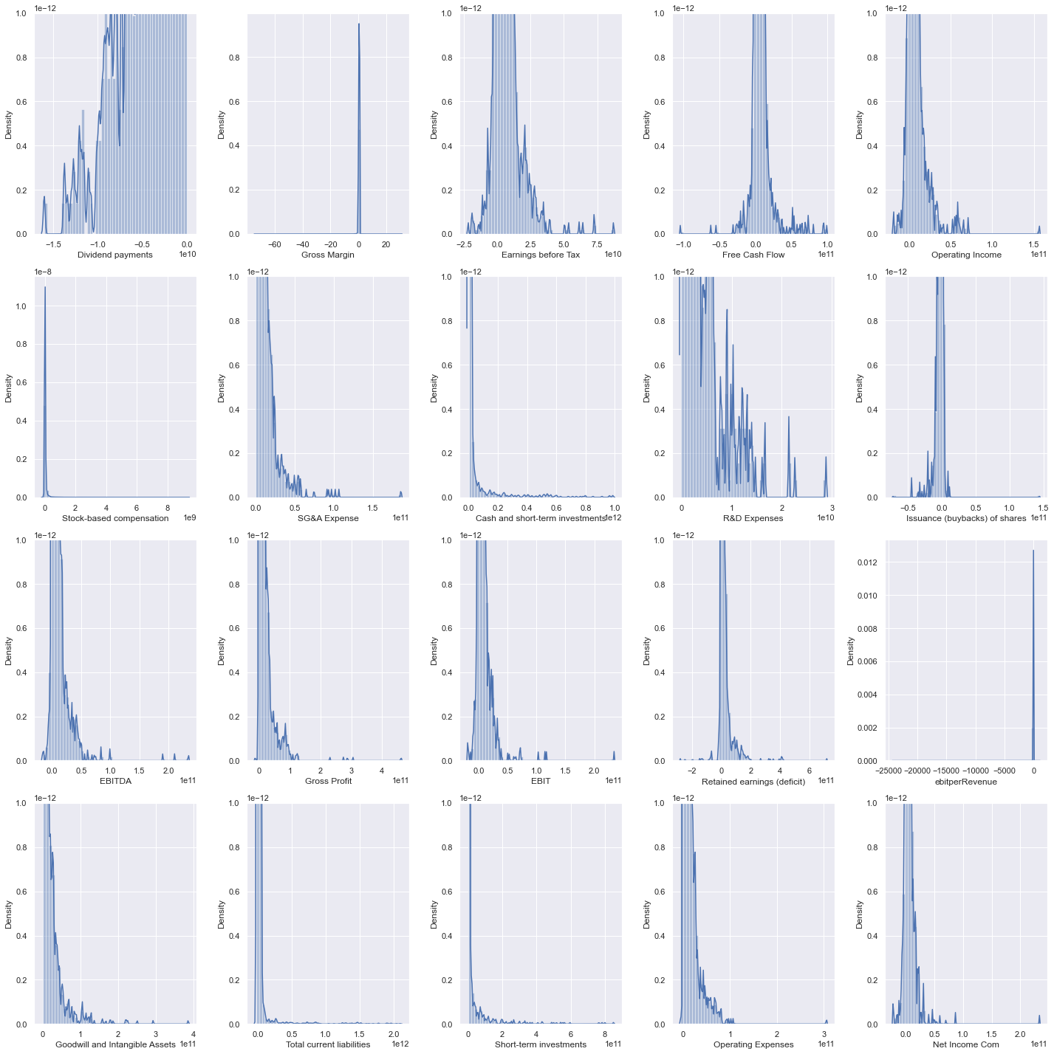

**Fig.8. Density (Distribution) Charts**

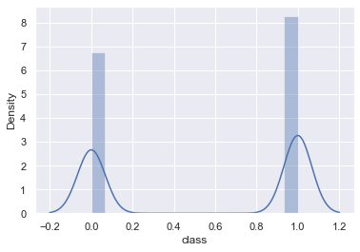

**Fig.9. Class Label Chart**

This is our class labels density chart. As you can see from the chart our stocks prices most likely to increase next year.

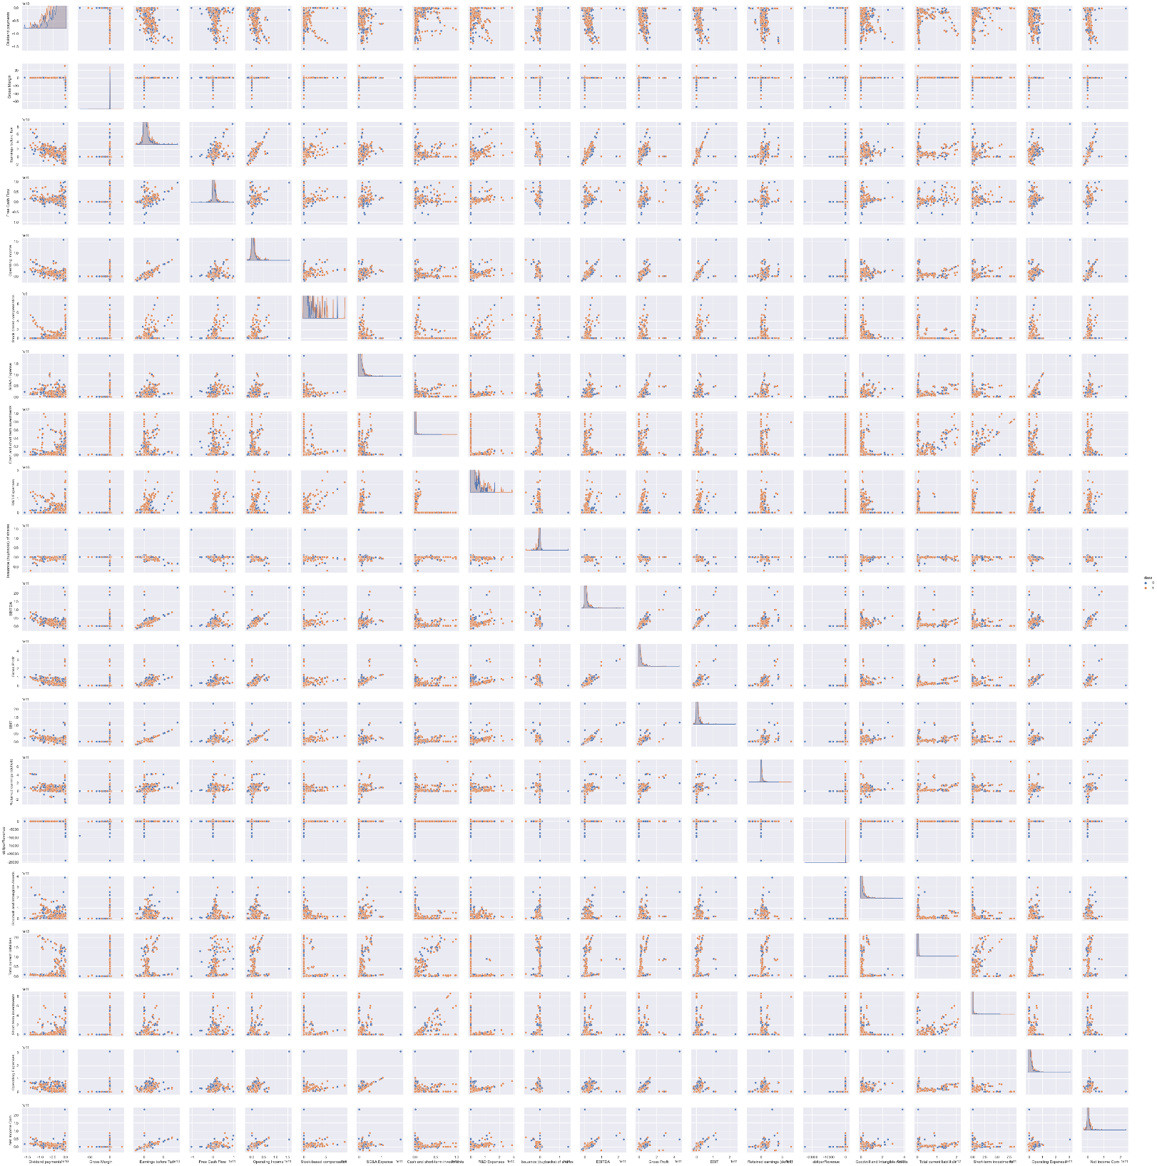

**Fig.10. Scatter Plot Matrix**

In Figure 10 relationships between financial indicators are observed. Interactions between these indicators are mostly positively correlated for e.g. (3,6) or negatively correlated for e.g. (17,17) due to slopes being either negative or positive.

**Delivery #5**

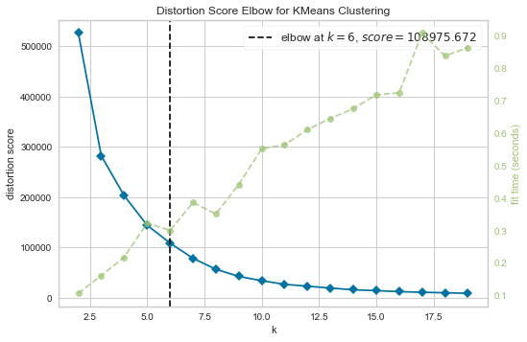

**Fig.11. Elbow Method for K-Means**

Elbow method is used to find out exact number of clusters to both not divide information unnecessarily and add much information possible. By looking at the blue-line we can see the elbow(bend) is exactly at point k=6. Also point of infliction suggest that point k=6 is the best fitting value for K-Means clustering.

**Table.5. Evaluation Table for clustering algorithms**

