**Generic-DMS Production Deployment Guide**

* Create below lists/Libraries on Production site (if not already there)
  + Use “Save as Template” functionality for the lists/libraries from UAT site

Below are the Lists/Libs:

**Note**:

1. Make sure and default Drop off Library is deleted (or hidden) from the site and the related feature is deactivated.
2. Make sure that newly created Document Library has all the Content Types attached and any List Column (Eg: Approval Status) is visible in Content Type.   
     
   Make sure to add Content Types 1st and then create any new Column (In case you are not using Save as Template Option).
3. If List is Already there , compare the columns and add missing columns

|  |  |  |
| --- | --- | --- |
| Name | Type | Source Url |
| DropOffLibrary | Custom Library | <http://hydvspsuat01:8082/sites/TestDocumentCenter/CustomDropOffLibrary> |
| ApprovalMetrix | List |  |
| Rejected Documents | List |  |
| RejectionHistory | List |  |
| ApprovalHistory | List |  |
| RoutingRule | List |  |
|  |  |  |
|  |  |  |

* Create workflow “Document Approval” on “DropOffLibrary”, copy the steps from UAT and publish it.
* Create another workflow “BreakTaskPermission” on the Task List associated with above Workflow.
* In order to add certain Functionality on Edit and New forms, we need to add Custom code.
  + Make sure Publishing Feature is enabled on Site
  + Move a copy of **assets** and **GenericDMS** folder in “Style Library” from UAT to Production.
  + Add Content Editor Web Part on Default New Form and Default Edit Form in **Approval Metrix** List and add below script:

Style Library/GenericDMS/JS/CustomizeEditForm.js

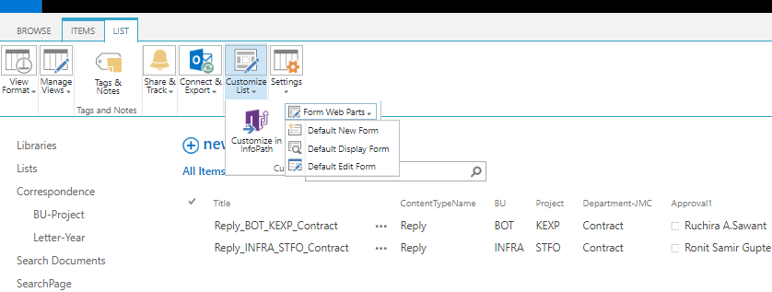

* + Add Content Editor Web Part Default Edit Form in DropOffLibrary Library and add below script:

/Style Library/GenericDMS/JS/CustomizeDropOffDocumentEditForm.js

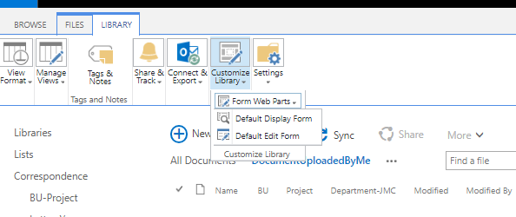

* Move Utility from \\hydvspsuat01\c$\Utilities\GenericDMS-DocumentRouter to Production Server. Schedule t to run in every 2 minutes
  + Make Sure that Log Folders are Created

**Create Custom Action**

* Create a Custom Page “ViewApprovalHistory” in Pages Library.



Add script “Style Library/GenericDMS/html/ViewApprovalHistory.html” to it.

* Create Custom Action in “Rejected Documents” and below Libraries:



* Follow below Steps to create a Custom Action .
  + Upload an icon in images Library. Move a copy from UAT (/sites/TestDocumentCenter/PublishingImages/WorkflowHistory.png ) in Images on Production
  + Open Designer, Go to specific List where Custom Action needs to be Created:

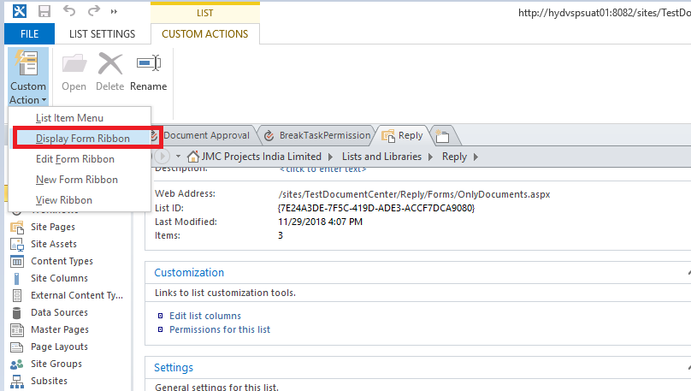

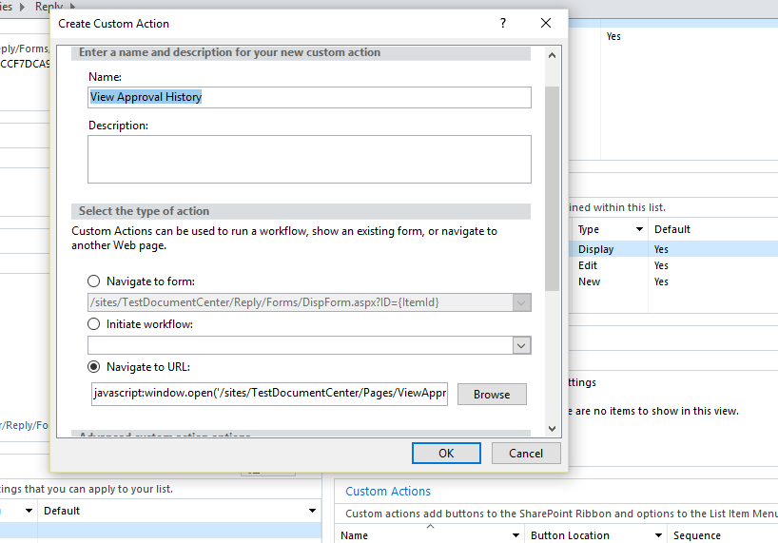

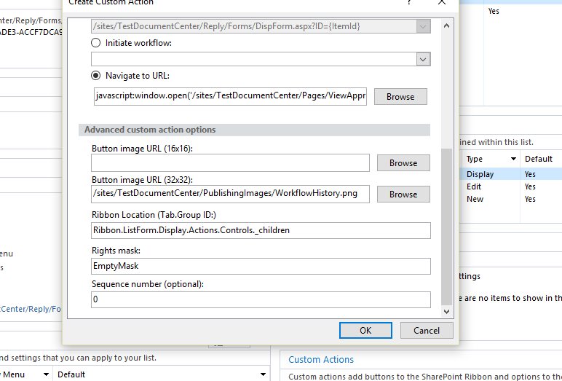

* + Add below values while Creating Custom Action :
    - **Name** : View Approval History
    - **Button Image URL(32*32):** <Relative Site url> /PublishingImages/WorkflowHistory.png
    - Navigate to URL (For **Rejected Document** Library):

javascript:window.open('/sites/TestDocumentCenter/Pages/ViewApprovalHistory.aspx?IsDlg=1&GUID={ItemId}&IsApproved=0&ListID={ListId}')

* + - Navigate to URL (For **other Libraries**): javascript:window.open('/sites/TestDocumentCenter/Pages/ViewApprovalHistory.aspx?IsDlg=1&GUID={ItemId}&IsApproved=1&ListID={ListId}')

**Execute PowerShell command**

Execute below PS commands on server to Restrict Metadata download with Document

$web=Get-SPweb “<site Url>”   
$web.ParserEnabled=$false  
$web.Update()

**Navigation and Upload Link**

* Create below Navigations:

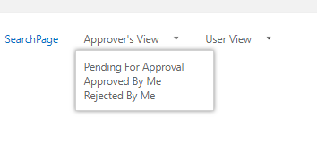

**Pending For Approval**: Task List View with items Pending at Me

**Approved By Me**: Task List View with items Assigned to me and are Approved.

**Rejected By Me**: Task List View with items Assigned to me and are Rejected.

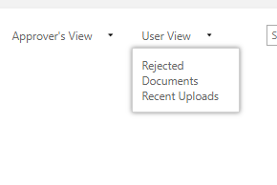

**Rejected Documents:** View from Rejected Document Library having items Created by Me

**Recent Uploads:** View from DropOff Library Document Library having items Created by Me

Upload Link: Change Upload link (present on Home Page) to created DropOff Library New Item page:

