PROVIDER HOSTED APP

1. Two certficates needs to be created for RERA

> CertificateKalpataruCommon

> CertificateKalpataruRERA

Note – Make sure that issuerID is different for both certificates

2) Below are the steps for creating certificate

## CERTIFICATE STEPS

1. Open IIS manager on the SharePoint Server and double click on Server Certificates in IIS section.

Machine generated alternative text:
Internet Information Services (IIS) Manager 
File Viewu 
nnectio 
SPDEVOI 
Help 
SPDEVOI 
Start Page 
SPDEVOI (PROSARES\Nirikshi 
Home 
.NET Error 
Shouu All 
.NET 
Globalization 
Default 
Document 
Certificates 
IIS Manager 
Group by: 
9 
Area 
ASP.NET 
.NET 
Authorizat... 
Authentic... 
Modules 
.NET 
.NET Trust 
Directory 
Bro•.msing 
Worker 
Processes 
Application 
Error Pages 
Connection 
Request Tra... 
Web 
Platfor... 
Machine Key 
Mappings 
Pages and 
Controls 
Redirect 
Providers 
Compilation 
Authorizat... 
Output 
Session State 
Ip Address 
and Doma.. 
SMTP E-mail 
ISAPI and 
CGI Restri... 
Ell 
Logging 
Open Feature 
Manage Server 
Restart 
Viewu Application Pools 
Viewu Sites 
Deploy 
Export. Server Package... 
8) 
Compression 
Request 
IIS Manager 
Permissions 
ISAPI Filters 
MIME Types 
Management 
Configurat... 
Delegation 
Management 
Shared 
Configurat... 
Features Viewu 
Content Viewu 
Import. Server or Site Package.. 
Change .NET Framewuork 
Version 
Get Neuu Web Platform 
Components 
ENG 
10-08-2016 

1. Click on Create Self-Signed Certificate.

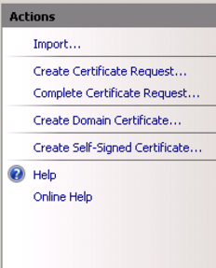

1. Specify Friendly Name of the certificate as " CertificateKalpataruCommon".

Machine generated alternative text:
Internet Information Services (IIS) Manager 
SPDEVOI 
File Viewu Help 
nnectio 
Start Page 
SPDEVOI (PROSARES\Nirikshi 
Application Pools 
Server Certificates 
use this feature to request and manage certificates that the Web server can use wuith wuebsites configured for SSI. 
Name 
Boardapp-godrej.prosares.net 
IIS Express Development Certifi... 
Issued T 
SPDEVOI 
App Sen.' 
Workflo 
SPDEVOI 
Forefron 
SPDEVOI 
WMSvc- 
Create Self-Signed Certificate 
Specify Friendly Name 
Specify a file name for the certificate request. This information can be sent to a certificate authority for 
Specify a friendly name for the certificate: 
HindaIcoTrustCeftificate 
Select a certificate store for the neuu certificate: 
Web Hosting 
Features Viewu 
Content Viewu 
Create Certificate Request... 
Complete Certificate Request... 
Create Domain Certificate... 
Create Self-Signed Certificate... 
Enable Automatic Rebind of 
Renewued Certificate 
ENG 
10-08-2016 

1. The certificate will appear in the list of Server certificates.

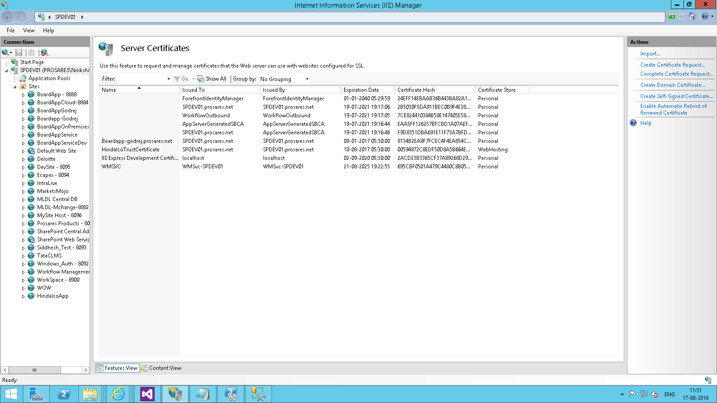

1. Go to windows explorer and create a folder named D:\RERACertificates.
2. In Server Certificates, right click on the certificate just created i.e. CertificateKalpataruCommon and click on Export

Machine generated alternative text:
Internet Information Services (IIS) Manager 
SPDEVOI 
Help 
File Viewu 
nnectio 
Start Page 
SPDEVOI (PROSARES\Nirikshi 
Application Pools 
Server Certificates 
use this feature to request and manage certificates that the Web server can use wuith wuebsites configured for SSI. 
Shouu All Group by: No Grouping 
Name 
Boardapp-godrej.prosares.net 
HindaIcoTrustCeftificate 
IIS Express Development Ce 
x 
Issued To 
SPDEVOI.prosares.net 
AppSewerGeneratedSBCA 
WorkflowuOutbound 
SPDEVOI.prosares.net 
ForefrontIdentityManager 
SPDEVOI.prosares.net 
Create Certificate Request... 
Issued By 
AppSewerGeneratedSBCA 
AppSewerGeneratedSBCA 
WorkflowuOutbound 
SPDEVOI.prosares.net 
ForefrontIdentityManager 
SPDEVOI.prosares.net 
Expiration Date 
19-07-2021 
19-07-2021 
19-07-2021 7:05 
19-07-2021 7:06 
01-01-2040 
08-01-2017 
10-08-2017 
02-09-2020 
Certificate Hash 
ÆDB351DBA6g1E11F73A7BFD... 
EAA5FF126257BFCBDIA07AEF... 
7CEB244103B4B5BE147405E5B... 
285030F5DAg11BECOB9F4E3B... 
24EFF14EBAAB36B443BAB2A1... 
813482EABF7FCEC4F4EAB54C.. 
00594872CBEDF50DRA5B664E... 
2ACD23B3365CF37AB926BDag... 
69TBF0501AA7gc44aocBB05... 
Certificate 
Personal 
Personal 
Personal 
Personal 
Personal 
Personal 
WebHostin 
Personal 
Personal 
Store 
Complete Certificate Request... 
Create Domain Certificate.. 
Create Self-Signed Certificate... 
Remove 
Enable Automatic Rebind of Renewued Certificate 
Features Viewu 
Content Viewu 
Create Certificate Request... 
Complete Certificate Request... 
Create Domain Certificate.. 
Create Self-Signed Certificate... 
x 
Remove 
Enable Automatic Rebind of 
Renewued Certificate 
ENG 
10-08-2016 

1. In Export To, provide the path created earlier (D:\RERACertificates) and give file a name like " CertificateKalpataruCommon ". The file has .pfx extension (password: prosares)

Machine generated alternative text:
Internet Information Services (IIS) Manager 
SPDEVOI 
File Viewu Help 
nnectio 
Start Page 
SPDEVOI (PROSARES\Nirikshi 
Application Pools 
Server Certificates 
use this feature to request and manage certificates that the Web server can use wuith wuebsites configured for SSI. 
Shouu All Group by: No Grouping 
Name 
Boardapp-godrej.prosares.net 
HindaIcoTrustCeftificate 
IIS Express Development Certifi... 
Issued To 
SPDEVOI.prosares.net 
AppSewerGeneratedSBCA 
WorkflowuOutbound 
SPDEVOI.prosares.net 
ForefrontIdentityManager 
SPDEVOI.prosares.net 
SPDEVOI.prosares.net 
WMSvc-SPDEV01 
Issued By 
AppSewerGeneratedSBCA 
AppSewerGeneratedSBCA 
WorkflowuOutbound 
SPDEVOI. rosares.net 
Expiration Date 
19-07-2021 
19-07-2021 
19-07-2021 7:05 
19-07-2021 7:06 
Export Certi ficate 
SPDE 
Export. to: 
Passwuord: 
Confirm pass.mord: 
Certificate Hash 
ÆDB351DBA6g1E11F73A7BFD... 
EAA5FF126257BFCBDIA07AEF... 
7CEB244103B4B5BE147405E5B... 
285030F5DAg11BECOB9F4E3B... 
3BAB2A1... 
F4EAB54C... 
8458664E... 
89268029... 
BOCBB05.. 
Cancel 
Certificate Store 
Personal 
Personal 
Personal 
Personal 
Personal 
Personal 
WebHosting 
Personal 
Personal 
Features Viewu 
Content Viewu 
Create Certificate Request... 
Complete Certificate Request... 
Create Domain Certificate... 
Create Self-Signed Certificate.. 
x 
Remove 
Enable Automatic Rebind of 
Renewued Certificate 
ENG 
10-08-2016 

1. Double click on the certificate " CertificateKalpataruCommon" in Server Certificates.

Machine generated alternative text:
Internet Information Services (IIS) Manager 
SPDEVOI 
File Viewu Help 
nnectio 
Server Certificates 
Start Page 
use this feature to request and manage certificates that the Web server can use wuith wuebsites configured for SSI. 
SPDEVOI (PROSARES\Nirikshi 
Application Pools 
Certificate 
Certification Path 
Certificate Hash 
ÆDB351DBA6g1E11F73A7BFD... 
EAA5FF126257BFCBDIA07AEF.. 
7CEB244103B4B5BE147405E5B... 
285030F5DAg11BECOB9F4E3B... 
24EFF14EBAAB36B443BAB2A1... 
813482EABF7FCEC4F4EAB54C... 
00594872CBEDF50DRA5B664E... 
2ACD23B3365CF37AB926BDag... 
69TBF0501AA7gc44aocBB05... 
Certificate 
Personal 
Personal 
Personal 
Personal 
Personal 
Personal 
Store 
General 
Show: 
Details 
41b 
Version 
Serial number 
Signature algorithm 
Signature hash algorithm 
neratedSBCA 
neratedSBCA 
tbound 
sares.net 
ntityManager 
sares.net 
sares.net 
Expiration Date 
19-07-2021 
19-07-2021 
19-07-2021 7:05 
19-07-2021 7:06 
01-01-2040 
08-01-2017 
10-08-2017 
02-09-2020 
12 17 77 46 70 4a 74... 
shalR5A 
5PDEV01 .prosares.net 
10 August 2016 11 
10 August 2017 
5PDEV01 .prosares.net 
WebHosting 
Personal 
Personal 
Valid From 
Valid to 
Subject 
Features Viewu 
Edit Properties... 
Content Viewu 
Copy to File... 
Create Certificate Request... 
Complete Certificate Request... 
Create Domain Certificate.. 
Create Self-Signed Certificate... 
x 
Remove 
Enable Automatic Rebind of 
Renewued Certificate 
ENG 
10-08-2016 

1. Click on Copy to File button at the bottom right to start export wizard.

1. Select the option No, do not export the private key and click Next.

1. Select default values and click Next.

1. Browse to D:\RERACertificates and name the file CertificateKalpataruCommon.cer and click Next.

Machine generated alternative text:
Internet Information Services (IIS) Manager 
SPDEVOI 
File Viewu Help 
nnectio 
Start Page 
SPDEVOI (PROSARES\Nirikshi 
Application Pools 
Server Certificates 
use this feature to request and manage certificates that the Web server can use wuith wuebsites configured for SSI. 
Certificate Hash 
ÆDB351DBA6g1E11F73A7BFD... 
EAA5FF126257BFCBDIA07AEF... 
7CEB244103B4B5BE147405E5B... 
285030F5DAg11BECOB9F4E3B... 
24EFF14EBAAB36B443BAB2A1... 
813482EABF7FCEC4F4EAB54C... 
00594872CBEDF50DRA5B664E... 
2ACD23B3365CF37AB926BDag... 
69TBF0501AA7gc44aocBB05.. 
Certificate 
Personal 
Personal 
Personal 
Personal 
Personal 
Personal 
Store 
Certificate Export Wizard 
Fik to 
Specify the name OF the File you want to export 
File name: 
C: XCerts\HindaIcoCertiFicate cer 
Expiration Date 
19-07-2021 
19-07-2021 
19-07-2021 7:05 
19-07-2021 7:06 
01-01-2040 
08-01-2017 
10-08-2017 
02-09-2020 
Browse... 
WebHosting 
Personal 
Personal 
Features Viewu 
Content Viewu 
Create Certificate Request... 
Complete Certificate Request... 
Create Domain Certificate.. 
Create Self-Signed Certificate... 
x 
Remove 
Enable Automatic Rebind of 
Renewued Certificate 
ENG 
10-08-2016 

1. Finally click on Finish

Machine generated alternative text:
Internet Information Services (IIS) Manager 
SPDEVOI 
File Viewu Help 
nnectio 
Start Page 
SPDEVOI (PROSARES\Nirikshi 
Application Pools 
Server Certificates 
use this feature to request and manage certificates that the Web server can use wuith wuebsites configured for SSI. 
Certificate Export Wizard 
Completing the Certificate Export Wi&rd 
You have successfully completed the Certificate Export "izard. 
Expiration Date 
19-07-2021 
19-07-2021 
19-07-2021 7:05 
19-07-2021 7:06 
01-01-2040 
08-01-2017 
10-08-2017 
02-09-2020 
Certi ficate Export Wizard 
The export wuas successful. 
Certificate Hash 
ÆDB351DBA6g1E11F73A7BFD... 
EAA5FF126257BFCBDIA07AEF... 
7CEB244103B4B5BE147405E5B... 
285030F5DAg11BECOB9F4E3B... 
24EFF14EBAAB36B443BAB2A1... 
813482EABF7FCEC4F4EAB54C.. 
00594872CBEDF50DRA5B664E... 
2ACD23B3365CF37AB926BDag... 
69TBF0501AA7gc44aocBB05... 
Certificate Store 
Personal 
Personal 
Personal 
Personal 
Personal 
Personal 
WebHosting 
Personal 
Personal 
You have specified the Following settings: 
File Name 
Export Keys 
Include all certificates in the certification path 
C: XCerts\HindaIcoCertiFicate cer 
No 
DER Encoded Binary X. 509 (8 .cer) 
File Format 
Features Viewu 
Content Viewu 
Create Certificate Request... 
Complete Certificate Request... 
Create Domain Certificate... 
Create Self-Signed Certificate.. 
x 
Remove 
Enable Automatic Rebind of 
Renewued Certificate 
ENG 
10-08-2016 

1. Now run the following PowerShell commands to configure SharePoint 2013 to use certificates

$publicCertPath = "D:\Preeti\FinalCerts\CertificateKalpataruCommon.cer"

$issuerId = "11111111-1111-1111-1111-111111111113"

$spurl = "http://spdev03/sites/RERA"

$spweb = Get-SPWeb $spurl

$sc = Get-SPServiceContext $spweb.site

$realm = Get-SPAuthenticationRealm -ServiceContext $sc

$certificate = Get-PfxCertificate $publicCertPath

$fullIssuerIdentifier = $issuerId + '@' + $realm

New-SPTrustedSecurityTokenIssuer -Name "Certificate Kalpataru Common High Trust" -Certificate $certificate -RegisteredIssuerName $fullIssuerIdentifier -IsTrustBroker

iisreset

4) Create two IIS site

i) KalpataruCommon

> http://spdev03.prosares.net:9091/

ii) KalpataruRERA

* http://spdev03.prosares.net:9092/

## DEPLOYMENT

Deployment involves App deployment and Website deployment

### WebSite Deployment:

1. Go to iis manager and click on create web site

Site name: KalpataruCommonApp

Physical Path : {Path containing the web site files}

Port: 9091

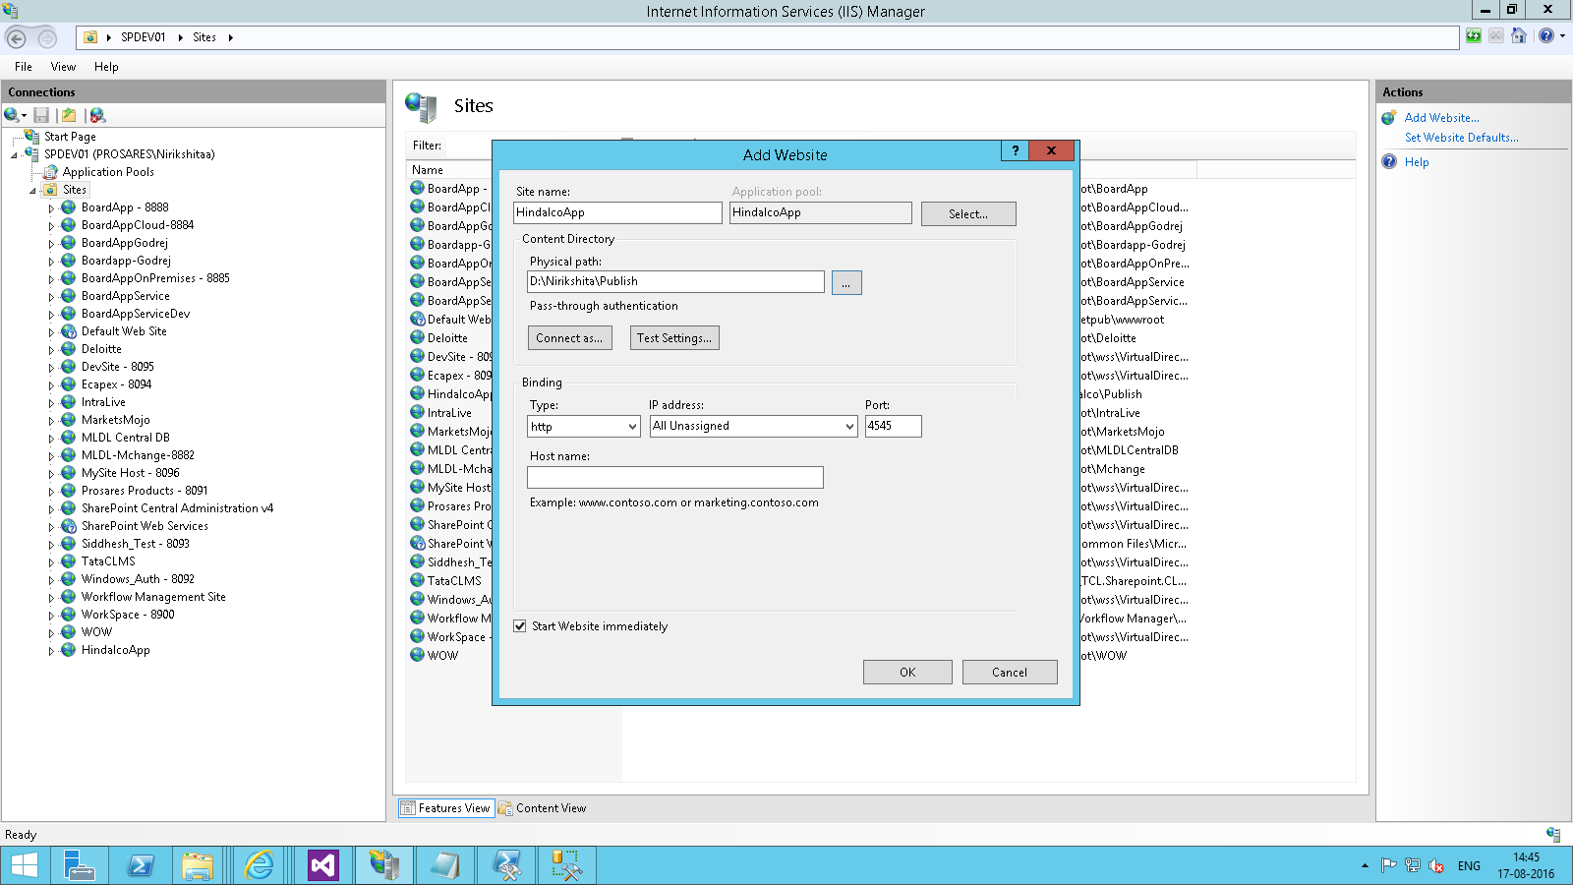

1. Authentication : disable anonymous access and enable Windows authentication

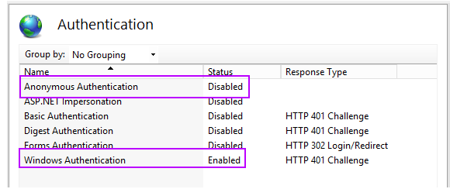

5) Generate ClientID and Client Secret for both the IIS site

Before publishing the app, a new client ID for the App should be generated form the app site.

1. Navigate to appregnew.aspx ({site collection url}/_layouts/15/Appregnew.aspx)
2. Click on Generate button for App Id. Note the generated id which will be used in app later on.

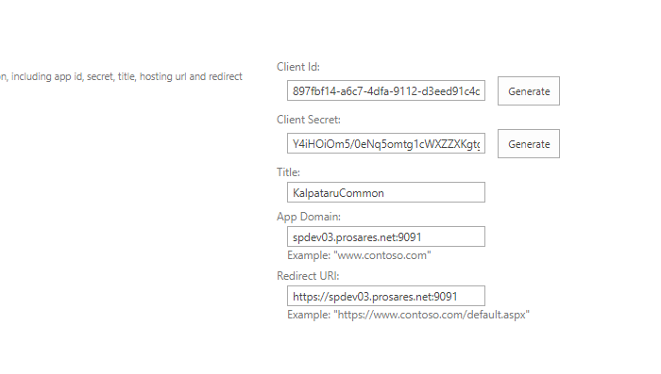

6)

Update web.config file

* ClientId - Id generated in step 3
* ClientSigningCertificatePath – Path of certificate (.pfx file) generated in step 2
* ClientSigningCertificatePassword – prosares (password used while creating certificate in step 2)



### 7) App Deployment:

1. Rename the .app file to a .zip file and opening it in windows explorer

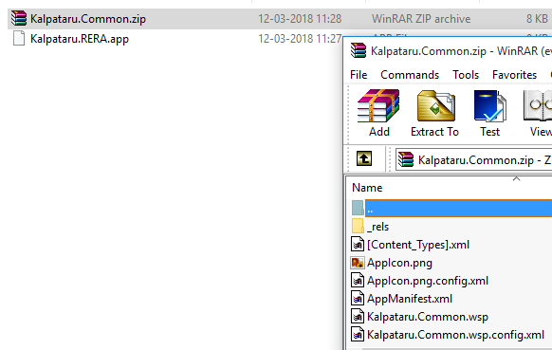

1. Open AppManifest.xml file in notepad and change the Client ID to the id generated in step 3

and change Start Page url to site create in iis during web deployment and add it back in the zip file. Rename it to .app file again.

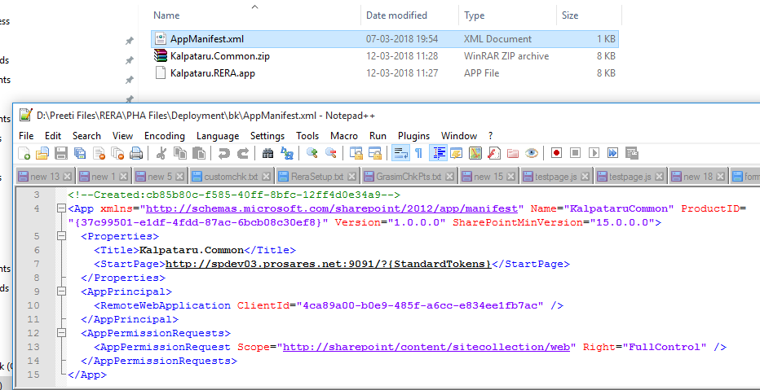

8) Remove below code in Web.config – PHA_RERA

i)

<add key="UserId" value="krishnap" />

<add key="Password" value="mar@123" />

<add key="Domain" value="Prosares" />

<add key="TempUserId" value="preetip" />

<add key="TempPassword" value="jan@2017" />

<add key="TempDomain" value="prosares" />

ii)

Replace SiteUrl with sitecollection url in Web.config – PHA_RERA

<add key="SiteUrl" value="http://spdev03/sites/RERA/" />