**Exercise 5. Calibrating Niche Models with Maxnet**

|  |  |
| --- | --- |
| Skills Acquired | Data Required |
| * Build an ecological niche model using a presence-background algorithm i.e. Maxent * Produce a set of model evaluation statistics for model selection | None |

NOTE: Remember to click on the “Component Guidance” tab if you need a refresher on the theoretical basis building and evaluating niche models, and the “Module Guidance” tab if you need additional information to help guide your model parameterization.

**Step 1: Click on “6 Model” in the browser window in which Wallace is running.**

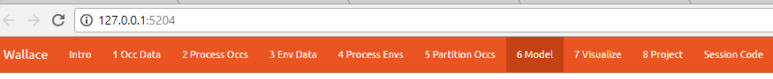

**Step 2: Choose your niche modeling method.** 

Select the “Maxent” radio button at the top left. Under “Select algorithm”, select the “maxnet” radio button. “Maxnet” and “maxent.jar” are algorithms that use the same underlying math. The difference is that “maxnet” does not use Java, which means it can run more readily on a wider range of computer operating systems than “maxent.jar”; Maxent was originally developed in the early 2000s using Java so that it had a clean user interface. Now Java often causes more problems than it solves.



**Step 3: Choosing your model parameters.**

As we discussed in lecture, the parameters you use in calibrating you niche model can be critical in determining the reliability of resulting model predictions. In Wallace we do this by selecting feature classes, which essentially set the rules for model fitting. These feature classes refer to the sorts of equations Maxent will use to try to model the data (linear equations, quadratic equations, and equations involving products). “Hinge” equations use two linear equations that “hinge” at a particular value of an explanatory variable. “Threshold” determines that above or below a particular value of a particular environmental variable, habitat is immediately no longer suitable. Ideally, we would select a combination of linear, quadratic, and product, which tends to fit models in a more biologically realistic manner and with less overfitting than if we also include hinge and threshold methods.

We can also select regularization multiplier and multiplier step values. The regularization multiplier sets how closely our model fits the data that we have used. A smaller value than the default of 1 will result in a more localized output distribution that is a closer fit to the presence records. Overfitting the model in this way may mean that it does’t generalize well to independent data. A larger multiplier will give a more spread out, less localized prediction. The multiplier step value sets the intervals at which regularization multiplier will be tested. So with multiplier values of 1-2 and a multiplier step value of 0.5, test models will be run for regularization multiplier values of 1, 1.5, and 2.

NOTE: ‘Wallace’ allows for very few opportunities to set the parameters of your models (as compared to using the Maxent GUI).

1. Under “Select feature classes” check the box beside LQHP.
2. Leave “Select regularization multiplier” and “Multiplier step value” at default. NOTE:Default values are normally adequate for building our models.
3. Press ‘Run”. Be patient, this process can take a few minutes.
4. When the process is complete, the ‘Results’ tab will open and display both the full model and partition evaluation statistics and the individual partition evaluation statistics. Remember, modeling algorithms are stochastic, so results displayed may be a little different each time you run the models.

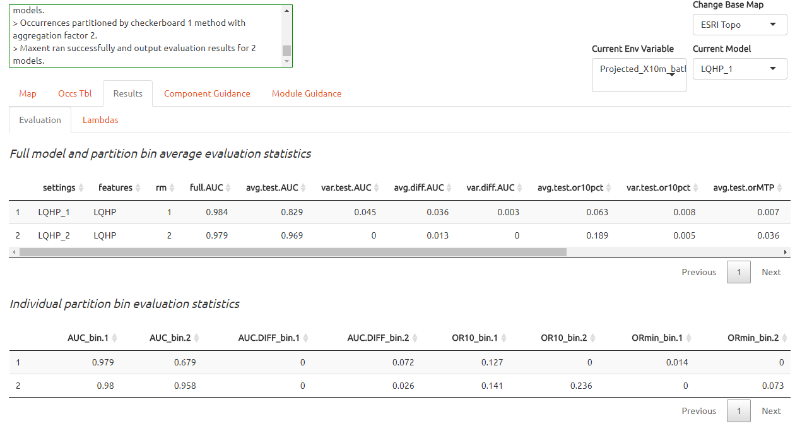

1. Save your model training results. Click “Download CSV” and save the file to your working project folder as: “*Gymnosarda_Maxent-train-eval.csv*”.

**Step 3: Model Evaluation and Selection**

Wallace provides a fairly broad suite of evaluation metrics to use in determining which model to utilize. For our purposes we will use AICc. Typically, the model with the lowest AICc score (or a delta AICc of 0) is considered to be the best model. But, omission rate is also a common and effective method of evaluating binary predictions, so we will look at these as well.

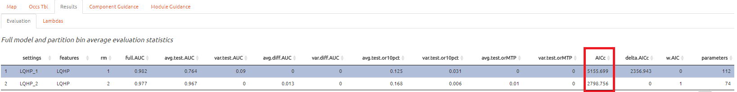

1. Look at the “Full model and partition bin average evaluation statistics” table in the Results section (the top table).
2. Record the AICc score for each model.
   1. LQHP_1: _____________
   2. LQHP_2: _____________
   3. Which model performed better according to AICc (delta AICc = 0)?

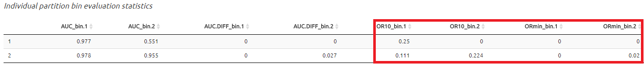

1. Now look at the “Individual partition bin evaluation statistics” table (the bottom results table). You’ll see that data have been evaluated using binning based on two threshold levels: the 10 percentile training (test.or10pct_bin.#) and the minimum presence training thresholds (test.orMTP_bin.#). Don’t worry if you don’t understand the thresholds yet -- we’ll discuss those in Exercise 8.

NOTE: The number of bins will depend on your selected spatial partitioning parameters. For example, the image above indicates only 2 binning sets because a *k*=2 parameter was selected; however, you may have 4 depending on your chosen parameters.

Fill in the following table with the model evaluation statistics for your models:

|  |  |  |  |  |  |  |  |  |
| --- | --- | --- | --- | --- | --- | --- | --- | --- |
| Model | 10% bin 1 | 10% bin 2 | 10% bin 3 | 10% bin 4 | MTP bin 1 | MTP bin 2 | MTP bin 3 | MTP bin 4 |
|  |  |  |  |  |  |  |  |  |
|  |  |  |  |  |  |  |  |  |

Based on the overall omission rate for all the bins, which model performed better? Does this match the conclusion reached using AICc?

1. Based on AICc and omission rate, which model do you think will be the best to continue working with? Keep note of this; you will use this in Exercise 8 for model projection.