BID Data Use Workshop - Use Case 1

**Ecological niche modeling of a marine species**

This is a use case story developed to be used as a base for practical exercises in thesecond capacity enhancement workshop on biodiversity data use within the Biodiversity Information for Development (BID) programme.

Please note that this use case is fictitious and built for instructional purposes using data downloaded from [www.gbif.org](http://www.gbif.org). Any reference to countries and structures/organisations, real or otherwise, within those countries are used merely to facilitate the use of the data and do not reflect the reality within those countries.

## Description of the use case

Gymnosarda unicolor, the Dogtooth tuna, is a medium-sized fish species in the family Scombridae, which includes mackerels, tunas, and other popular commercial fish species. They are found predominantly in reef environments throughout the tropical Indo-Pacific region, with smaller fish being more commonly found near shallow reef areas and larger ones haunting deep reef drop off areas, seamounts and steep underwater walls. Rainbow tuna prey primarily on smaller schooling fishes and squids. Usually they occur in small schools to a depth of 10–300 metres, but tagging studies in the Indian ocean have shown that individuals are able to disperse across distances of 4,000 km. *Gymnosarda unicolor* is harvested extensively across its range, both supplying local markets and as part of international trade. In the last 30 years, there has been a 200% increase in catch size for this species due to the increased mechanisation of the fishing fleet and increased demand from more affluent urban communities on the islands that can afford the fish. Further, in the last 5 years US retailer M&Vs has incorporated *Gymnosarda unicolor* within its supply chain in response to a new trend in the USA for the fish in “unicorn” sushi. With 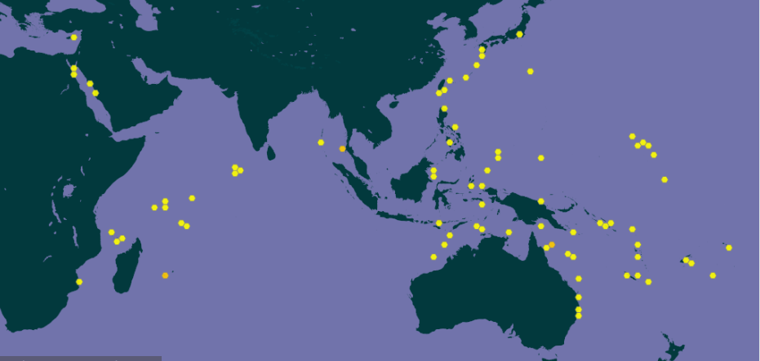increasing targeted fishing of this species to supply domestic and international markets, there is concern over the continued persistence of the species and there is no information on its conservation status. Though this species is well-known by commercial fishermen, there has been no systematic study of the distribution of the species at global scale. A distribution map for the species would provide a starting point from which fishery management plans could be developed to ensure the sustainability of stocks.

You will need to download the current dataset for Gymnosarda unicolor from [www.gbif.org](http://www.gbif.org/).

# 

## Exercise 1 – Fit-for-purpose data

We have given you the results of a GBIF global search for *Gymnosarda unicolor*, an economically-important fish in the Philippines. You have been given a Darwin Core archive for that species. Imagine you are about to assess a species, perhaps choose a species that you are familiar with. Discuss on your tables which of the following Darwin Core terms might be more relevant than others in assessing the conservation status of a species and what might be some of the data quality issues be associated with those terms. Remember that information for a red list assessment can be observed, estimated, inferred, projected and suspected.

For reference, these are the criteria used for assessing the conservation status of a species

* **Population reduction** - assessment based on trends in population size over time
* **Restricted geographic range** - assessment based on the size of the species’ geographic range and information on population structure and declines in population and habitat.
* **Small population size and continuing decline** - assessment based on the present day number of individuals within the population and observed, estimated, projected or inferred declines in population size
* **Very small or restricted population** - assessment based on species with very small number of individuals

Answer questions 1 to 3 before then cleaning the dataset provided in line with data quality requirements above. You have been provided with a step-by-step guide for processing your data with Excel and QGIS. You may want to use whichever tool you are most familiar with. Question

|  |
| --- |
| Q1. What are the taxonkeys for each of the species and what is the taxonomic status of each species? |
|  |
| Q2. In what format did you download the data and how what are the unique properties of this type of download? |
|  |
| Q3. What are the DOIs of your downloads? |
|  |
| Q4. What are the following key data quality processing steps did you use for cleaning both datasets? For each requirement, what is your justification? |
| * Default geospatial issues * Absence records * Fossils and living specimens * Establishment Means * Old records * Uncertain location * Bad default values for coordinate uncertainty * Points along the Equator or prime meridian * Country centroids * Duplicate removal * Outliers * Metagenomics * Outside Native ranges * Gridded datasets * Automated identifications |
| Q5. What additional data processing steps might you want to validate taxonomic identification of species? |
|  |

## Exercise 4 - Starting Wallace and Loading Occurrences

First thing’s first. We’ll start by launching Wallace and giving you a quick overview of the steps you will go through to generate a niche model. You have been provided with a step-by-step guide to this exercise.

## Exercise 4:

|  |
| --- |
| Q1. What is the overall goal of your ecological niche model? That is, what question or hypothesis are you exploring? |
|  |
| Q2. What type of niche are we modeling? What limits our ability to model the kind of niche we hope to model? |
|  |

## 

## Exercise 5 - Determining a training region

|  |
| --- |
| Q1. On the map below, draw what you think would be a good training region for the model. |
|  |
| Q2. Why did you choose this area? Is it based on where the species is known to occur, as well as areas it could access? Are there features of the species’ natural history that help inform your choice? |
|  |

## Exercise 6 - Partitioning Occurrence Data

In this exercise, you will partition your occurrence data in Wallace. You have been provided with a step-by-step guide to this exercise.

# **Exercise 7 - Calibrating Niche Models**

|  |
| --- |
| Q1. Record the AICc score for each model. |
| * 1. LQHP_1:   2. LQHP_2: |
| Q2. Which model performed better according to AICc |
|  |
| Q3. Fill in the following table with the model evaluation statistics for your model |
| |  |  |  |  |  |  |  |  |  | | --- | --- | --- | --- | --- | --- | --- | --- | --- | | Model | OR10_bin.1 | OR10_bin.2 | OR10_bin.3 | OR10_bin.4 | ORmin_bin.1 | ORmin_bin.2 | ORmin_bin.3 | ORmin_bin.4 | | LQHP_1 |  |  |  |  |  |  |  |  | | LQHP_2 |  |  |  |  |  |  |  |  | |
| Q4. Based on the overall omission rate for all the bins, which model performed better? Does this match the conclusion reached using AICc? |
|  |
| Q5. Based on AICc and omission rate, which model do you think will be the best to continue working with? |
|  |

# 

## Exercise 8 - Visualizing, Thresholding, and Projecting Niche Models

In this exercise, you will process results from Exercise 6 to produce maps of *Gymnosarda arcus* suitable habitat, as well as several plots to diagnose model performance. You will also project your Rainbow tuna model into different bioclimatic conditions. You have been provided with a step-by-step guide to this exercise.

|  |
| --- |
| Q1. What similarities do you see across the four visualizations? What are the major differences? |
|  |
| Q2. Look closely at your projected model. Based on what you know about our study species, *Gymnosarda arcus*, do your model results make sense? Are there any areas of predicted absence or presence that are questionable? What areas? Why do you question the model prediction in these areas? |
|  |

# 

### Exercise 10 - Developing a Communication Strategy

Part 1 - Prioritizing stakeholders

In this exercise, you will use information from previous exercises and all the information available to you in the Rainbow tunause case to **prioritize the stakeholders relevant to influencing your key policy entry points.**

1. Read through the Rainbow tunause case
2. Review your entry point and stakeholders from Exercise 1 Identify any missing stakeholders in the use case and discuss why you should engage with them. Complete the stakeholder mapping matrix on a flipchart and record your results on your exercise sheet.
3. Select an individual from your group to report back. Complete your exercise sheet with the responses.
4. Group report back and discussion

### Part 2 - Developing a communication plan

In this exercise, you will use information from all the previous exercises and all the information available to you in the Rainbow tuna use case to **develop a simple but realistic communication plan.**

Please note that in the next exercise you will be asked to pitch your key messages.

In your groups, discuss the following in relation to each of your stakeholders for your chosen policy entry point:

1. Why you want to communicate with them? i.e. your communication objective(s)
2. What message do you want to communicate with them?
3. What approaches will you use to communicate? i.e. push or pull
4. How will you communicate or present your message? i.e. types of communication activities and channels
5. What do you want to achieve by communicating the message? i.e. your desired outcome.
6. When in the process will you communicate with them?
7. Where might you communicate with them (e.g. specific opportunities/events)?
8. Indicate success criteria
9. Complete the communication plan matrix with your results
10. Select an individual from your team to report back

# Part 3 - Stakeholder Communication

In your group, review the case study and all of the information you have gathered and generated over the last week. You have already described the problem, the approach and the desired impact. You know the entry points and the key stakeholders, and you have some insight into the influence those stakeholders hold and what they think about biodiversity. You have developed a communication plan, and you are equipped with a number of communication tools.

Your task is to synthesise all of this information into a succinct and convincing pitch to fund your approach and develop your information product. But you are not only pitching your own ideas, you are also scrutinising another group’s pitch, and you need to be prepared to ask some challenging questions. This might also help you to think about what the Minister will ask you when you make your pitch.

Find a group whose first language is the same as yours and pair up. Each pair of groups will take centre stage in front of the other same language groups, taking turns to make a pitch and act as Minister. There will be **five** minutes for the pitch, **two** minutes for follow-up questions by the Minister and then a further couple of minutes for plenary reflections on the pitch - what went well, what points could have been made more strongly, was the language appropriate etc.

|  |
| --- |
| Q1. Fill in the table below for your selected policy entry point identifying your relevant stakeholders and the level of influence and support each one has. |
| |  |  |  | | --- | --- | --- | | Stakeholder | Describe the level of influence this stakeholder has on your policy entry point? | Describe how this stakeholder will or will not support the desired outcome of your approach? | |  |  |  | |  |  |  | |  |  |  | |  |  |  | |
| Q2. Outline your communication plan in order to achieve your desired outcome for your primary stakeholder for your selected policy entry point. (Copy the table if you are developing a plan for several stakeholders) |
| |  |  | | --- | --- | | **Stakeholder** |  | | Communication Objective(s) |  | | Message |  | | Approach |  | | Type of communication activities and channels? |  | | Desired outcome |  | | When? |  | | Where? |  | | Success criteria |  | |