SER 401: Team 41

Learning and Research Doc - MongoDB

**MongoDB**

|  |  |  |  |  |
| --- | --- | --- | --- | --- |
| Team member: | Ty | Curtis | Isaac | Penelope |
| Feels up to speed check mark: | X | X |  | X |

**Resources:**

Tutorial: <https://www.tutorialspoint.com/mongodb/index.htm>

Downloadable reference cards: <https://www.mongodb.com/collateral/quick-reference-cards>

Download MongoDB: <https://www.mongodb.com/try>

A good refresher if you feel like you remember it at least a little: https://codisfy.com/mongodb-refresher/

Json quick reference: <https://www.tutorialspoint.com/json/json_quick_guide.htm>

Json queries: <https://docs.jsonata.org/simple>

Schema creation quick reference: <https://docs.mongodb.com/realm/mongodb/document-schemas/>

**Notes:**

-MongoDB provides a unique document ID automatically. You can also provide your own ID, however.

-Data is stored in JSON style documents, internally as BSON

- is schema-less, and doesn’t force each document to have the same structure

- validators for javascript: Orderly (BSD); JSV; json-schema; Matic (MIT); Dojo; Persevere (modified BSD or AFL 2.0); schema.js.

- basic example of syntax:

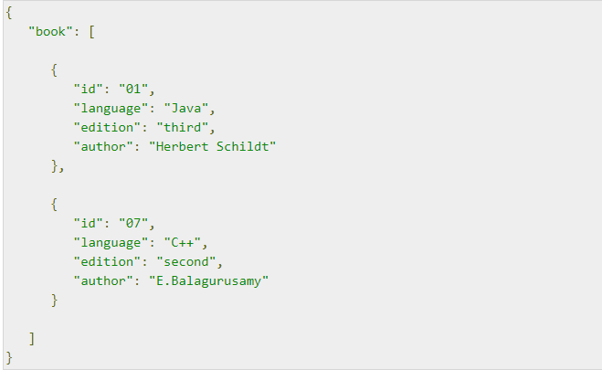

-can store database in embedded or normalized data models. Embedded docs have all the information stored in one place under different tags. Normalized models have docs referencing each other using their reference IDs. Example below:

Embedded:

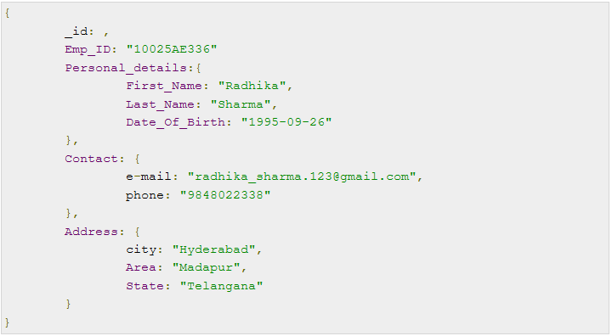

Normalized:

