SER 401: Team 41

Learning and Research Doc - TypeScript

**Typescript**

|  |  |  |  |  |
| --- | --- | --- | --- | --- |
| Team member: | Ty | Curtis | Isaac | Penelope |
| Feels up to speed check mark: | X | X |  | X |

Resources:

Tutorial: <https://www.tutorialspoint.com/typescript/index.htm>

The quick rundown: <https://www.typescriptlang.org/docs/handbook/typescript-in-5-minutes.html>

Great resource for learning the basics of Javascript: <https://developer.mozilla.org/en-US/docs/Web/JavaScript/Guide/Grammar_and_types>

Good “get started” video: <https://www.youtube.com/watch?v=ahCwqrYpIuM>

Notes:

- Existing JavaScript code is also TypeScript code- Typescript has benefit of highlighting unexpected behavior in code to lower chance of bugs

- Typescript allows for typing by inference, but also offers the ability to explicitly define types- supports classes and object oriented programming

-  In TypeScript types are just sets, a particular value can belong to *many* sets at the same time

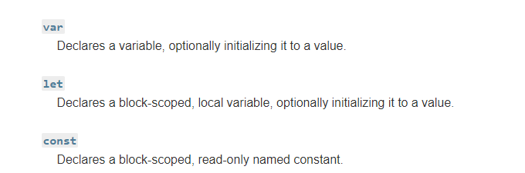

- adds primitive types:

- any: allow anything

- unknown: unsure of type

- never: this type is not possible

-void: a function returns undefined or has no return value

- you can combine simple types to create complex ones with unions and generics

-Type checking focuses on the /shape/ of values

- Javascript: is case sensitive, statements don’t need semicolons if they’re on their own line