Enterprise Google Cloud Data Platform Blueprint
Volume 02: Landing Zone
Google Cloud organization, network, identity and security foundation

Document attribute | Value
Version | 0.1 reference implementation
Date | 2026-07-10
Intended audience | Executive, architecture, security, platform engineering, data, AI, SRE and FinOps stakeholders
Scope | Fortune 100 reference blueprint for petabyte-scale Google Cloud data platform
Status | Generated implementation starter set; verify service-specific settings against current Google Cloud documentation

Table of Contents
- 1. Landing Zone Objectives
- 2. Organization and Folder Structure
- 3. Network Architecture
- 4. Identity and IAM
- 5. Security Foundation

Inherited Fortune 100 Assumptions
Area | Assumption
Scale | 10-50 PB historical data; 50-250 TB/day new data; billions of events/day
Organization | Global enterprise with central platform team and federated domain teams
Regulatory | GDPR, HIPAA, PCI DSS, SOC 2, ISO 27001, NIST and regional residency constraints may apply
Availability | Tier 0 RTO <1 hour and RPO <5 minutes; Tier 1 RTO <4 hours and RPO <15 minutes
Cloud posture | Hybrid and multi-cloud integration with Google Cloud as the enterprise data platform foundation
Security | Zero Trust, least privilege, private connectivity, service perimeters, CMEK for restricted data

1. Landing Zone Objectives
The landing zone provides governed, repeatable, secure foundations for data and AI workloads across development, test, staging, production and sandbox environments.

2. Organization and Folder Structure
The hierarchy separates platform, security, network, logging, monitoring, CI/CD, domain and sandbox responsibilities. Production and non-production isolation is enforced at folder, project, network, IAM and KMS boundaries.
Folder | Purpose
platform | Shared services, CI/CD and platform automation
security | SCC, KMS, centralized controls, SIEM integration
networking | Shared VPC host projects and connectivity
data-domains | Domain service projects for data products
sandbox | Time-bound experimentation with quotas

Figure: Google Cloud Landing Zone and Shared VPC
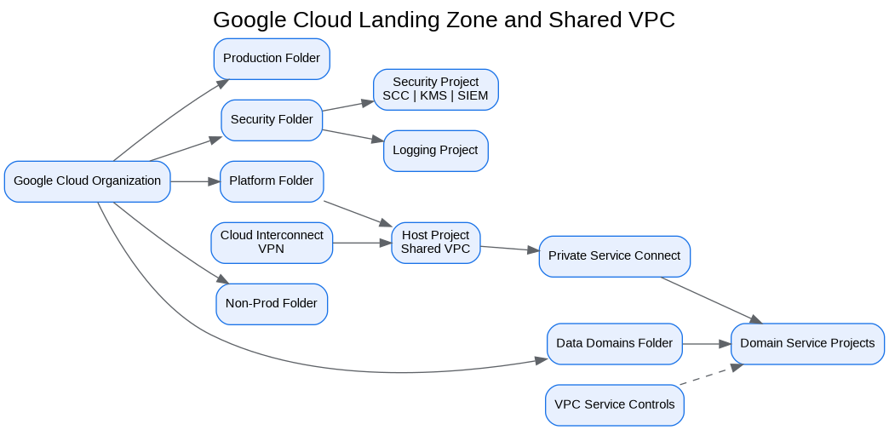
Figure: Security and Zero Trust Control Plane
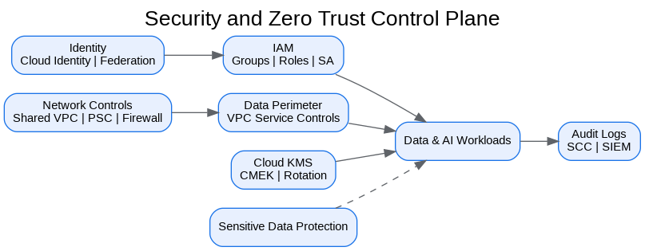

3. Network Architecture
Use Shared VPC with host projects, private Google access, Private Service Connect for service access, hierarchical firewall policies and Cloud Interconnect or VPN for hybrid connectivity.

4. Identity and IAM
Use group-based IAM for humans, dedicated service accounts for workloads, service-account impersonation, Workforce Identity Federation and Workload Identity Federation. Privileged access must be just-in-time and audited.

5. Security Foundation
VPC Service Controls, Organization Policy, Cloud KMS, Secret Manager, Security Command Center, centralized logging and monitoring form the mandatory security baseline.
Service | Purpose | Benefits | Limitations / Pitfalls | Cost Controls
BigQuery | Enterprise analytics warehouse and curated serving layer | Serverless SQL, separation of storage/compute, strong ecosystem | Poor partitioning and unrestricted ad-hoc queries can create high costs | Reservations, labels, max bytes billed, partitioning, clustering
Cloud Storage | Raw, landing, archive and open-format lakehouse storage | Durable object storage, lifecycle policies, broad integration | Bucket sprawl and direct consumer access can weaken governance | Lifecycle policies, storage classes, retention controls
BigLake | Governed access to Cloud Storage data through BigQuery interfaces | Fine-grained access without direct bucket reads | Requires metadata and permission design | Table lifecycle, open-format governance
Dataflow | Batch and streaming pipelines using Apache Beam | Unified model, autoscaling, managed execution | Complex stateful pipelines require strong testing | Autoscaling, worker sizing, streaming engine
Pub/Sub | Event ingestion and decoupling | Reliable async messaging, retry and dead-letter support | Schema/version drift can impact consumers | Retention tuning and payload design
Knowledge Catalog | Metadata, glossary, lineage, governance and data discovery | Enterprise context layer for data and AI | Incomplete stewardship reduces trust | Metadata ownership and lifecycle controls

Architecture Decision Records
ADR | Decision | Problem | Alternatives | Decision | Tradeoffs/Risks | Mitigation
ADR-001 | Google Cloud as enterprise data platform | Fragmented analytics estate | Continue legacy; multi-cloud split; Google Cloud data platform | Adopt Google Cloud data platform with hybrid integration | Requires operating-model change | Phased landing zone, domain pilots, and governance automation
ADR-002 | BigQuery analytical core | Need PB-scale SQL analytics | Legacy EDW; Spark-only; third-party warehouse | Use BigQuery for curated/serving layers | Cost governance required | Reservations, labels, query controls, FinOps dashboards
ADR-003 | Lakehouse with Cloud Storage and BigLake | Need open data and governed access | BigQuery-only; unmanaged object lake | Use Cloud Storage + BigLake + BigQuery | Open table governance maturity required | Catalog, policies, certified data-product lifecycle
ADR-004 | Zero Trust and VPC SC | Exfiltration risk and regulated data | Network-only perimeter; IAM-only controls | Use identity, network, data and service perimeters | Service exceptions require testing | Perimeter dry runs and explicit ingress/egress policies

Risks and Mitigations
Risk | Impact | Mitigation
Underestimated legacy complexity | High | Complete source, pipeline, report and dependency assessment before migration waves
Data ownership gaps | High | Create domain owner RACI and data-product certification gate
Cost overrun | High | Enforce labels, budgets, reservations, query guardrails and monthly FinOps reviews
Security control drift | Critical | Deploy IaC, policy-as-code, automated IAM review and security posture monitoring
AI data leakage | Critical | Use certified datasets, service perimeters, DLP, RAG guardrails and model governance

Production Readiness Checklist
- All projects, networks, KMS keys and service accounts deployed through Terraform.
- All data products registered with owner, steward, classification, SLO, contract and support model.
- All restricted paths validated against VPC Service Controls and private connectivity requirements.
- All pipelines implement retries, dead-letter handling, reconciliation and operational metrics.
- All dashboards, alerts, runbooks and escalation routes tested before production cutover.
- All cost allocation labels present and billing export dashboards available to product owners.

References
- Google Cloud Architecture Framework: https://docs.cloud.google.com/architecture/framework
- Google Cloud Enterprise Foundations Blueprint: https://docs.cloud.google.com/architecture/blueprints/security-foundations
- Google Cloud Terraform blueprints and modules: https://docs.cloud.google.com/docs/terraform/blueprints/terraform-blueprints
- Build data products in a data mesh: https://docs.cloud.google.com/architecture/build-data-products-data-mesh
- Architecture and functions in a data mesh: https://docs.cloud.google.com/architecture/data-mesh
- Knowledge Catalog formerly Dataplex: https://cloud.google.com/products/knowledge-catalog
- Optimize costs with FinOps hub: https://docs.cloud.google.com/billing/docs/how-to/finops-hub
- VPC Service Controls supported products: https://docs.cloud.google.com/vpc-service-controls/docs/supported-products

