Enterprise Google Cloud Data Platform Blueprint
Volume 03: Enterprise Data Platform
Data sources, ingestion, storage, governance and data products

Document attribute | Value
Version | 0.1 reference implementation
Date | 2026-07-10
Intended audience | Executive, architecture, security, platform engineering, data, AI, SRE and FinOps stakeholders
Scope | Fortune 100 reference blueprint for petabyte-scale Google Cloud data platform
Status | Generated implementation starter set; verify service-specific settings against current Google Cloud documentation

Table of Contents
- 1. Platform Objectives
- 2. Data Layers
- 3. Ingestion Architecture
- 4. Metadata and Governance
- 5. Service Assessment

Inherited Fortune 100 Assumptions
Area | Assumption
Scale | 10-50 PB historical data; 50-250 TB/day new data; billions of events/day
Organization | Global enterprise with central platform team and federated domain teams
Regulatory | GDPR, HIPAA, PCI DSS, SOC 2, ISO 27001, NIST and regional residency constraints may apply
Availability | Tier 0 RTO <1 hour and RPO <5 minutes; Tier 1 RTO <4 hours and RPO <15 minutes
Cloud posture | Hybrid and multi-cloud integration with Google Cloud as the enterprise data platform foundation
Security | Zero Trust, least privilege, private connectivity, service perimeters, CMEK for restricted data

1. Platform Objectives
The enterprise data platform unifies batch, streaming, CDC, API and SaaS data into governed data layers and certified data products.

2. Data Layers
Landing, quarantine, raw/bronze, silver, gold/curated, semantic, sandbox and archive layers provide clear quality, lifecycle and ownership boundaries.
Layer | Purpose | Primary Services | Controls
Landing | Transient source handoff | Cloud Storage | Retention, checksum, malware scan
Raw/Bronze | Immutable source history | Cloud Storage/BigQuery | Restricted access, lineage
Silver | Standardized and conformed | BigQuery | DQ checks, schema contracts
Gold/Curated | Certified business data products | BigQuery/BigLake | Owner, SLO, policy tags
Archive | Long-term retention/legal hold | Cloud Storage | Lifecycle and retention policies

Figure: Enterprise Data Platform - Data Layers
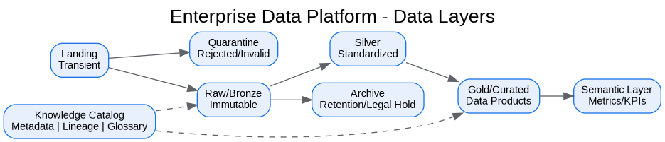
Figure: Enterprise Google Cloud Data Platform - Conceptual Reference Architecture
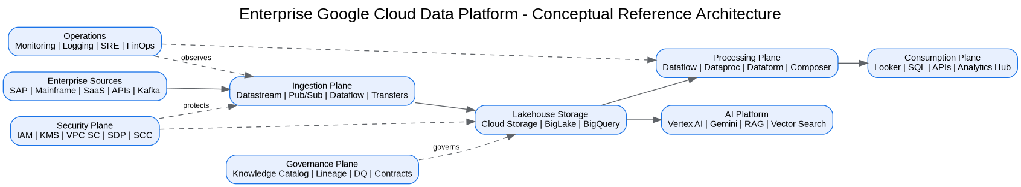

3. Ingestion Architecture
Batch ingestion uses managed transfers and Dataflow; CDC uses Datastream; event ingestion uses Pub/Sub and Dataflow; API/SaaS ingestion uses connector patterns and Cloud Run when custom integration is needed.

4. Metadata and Governance
Knowledge Catalog provides enterprise metadata, business glossary, lineage, quality status, certification, data-product registration and discovery.

5. Service Assessment
Services are selected only where they support business capabilities, operational controls or compliance requirements.
Service | Purpose | Benefits | Limitations / Pitfalls | Cost Controls
BigQuery | Enterprise analytics warehouse and curated serving layer | Serverless SQL, separation of storage/compute, strong ecosystem | Poor partitioning and unrestricted ad-hoc queries can create high costs | Reservations, labels, max bytes billed, partitioning, clustering
Cloud Storage | Raw, landing, archive and open-format lakehouse storage | Durable object storage, lifecycle policies, broad integration | Bucket sprawl and direct consumer access can weaken governance | Lifecycle policies, storage classes, retention controls
BigLake | Governed access to Cloud Storage data through BigQuery interfaces | Fine-grained access without direct bucket reads | Requires metadata and permission design | Table lifecycle, open-format governance
Dataflow | Batch and streaming pipelines using Apache Beam | Unified model, autoscaling, managed execution | Complex stateful pipelines require strong testing | Autoscaling, worker sizing, streaming engine
Pub/Sub | Event ingestion and decoupling | Reliable async messaging, retry and dead-letter support | Schema/version drift can impact consumers | Retention tuning and payload design
Knowledge Catalog | Metadata, glossary, lineage, governance and data discovery | Enterprise context layer for data and AI | Incomplete stewardship reduces trust | Metadata ownership and lifecycle controls

Architecture Decision Records
ADR | Decision | Problem | Alternatives | Decision | Tradeoffs/Risks | Mitigation
ADR-001 | Google Cloud as enterprise data platform | Fragmented analytics estate | Continue legacy; multi-cloud split; Google Cloud data platform | Adopt Google Cloud data platform with hybrid integration | Requires operating-model change | Phased landing zone, domain pilots, and governance automation
ADR-002 | BigQuery analytical core | Need PB-scale SQL analytics | Legacy EDW; Spark-only; third-party warehouse | Use BigQuery for curated/serving layers | Cost governance required | Reservations, labels, query controls, FinOps dashboards
ADR-003 | Lakehouse with Cloud Storage and BigLake | Need open data and governed access | BigQuery-only; unmanaged object lake | Use Cloud Storage + BigLake + BigQuery | Open table governance maturity required | Catalog, policies, certified data-product lifecycle
ADR-004 | Zero Trust and VPC SC | Exfiltration risk and regulated data | Network-only perimeter; IAM-only controls | Use identity, network, data and service perimeters | Service exceptions require testing | Perimeter dry runs and explicit ingress/egress policies

Risks and Mitigations
Risk | Impact | Mitigation
Underestimated legacy complexity | High | Complete source, pipeline, report and dependency assessment before migration waves
Data ownership gaps | High | Create domain owner RACI and data-product certification gate
Cost overrun | High | Enforce labels, budgets, reservations, query guardrails and monthly FinOps reviews
Security control drift | Critical | Deploy IaC, policy-as-code, automated IAM review and security posture monitoring
AI data leakage | Critical | Use certified datasets, service perimeters, DLP, RAG guardrails and model governance

Production Readiness Checklist
- All projects, networks, KMS keys and service accounts deployed through Terraform.
- All data products registered with owner, steward, classification, SLO, contract and support model.
- All restricted paths validated against VPC Service Controls and private connectivity requirements.
- All pipelines implement retries, dead-letter handling, reconciliation and operational metrics.
- All dashboards, alerts, runbooks and escalation routes tested before production cutover.
- All cost allocation labels present and billing export dashboards available to product owners.

References
- Google Cloud Architecture Framework: https://docs.cloud.google.com/architecture/framework
- Google Cloud Enterprise Foundations Blueprint: https://docs.cloud.google.com/architecture/blueprints/security-foundations
- Google Cloud Terraform blueprints and modules: https://docs.cloud.google.com/docs/terraform/blueprints/terraform-blueprints
- Build data products in a data mesh: https://docs.cloud.google.com/architecture/build-data-products-data-mesh
- Architecture and functions in a data mesh: https://docs.cloud.google.com/architecture/data-mesh
- Knowledge Catalog formerly Dataplex: https://cloud.google.com/products/knowledge-catalog
- Optimize costs with FinOps hub: https://docs.cloud.google.com/billing/docs/how-to/finops-hub
- VPC Service Controls supported products: https://docs.cloud.google.com/vpc-service-controls/docs/supported-products

