Enterprise Google Cloud Data Platform Blueprint
Volume 04: Data Engineering
Pipeline patterns, reusable components and engineering standards

Document attribute | Value
Version | 0.1 reference implementation
Date | 2026-07-10
Intended audience | Executive, architecture, security, platform engineering, data, AI, SRE and FinOps stakeholders
Scope | Fortune 100 reference blueprint for petabyte-scale Google Cloud data platform
Status | Generated implementation starter set; verify service-specific settings against current Google Cloud documentation

Table of Contents
- 1. Engineering Strategy
- 2. Pipeline Standards
- 3. Reusable Templates
- 4. Operations
- 5. Pitfalls

Inherited Fortune 100 Assumptions
Area | Assumption
Scale | 10-50 PB historical data; 50-250 TB/day new data; billions of events/day
Organization | Global enterprise with central platform team and federated domain teams
Regulatory | GDPR, HIPAA, PCI DSS, SOC 2, ISO 27001, NIST and regional residency constraints may apply
Availability | Tier 0 RTO <1 hour and RPO <5 minutes; Tier 1 RTO <4 hours and RPO <15 minutes
Cloud posture | Hybrid and multi-cloud integration with Google Cloud as the enterprise data platform foundation
Security | Zero Trust, least privilege, private connectivity, service perimeters, CMEK for restricted data

1. Engineering Strategy
Standardize pipeline templates for batch, micro-batch, CDC and streaming. Reusable components reduce delivery time and improve reliability.

2. Pipeline Standards
Every production pipeline must implement configuration-as-data, schema validation, DQ checks, idempotency, retries, DLQ/quarantine, observability, SLOs and rollback procedures.
Pattern | Primary Service | Use Case
Batch ETL | Dataflow/Beam | Large-scale file parsing and normalization
ELT | Dataform/BigQuery SQL | Warehouse transformations and data marts
Streaming | Pub/Sub + Dataflow | Low-latency events and CDC enrichment
Spark | Dataproc/Serverless Spark | Existing Spark migrations and advanced transformations
Orchestration | Cloud Composer | Complex DAG dependencies

Figure: Data Engineering Pipeline Patterns
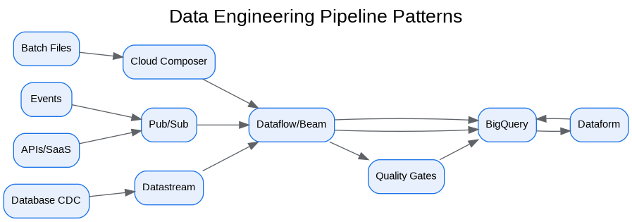
Figure: Enterprise Data Platform - Data Layers
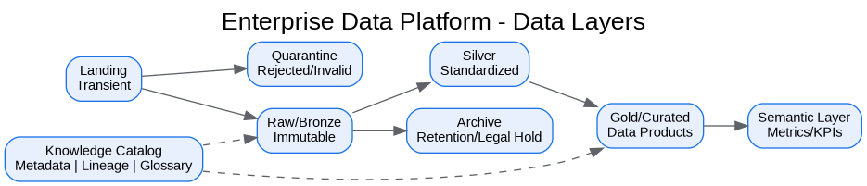

3. Reusable Templates
Reference implementations are provided for Airflow DAGs, Dataflow Beam jobs, PySpark, Dataform SQLX and BigQuery SQL.

4. Operations
Pipelines emit freshness, volume, error-rate, backlog, cost and data-quality metrics. SLO violations trigger alerts and domain-owner escalation.

5. Pitfalls
- Building one-off pipelines without templates.
- Using streaming when business latency is batch.
- Missing reconciliation and replay design.
- Mixing security credentials across environments.

Architecture Decision Records
ADR | Decision | Problem | Alternatives | Decision | Tradeoffs/Risks | Mitigation
ADR-001 | Google Cloud as enterprise data platform | Fragmented analytics estate | Continue legacy; multi-cloud split; Google Cloud data platform | Adopt Google Cloud data platform with hybrid integration | Requires operating-model change | Phased landing zone, domain pilots, and governance automation
ADR-002 | BigQuery analytical core | Need PB-scale SQL analytics | Legacy EDW; Spark-only; third-party warehouse | Use BigQuery for curated/serving layers | Cost governance required | Reservations, labels, query controls, FinOps dashboards
ADR-003 | Lakehouse with Cloud Storage and BigLake | Need open data and governed access | BigQuery-only; unmanaged object lake | Use Cloud Storage + BigLake + BigQuery | Open table governance maturity required | Catalog, policies, certified data-product lifecycle
ADR-004 | Zero Trust and VPC SC | Exfiltration risk and regulated data | Network-only perimeter; IAM-only controls | Use identity, network, data and service perimeters | Service exceptions require testing | Perimeter dry runs and explicit ingress/egress policies

Risks and Mitigations
Risk | Impact | Mitigation
Underestimated legacy complexity | High | Complete source, pipeline, report and dependency assessment before migration waves
Data ownership gaps | High | Create domain owner RACI and data-product certification gate
Cost overrun | High | Enforce labels, budgets, reservations, query guardrails and monthly FinOps reviews
Security control drift | Critical | Deploy IaC, policy-as-code, automated IAM review and security posture monitoring
AI data leakage | Critical | Use certified datasets, service perimeters, DLP, RAG guardrails and model governance

Production Readiness Checklist
- All projects, networks, KMS keys and service accounts deployed through Terraform.
- All data products registered with owner, steward, classification, SLO, contract and support model.
- All restricted paths validated against VPC Service Controls and private connectivity requirements.
- All pipelines implement retries, dead-letter handling, reconciliation and operational metrics.
- All dashboards, alerts, runbooks and escalation routes tested before production cutover.
- All cost allocation labels present and billing export dashboards available to product owners.

References
- Google Cloud Architecture Framework: https://docs.cloud.google.com/architecture/framework
- Google Cloud Enterprise Foundations Blueprint: https://docs.cloud.google.com/architecture/blueprints/security-foundations
- Google Cloud Terraform blueprints and modules: https://docs.cloud.google.com/docs/terraform/blueprints/terraform-blueprints
- Build data products in a data mesh: https://docs.cloud.google.com/architecture/build-data-products-data-mesh
- Architecture and functions in a data mesh: https://docs.cloud.google.com/architecture/data-mesh
- Knowledge Catalog formerly Dataplex: https://cloud.google.com/products/knowledge-catalog
- Optimize costs with FinOps hub: https://docs.cloud.google.com/billing/docs/how-to/finops-hub
- VPC Service Controls supported products: https://docs.cloud.google.com/vpc-service-controls/docs/supported-products

