Enterprise Google Cloud Data Platform Blueprint
Volume 08: DevSecOps Automation
CI/CD, GitOps, policy-as-code and automated promotion

Document attribute | Value
Version | 0.1 reference implementation
Date | 2026-07-10
Intended audience | Executive, architecture, security, platform engineering, data, AI, SRE and FinOps stakeholders
Scope | Fortune 100 reference blueprint for petabyte-scale Google Cloud data platform
Status | Generated implementation starter set; verify service-specific settings against current Google Cloud documentation

Table of Contents
- 1. DevSecOps Strategy
- 2. Repository Strategy
- 3. Pipeline Controls
- 4. Environment Promotion
- 5. Release Metrics

Inherited Fortune 100 Assumptions
Area | Assumption
Scale | 10-50 PB historical data; 50-250 TB/day new data; billions of events/day
Organization | Global enterprise with central platform team and federated domain teams
Regulatory | GDPR, HIPAA, PCI DSS, SOC 2, ISO 27001, NIST and regional residency constraints may apply
Availability | Tier 0 RTO <1 hour and RPO <5 minutes; Tier 1 RTO <4 hours and RPO <15 minutes
Cloud posture | Hybrid and multi-cloud integration with Google Cloud as the enterprise data platform foundation
Security | Zero Trust, least privilege, private connectivity, service perimeters, CMEK for restricted data

1. DevSecOps Strategy
Use Git as the source of truth for infrastructure, policy, pipelines, schemas, data-quality rules and AI artifacts. Promotion is automated but gated by tests and approvals.

2. Repository Strategy
A hybrid structure separates platform foundations, reusable modules, domain implementations and reference applications while maintaining common release standards.
Repository Area | Purpose
platform-foundation | Organization, folders, shared VPC, policies, logging, KMS
terraform-modules | Reusable golden modules
domains | Domain pipelines, datasets, data products
dataform | SQL transformations and assertions
ai | RAG, prompts, models and pipelines

Figure: DevSecOps and Environment Promotion
Figure: Google Cloud Landing Zone and Shared VPC
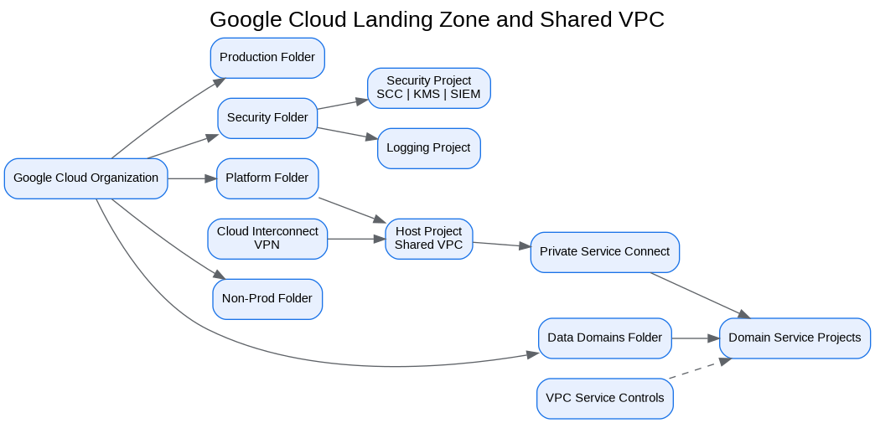

3. Pipeline Controls
Each pipeline includes linting, unit tests, policy validation, secret scanning, IaC plan review, security scanning, deployment approvals and post-deployment validation.

4. Environment Promotion
Development to test to staging to production promotion uses immutable artifacts, reviewed plans, service-account impersonation and rollback instructions.

5. Release Metrics
Measure lead time, deployment frequency, change failure rate, mean time to restore and policy compliance.

Architecture Decision Records
ADR | Decision | Problem | Alternatives | Decision | Tradeoffs/Risks | Mitigation
ADR-001 | Google Cloud as enterprise data platform | Fragmented analytics estate | Continue legacy; multi-cloud split; Google Cloud data platform | Adopt Google Cloud data platform with hybrid integration | Requires operating-model change | Phased landing zone, domain pilots, and governance automation
ADR-002 | BigQuery analytical core | Need PB-scale SQL analytics | Legacy EDW; Spark-only; third-party warehouse | Use BigQuery for curated/serving layers | Cost governance required | Reservations, labels, query controls, FinOps dashboards
ADR-003 | Lakehouse with Cloud Storage and BigLake | Need open data and governed access | BigQuery-only; unmanaged object lake | Use Cloud Storage + BigLake + BigQuery | Open table governance maturity required | Catalog, policies, certified data-product lifecycle
ADR-004 | Zero Trust and VPC SC | Exfiltration risk and regulated data | Network-only perimeter; IAM-only controls | Use identity, network, data and service perimeters | Service exceptions require testing | Perimeter dry runs and explicit ingress/egress policies

Risks and Mitigations
Risk | Impact | Mitigation
Underestimated legacy complexity | High | Complete source, pipeline, report and dependency assessment before migration waves
Data ownership gaps | High | Create domain owner RACI and data-product certification gate
Cost overrun | High | Enforce labels, budgets, reservations, query guardrails and monthly FinOps reviews
Security control drift | Critical | Deploy IaC, policy-as-code, automated IAM review and security posture monitoring
AI data leakage | Critical | Use certified datasets, service perimeters, DLP, RAG guardrails and model governance

Production Readiness Checklist
- All projects, networks, KMS keys and service accounts deployed through Terraform.
- All data products registered with owner, steward, classification, SLO, contract and support model.
- All restricted paths validated against VPC Service Controls and private connectivity requirements.
- All pipelines implement retries, dead-letter handling, reconciliation and operational metrics.
- All dashboards, alerts, runbooks and escalation routes tested before production cutover.
- All cost allocation labels present and billing export dashboards available to product owners.

References
- Google Cloud Architecture Framework: https://docs.cloud.google.com/architecture/framework
- Google Cloud Enterprise Foundations Blueprint: https://docs.cloud.google.com/architecture/blueprints/security-foundations
- Google Cloud Terraform blueprints and modules: https://docs.cloud.google.com/docs/terraform/blueprints/terraform-blueprints
- Build data products in a data mesh: https://docs.cloud.google.com/architecture/build-data-products-data-mesh
- Architecture and functions in a data mesh: https://docs.cloud.google.com/architecture/data-mesh
- Knowledge Catalog formerly Dataplex: https://cloud.google.com/products/knowledge-catalog
- Optimize costs with FinOps hub: https://docs.cloud.google.com/billing/docs/how-to/finops-hub
- VPC Service Controls supported products: https://docs.cloud.google.com/vpc-service-controls/docs/supported-products

