Enterprise Google Cloud Data Platform Blueprint
Volume 10: Operations SRE
Observability, runbooks, SLIs, SLOs and incident management

Document attribute | Value
Version | 0.1 reference implementation
Date | 2026-07-10
Intended audience | Executive, architecture, security, platform engineering, data, AI, SRE and FinOps stakeholders
Scope | Fortune 100 reference blueprint for petabyte-scale Google Cloud data platform
Status | Generated implementation starter set; verify service-specific settings against current Google Cloud documentation

Table of Contents
- 1. Operations Strategy
- 2. SLI/SLO Catalog
- 3. Incident Management
- 4. Runbooks
- 5. Readiness Reviews

Inherited Fortune 100 Assumptions
Area | Assumption
Scale | 10-50 PB historical data; 50-250 TB/day new data; billions of events/day
Organization | Global enterprise with central platform team and federated domain teams
Regulatory | GDPR, HIPAA, PCI DSS, SOC 2, ISO 27001, NIST and regional residency constraints may apply
Availability | Tier 0 RTO <1 hour and RPO <5 minutes; Tier 1 RTO <4 hours and RPO <15 minutes
Cloud posture | Hybrid and multi-cloud integration with Google Cloud as the enterprise data platform foundation
Security | Zero Trust, least privilege, private connectivity, service perimeters, CMEK for restricted data

1. Operations Strategy
SRE practices apply to platform services, domain data products, pipelines, BI, AI and security controls. Each data product has ownership, SLOs and runbooks.

2. SLI/SLO Catalog
Key SLIs include pipeline success rate, data freshness, streaming backlog, data-quality pass rate, query latency, model endpoint availability and cost variance.
Service | SLI | Default SLO
Batch pipeline | Successful runs | 99% monthly
Streaming pipeline | End-to-end latency | 95% under 5 minutes
Data product | Freshness | 99% within published SLA
BigQuery BI | Dashboard load time | 95% under target
AI endpoint | Availability | 99.5%+ by tier

Figure: SRE Observability and Incident Management
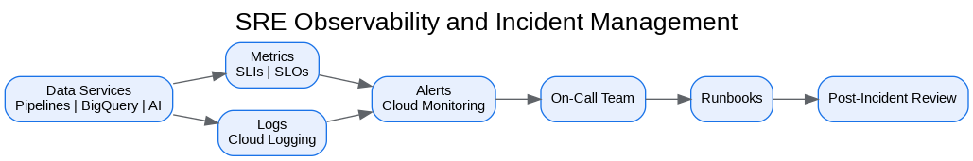
Figure: Data Engineering Pipeline Patterns
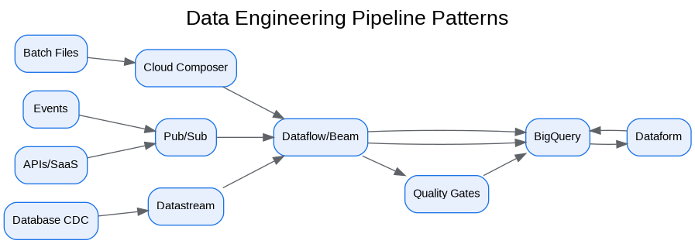

3. Incident Management
Alerts route by severity to the responsible platform or domain team. Incidents include timeline, impact, mitigation, root cause, prevention and owner.

4. Runbooks
Runbooks cover pipeline failure, freshness breach, BigQuery cost spike, VPC SC access failure, KMS denial, data-quality breach and AI safety alert.

5. Readiness Reviews
Operational readiness review and production readiness review are mandatory before go-live.

Architecture Decision Records
ADR | Decision | Problem | Alternatives | Decision | Tradeoffs/Risks | Mitigation
ADR-001 | Google Cloud as enterprise data platform | Fragmented analytics estate | Continue legacy; multi-cloud split; Google Cloud data platform | Adopt Google Cloud data platform with hybrid integration | Requires operating-model change | Phased landing zone, domain pilots, and governance automation
ADR-002 | BigQuery analytical core | Need PB-scale SQL analytics | Legacy EDW; Spark-only; third-party warehouse | Use BigQuery for curated/serving layers | Cost governance required | Reservations, labels, query controls, FinOps dashboards
ADR-003 | Lakehouse with Cloud Storage and BigLake | Need open data and governed access | BigQuery-only; unmanaged object lake | Use Cloud Storage + BigLake + BigQuery | Open table governance maturity required | Catalog, policies, certified data-product lifecycle
ADR-004 | Zero Trust and VPC SC | Exfiltration risk and regulated data | Network-only perimeter; IAM-only controls | Use identity, network, data and service perimeters | Service exceptions require testing | Perimeter dry runs and explicit ingress/egress policies

Risks and Mitigations
Risk | Impact | Mitigation
Underestimated legacy complexity | High | Complete source, pipeline, report and dependency assessment before migration waves
Data ownership gaps | High | Create domain owner RACI and data-product certification gate
Cost overrun | High | Enforce labels, budgets, reservations, query guardrails and monthly FinOps reviews
Security control drift | Critical | Deploy IaC, policy-as-code, automated IAM review and security posture monitoring
AI data leakage | Critical | Use certified datasets, service perimeters, DLP, RAG guardrails and model governance

Production Readiness Checklist
- All projects, networks, KMS keys and service accounts deployed through Terraform.
- All data products registered with owner, steward, classification, SLO, contract and support model.
- All restricted paths validated against VPC Service Controls and private connectivity requirements.
- All pipelines implement retries, dead-letter handling, reconciliation and operational metrics.
- All dashboards, alerts, runbooks and escalation routes tested before production cutover.
- All cost allocation labels present and billing export dashboards available to product owners.

References
- Google Cloud Architecture Framework: https://docs.cloud.google.com/architecture/framework
- Google Cloud Enterprise Foundations Blueprint: https://docs.cloud.google.com/architecture/blueprints/security-foundations
- Google Cloud Terraform blueprints and modules: https://docs.cloud.google.com/docs/terraform/blueprints/terraform-blueprints
- Build data products in a data mesh: https://docs.cloud.google.com/architecture/build-data-products-data-mesh
- Architecture and functions in a data mesh: https://docs.cloud.google.com/architecture/data-mesh
- Knowledge Catalog formerly Dataplex: https://cloud.google.com/products/knowledge-catalog
- Optimize costs with FinOps hub: https://docs.cloud.google.com/billing/docs/how-to/finops-hub
- VPC Service Controls supported products: https://docs.cloud.google.com/vpc-service-controls/docs/supported-products

