Enterprise Google Cloud Data Platform Blueprint
Volume 13: Architecture Playbook
Workshops, decision guides and review checklists

Document attribute | Value
Version | 0.1 reference implementation
Date | 2026-07-10
Intended audience | Executive, architecture, security, platform engineering, data, AI, SRE and FinOps stakeholders
Scope | Fortune 100 reference blueprint for petabyte-scale Google Cloud data platform
Status | Generated implementation starter set; verify service-specific settings against current Google Cloud documentation

Table of Contents
- 1. Playbook Purpose
- 2. Workshop Model
- 3. Review Checklists
- 4. Decision Facilitation
- 5. How to Use the Blueprint

Inherited Fortune 100 Assumptions
Area | Assumption
Scale | 10-50 PB historical data; 50-250 TB/day new data; billions of events/day
Organization | Global enterprise with central platform team and federated domain teams
Regulatory | GDPR, HIPAA, PCI DSS, SOC 2, ISO 27001, NIST and regional residency constraints may apply
Availability | Tier 0 RTO <1 hour and RPO <5 minutes; Tier 1 RTO <4 hours and RPO <15 minutes
Cloud posture | Hybrid and multi-cloud integration with Google Cloud as the enterprise data platform foundation
Security | Zero Trust, least privilege, private connectivity, service perimeters, CMEK for restricted data

1. Playbook Purpose
The playbook provides facilitation material for architecture workshops, design reviews, production readiness, migration planning and executive decision sessions.

2. Workshop Model
Workshops are structured around current-state assessment, business capability mapping, data-domain discovery, security design, platform MVP, migration waves and operating model.
Figure: Enterprise Google Cloud Data Platform - Conceptual Reference Architecture
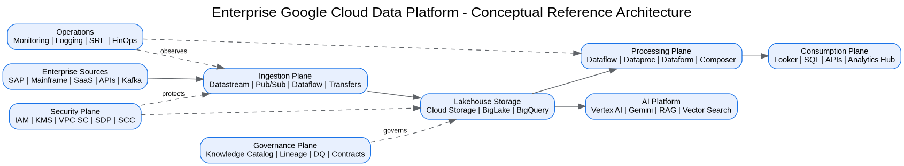
Figure: SRE Observability and Incident Management
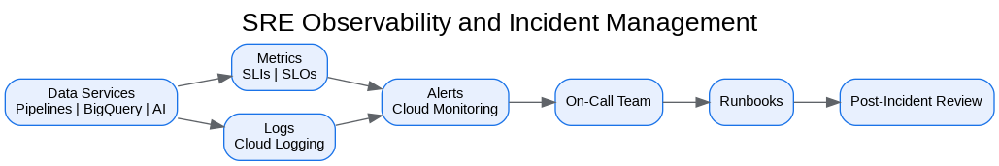

3. Review Checklists
Architecture Review Board, Security Review Board, Data Governance Council, SRE readiness and FinOps readiness checklists are included.
Review | Core Questions
Architecture | Does the design map requirements to services and decisions?
Security | Are identity, network, data and workload controls explicit?
Governance | Are data owners, contracts, quality and catalog controls defined?
Operations | Are SLOs, alerts, runbooks and escalation tested?
FinOps | Are budgets, labels, forecasts and optimization owners defined?

4. Decision Facilitation
Every decision is documented with problem, alternatives, decision, tradeoffs, risks and mitigations.

5. How to Use the Blueprint
Start with Volumes 1 and 2, then deliver platform MVP using Volumes 3, 4, 7, 8, 10 and 11. Use Volume 13 to govern workshops and checkpoints.

Architecture Decision Records
ADR | Decision | Problem | Alternatives | Decision | Tradeoffs/Risks | Mitigation
ADR-001 | Google Cloud as enterprise data platform | Fragmented analytics estate | Continue legacy; multi-cloud split; Google Cloud data platform | Adopt Google Cloud data platform with hybrid integration | Requires operating-model change | Phased landing zone, domain pilots, and governance automation
ADR-002 | BigQuery analytical core | Need PB-scale SQL analytics | Legacy EDW; Spark-only; third-party warehouse | Use BigQuery for curated/serving layers | Cost governance required | Reservations, labels, query controls, FinOps dashboards
ADR-003 | Lakehouse with Cloud Storage and BigLake | Need open data and governed access | BigQuery-only; unmanaged object lake | Use Cloud Storage + BigLake + BigQuery | Open table governance maturity required | Catalog, policies, certified data-product lifecycle
ADR-004 | Zero Trust and VPC SC | Exfiltration risk and regulated data | Network-only perimeter; IAM-only controls | Use identity, network, data and service perimeters | Service exceptions require testing | Perimeter dry runs and explicit ingress/egress policies

Risks and Mitigations
Risk | Impact | Mitigation
Underestimated legacy complexity | High | Complete source, pipeline, report and dependency assessment before migration waves
Data ownership gaps | High | Create domain owner RACI and data-product certification gate
Cost overrun | High | Enforce labels, budgets, reservations, query guardrails and monthly FinOps reviews
Security control drift | Critical | Deploy IaC, policy-as-code, automated IAM review and security posture monitoring
AI data leakage | Critical | Use certified datasets, service perimeters, DLP, RAG guardrails and model governance

Production Readiness Checklist
- All projects, networks, KMS keys and service accounts deployed through Terraform.
- All data products registered with owner, steward, classification, SLO, contract and support model.
- All restricted paths validated against VPC Service Controls and private connectivity requirements.
- All pipelines implement retries, dead-letter handling, reconciliation and operational metrics.
- All dashboards, alerts, runbooks and escalation routes tested before production cutover.
- All cost allocation labels present and billing export dashboards available to product owners.

References
- Google Cloud Architecture Framework: https://docs.cloud.google.com/architecture/framework
- Google Cloud Enterprise Foundations Blueprint: https://docs.cloud.google.com/architecture/blueprints/security-foundations
- Google Cloud Terraform blueprints and modules: https://docs.cloud.google.com/docs/terraform/blueprints/terraform-blueprints
- Build data products in a data mesh: https://docs.cloud.google.com/architecture/build-data-products-data-mesh
- Architecture and functions in a data mesh: https://docs.cloud.google.com/architecture/data-mesh
- Knowledge Catalog formerly Dataplex: https://cloud.google.com/products/knowledge-catalog
- Optimize costs with FinOps hub: https://docs.cloud.google.com/billing/docs/how-to/finops-hub
- VPC Service Controls supported products: https://docs.cloud.google.com/vpc-service-controls/docs/supported-products

