Descriptive summary of Images in the database

Chandan Kumar Pandey

### This report is the descriptive result of the tiger and leopard images in the database which we will be using for training the machine learning network.

### Number of tigers and leopards in different capture mode.

The are total 43781 images belonging to 3367 individuals taken in 20 different sites. Among these animals there are 25041 images for 1749 tigers and 18740 images belonging to 1618 leopards. However, the images in the database consist of camera traps, photo from naturalist, dead tigers, pelted skin etc. The following graph provide summary of this.

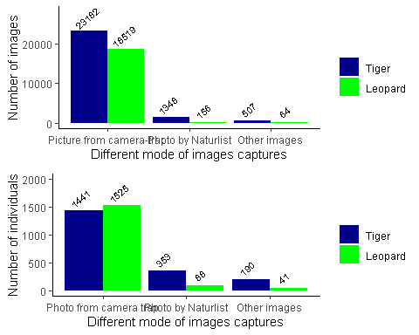

### Histrogram of number of image per individuals.

It is clear that **99%** leopard and **93%** Tigers images are from camera trap. Therefore we will only be using the image that were capture using camera traps.

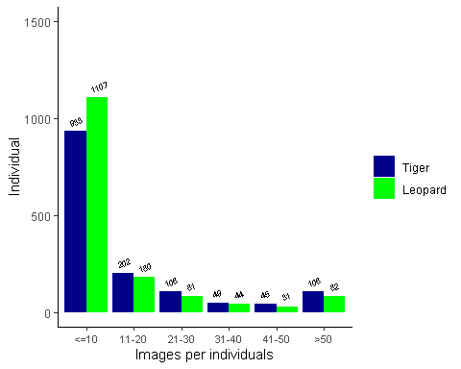

Form the above graph it is clear that 1107 leopards and 933 tigers have 10 or less number of images. Moreover over 1443 out of 1525 leopards and 1335 out of 1441 tigers indivduals fall in the range of less that 50 images.

### Number of camera trap images on different flanks

Further camera trap images are take in left and right flank. The number of left and right flanks might not be same for all the tigers.

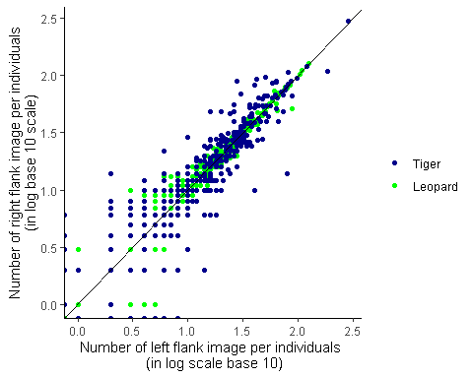 ### Camera trap images at different times of the day

As from the discussion it was clear that night and day image was important in classification of the image. It is also important which training the network

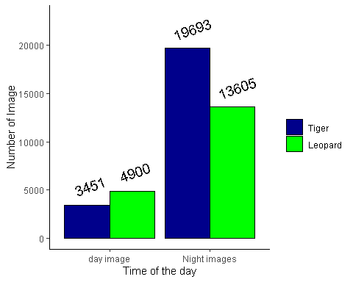 The discrpency in the total number of image in above graph and the first graps is due to fact that for some camera trap images the timing are missing. To be exact, there are 57 camera trap images that do not have time associated with it

### Images and individual at diffrent sites

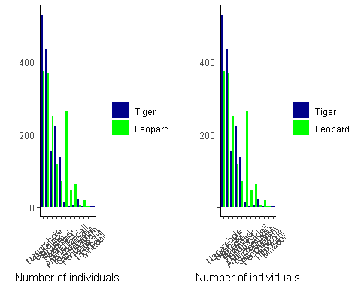

Tiger images

|  |  |  |  |
| --- | --- | --- | --- |
| Camera trapsites | Speceis | number of images | number of individuals |
| Nagarahole | Tiger | 8201 | 531 |
| Bandipur | Tiger | 6517 | 437 |
| Bhadra | Tiger | 2863 | 153 |
| Wayanad | Tiger | 2816 | 222 |
| BiligiriRT | Tiger | 2190 | 136 |
| Pench(Mah) | Tiger | 223 | 22 |
| Anshi-Dandeli | Tiger | 159 | 11 |
| Kudremukh | Tiger | 112 | 2 |
| CauveryMM | Tiger | 56 | 5 |
| Mhadei | Tiger | 4 | 1 |
| Goa | Tiger | 3 | 1 |

Leopard images

|  |  |  |  |
| --- | --- | --- | --- |
| Camera trapsites | Speceis | number of images | number of individuals |
| Bandipur | Leopard | 5103 | 370 |
| Bhadra | Leopard | 4865 | 251 |
| Nagarahole | Leopard | 4818 | 375 |
| Wayanad | Leopard | 1024 | 117 |
| Anshi-Dandeli | Leopard | 872 | 265 |
| Kudremukh | Leopard | 793 | 47 |
| BiligiriRT | Leopard | 638 | 69 |
| CauveryMM | Leopard | 332 | 62 |
| Goa | Leopard | 36 | 17 |
| Pench(Mah) | Leopard | 17 | 4 |
| Tithimathi | Leopard | 7 | 2 |

The final out come from the data is that most of the individuals have 1-10 pictures, while most of the images are from camera trap data.