Descriptive summary of Images in the database

Chandan Kumar Pandey

### This report is the descriptive summary of the tiger database which we will be using for training the machine learning network.

### Number of tigers in different capture mode.

The are total 25041 images belonging to 1749 individuals taken in 18 different sites. However, the images in the database consist of camera traps, photo from naturalist, dead tigers, pelted skin etc. The following graph provide summary of this.

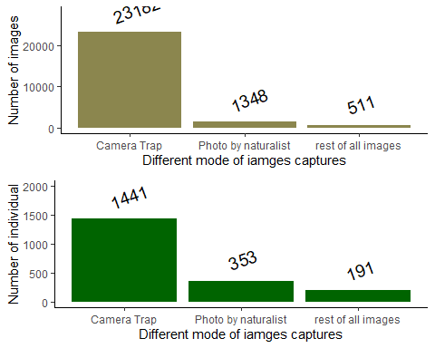

### Histrogram of number of image per individuals.

It is clear that **93**% of data is camera trap followed by photographed images which together makes **95**% of total images. Therefore we will only be using the image that were capture using camera traps.

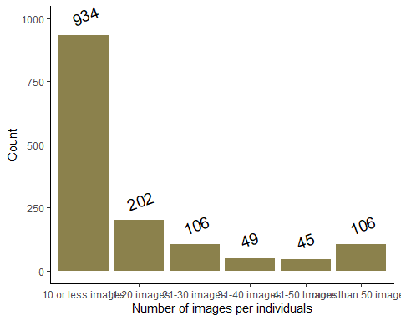

Form the above graph it is clear that 934 individuals have 10 or less number of images. Moreover over 1336 out of 1442individuals fall in the range of less that 50 images.

### Number of camera trap images on different flanks

Further camera trap images are take in left and right flank. The number of left and right flanks might not be same for all the tigers.

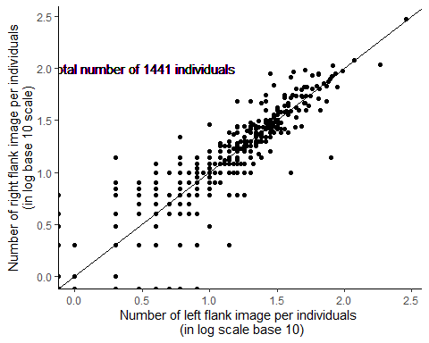 ### Camera trap images at different times of the day

As from the discussion it was clear that night and day image was important in classification of the image. It is also important which training the network

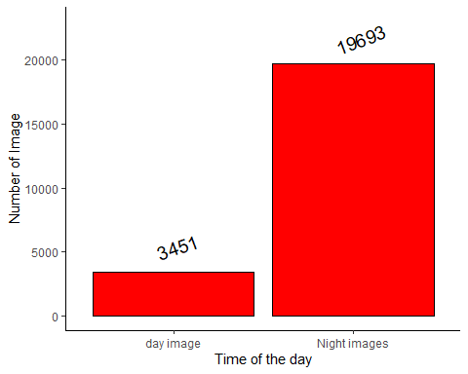

### Images and individual at diffrent sites

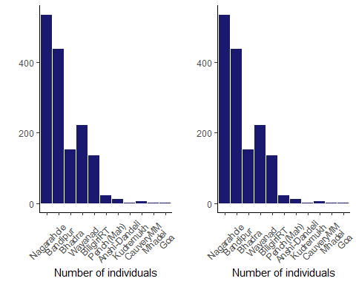

|  |  |  |  |
| --- | --- | --- | --- |
|  | Camera trapsites | number of images | number of individuals |
| 9 | Nagarahole | 8233 | 534 |
| 2 | Bandipur | 6517 | 437 |
| 3 | Bhadra | 2869 | 153 |
| 11 | Wayanad | 2816 | 222 |
| 4 | BiligiriRT | 2190 | 136 |
| 10 | Pench(Mah) | 223 | 22 |
| 1 | Anshi-Dandeli | 159 | 11 |
| 7 | Kudremukh | 112 | 2 |
| 5 | CauveryMM | 56 | 5 |
| 8 | Mhadei | 4 | 1 |
| 6 | Goa | 3 | 1 |

The final out come from the data is that most of the TIGERS individuals have 1-10 pics, while most of the images are from camera trap data.