Dry run the problem_01---PrintOneToFive(int n)
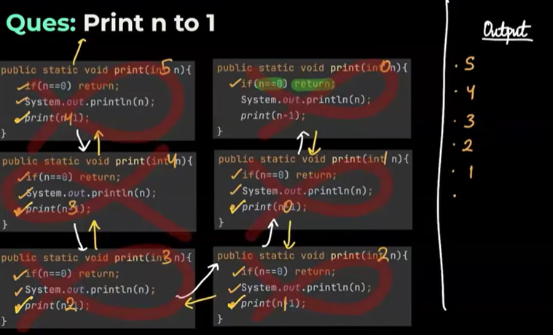

Question6 :--Print the 1 to N

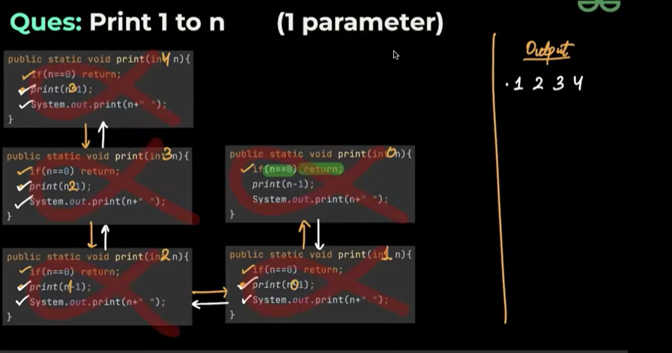

Standard recursive code:--

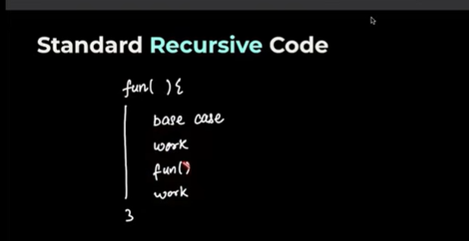
public static void PrintOneToFive ( int n){
if (n==0) return;
System.out.print(n+" ");
PrintOneToFive(n-1);
System.out.print(n+" ");
}

