Diabetes Risk Prediction Using PySpark MLlib:
Exploratory Analysis and Binary Classification
Alvin Boakai and Chakatpum Srisuvanuntac
DSCI 632 – Applied Cloud Computing, Drexel University

ABSTRACT

This project develops a scalable diabetes-risk prediction workflow using PySpark DataFrames, Spark SQL, and PySpark MLlib. The dataset contains 100,000 patient records and nine variables, including demographic characteristics, cardiovascular comorbidities, smoking history, body mass index (BMI), HbA1c, blood glucose, and a binary diabetes outcome. Exploratory data analysis (EDA) identified substantial class imbalance: 91.5% of records are non-diabetic and 8.5% are diabetic. Diabetic patients were older and had higher mean BMI, HbA1c, and blood glucose. Diabetes prevalence was also markedly higher among patients with hypertension, heart disease, obesity, and HbA1c above 6.5. The machine-learning component specifies Logistic Regression and Random Forest classifiers in PySpark MLlib, evaluated on a held-out 20% test set using accuracy, precision, recall, F1 score, AUC-ROC, and confusion matrices. Recall is emphasized because diabetic cases form the minority class.
Keywords—PySpark, MLlib, diabetes, exploratory data analysis, Logistic Regression, Random Forest, cloud computing.

1. INTRODUCTION
Diabetes is a chronic condition for which early risk identification can support timely clinical intervention and personalized care. The project proposal defines the objective as a complete PySpark pipeline spanning data ingestion, preprocessing, EDA, feature engineering, predictive modeling, and evaluation. The computational design is appropriate for DSCI 632 because Spark provides distributed DataFrame operations, SQL analytics, and an integrated machine-learning library within one workflow.
The research question is: How accurately can routinely available demographic, behavioral, and medical indicators distinguish diabetic from non-diabetic patients, and which variables are most informative?

2. DATASET AND COMPUTATIONAL ENVIRONMENT
The Diabetes Prediction Dataset contains 100,000 rows and 9 columns. Variables are gender, age, hypertension, heart_disease, smoking_history, bmi, HbA1c_level, blood_glucose_level, and diabetes. The outcome diabetes is binary (0 = non-diabetic, 1 = diabetic). The project proposal identifies PySpark MLlib as the required machine-learning framework and excludes scikit-learn and Pandas from the modeling workflow.
Component | Implementation | Purpose
Ingestion | spark.read.csv(header=True, inferSchema=True) | Load CSV as Spark DataFrame
EDA | PySpark DataFrame + Spark SQL | Distributed summaries and risk comparisons
Feature engineering | withColumn(), when()/UDFs | Create clinical risk categories
Encoding | StringIndexer + OneHotEncoder | Convert categorical predictors
Feature vector | VectorAssembler | Build MLlib features column
Models | LogisticRegression; RandomForestClassifier | Binary classification
Evaluation | Binary/MulticlassClassificationEvaluator | AUC-ROC, accuracy, precision, recall, F1
3. EXPLORATORY DATA ANALYSIS
EDA was performed with PySpark groupBy(), aggregation functions, crosstab(), Spark SQL, and DataFrame correlation functions. The notebook confirms 100,000 rows, nine columns, and no null values in the supplied dataset.
Measure | Non-diabetic | Diabetic
Patients | 91,500 (91.5%) | 8,500 (8.5%)
Mean age | 40.12 | 60.95
Mean BMI | 26.89 | 31.99
Mean HbA1c | 5.40 | 6.93
Mean blood glucose | 132.85 | 194.09

Class distribution.
The non-diabetic-to-diabetic ratio is approximately 10.76:1, demonstrating strong class imbalance. This motivates the use of recall, F1, and AUC-ROC in addition to accuracy.
Demographics and behavior. The mean age of diabetic patients is 60.95 years versus 40.12 years for non-diabetic patients. Diabetes prevalence rises sharply in older age groups. Smoking-history analysis shows the highest observed prevalence among former smokers (17.00%), followed by ever smokers (11.79%), not-current smokers (10.70%), current smokers (10.21%), never smokers (9.53%), and records with no smoking information (4.06%). These are associations, not causal estimates.
Medical indicators. Patients with HbA1c > 6.5 had a diabetes prevalence of 36.82%, compared with 4.48% among those at or below 6.5. Diabetes prevalence was 27.90% among patients with hypertension versus 6.93% without hypertension, and 32.14% among patients with heart disease versus 7.53% without. Patients with both hypertension and heart disease had the highest co-occurrence rate, 39.08%.
BMI. Diabetes prevalence increased across BMI categories: 0.75% for underweight, 3.88% for normal weight, 7.30% for overweight, and 17.99% for obesity. The age-stratified analysis showed particularly high prevalence among obese patients aged 60–74 (32.04%) and 75+ (33.63%).
Correlation. Blood glucose had the strongest Pearson correlation with the diabetes outcome (r = 0.4196), followed by HbA1c (r = 0.4007), age (r = 0.2580), BMI (r = 0.2144), hypertension (r = 0.1978), and heart disease (r = 0.1717). HbA1c and blood glucose were only modestly correlated with each other (r = 0.1667), so the notebook does not support the proposal's initial expectation of a high pairwise correlation.
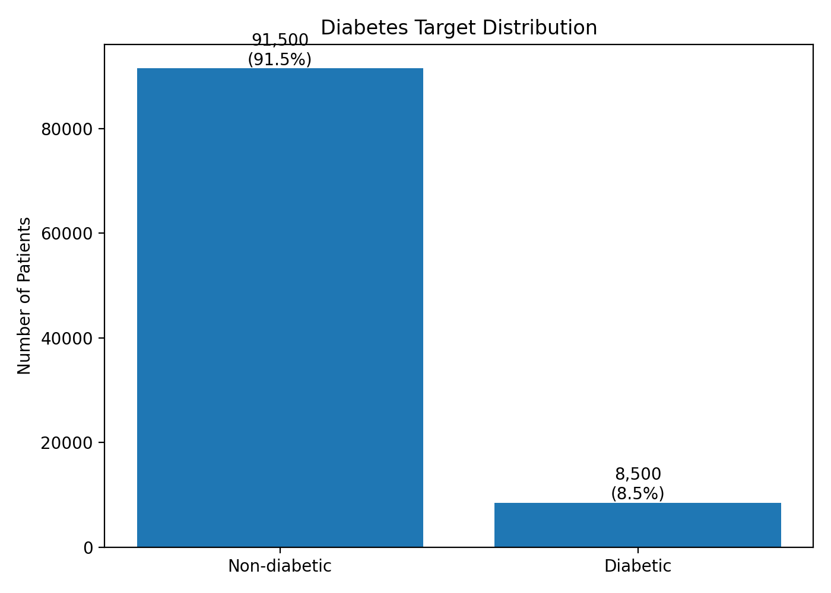
Fig. 1. Diabetes target distribution.
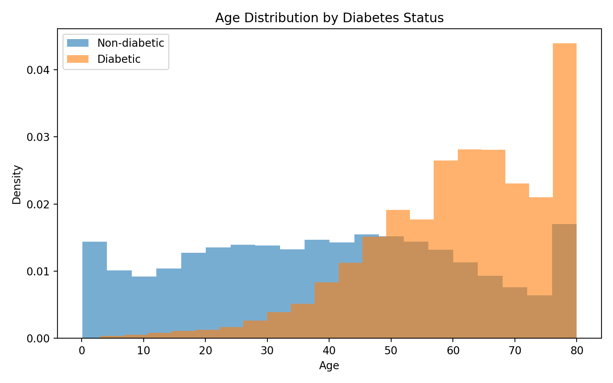
Fig. 2. Age distribution by diabetes status.
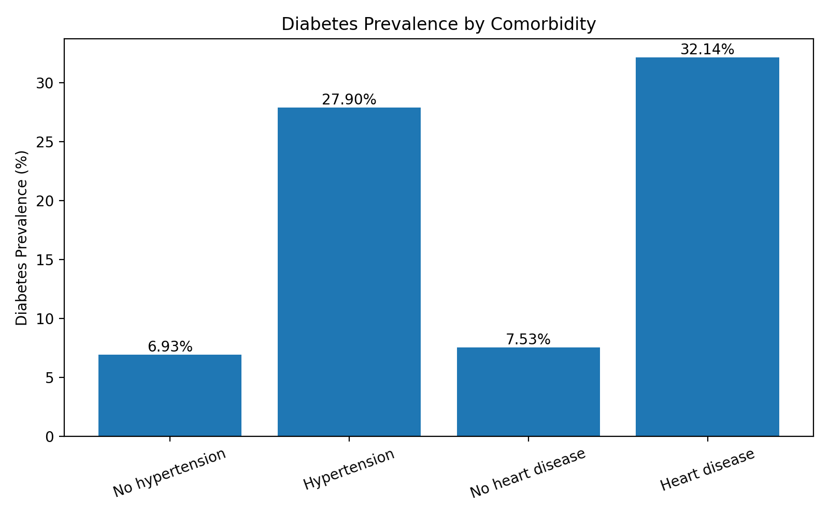
Fig. 3. Diabetes prevalence by comorbidity.
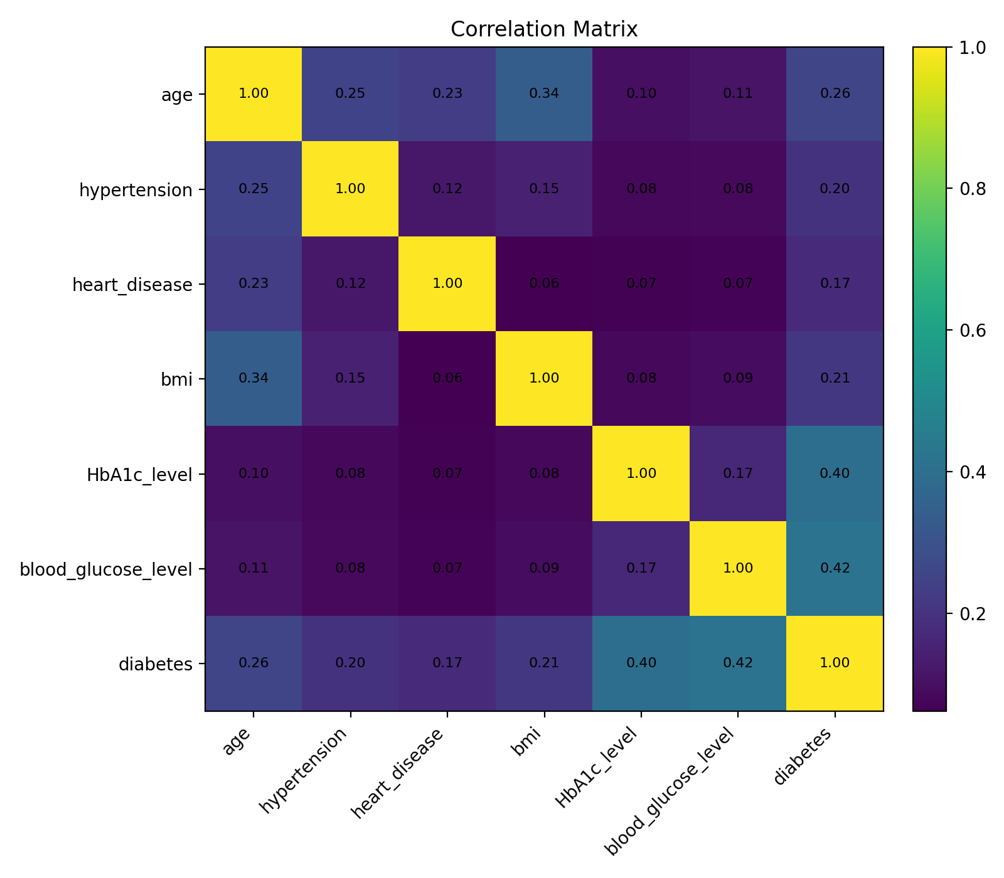
Fig. 4. Correlation matrix for major numeric risk factors.

4. FEATURE ENGINEERING AND DATA PREPARATION

The project proposal specifies four engineered categorical features: bmi_category (Underweight, Normal, Overweight, Obese), hba1c_risk (Normal, Pre-diabetic, Diabetic), age_group (Young, Middle, Senior), and glucose_risk (Normal, Pre-diabetic, High). The final code implements these transformations with native PySpark column expressions. Categorical predictors are indexed with StringIndexer and encoded with OneHotEncoder; numerical and encoded features are combined with VectorAssembler. Data are split 80/20 using randomSplit([0.8, 0.2], seed=42).
To reduce target leakage, the final predictive feature vector uses the original clinical measurements (HbA1c and blood glucose) rather than their threshold-derived risk labels. The engineered categories remain valuable for EDA and interpretation but are not duplicated alongside their source variables in the primary model.

5. MACHINE LEARNING METHODOLOGY

Two binary classifiers are compared. Logistic Regression is configured with maxIter=100 and provides an interpretable linear baseline. Random Forest uses 100 decision trees and can capture nonlinear relationships and interactions. Both are implemented with PySpark MLlib Pipelines so indexing, encoding, feature assembly, and estimation are reproducible.
Because only 8.5% of observations are diabetic, model selection should not rely on accuracy alone. The evaluation code reports AUC-ROC, accuracy, weighted precision, weighted recall, weighted F1, minority-class precision/recall/F1 computed from the Spark confusion matrix, and counts of TP, TN, FP, and FN. Minority-class recall is the principal metric because false negatives correspond to missed diabetic cases.

6. MACHINE LEARNING RESULTS

The attached notebook supplied with the project contains completed EDA outputs but does not contain executed Logistic Regression or Random Forest results. Therefore, this report does not invent model performance values. The accompanying final PySpark notebook adds the complete MLlib training and evaluation workflow. After running it in Google Colab, the generated model-comparison table and confusion matrices should be inserted here. The preferred model should be the one that achieves the strongest minority-class recall while maintaining acceptable precision, F1, and AUC-ROC.
Model | AUC-ROC | Accuracy | Precision (1) | Recall (1) | F1 (1) | Selection
Logistic Regression | Run notebook | Run notebook | Run notebook | Run notebook | Run notebook | Pending
Random Forest | Run notebook | Run notebook | Run notebook | Run notebook | Run notebook | Pending

7. DISCUSSION

The EDA consistently identifies age, adiposity, glycemic markers, and cardiovascular comorbidities as important risk signals. Blood glucose and HbA1c show the strongest univariate correlations with the target, while obesity and older age groups exhibit substantially higher diabetes prevalence. The findings also illustrate why class imbalance must be handled carefully: a classifier that predicts the majority class too often could obtain high overall accuracy while failing to identify diabetic patients.
Random Forest may offer an advantage when nonlinear thresholds and interactions are important, whereas Logistic Regression provides a transparent baseline. The final comparison must be determined empirically from the held-out test set rather than assumed in advance.

8. LIMITATIONS

The analysis is observational and does not establish causality. Smoking history contains a substantial 'No Info' category, and some variables may be correlated with age or other unmeasured factors. The class imbalance can bias naive accuracy-based evaluation. In addition, threshold-derived categories should not be interpreted as independent clinical diagnoses. External validation on a separate population would be needed before any clinical deployment.

9. CONCLUSION

This project demonstrates an end-to-end PySpark workflow for diabetes-risk analysis at 100,000-record scale. EDA reveals a highly imbalanced outcome and strong associations between diabetes and blood glucose, HbA1c, age, BMI, hypertension, and heart disease. The accompanying PySpark MLlib notebook completes the project by training Logistic Regression and Random Forest classifiers under a common preprocessing pipeline and evaluating them with metrics appropriate for an imbalanced binary-classification problem.

REFERENCES

DSCI 632 Project Proposal, “Diabetes Risk Prediction Using PySpark MLlib,” course project document.

Diabetes Prediction Dataset (Kaggle — iammustafatz), dataset identified in the project proposal.

Apache Spark MLlib, PySpark machine-learning framework used for preprocessing, classification, and evaluation.

