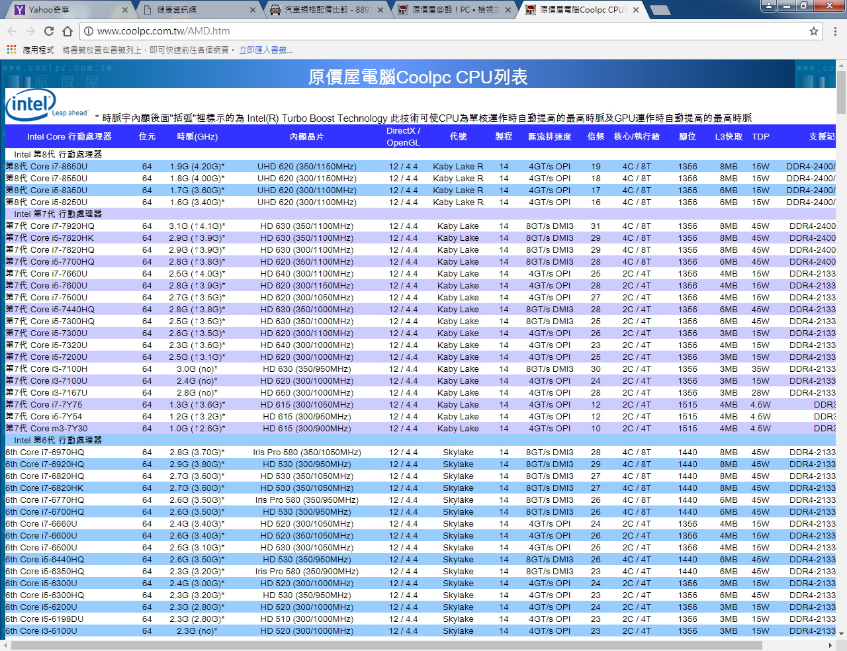

<http://www.coolpc.com.tw/AMD.htm>

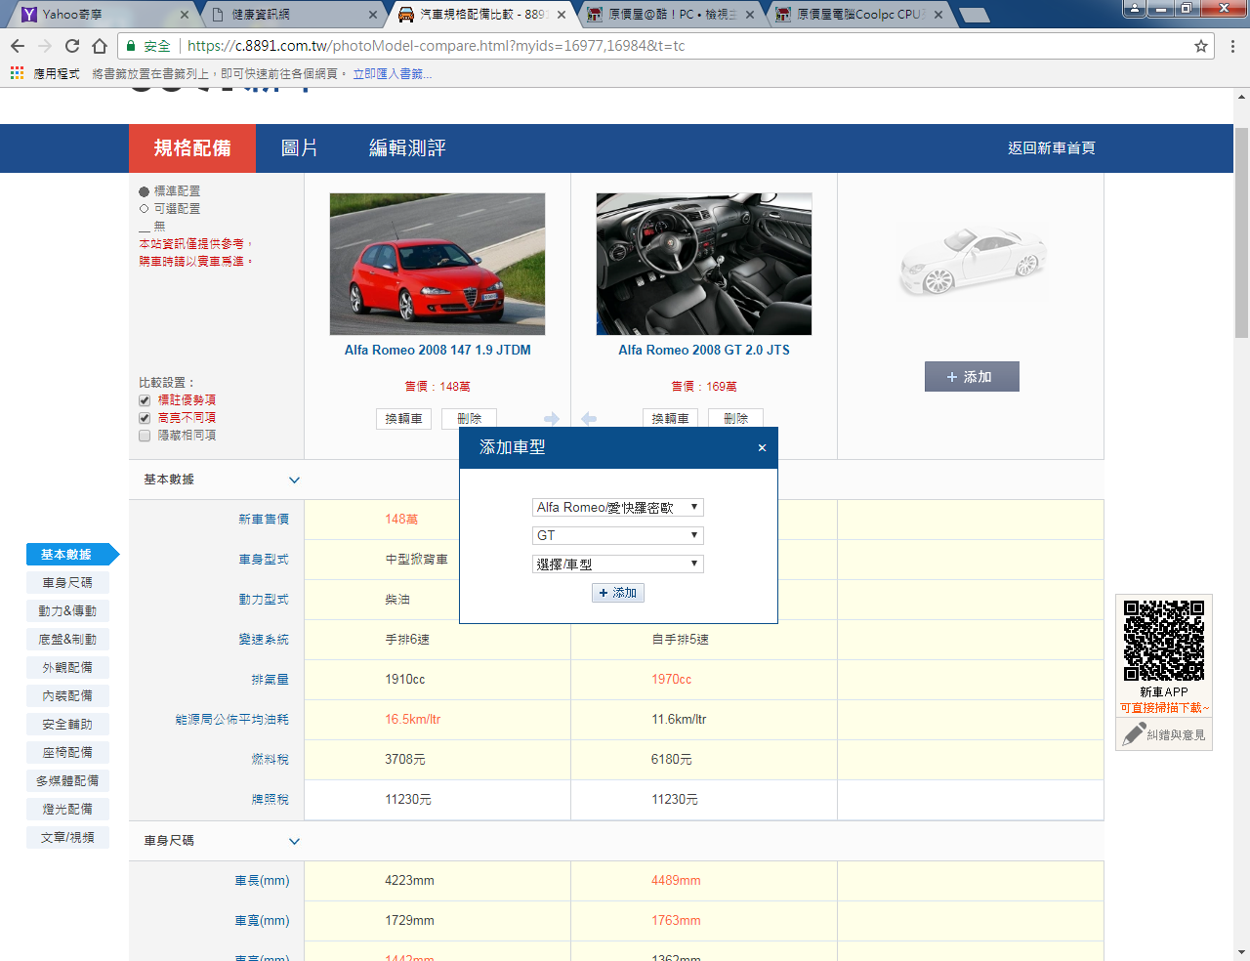

https://c.8891.com.tw/photoModel-compare.html?myids=16977,16984&t=tc