Usage

Open TMCP software, go to the f1 view page

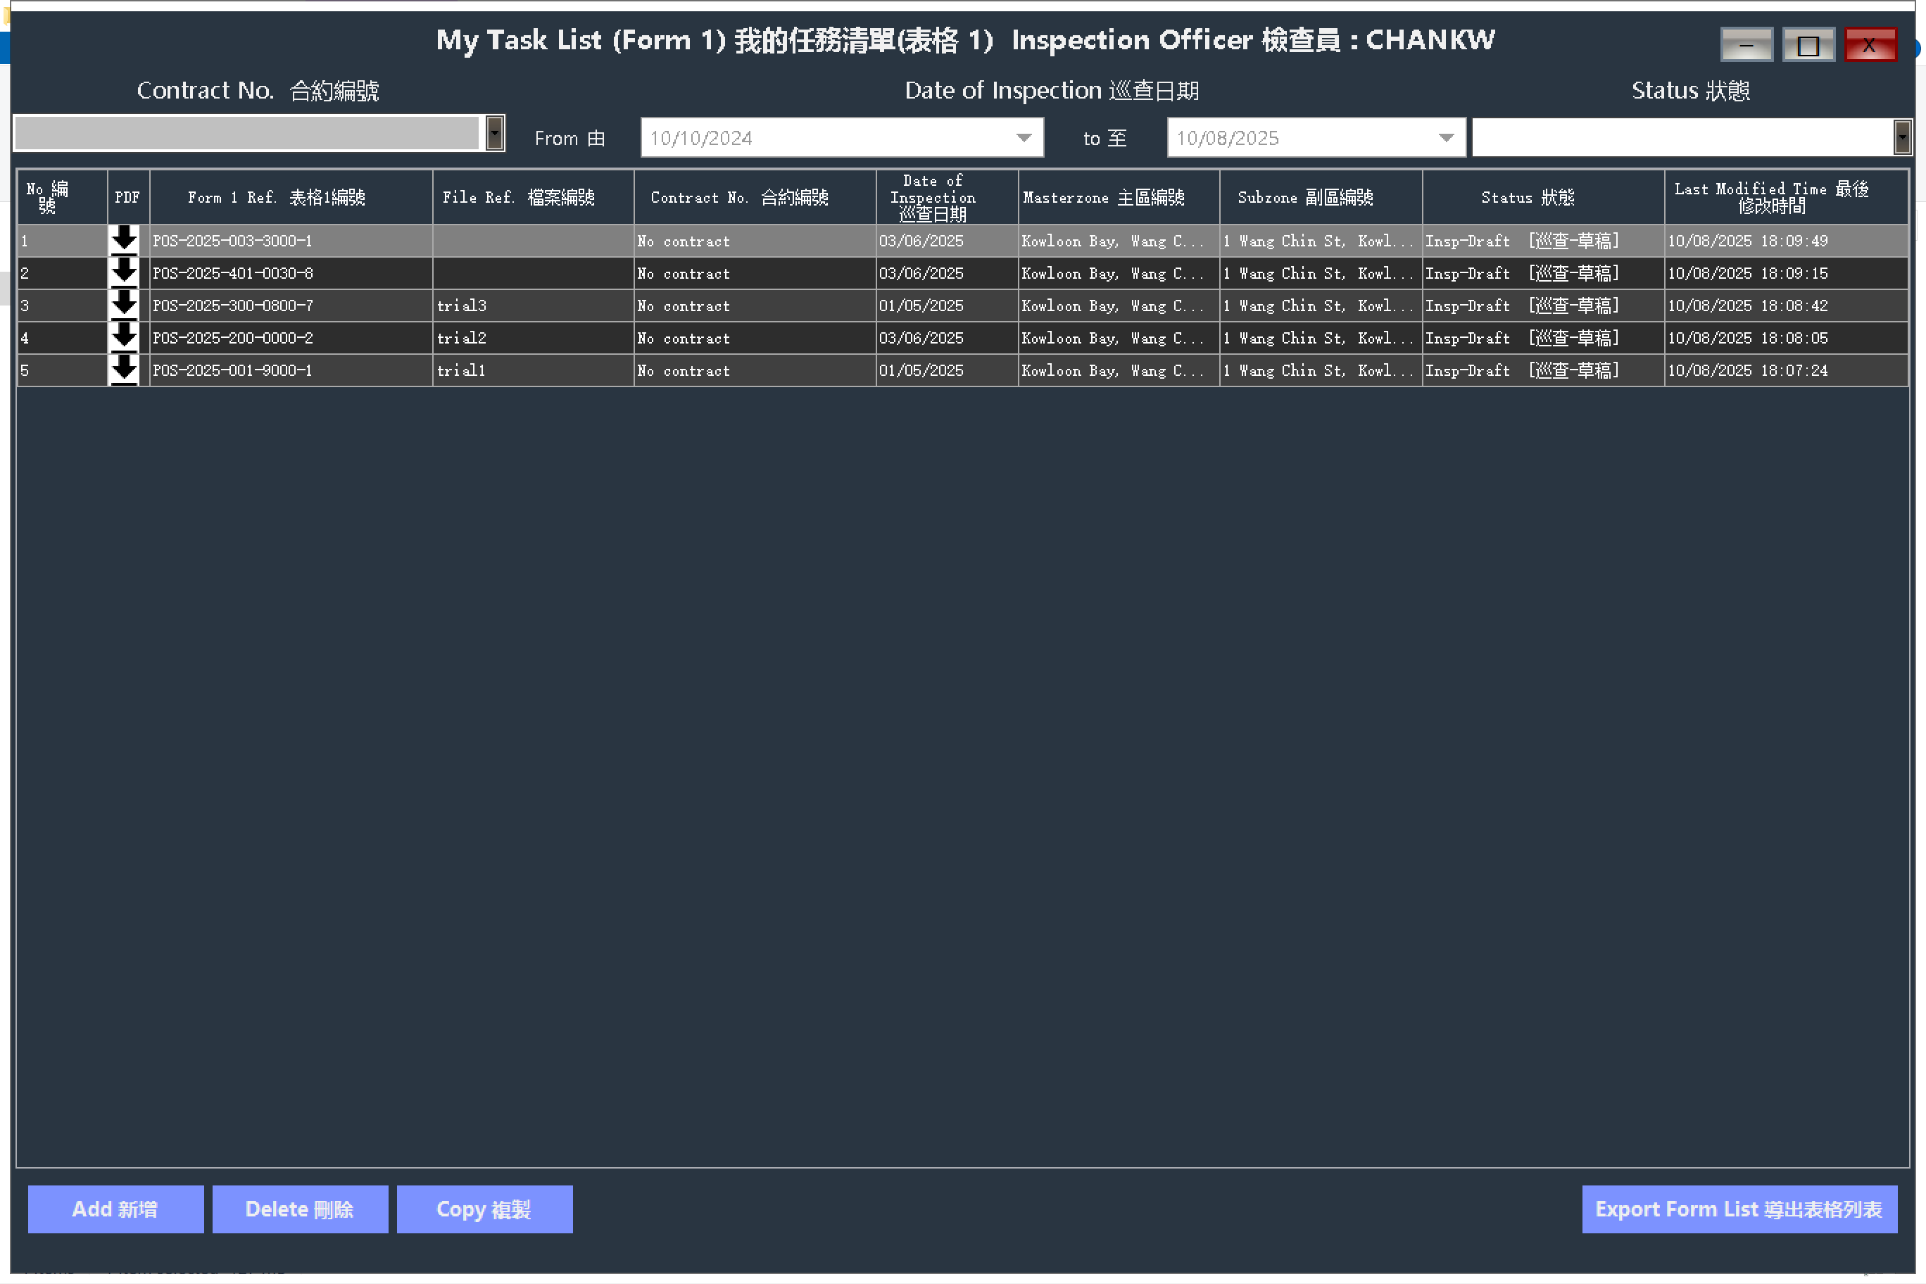

Click the PCMT.exe



Terminal will show on the screen for monitoring program status

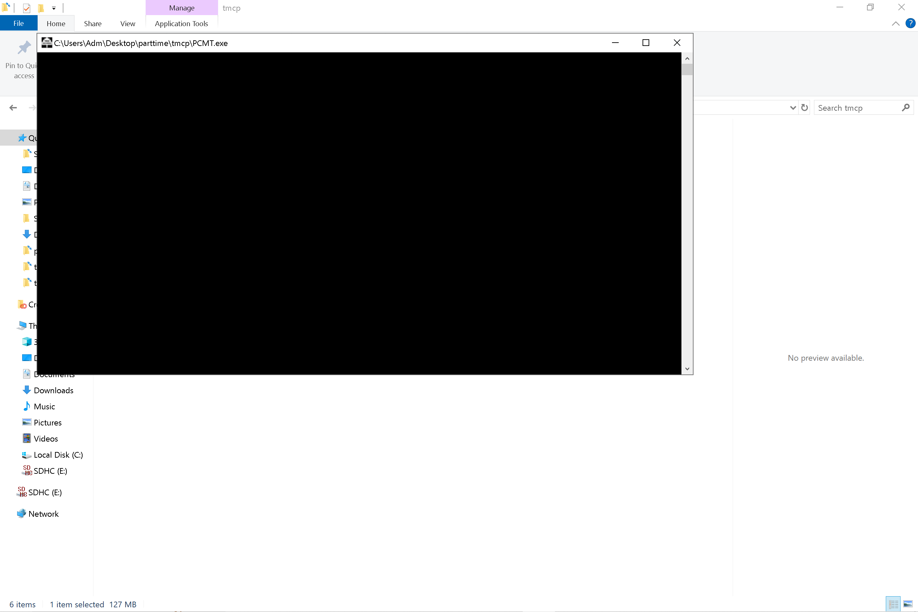

Waiting for 10 ~ 20 seconds, until the below msg showed in terminal

“Transforming Nature: The Revolution of HK Urban Forest Management”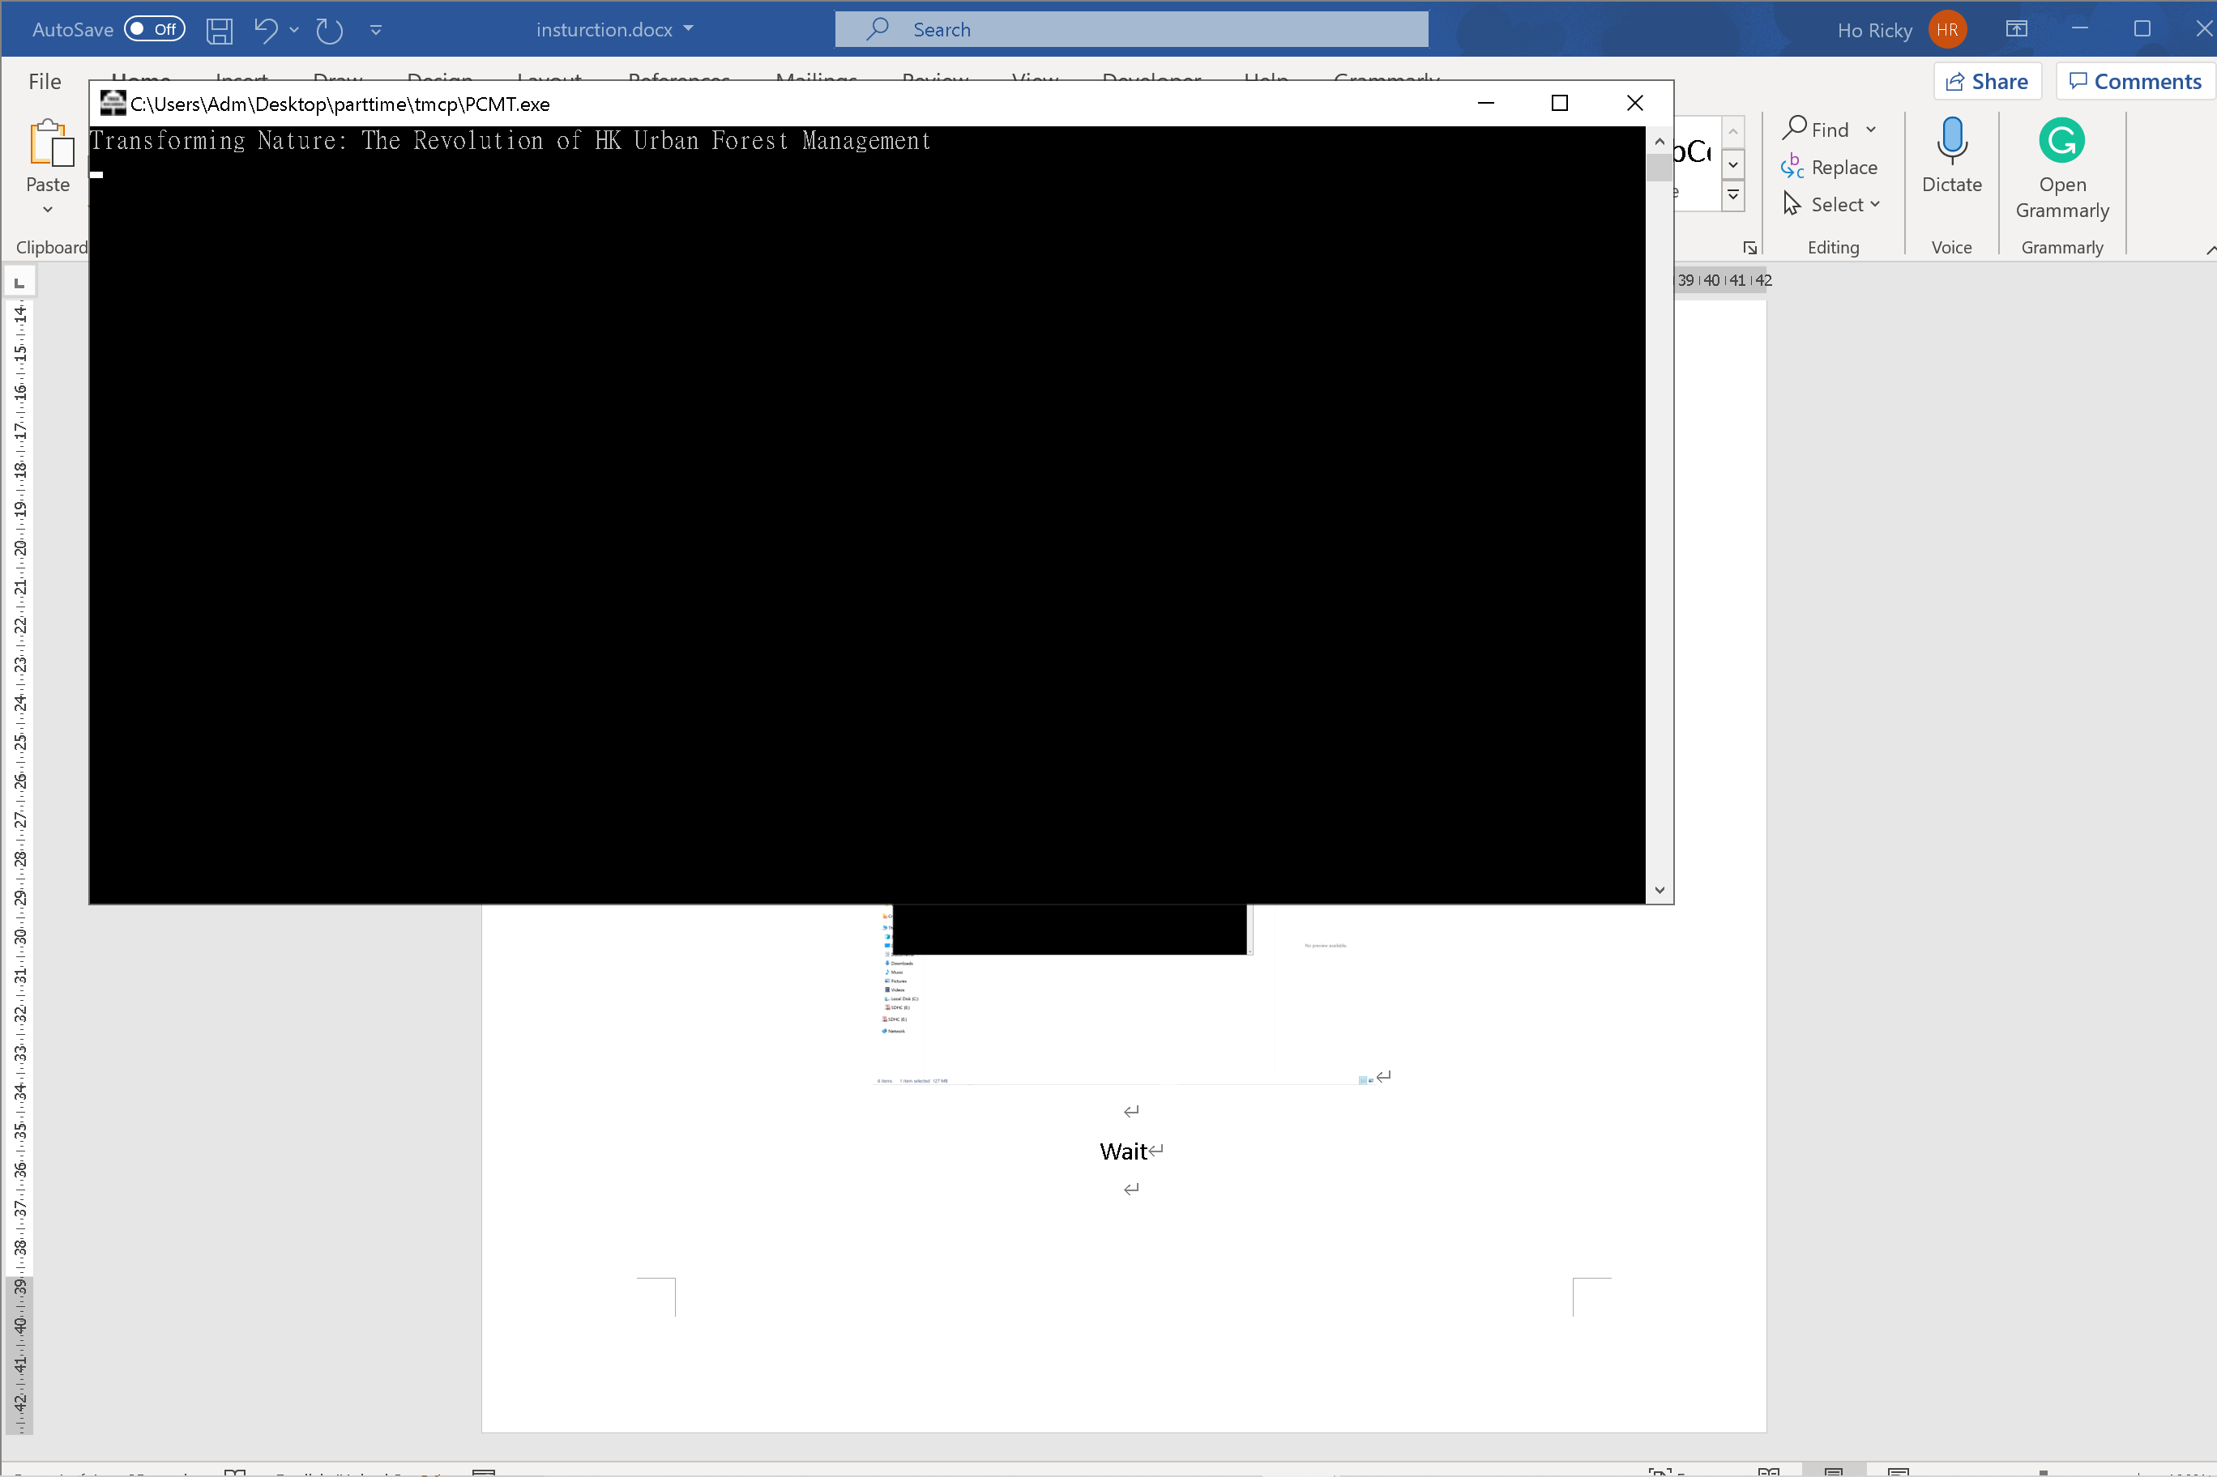

GUI shows on your screen, including your screen dimensions

1. To browse the file, select the Excel file named **"form1TMCP.xlsx."**
2. Enter the password. This **password can be changed** in the Google Spreadsheet; therefore, an internet connection is required.
3. When pressing submit button, the program will execute. Please do not disturb anything. (Screen locations and elements will be recognized automatically)

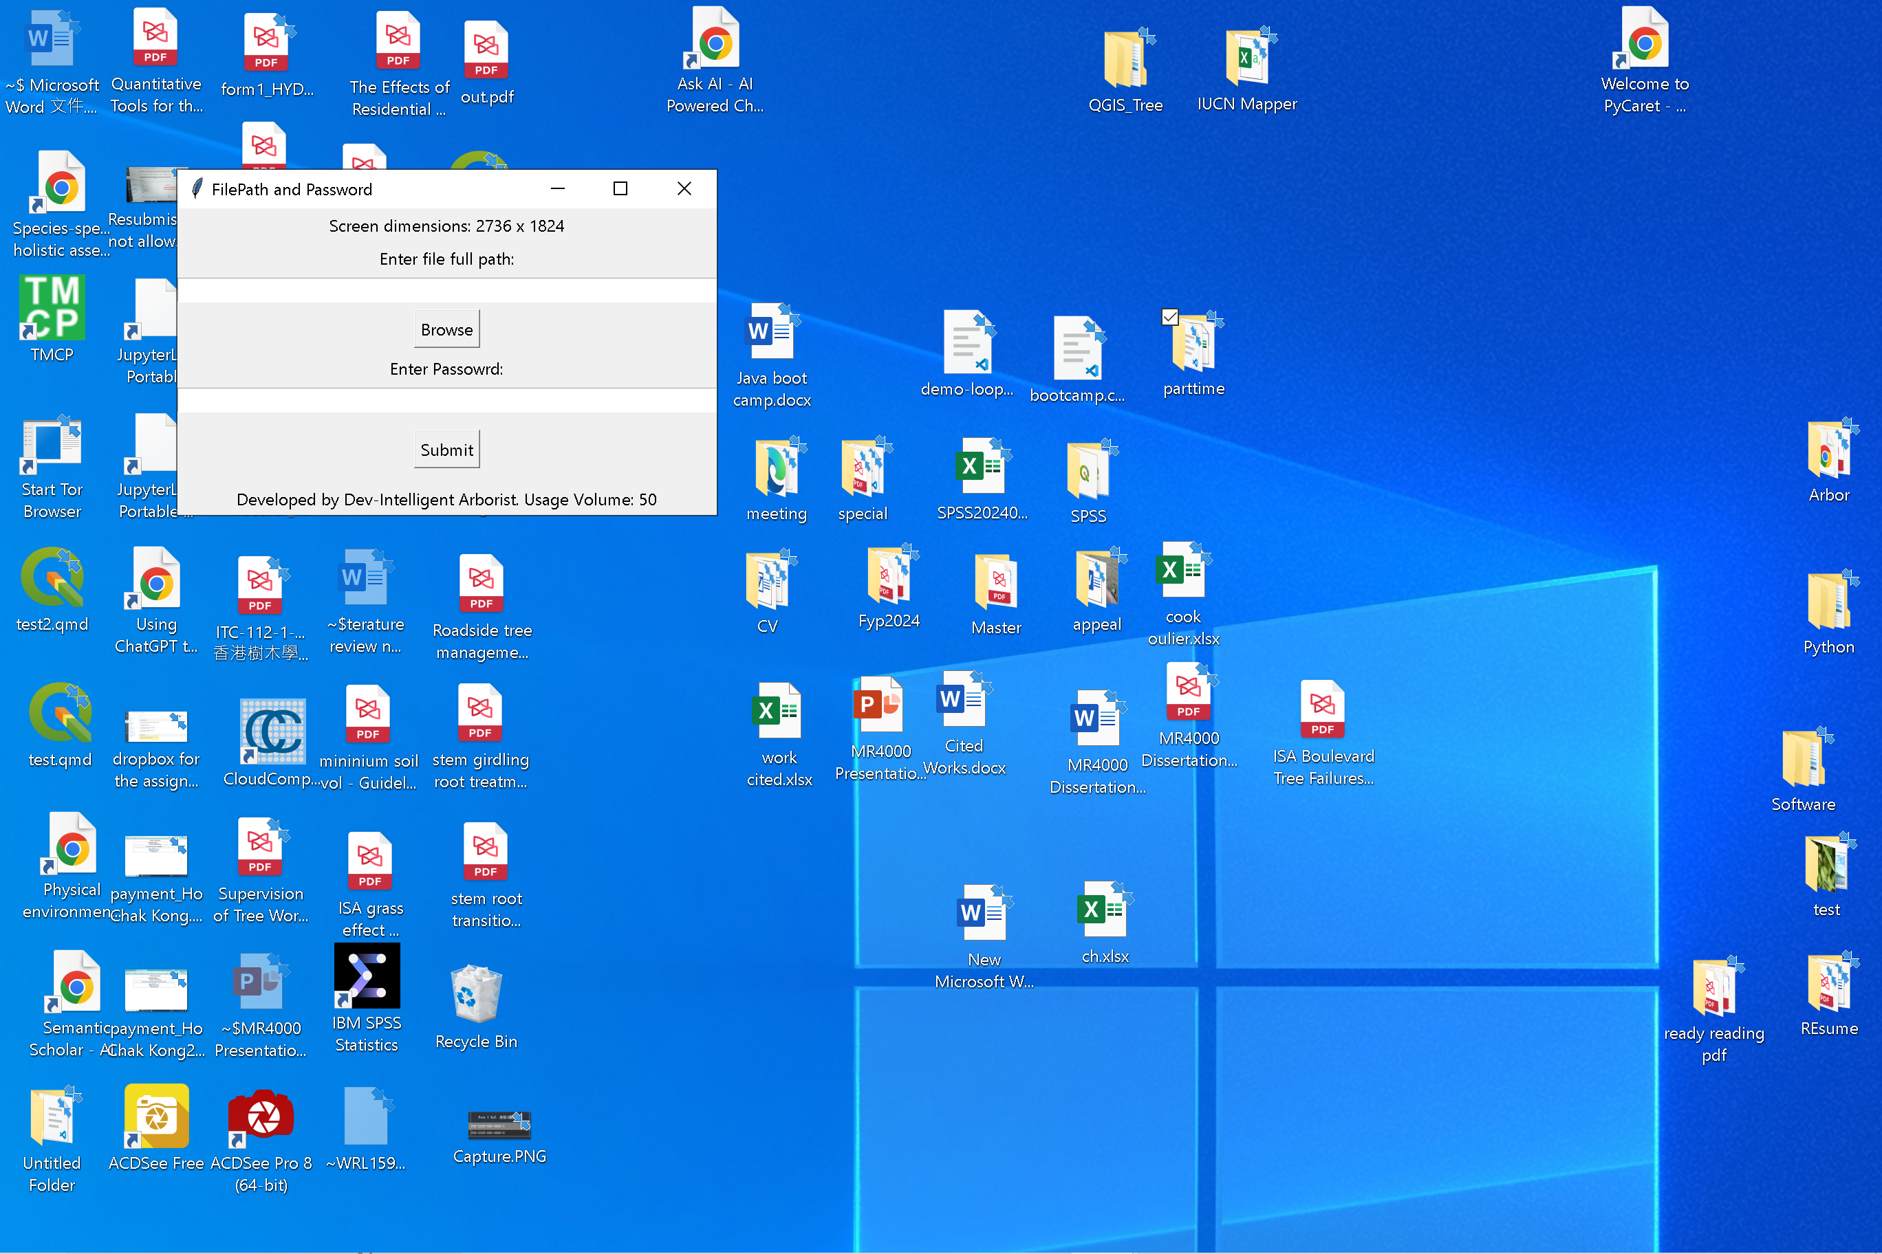

Select excel

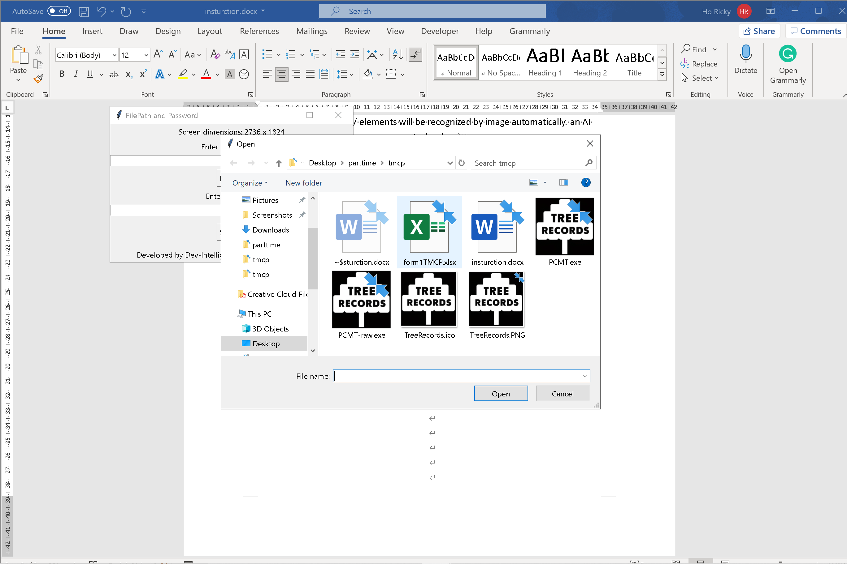

A message box will notify you when the entire process is complete. Please do not do anything before the box appears.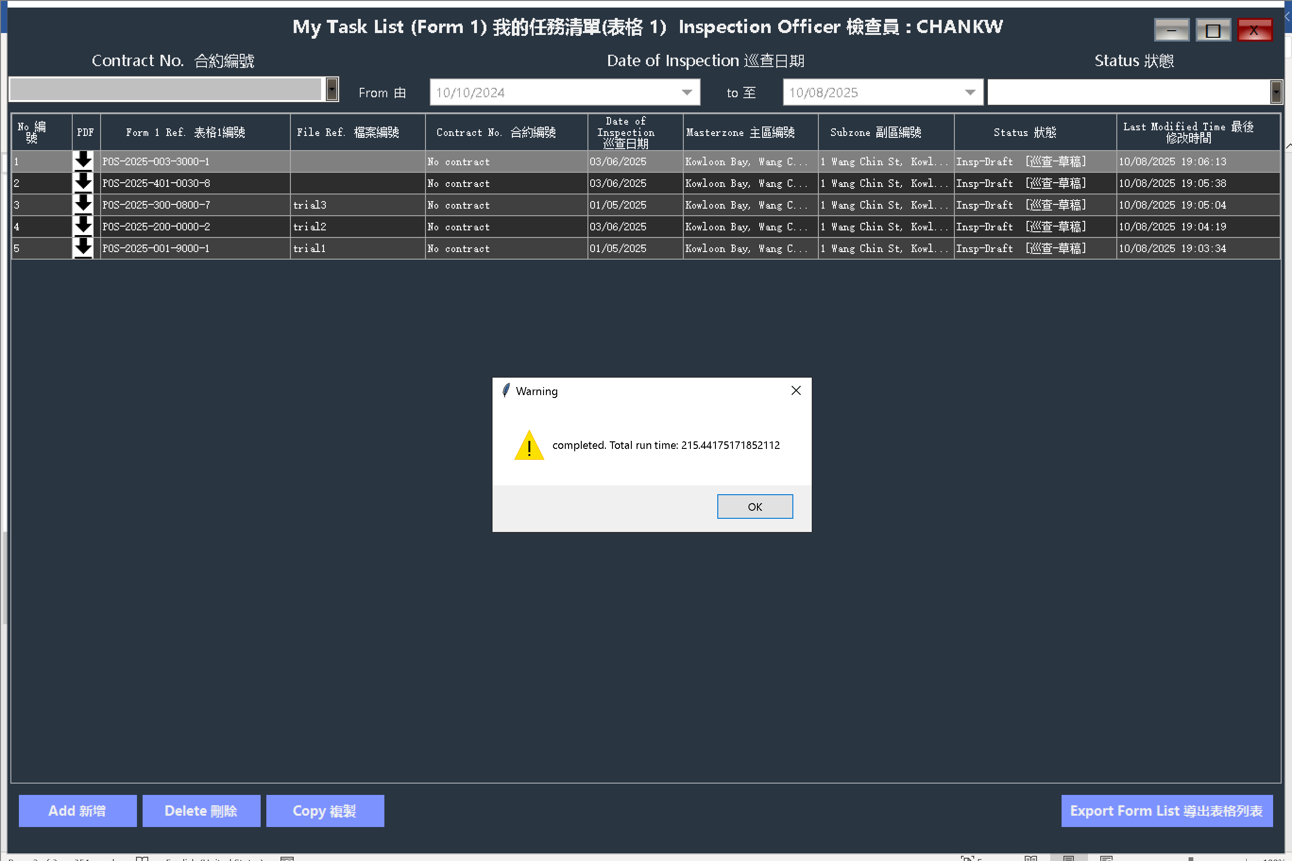

Things you need to know

* Ensure that keyboard input is set to English.
* The antivirus software may notify you of warnings if it is installed.
* The program does not utilize personal data.
* An internet connection is required.
* During testing, use a clean desktop account to avoid accidental clicks during automation.
* Clear any unnecessary software from the Windows taskbar.
* If the program cannot detect an image within 60 seconds, it will automatically stop.
* I have not tested it on other computers.
* Due to limited location options in the postal account, the testing scope is insufficient.
* Coordinate control will be adjusted based on screen dimensions and may require further fine-tuning.
* Excel data must be entered in a reasonable and orderly manner; check for errors or omissions. Perform a smart counter-check before running the executable.
* Specifications for the Excel file are explained in the first row (heading).
* The Excel file must match my Excel table format; do not use colors to mislead me. Excel usage cannot deceive me.
* There is no program without bugs.
* For password-related matters, please contact me after reading this information thoroughly.