React

react hooks :

npx create-react-app file_name

npm start

🡪react hooks are spec function which hook in the react features without creating class component of using state

**use state :**

the data cant be updated by assigning because component is not re- render after updating so using use state

Use state rules :

1.USE-STATE is not used in conditionally statements like if , while ..... and also in functions

2. use-state returns 2 things , 1. current state 2. function where we update

console.lo(useState()) --> [undefined, f())

Usestate using in 4 diff ways

1. String
2. Boolean
3. Array
4. Objects

Ex 1: **when the button is clicked the value should be updated with new value(string)**

this is the format of use-state

const [name , setName] = useState(“Dipesh”)



things here may be any value initial value



format 🡪 name is in lowercase and SetName is should be camel case

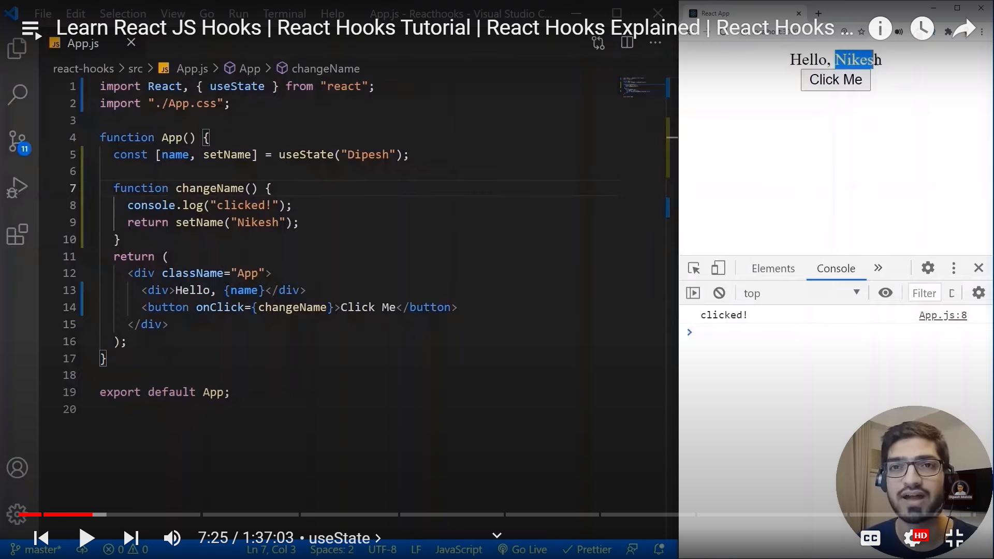

EX:

setName updates through the function in button tag

When button is clicked the state is updated by component is re-rendering

Ex:2 **for Boolean , if flag is name then print name or else hide the name**

Using flag as usestate

Const [flag , setFlag] = useState(false)

🡪false at initial

setFlag(!flag)

!flag = true (opp to flag )

For hiding and printing using a condition statement

{Flag ? name : “ ”} 🡪based on input checks condition and returns output by rendering component based on true or false

