**Banking System**

**GitHub ReadMe file as follow URL for Install and configuration of Bank Application**

<https://github.com/cksangili/bankassesment>

To download Jar from a GitHub repository, you can clone it to your local machine.

**UNIT test coverage report**

<https://github.com/cksangili/bankassesment/tree/main/jacoco>

Report details: Please refer the below

**JAR Download and Run**

* **Go to GitHub ReadMe file**

<https://github.com/cksangili/bankassesment/blob/main/README.md>

Step1: Download the BankProject.jar

Step2: Copy to your local directory (Eg. C:\\GICJAR)

Step3: Open Command prompt

Step4: Go to the path where you copied the BankProject.jar (C:\\GICJAR\BankProject.jar)



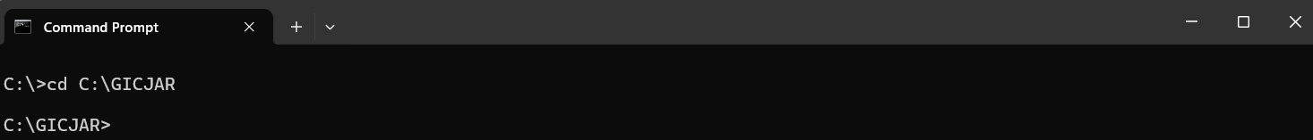

Step5: Execute the below command

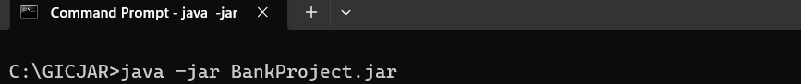

Step6: Click enter key

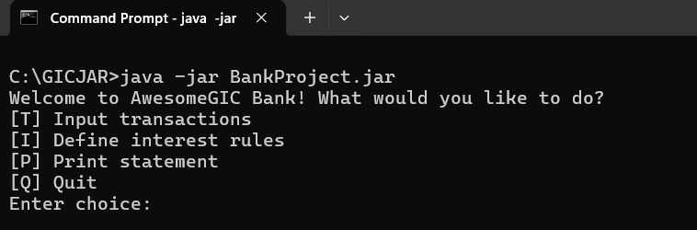

Spte7: Proceed for the validations

Enter choice: T

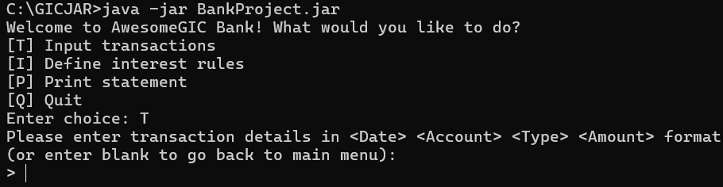

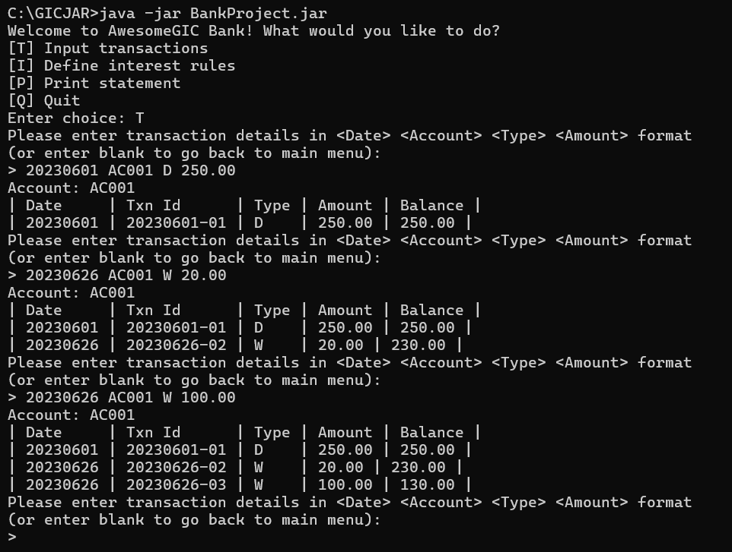

Step8: Click enter to go main menu

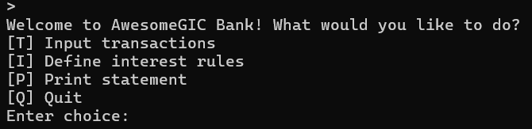

Step9: Enter choice: I

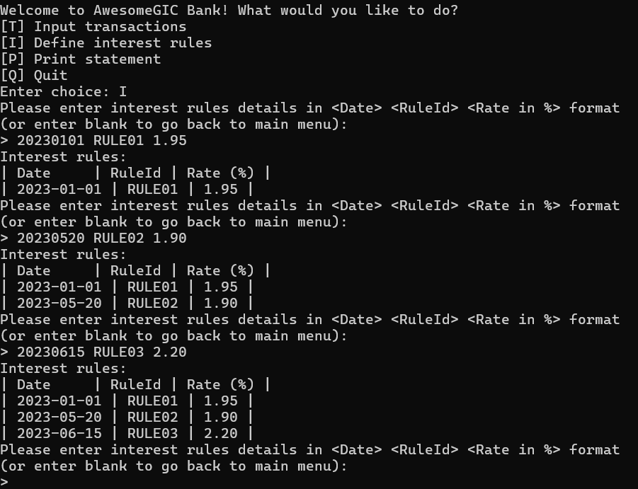

Step10: Click enter to go main menu

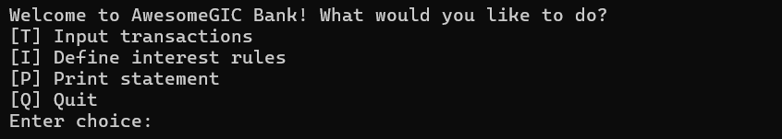

Spte11: Enter choice: P

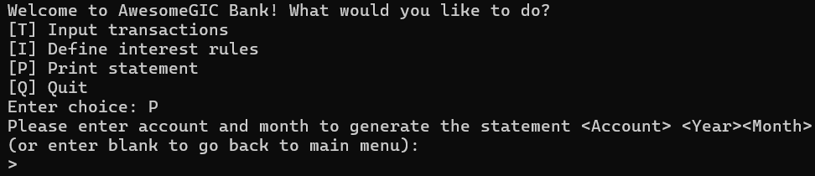

Spte12: Enter report command (AC001 202306)

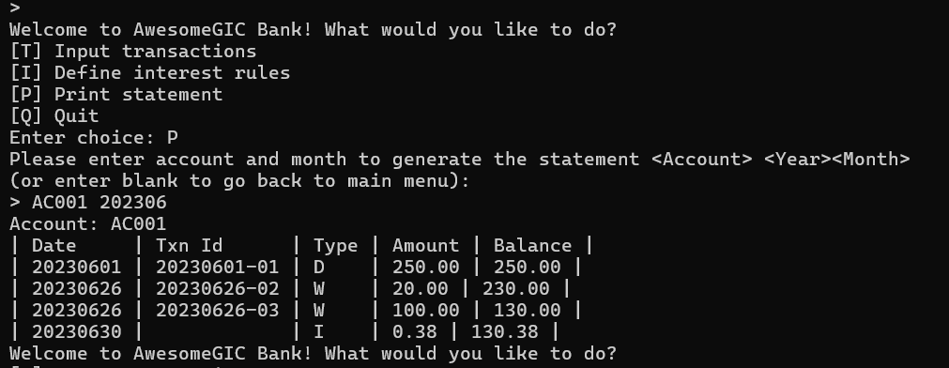

Spte13: Enter choice: Q

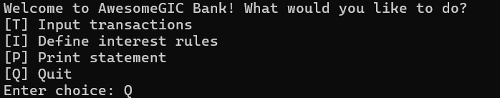

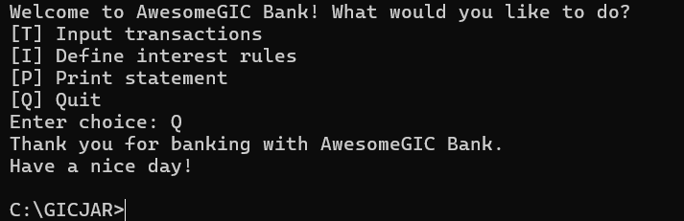

**JUnit test coverage**

