#### Monte-Carlo Policy Evaluation

Greedy poliucy (van vorige opdracht)

Gamma = 0.9 Gamma = 1

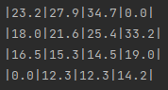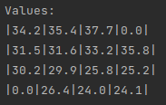

Random policy

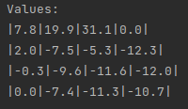Gamma = 0.9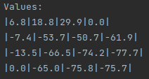 Gamma = 1

#### Temporal Difference Learning

Greedy poliucy (van vorige opdracht)

Gamma = 0.9 Gamma = 1

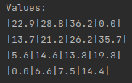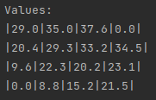

Random policy

Gamma = 0.9 Gamma = 1

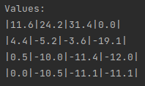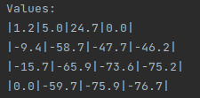

#### On-policy first-visit Monte-Carlo Control

Gamma = 0.9

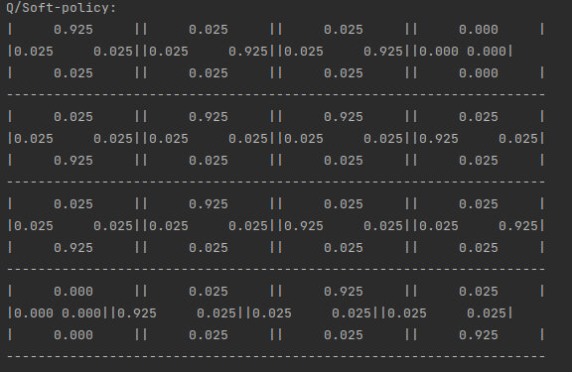

Gamma = 1

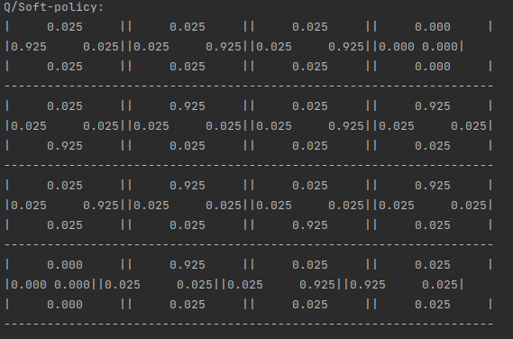

#### SARSA

Gamma = 0.9

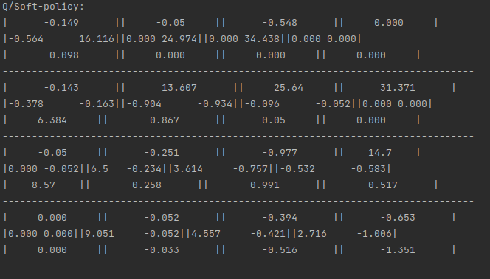

Gamma = 1

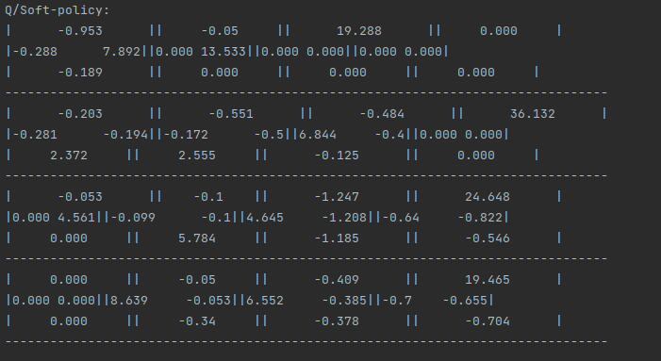

#### Q-Learning

Gamma = 0.9

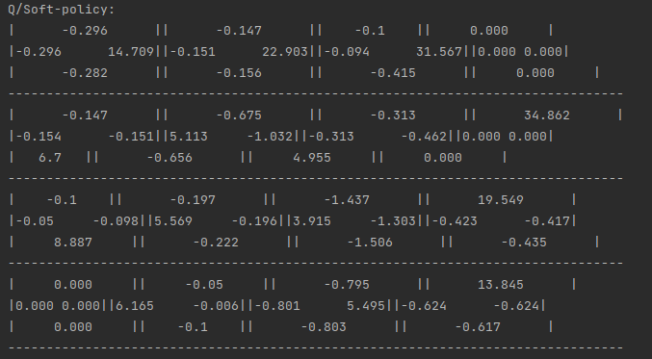

Gamma = 1

