#### BDC批导程序操作手册

### T-code

输入事物码“SE38”

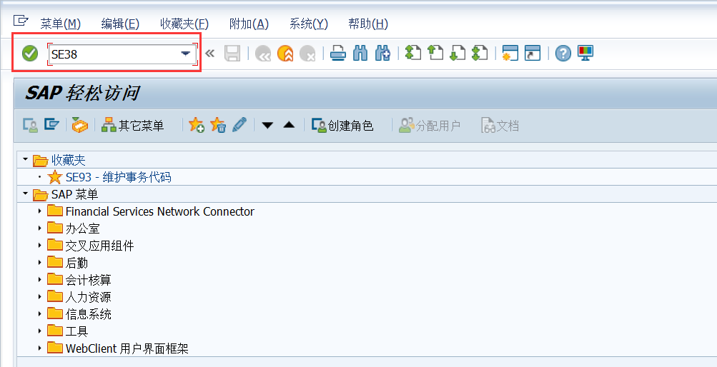

### 配置批导程序

以“ZR_HR_BDC_XXXX”命名需要创建的批导程序，XXXX为所对应的信息类型编码。

选择“源代码”，点击“创建”。

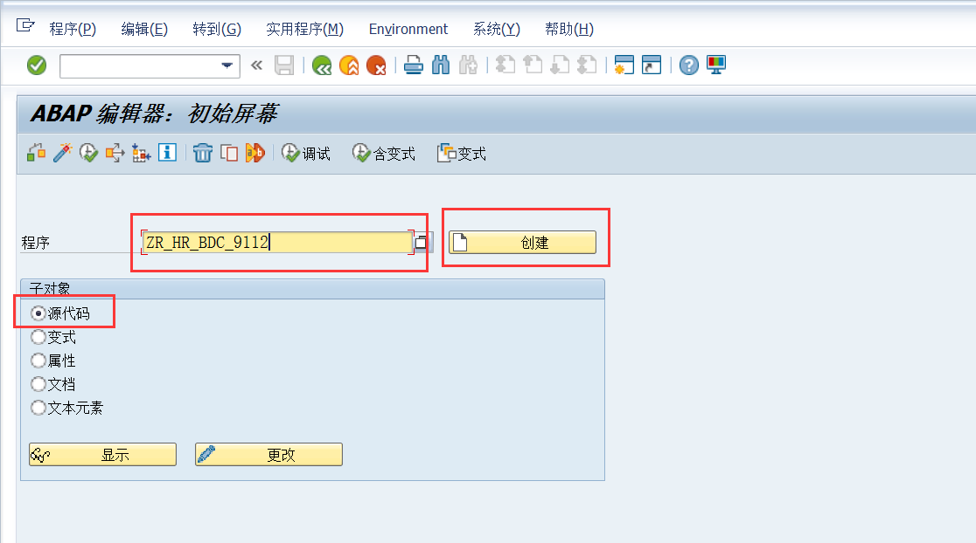

输入批导程序标题“英语水平批导程序”。

选择类型“”，

选择状态“”。

勾选“”和“”，点击“保存”。

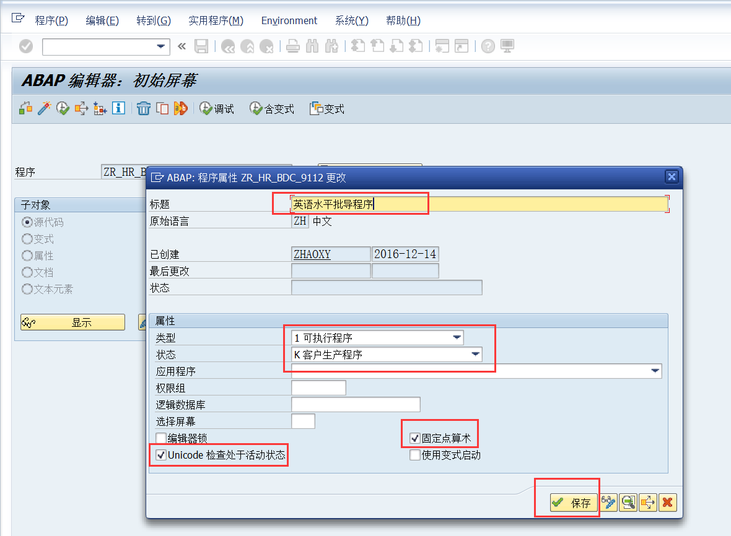

选择所需要的“包”，点击“保存”

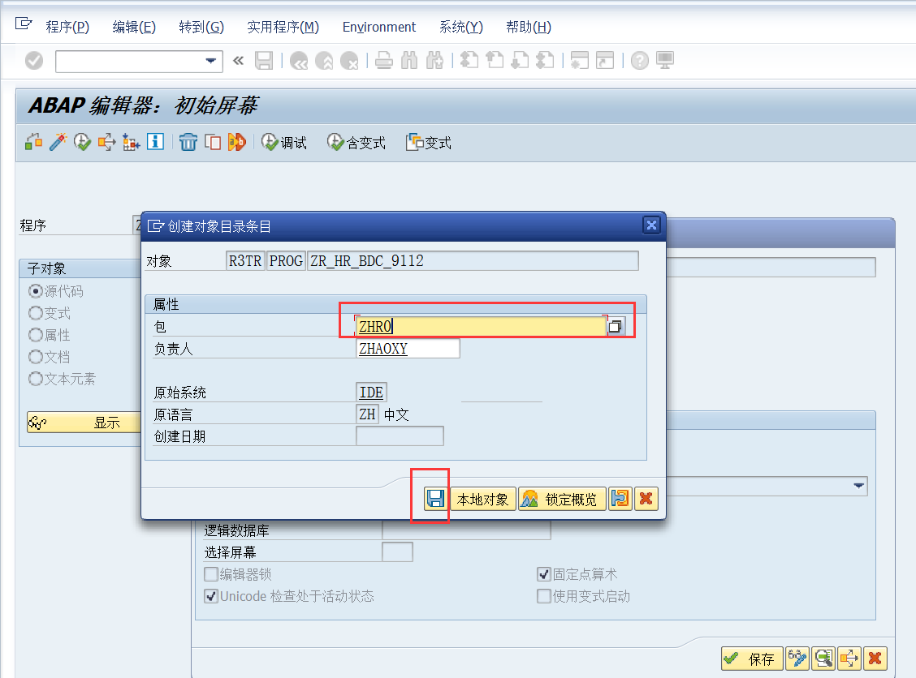

生成请求号，点击“执行”。

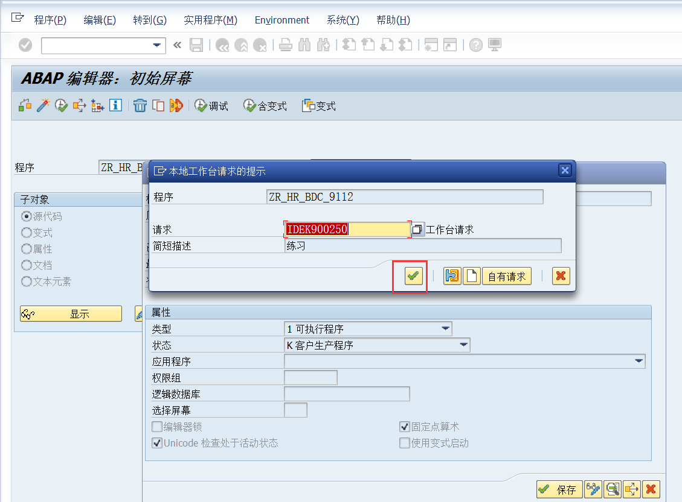

### 配置批导程序相关代码

*&---------------------------------------------------------------------*  
*& Report  ZR_HR_BDC_9112  
*&  
*&---------------------------------------------------------------------*  
*&   zhaoxy  
*&   20161214  
*&---------------------------------------------------------------------*  
  
REPORT ZR_HR_BDC_9112.  
  
**********************************************************************   导入数据声明  
* UpLoad Data Record.  
TYPES: BEGIN OF  tab_str,  
        PERNR(020),  
        BEGDA(020),  
        ENDDA(020),  
        ZYYZSMC(040),  
        ZYYFS(020),  
        ZYYTSNL(002),  
  
  
      END OF tab_str.  
  
* Down Load Data Format.  字段描述  
DATA : BEGIN OF IT_DOWN OCCURS 0,  
        PERNR(020),  
        BEGDA(020),  
        ENDDA(020),  
        ZYYZSMC(040),  
        ZYYFS(020),  
        ZYYTSNL(20),  
  
  
  
  
        END OF IT_DOWN.  
**********************************************************************  
  
  
DATA: record TYPE tab_str OCCURS 0 WITH HEADER LINE.  
DATA: BEGIN OF err_table OCCURS 0.  
        INCLUDE TYPE tab_str.  
DATA: msg(100) TYPE c.  
DATA: END OF err_table.  
DATA : v_line  TYPE i.            "Record number  
DATA: g_line TYPE i .  
  
  
INCLUDE ZR_HR_BDC_DATA.  
  
  
**********************************************************************    数据地址  
INITIALIZATION.  
  pa_file = 'D:\9112.txt'.        "数据存放位置  
  pa_flog = 'D:\9112_err.txt'.    "错误日志存放位置  
*  b_write = 'X'.         "是否屏幕显示结果信息， X 为显示  
**********************************************************************  
  
  
AT SELECTION-SCREEN.  
  CASE SSCRFIELDS-UCOMM.  
    WHEN 'FC01'.  "template down  
      PERFORM EXCELL_DOWNLOAD.          "下载数据模版  
      p_fun1 = 'X'.  
  ENDCASE.  
  
*----------------------------------------------------------------------*  
AT SELECTION-SCREEN ON VALUE-REQUEST FOR pa_file.  
*----------------------------------------------------------------------*  
  PERFORM get_filename CHANGING pa_file.  
  
*----------------------------------------------------------------------*  
AT SELECTION-SCREEN ON VALUE-REQUEST FOR pa_flog.  
*----------------------------------------------------------------------*  
  PERFORM get_filename CHANGING pa_flog.  
  
START-OF-SELECTION.  
  PERFORM upload_data USING pa_file.  "upload PC file to itab  
  PERFORM insert_data.  
  PERFORM write_file TABLES err_table  
                     USING  pa_flog.  "Write file-data  
  
  """"附加ALV显示  
  PERFORM show_alv .  
*  
*  LOOP AT err_table.  
*    WRITE: / err_table.  
*  ENDLOOP.  
*  
*  DESCRIBE TABLE record LINES v_line.  
*  WRITE:/ 'Read data: ', v_line.  
*  DESCRIBE TABLE err_table LINES v_line.  
*  WRITE:/ 'Error data: ', v_line.  
*  
*  WRITE:/'Finish.'.       " 显示错误数据记录  
  
  
*&---------------------------------------------------------------------*  
*&      Form  insert_data  
*&---------------------------------------------------------------------*  
*       " 写入数据主函数，更改屏幕录入字段  
*----------------------------------------------------------------------*  
FORM insert_data .  
  
  CLEAR v_line.  
  DESCRIBE TABLE record LINES v_line.  
  IF v_line = 0.  
    EXIT.  
  ENDIF.  
  
  
  LOOP AT record.  
  
    perform bdc_dynpro      using 'SAPMP50A' '1000'.  
    perform bdc_field       using 'BDC_OKCODE'  
                                  '=/00'.  
  
    perform bdc_field       using 'RP50G-PERNR'  
                                  record-PERNR.  
  
    perform bdc_field       using 'RP50G-TIMR6'  
                                  'x'.  
  
    perform bdc_field       using 'BDC_CURSOR'  
                                  'RP50G-CHOIC'.  
  
    perform bdc_field       using 'RP50G-CHOIC'  
                                  '9112'.  
  
  
       perform bdc_dynpro      using 'SAPMP50A' '1000'.  
     perform bdc_field       using 'BDC_CURSOR'  
                                  'RP50G-PERNR'.  
  
    perform bdc_field       using 'BDC_OKCODE'  
                                  '=/00'.  
  
    perform bdc_field       using 'RP50G-PERNR'  
                                  record-PERNR.  
  
    perform bdc_field       using 'RP50G-TIMR6'  
                                  'x'.  
  
    perform bdc_field       using 'RP50G-CHOIC'  
                                  '英语水平'.  
  
  
  
       perform bdc_dynpro      using 'SAPMP50A' '1000'.  
     perform bdc_field       using 'BDC_CURSOR'  
                                  'RP50G-PERNR'.  
  
    perform bdc_field       using 'BDC_OKCODE'  
                                  '=INS'.  
  
    perform bdc_field       using 'RP50G-PERNR'  
                                  record-PERNR.  
  
    perform bdc_field       using 'RP50G-TIMR6'  
                                  'x'.  
  
    perform bdc_field       using 'RP50G-CHOIC'  
                                  '英语水平'.  
  
  
  
  
      perform bdc_dynpro      using 'MP911200' '2000'.  
      perform bdc_field       using 'BDC_CURSOR'  
                                    'P9112-ZYYTSNL'.  
  
      perform bdc_field       using 'BDC_OKCODE'  
                                    '=UPD'.  
  
      perform bdc_field       using 'P9112-BEGDA'  
                                    record-BEGDA.  
  
      perform bdc_field       using 'P9112-ENDDA'  
                                    record-ENDDA.  
  
      perform bdc_field       using 'P9112-ZYYZSMC'  
                                    record-ZYYZSMC.  
  
      perform bdc_field       using 'P9112-ZYYFS'  
                                    record-ZYYFS.  
  
     perform bdc_field       using 'P9112-ZYYTSNL'  
                                    record-ZYYTSNL.  
  
  
  
  
  
    PERFORM bdc_transaction USING 'PA30' CHANGING record.  
  
    g_line = g_line + 1.  
    PERFORM progress_indicator USING g_line.  
  
    PERFORM err_message.  
*    IF b_write = 'X'.  
*      WRITE : / record  COLOR 1.  
*      SKIP 1.  
*    ENDIF.  
  ENDLOOP.  
  
ENDFORM.                    " insert_data  
  
  
*&---------------------------------------------------------------------*  
*&      Form  progress_indicator  
*&---------------------------------------------------------------------*  
*       text  
*----------------------------------------------------------------------*  
*      -->P_SY_TABIX text  
*----------------------------------------------------------------------*  
FORM progress_indicator  USING    p_sy_tabix.  
  
  DATA: s_string      TYPE string,  
        pernt(6)      TYPE p DECIMALS 2,  
        percc(6)      TYPE c,  
        l_idx(6)      TYPE C.  
  v_line = v_line + 1.  
  pernt = p_sy_tabix / v_line  * 100.  
  percc+0(5) = pernt.  
  percc+5(1) = '%'.  
  l_idx = p_sy_tabix.  
  CONCATENATE '正在读取第' l_idx '笔数据.......' INTO s_string SEPARATED BY space.  
  CONDENSE s_string.  
  
*  move record to s_string.  
  CONDENSE s_string.  
  CALL FUNCTION 'PROGRESS_INDICATOR'  
    EXPORTING  
      i_text               = '&1 &3 &4  &2 '  
      i_msgv1              = percc  
      i_msgv2              = s_string  
*     i_msgv3              = record-massg_006  
*     i_msgv4              = record-plans_008  
      i_processed          = v_line  
      i_total              = p_sy_tabix  
      i_output_immediately = 'X'.  
  
  
ENDFORM.                    " progress_indicator  
  
  
  
  
*&---------------------------------------------------------------------*  
*&      Form  EXCELL_DOWN  
*&---------------------------------------------------------------------*  
*       text  
*----------------------------------------------------------------------*  
FORM EXCELL_DOWNLOAD.  
  CLEAR: IT_DOWN, IT_DOWN[].  
  MOVE:     '人员编号'                  TO IT_DOWN-PERNR,       "将字段描述赋值  
            '开始日期'                  TO IT_DOWN-BEGDA,  
            '结束日期'                  TO IT_DOWN-ENDDA,  
            '英语证书名称'         TO IT_DOWN-ZYYZSMC,  
            '英语分数' TO IT_DOWN-ZYYFS,  
'档英语听说能力'     TO IT_DOWN-ZYYTSNL.  
  
  
  
  
  
  APPEND IT_DOWN.  
  
  PERFORM EXCELL_DOWN TABLES IT_DOWN.  
  
ENDFORM.                    "EXCELL_DOWNLOAD

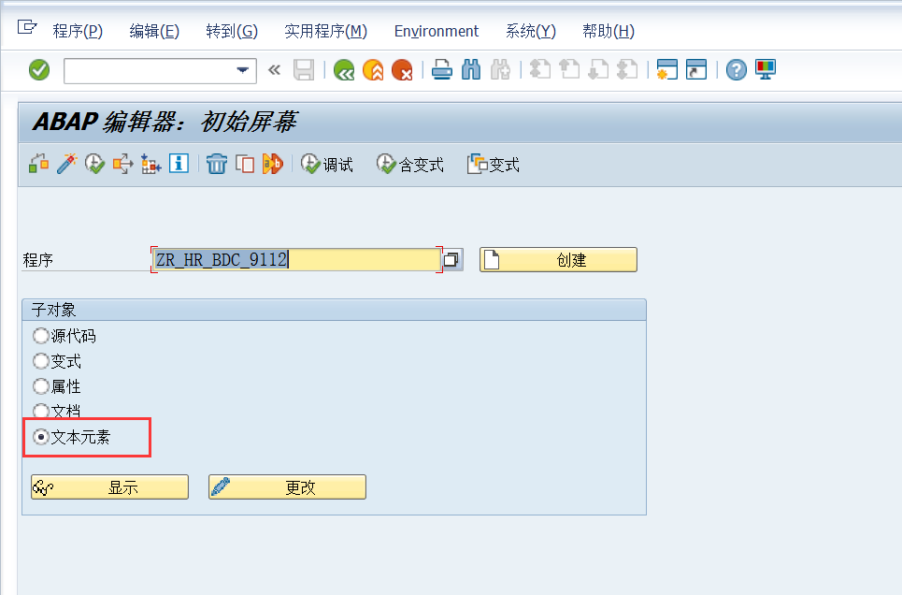

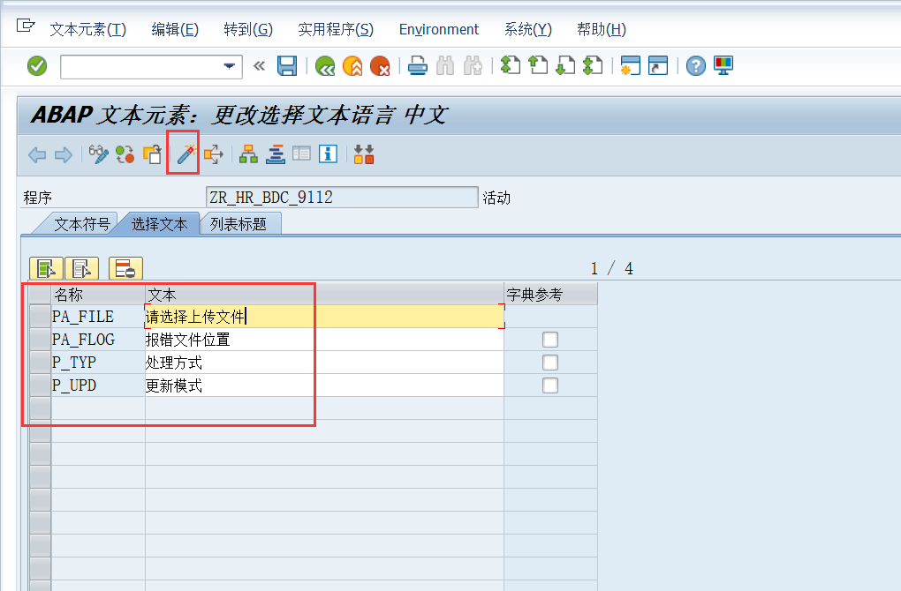

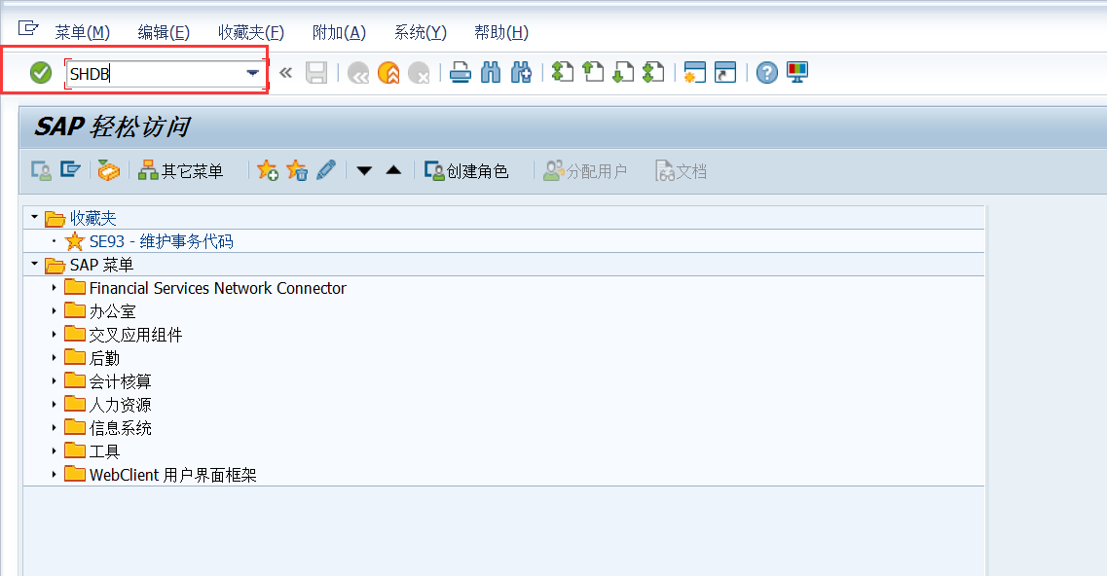

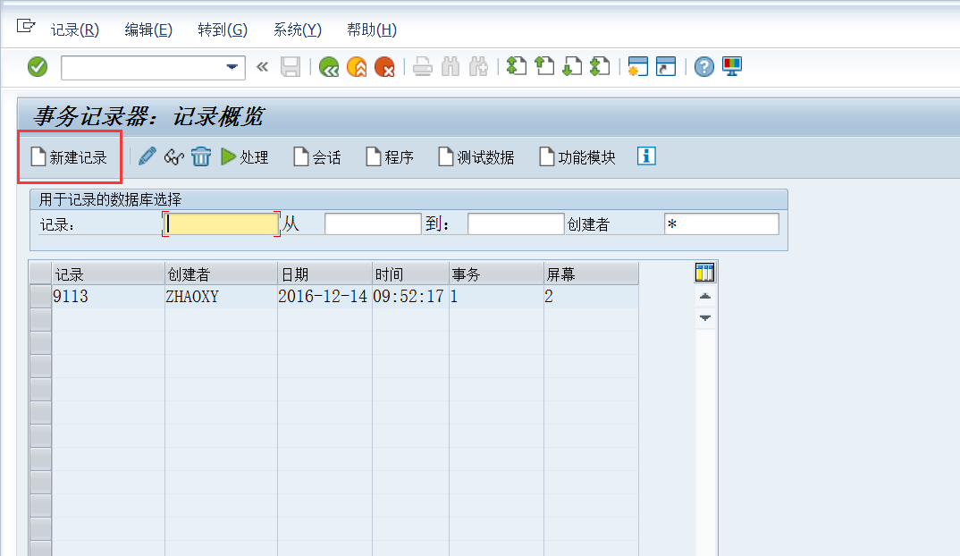

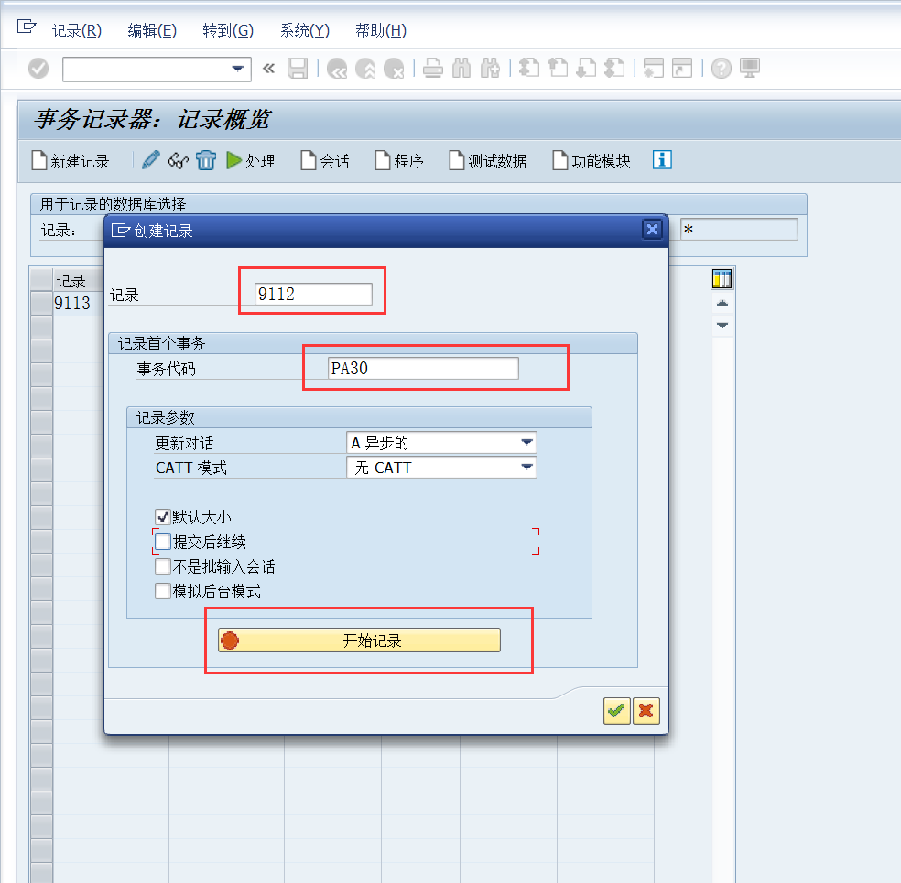

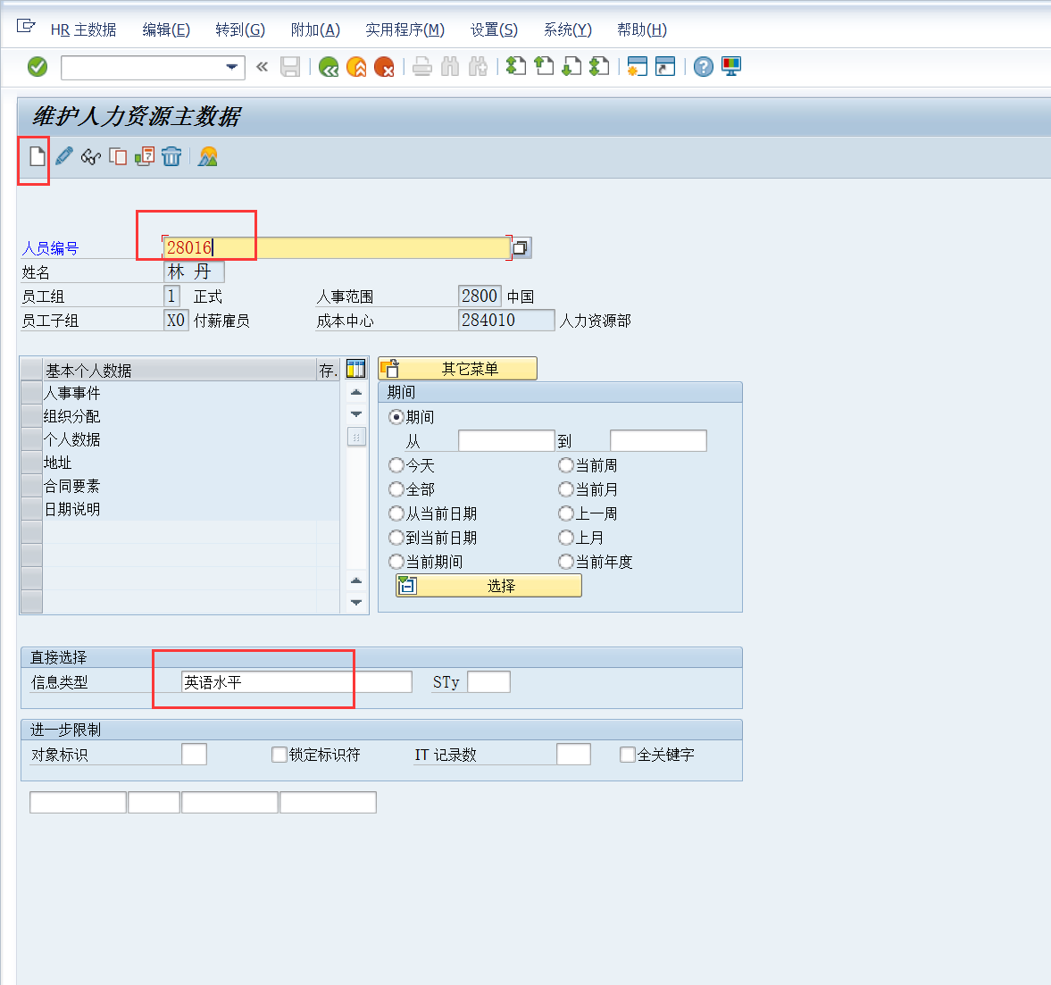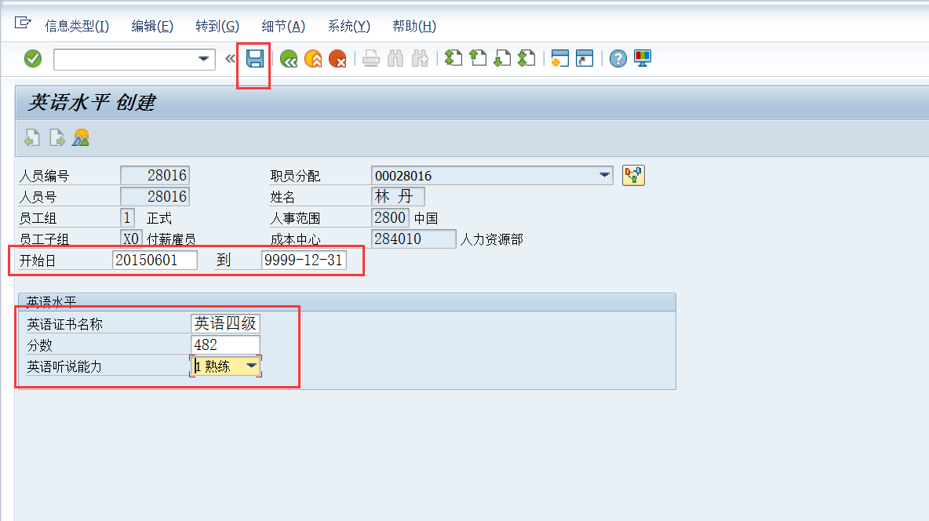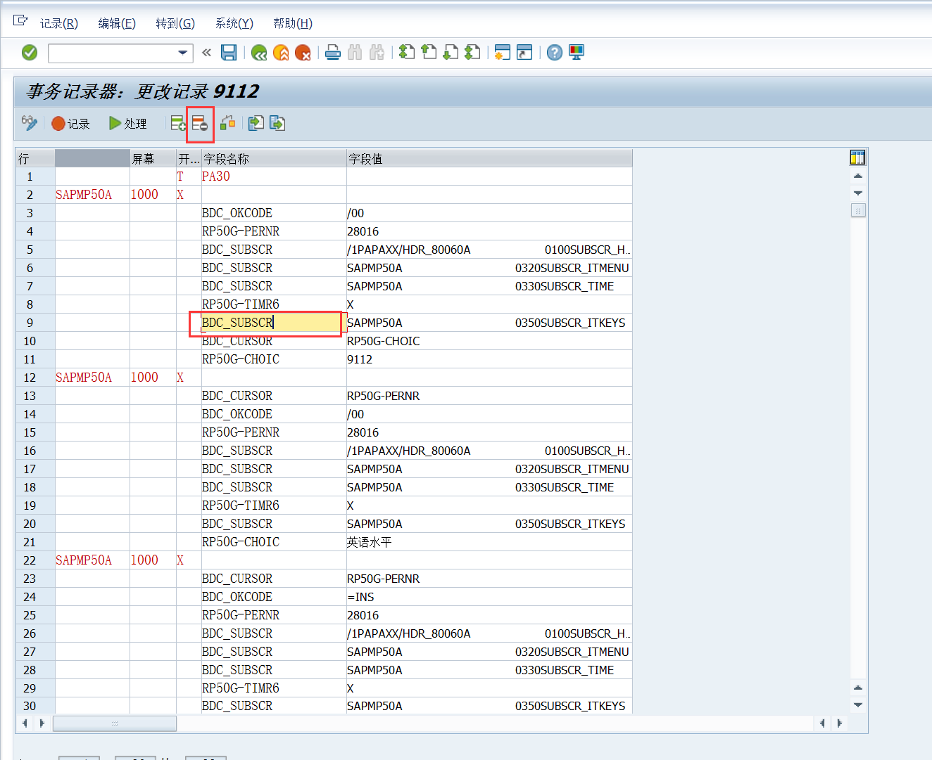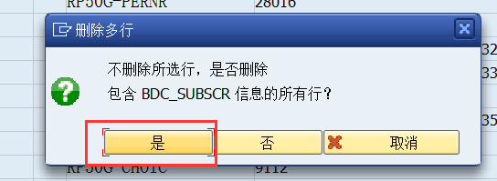

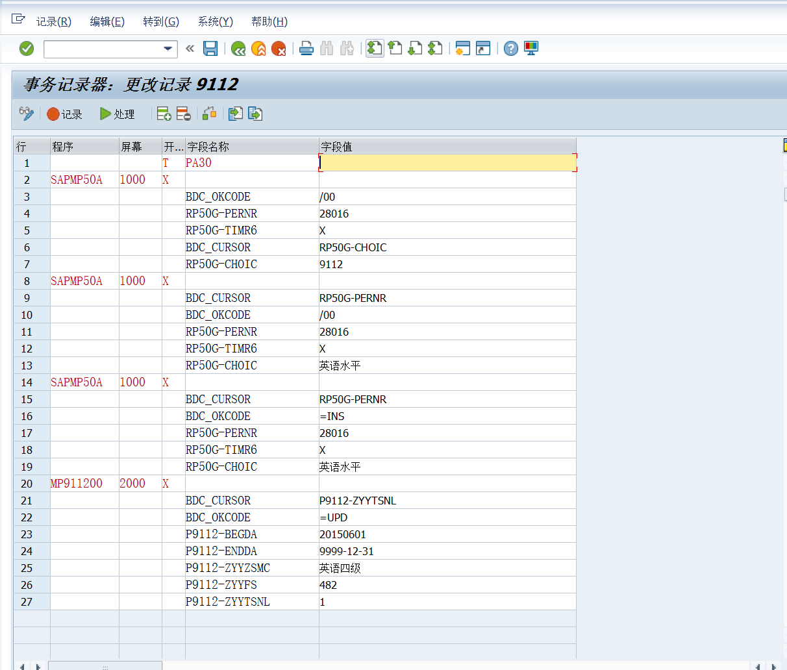

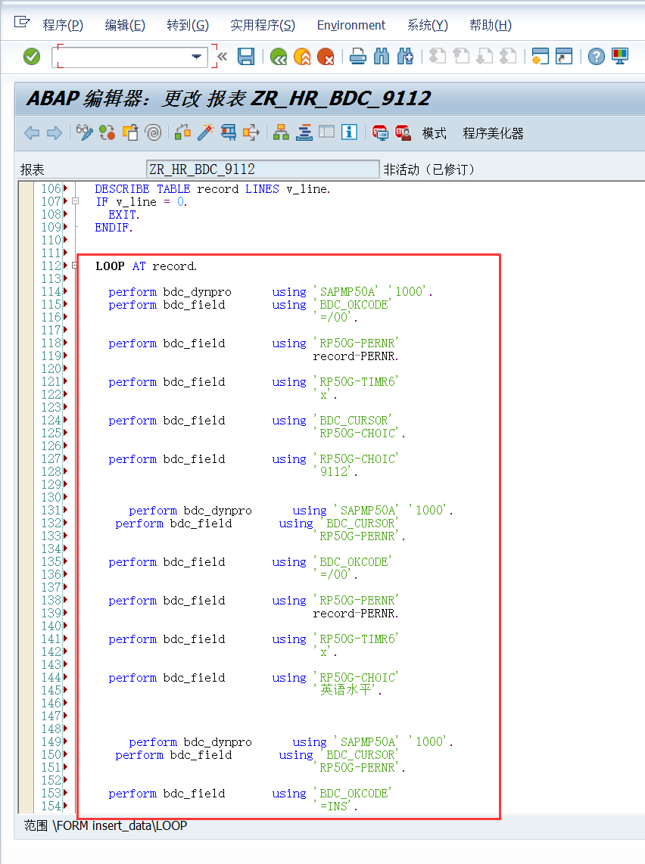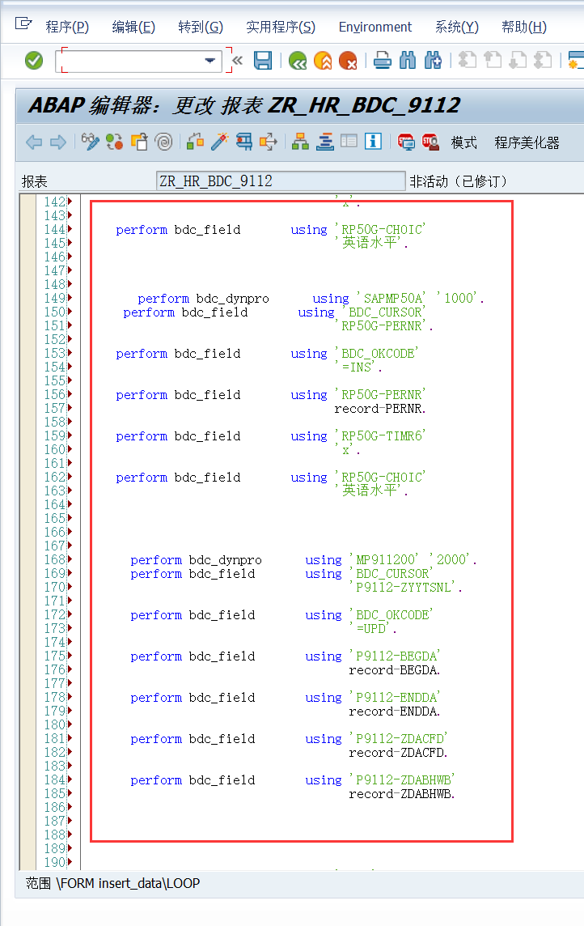

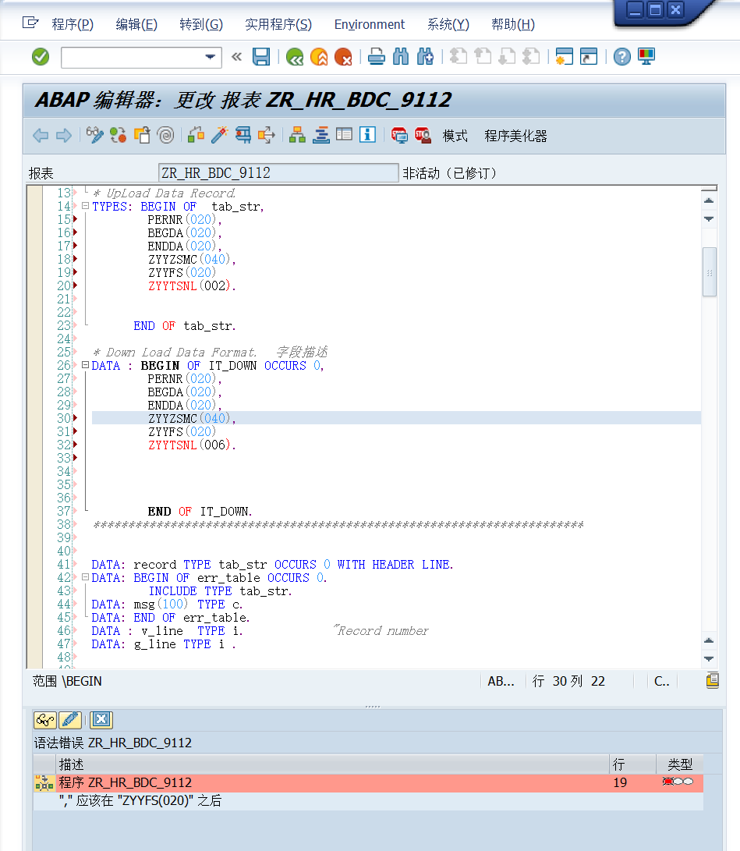

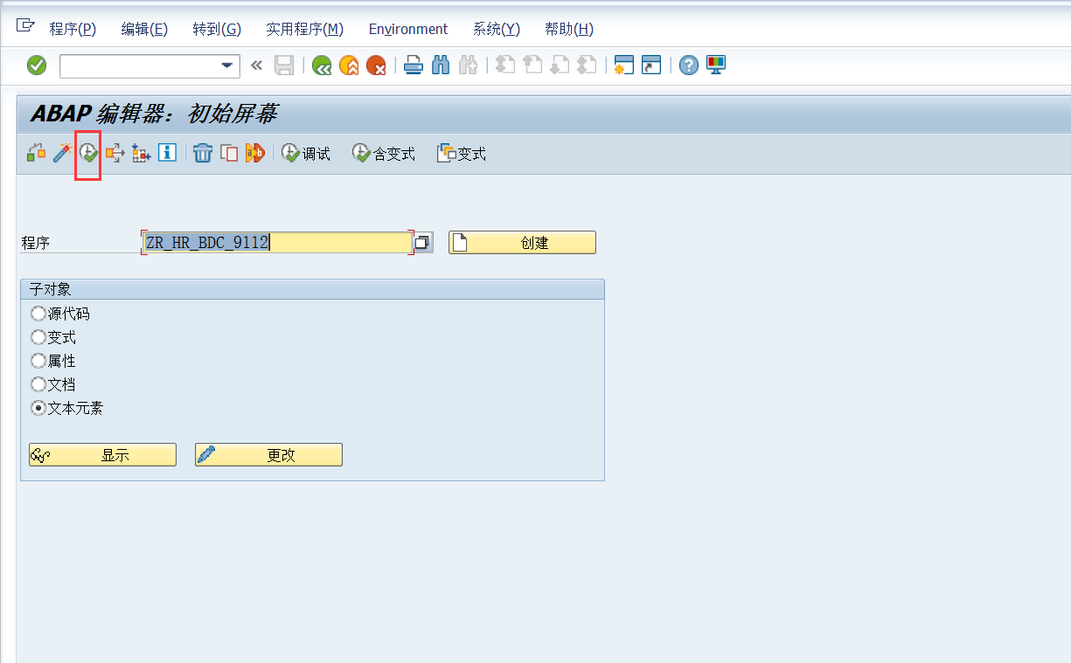

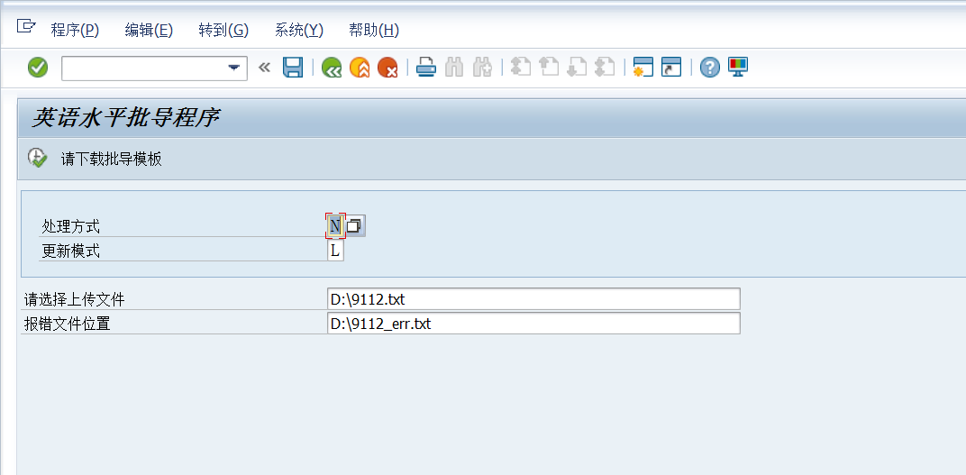

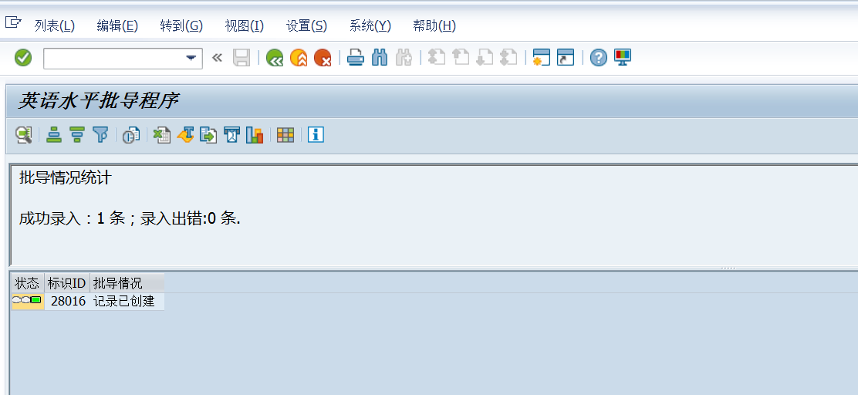

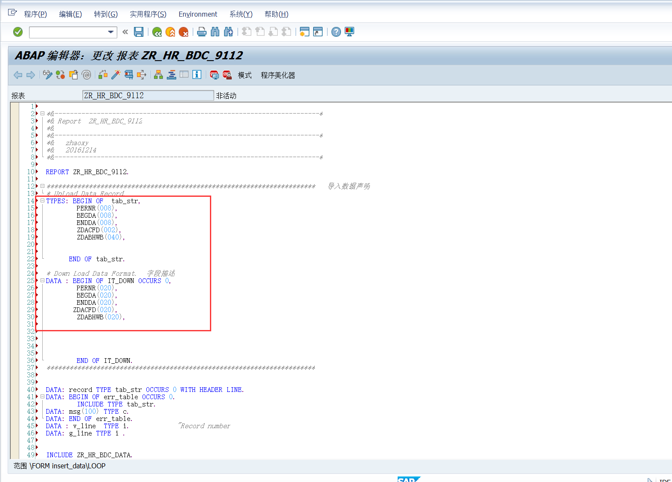

SE93 挂事物码

