目录

1 Table control 1

2 点击弹屏 4

3 Table control 的选择帮助（下拉框选择帮助及自动带出帮助） 6

# 1 Table control

***TABLES:ZCLASS.***

***DATA BEGIN OF ITAB OCCURS 0.***

***DATA:FLAG(1).***

***INCLUDE STRUCTURE ZCLASS.***

***DATA END OF ITAB.***

***SELECTION-SCREEN BEGIN OF BLOCK B1 WITH FRAME TITLE TEXT-001.***

***SELECT-OPTIONS:S FOR zclass-ZCK_BJBM ."NO INTERVALS NO-EXTENSION.***

***SELECTION-SCREEN END OF BLOCK B1.***

***START-OF-SELECTION.***

***SELECT * INTO CORRESPONDING FIELDS OF TABLE ITAB***

***FROM zclass WHERE ZCK_BJBM IN S.***

***END-OF-SELECTION.***

***CALL SCREEN 1001.***

***\*&SPWizard: Data incl. inserted by SP Wizard. DO NOT CHANGE THIS LINE!***

***INCLUDE ZTABLECONTROL_1001 .(最后一个选项自动生成)***

*\*&---------------------------------------------------------------------\**

*\*&      Module  STATUS_1001  OUTPUT*

*\*&---------------------------------------------------------------------\*****以上就是所有程序 然后放开下面程序***

*\*       text*

*\*---------------------------- ------------------------------------------\**

MODULE STATUS_1001 OUTPUT.

SET PF-STATUS 'STATUS_1001'.

*\*  SET TITLEBAR 'xxx'.*

ENDMODULE.                 *" STATUS_1001  OUTPUT*

*\*&---------------------------------------------------------------------\**

*\*&      Module  USER_COMMAND_1001  INPUT*

*\*&---------------------------------------------------------------------\**

*\*       text*

*\*----------------------------------------------------------------------\**

MODULE USER_COMMAND_1001 INPUT.

DATA:ok_1001 like SY-UCOMM.

 ok_1001 = SY-UCOMM.

CASE ok_1001.zhao

WHEN 'EXIT' .

LEAVE TO SCREEN 0.

WHEN 'BACK' .

LEAVE TO SCREEN 0.

WHEN OTHERS.

LEAVE PROGRAM.

ENDCASE.

ENDMODULE.                 *" USER_COMMAND_1001  INPUT*

**双击STATUS(屏幕号)填写按钮。 CALL SCREEN 1001.双击1001，把源程序注释去掉，放出来。**

**隐藏**

**PBO部分**

    CURSOR ZJTZWTXJC_1001-CURRENT_LINE.

    MODULE ZJTZWTXJC_1001_GET_LINES.

    MODULE a_1001.

module a_1001 output.

data: l_col like line of ZJTZWTXJC_1001-cols.  *"生丰配送通知单*

  loop at ZJTZWTXJC_1001-cols into l_col.

    if  l_col-screen-name = 'GT_RETULT-ZINX'  . *"GW_YS_ITEM-SEL 需要隐藏的列名称*

      l_col-invisible = '1' .

      modify ZJTZWTXJC_1001-cols from l_col.  *"ZJTZWTXJC_1001  表控制名字*

    endif.

  endloop.

endmodule.

**自动带出**

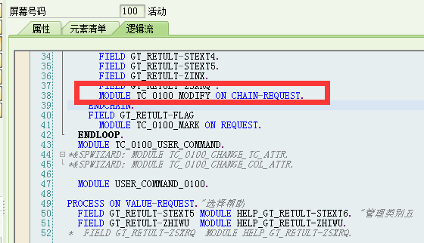

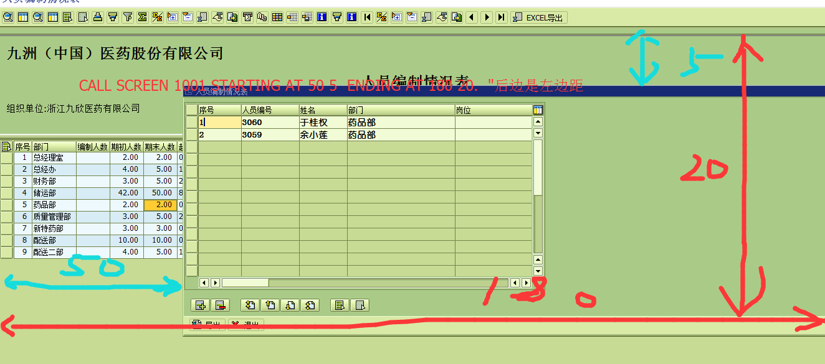

**分配一个功能码 给他**

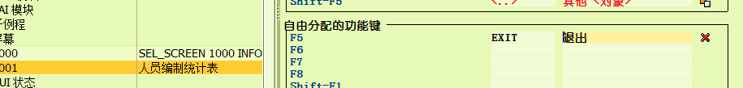

# 2 点击弹屏

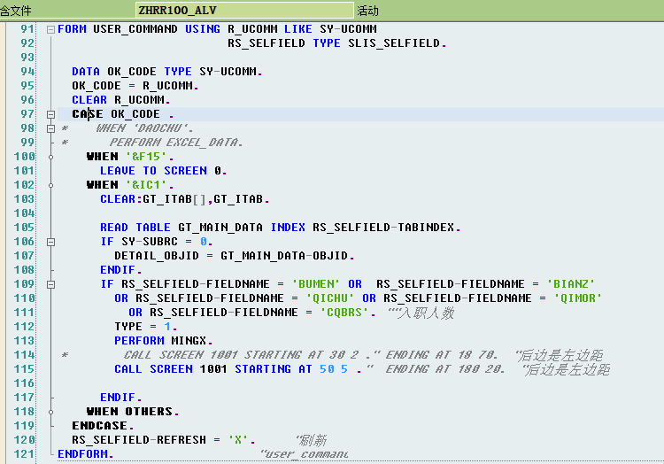

FORM USER_COMMAND USING R_UCOMM LIKE SY-UCOMM

                        RS_SELFIELD TYPE SLIS_SELFIELD.

  DATA OK_CODE TYPE SY-UCOMM.

  OK_CODE = R_UCOMM.

  CLEAR R_UCOMM.

  CASE OK_CODE .

*    WHEN 'DAOCHU'.

*      PERFORM EXCEL_DATA.

    WHEN '&F15'.

      LEAVE TO SCREEN 0.

    WHEN '&IC1'.

      CLEAR:GT_ITAB[],GT_ITAB.

      READ TABLE GT_MAIN_DATA INDEX RS_SELFIELD-TABINDEX.

      IF SY-SUBRC = 0.

        DETAIL_OBJID = GT_MAIN_DATA-OBJID.

      ENDIF.

      IF RS_SELFIELD-FIELDNAME = 'BUMEN' OR  RS_SELFIELD-FIELDNAME = 'BIANZ'

        OR RS_SELFIELD-FIELDNAME = 'QICHU' OR RS_SELFIELD-FIELDNAME = 'QIMOR'

          OR RS_SELFIELD-FIELDNAME = 'CQBRS'. ""入职人数

        TYPE = 1.

        PERFORM MINGX.

*        CALL SCREEN 1001 STARTING AT 30 2 ." ENDING AT 18 70.  "后边是左边距

        CALL SCREEN 1001 STARTING AT 50 5 ."  ENDING AT 180 20.  "后边是左边距

      ENDIF.

    WHEN OTHERS.

  ENDCASE.

  RS_SELFIELD-REFRESH = 'X'.     "刷新

ENDFORM.                    "user_command

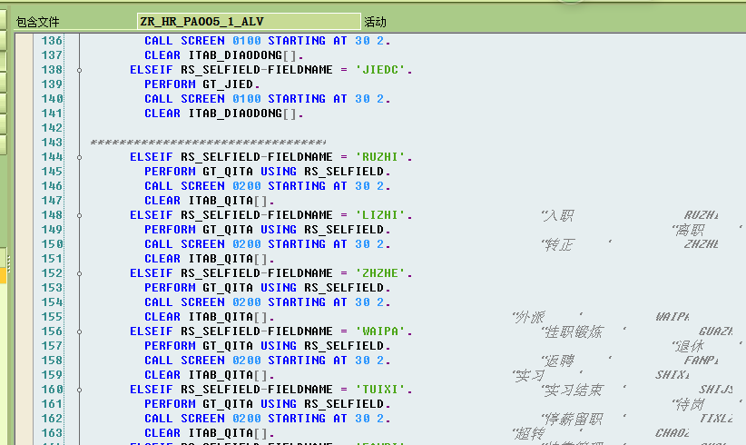

# 3 Table control 的选择帮助（下拉框选择帮助及自动带出帮助）

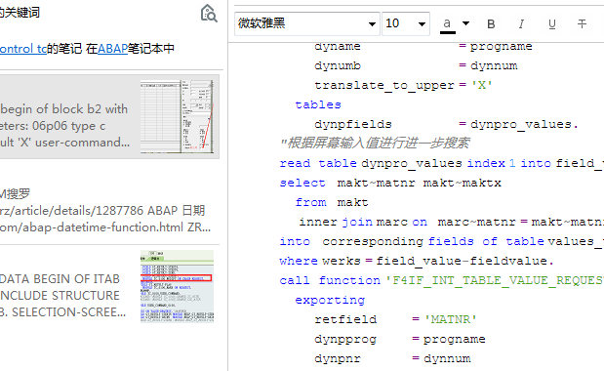

selection-screen begin of block b2 with frame title text-003.

parameters: 06p06 type c radiobutton group g1 default 'X' user-command flag .

parameters: 07p07 type c radiobutton group g1 .

selection-screen end of block b2 .

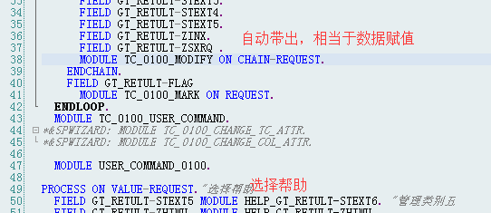

*自动带出选择帮助*

*PAI部分*

FIELD ITAB-ZXUEHAO MODULE HELP ON CHAIN-REQUEST.*"带出其他文本.*

*"屏幕最下方选择帮助*

    PROCESS ON VALUE-REQUEST.

  FIELD itab-ZXUEHAO MODULE FILL_ZXUEHAO.

~~~~~~~~~~~~~~~~~~~~~~~~~~~~~~~~~~~~~~~~~~~~~~~~~~~~~~~~~~~~~

module fill_zxuehao input.

data:it_return_tab like  table of ddshretval with header line .

 DATA : BEGIN OF lt_zstu OCCURS 0,

    ZXUEHAO LIKE zstu-ZXUEHAO,           *"只给学号编码做选择帮助*

    END OF lt_zstu.

SELECT * INTO CORRESPONDING FIELDS OF TABLE lt_zstu FROM zstu.

*\*select single  ZCK_BJBM into  lt_zstu-ZCK_BJBM from zstu where zck_bjbm = itab-zck_bjbm ."or zxuehao = itab-zxuehao.  "选择帮助所有*

  call function 'F4IF_INT_TABLE_VALUE_REQUEST'

    exporting

      retfield    = 'ZXUEHAO'

      dynpprog    = sy-repid

      dynpnr      = sy-dynnr

      dynprofield = 'ZXUEHAO'

      value_org   = 'S'

    tables

      value_tab   = lt_zstu

      return_tab  = it_return_tab.

  if sy-subrc <> 0.

  endif.

endmodule.                 *" FILL_ZXUEHAO  INPUT*

*~~~~~~~~~~~~~~~~~~~~~~~~~~~~~~~~~~~~~~~~~~~~~~~~~~~~~~~~~~~~~*

下拉框选择帮助

form frm_set_dropdownlist .

DATA: lv_name TYPE vrm_id,

          lt_list TYPE vrm_values,

         lw_value LIKE LINE OF lt_list.

  CLEAR: lv_name,lt_list[],lw_value.

  SELECT ZNAME INTO CORRESPONDING FIELDS OF TABLE ITAB1 FROM zstu.

  lv_name = 'ITAB-ZNAME'.  *"内表的字段名*

DATA: num TYPE i.

num = '0'.

LOOP AT ITAB1.

  num = num + 1.

lw_value-text = ITAB1-ZNAME.

   lw_value-key = num .

    APPEND lw_value TO lt_list.

ENDLOOP.

*\*lw_value-KEY = '1' . "这个就是变量P_LIST的值*

*\*lw_value-TEXT = '10' . "这个是text*

*\*APPEND lw_value TO lt_list .*

*\**

*\*lw_value-KEY = '2' .*

*\*lw_value-TEXT = '20' .*

*\*APPEND lw_value TO lt_list .*

*\**

*\*lw_value-KEY = '3' .*

*\*lw_value-TEXT = '30' .*

APPEND lw_value TO lt_list .

  CALL FUNCTION 'VRM_SET_VALUES'

    EXPORTING

      id              = lv_name

       values          = lt_list

     EXCEPTIONS

       id_illegal_name = 1

       OTHERS          = 2.

   IF sy-subrc <> 0.

*\*      * MESSAGE ID SY-MSGID TYPE SY-MSGTY NUMBER SY-MSGNO*

*\*       *         WITH SY-MSGV1 SY-MSGV2 SY-MSGV3 SY-MSGV4.*

  ENDIF.

endform.                    *" FRM_SET_DROPDOWNLIST*

选择帮助

AT SELECTION-SCREEN ON VALUE-REQUEST FOR p_objid.

  PERFORM frm_set_scr USING 'O' 'P_OBJID'.

AT SELECTION-SCREEN ON VALUE-REQUEST FOR s_data-high.

  PERFORM init_s_data-high.

FORM FRM_SET_SCR  USING    U_OTYPE U_FIELDNAME.

  DATA: DYNPFIELDS_UP LIKE DYNPREAD OCCURS 0 WITH HEADER LINE.

  DATA: PROGNAME LIKE SY-REPID.

  DATA: DYNPNUMB LIKE SY-DYNNR."当前屏幕号

  DATA: STEPLOOP LIKE SY-STEPL."返回当前操作的屏幕行号（Table Control）

  DATA : SELF_REPID LIKE SY-REPID .                         *"YNKK100992*

  DATA : SELF_DYNNR LIKE SY-DYNNR .                         *"YNKK100992*

  DATA : F4_OBJEC   LIKE OBJEC.                            *"XMKBCEK002468*

  SELF_REPID = SY-REPID.                                    *"YNKK100992*

  SELF_DYNNR = SY-DYNNR.                                    *"YNKK100992*

  CALL FUNCTION 'RH_OBJID_REQUEST'                       *"XMKBCEK002468*

    EXPORTING

      PLVAR           = '01'

      OTYPE           = U_OTYPE

      DYNPRO_REPID    = SELF_REPID

      DYNPRO_DYNNR    = SELF_DYNNR

*\*     dynpro_plvarfield     = 'PPHDR-PLVAR'*

*\*     dynpro_searkfield     = 'S_EOBJ-LOW'*

    IMPORTING

      SEL_OBJECT      = F4_OBJEC

    EXCEPTIONS

      CANCELLED       = 1

      WRONG_CONDITION = 2

      NOTHING_FOUND   = 3

      ILLEGAL_MODE    = 4

      INTERNAL_ERROR  = 5

      OTHERS          = 6.

  CHECK F4_OBJEC-OBJID IS NOT INITIAL.

*\*  get actual position*

  CALL FUNCTION 'DYNP_GET_STEPL'

    IMPORTING

      POVSTEPL = STEPLOOP.

  REFRESH DYNPFIELDS_UP.

  DYNPFIELDS_UP-STEPL     = STEPLOOP.

  DYNPFIELDS_UP-FIELDNAME = U_FIELDNAME.

  DYNPFIELDS_UP-FIELDVALUE = F4_OBJEC-OBJID.

  APPEND DYNPFIELDS_UP.

*\*  update table control*

  CALL FUNCTION 'DYNP_VALUES_UPDATE'

    EXPORTING

      DYNAME               = PROGNAME

      DYNUMB               = DYNPNUMB

    TABLES

      DYNPFIELDS           = DYNPFIELDS_UP

    EXCEPTIONS

      INVALID_ABAPWORKAREA = 1

      INVALID_DYNPROFIELD  = 2

      INVALID_DYNPRONAME   = 3

      INVALID_DYNPRONUMMER = 4

      INVALID_REQUEST      = 5

      NO_FIELDDESCRIPTION  = 6

      UNDEFIND_ERROR       = 7

      OTHERS               = 8.

ENDFORM.

FORM INIT_S_DATA-HIGH .

  S_DATA-HIGH = SY-DATUM+0(6).

  CALL FUNCTION 'POPUP_TO_SELECT_MONTH'

    EXPORTING

      ACTUAL_MONTH   = S_DATA-HIGH

      LANGUAGE       = SY-LANGU

      START_COLUMN   = 8

      START_ROW      = 5

    IMPORTING

      SELECTED_MONTH = S_DATA-HIGH.

ENDFORM.

selection-screen begin of block b1 with frame title text-001.

parameters:  p_matnr type  matnr.

selection-screen end of block b1.

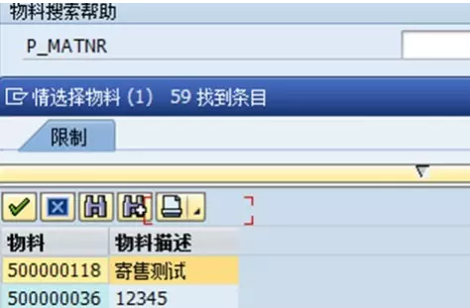

at selection-screen on value-request for p_matnr.

  perform frm_f4.

form frm_f4.

  types: begin of values,

         matnr type matnr,

         maktx type maktx,

       end of values.

  data: values_tab       type table of values.

  select  matnr maktx

    from  makt

  into table values_tab.

  call function 'F4IF_INT_TABLE_VALUE_REQUEST'

    exporting

      retfield     = 'MATNR'                    *"需要回传的字段*

      dynpprog     = sy-repid

      dynpnr       = sy-dynnr

      dynprofield  = 'MAKTX'                    *"需要显示的字段*

      window_title = '情选择物料 '

      value_org    = 'S'

    tables

      value_tab    = values_tab.

endform.                    *"frm_f4*

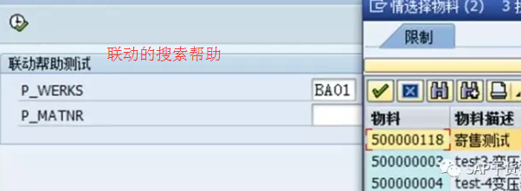

selection-screen begin of block b1 with frame title text-001.

parameters: p_werks type  werks_d,

            p_matnr type  matnr.

selection-screen end of block b1.

start-of-selection.

at selection-screen on value-request for p_matnr.

  perform frm_f4.

*\*&-------------------------------------------------------------------*

*\*&搜索帮助*

*\*&-------------------------------------------------------------------*

form frm_f4.

  types: begin of values,

         matnr type matnr,

         maktx type maktx,

       end of values.

  data: progname         type sy-repid,

        dynnum           type sy-dynnr,

        dynpro_values    type table of dynpread,

        field_value      like line of dynpro_values,

        values_tab       type table of values.

  progname = sy-repid.

  dynnum   = sy-dynnr.

  clear: field_value, dynpro_values.

*"指定需要取值的屏幕字段*

  field_value-fieldname = 'P_WERKS'.      *"*

  append field_value to dynpro_values.

*"获取屏幕 P_WERKS 字段的值*

  call function 'DYNP_VALUES_READ'

    exporting

      dyname             = progname

      dynumb             = dynnum

      translate_to_upper = 'X'

    tables

      dynpfields         = dynpro_values.

*"根据屏幕输入值进行进一步搜索*

  read table dynpro_values index 1 into field_value.

  select  makt~matnr makt~maktx

    from  makt

    inner join marc on  marc~matnr = makt~matnr

  into  corresponding fields of table values_tab

  where werks = field_value-fieldvalue.

  call function 'F4IF_INT_TABLE_VALUE_REQUEST'

    exporting

      retfield     = 'MATNR'                    *"需要回传的字段*

      dynpprog     = progname

      dynpnr       = dynnum

      dynprofield  = 'MAKTX'                    *"需要显示的字段*

      window_title = '情选择物料 '

      value_org    = 'S'

    tables

      value_tab    = values_tab.

endform.                    *"frm_f4*

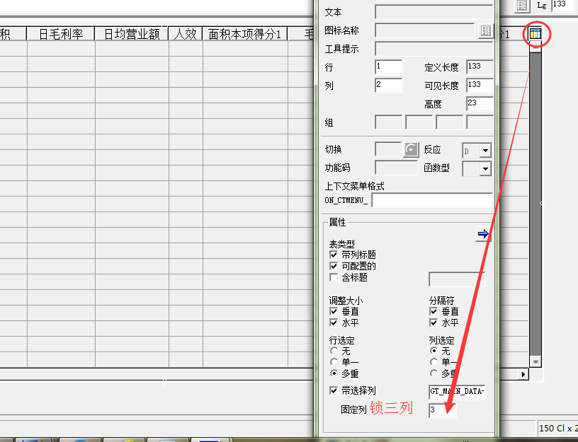

插入列 ：从最后一列复制完以后，点击文本下方，拖至所要插入的列

列锁定：

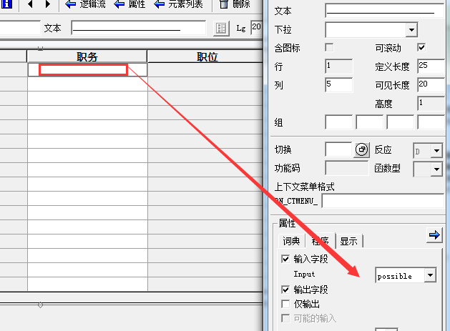

 比如：（用char类型） 0.00显示不出来  0008871 显示不出来

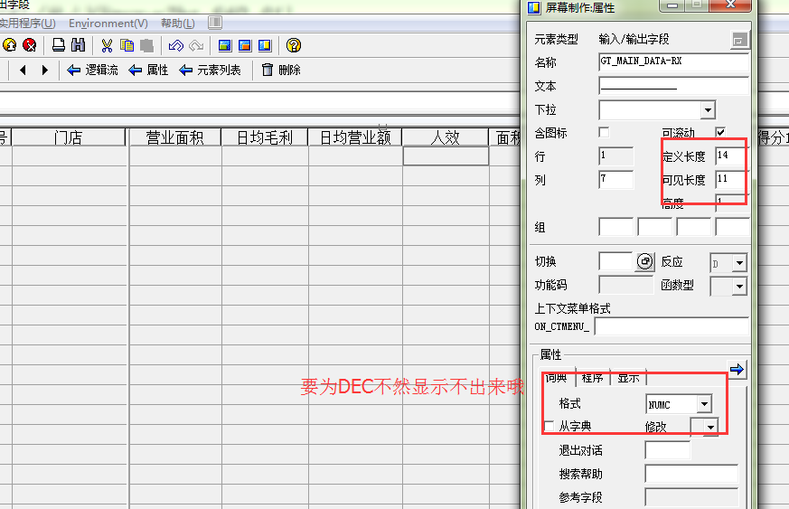

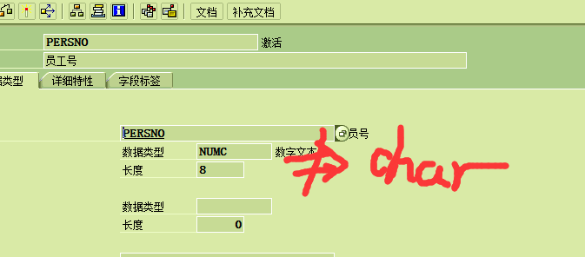

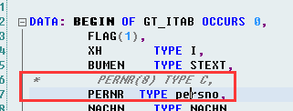

char 接不过去 numc 类型

