selection-screen begin of block b3 with frame title text-003.
parameters:p_tongji type c radiobutton group g1 default 'X' user-command flag.
parameters:p_mingxi type c radiobutton group g1 .

selection-screen begin of line.

selection-screen position 1.
parameters:p_mxall type c radiobutton group g2 default 'X'.
selection-screen comment (8) text034 for field p_mxall.
"全部显示

selection-screen position 31.
parameters:p_mxyou type c radiobutton group g2.
selection-screen comment (10) text035 for field p_mxyou.
"仅显示数据不完整人员

selection-screen position 62.
parameters:p_mxwu type c radiobutton group g2.
selection-screen comment (10) text036 for field p_mxwu.
"仅显示数据完整人员
selection-screen end of line.

selection-screen end of block b3.
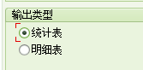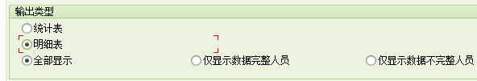
selection-screen begin of block b2 with frame title text-002.

parameters: 01p01 type c as checkbox." DEFAULT 'X'.

selection-screen end of block b2 .
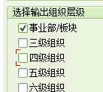
selection-screen begin of block b1 with frame title text-001.
parameters:p_objid like hrp1000-objid obligatory.
parameters:p_date like sy-datum default sy-datum.
selection-screen end of block b1.
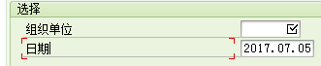

选择屏幕写页签：
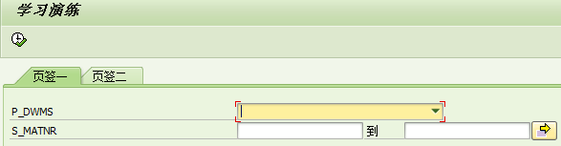
tables:mara.
selection-screen begin of screen 0100 as subscreen .
parameters:
p_dwms type char1 as listbox visible length 30,
p_dwm type string no-display.
select-options:
s_matnr for mara-matnr .

selection-screen end of screen 0100.

selection-screen begin of screen 0300 as subscreen.
parameters: rb_down radiobutton group rad1, "下载模版
rb_up radiobutton group rad1, "导入数据
p_file like rlgrap-filename. "文件路径

selection-screen end of screen 0300.

selection-screen begin of tabbed block mytab for 4 lines."子屏幕的行数
selection-screen tab (6) text1 user-command but1.
selection-screen tab (10) text2 user-command but2.
selection-screen end of block mytab.

*----------------------------------------------------------------------*
* INITIALIZATION
*----------------------------------------------------------------------*

initialization . "给标签赋值
perform frm_init.

*----------------------------------------------------------------------*
* AT SELECTION-SCREEN.
*----------------------------------------------------------------------*
at selection-screen.
case sy-dynnr.
when 1000.
case sy-ucomm.
when 'BUT1'. " 'BUT1'
mytab-dynnr = 0100.
when 'BUT2'. " 'BUT2'
mytab-dynnr = 0300.
when others.
endcase.
endcase.

*----------------------------------------------------------------------*
* 事件处理
*----------------------------------------------------------------------*

start-of-selection.
case mytab-dynnr.
when 0100.
message '1' type 'I'.
when 0300. "300屏幕的操作
data: lv_subscreen type string .
"ABAP memory是为了能控制返回时返回到哪个页签
lv_subscreen = '0300'.
export lv_subscreen to memory id 'M1'.
message '2' type 'I'.
endcase.

form frm_init .
data: lv_subscreen type string .

text1 = '页签一'.
text2 = '页签二'.

import lv_subscreen from memory id 'M1' . "读取内存，获取当前处理页签

data(v_dynnr) = lv_subscreen.

mytab-prog = sy-repid.

if v_dynnr = space.
mytab-dynnr = 0100.
mytab-activetab = 'BUT1'. " 'BUT1'
else.
mytab-dynnr = v_dynnr.

if v_dynnr = 0300 .
mytab-activetab = 'BUT2'. "'BUT2'
endif.
endif.
endform. " FRM_INIT

pushButton，选择屏幕中定义按钮

其实也很简单，用的是pushbutton
代码如下

参考代码
tables sscrfields.
selection-screen:
pushbutton 2(10) but1 user-command cli1,
pushbutton 20(30) but2 user-command cli2 visible length 10.

initialization.

but1 = '预览'.

call function 'ICON_CREATE'
exporting
name = icon_print
text = '打印'
info = 'liumeng test'
* ADD_STDINF = 'X'
importing
result = but2
exceptions
icon_not_found = 1
outputfield_too_short = 2
others = 3.
if sy-subrc <> 0.
* Implement suitable error handling here
endif.

at selection-screen.
case sscrfields.
when 'CLI1'.
when 'CLI12'.
when others.
endcase.
选择屏幕动态显示 BLOCK TITLE
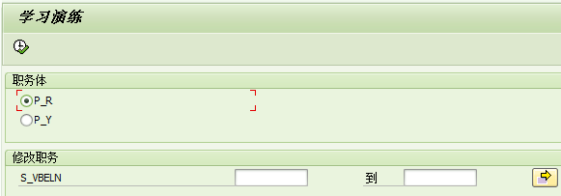
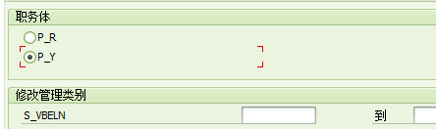
tables vbak.
selection-screen begin of block b1 with frame title text-001.
parameters p_r radiobutton group g1 user-command select default 'X'. "日模式
parameters p_y radiobutton group g1 . "月模式
selection-screen end of block b1.

selection-screen begin of block b2 with frame title t1.
select-options:
s_VBELN for vbak-VBELN . " 公司代码
selection-screen end of block b2.

at selection-screen output .
if p_r is not initial.
t1 = '修改职务'.
else.
t1 = '修改管理类别'.
endif.

组织选择帮助

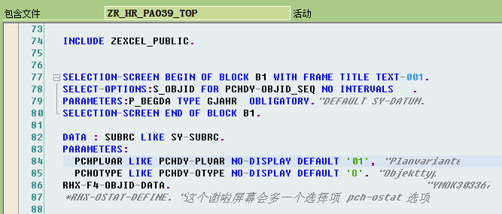
SELECT-OPTIONS:S_OBJID FOR PCHDY-OBJID_SEQ NO INTERVALS .

DATA : SUBRC LIKE SY-SUBRC.
PARAMETERS:
PCHPLVAR LIKE PCHDY-PLVAR NO-DISPLAY DEFAULT '01', "Planvariante
PCHOTYPE LIKE PCHDY-OTYPE NO-DISPLAY DEFAULT 'O'. "Objekttyp
RHX-F4-OBJID-DATA. "YMOK303367
*RHX-OSTAT-DEFINE. "这个谢啦屏幕会多一个选择项 pch-ostat 选项
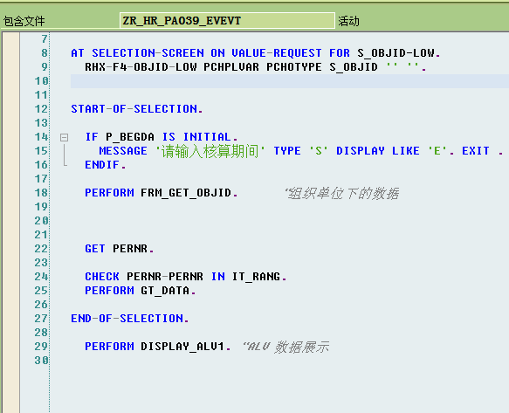

AT SELECTION-SCREEN ON VALUE-REQUEST FOR S_OBJID-LOW.
RHX-F4-OBJID-LOW PCHPLVAR PCHOTYPE S_OBJID '' ''.

组织单位：
DATA : SUBRC LIKE SY-SUBRC.
PARAMETERS:
PCHPLVAR LIKE PCHDY-PLVAR NO-DISPLAY DEFAULT '01', "Planvariante
PCHOTYPE LIKE PCHDY-OTYPE NO-DISPLAY DEFAULT 'O'. "Objekttyp
RHX-F4-OBJID-DATA. "YMOK303367
RHX-OSTAT-DEFINE.
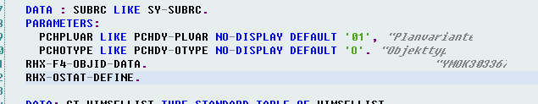

AT SELECTION-SCREEN ON VALUE-REQUEST FOR S_OBJID-LOW.
RHX-F4-OBJID-LOW PCHPLVAR PCHOTYPE S_OBJID '' ''.
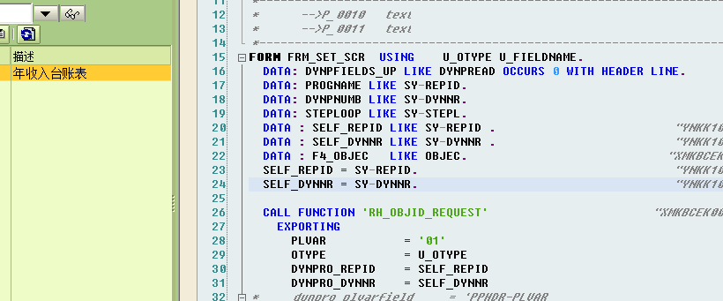

FORM FRM_SET_SCR USING U_OTYPE U_FIELDNAME.
DATA: DYNPFIELDS_UP LIKE DYNPREAD OCCURS 0 WITH HEADER LINE.
DATA: PROGNAME LIKE SY-REPID.
DATA: DYNPNUMB LIKE SY-DYNNR.
DATA: STEPLOOP LIKE SY-STEPL.
DATA : SELF_REPID LIKE SY-REPID . "YNKK100992
DATA : SELF_DYNNR LIKE SY-DYNNR . "YNKK100992
DATA : F4_OBJEC LIKE OBJEC. "XMKBCEK002468
SELF_REPID = SY-REPID. "YNKK100992
SELF_DYNNR = SY-DYNNR. "YNKK100992

CALL FUNCTION 'RH_OBJID_REQUEST' "XMKBCEK002468
EXPORTING
PLVAR = '01'
OTYPE = U_OTYPE
DYNPRO_REPID = SELF_REPID
DYNPRO_DYNNR = SELF_DYNNR
* dynpro_plvarfield = 'PPHDR-PLVAR'
* dynpro_searkfield = 'S_EOBJ-LOW'
IMPORTING
SEL_OBJECT = F4_OBJEC
EXCEPTIONS
CANCELLED = 1
WRONG_CONDITION = 2
NOTHING_FOUND = 3
ILLEGAL_MODE = 4
INTERNAL_ERROR = 5
OTHERS = 6.
CHECK F4_OBJEC-OBJID IS NOT INITIAL.
* get actual position
CALL FUNCTION 'DYNP_GET_STEPL'
IMPORTING
POVSTEPL = STEPLOOP.
REFRESH DYNPFIELDS_UP.
DYNPFIELDS_UP-STEPL = STEPLOOP.
DYNPFIELDS_UP-FIELDNAME = U_FIELDNAME.
DYNPFIELDS_UP-FIELDVALUE = F4_OBJEC-OBJID.
APPEND DYNPFIELDS_UP.

* update table control
CALL FUNCTION 'DYNP_VALUES_UPDATE'
EXPORTING
DYNAME = PROGNAME
DYNUMB = DYNPNUMB
TABLES
DYNPFIELDS = DYNPFIELDS_UP
EXCEPTIONS
INVALID_ABAPWORKAREA = 1
INVALID_DYNPROFIELD = 2
INVALID_DYNPRONAME = 3
INVALID_DYNPRONUMMER = 4
INVALID_REQUEST = 5
NO_FIELDDESCRIPTION = 6
UNDEFIND_ERROR = 7
OTHERS = 8.
ENDFORM. "FRM_SET_SCR

