|  |
| --- |
| Global Name Registry Software Requirement Specification |
| [Type the document subtitle] |
|  |
| **GROUP 10** |
| **[Pick the date]** |

|  |
| --- |
| [Type the abstract of the document here. The abstract is typically a short summary of the contents of the document. Type the abstract of the document here. The abstract is typically a short summary of the contents of the document.] |

Contents

Contents 2

1 Introduction 3

1.1 Purpose 3

1.2 Scope 3

1.3 Product / System Overview 3

1.4 User Characteristics 3

1.5 Definitions, Acronyms & Abbreviations 3

1.6 Constraints 4

1.7 Assumptions and Dependencies 4

1.8 References 4

2 Functional Requirements 5

3 Non-Functional Requirements 5

3.1 Performance Requirements 5

3.2 Security Requirements 5

3.3 Software System Attributes 6

4 External Interface Requirements 6

4.1 User Interfaces 6

4.2 Hardware Interfaces 6

4.3 Software Interfaces 7

4.4 Communication Interfaces 7

# Introduction

## Purpose

This document details the software requirements for the Global Name Registry project. It defines what the problem is and what problems a complete solution has to solve. The intended audiences for this document are the development team, the team manager, the customer and all other stakeholders in the system.

## Scope

The Global Name Registry is a website that connects names to other names, forming a network of names that highlights relationships between people, places and things. It enables users to instantly look up and view information on names of people, things, places, etc.

## Product / System Overview

Global Name Registry project allows users to search for a registered name and find its associated names. It encourages to register names of various parties and add associations between those registered names. The association can be given a name and must be authorized by all parties being linked. Thus, the system in effect tracks and serves information about relations between individuals.

## User Characteristics

The typical user will be a person, from the age of 18 and up. There will more than likely be a fairly equal distribution of males and females. The typical customer will probably use the online service, a couple of times a week. The typical customer might not know anything about computers, so their system needs to be very simple and easy to use. The typically customer will probably be a busy person; therefore, they will need to perform actions as quickly and efficiently as possible. Due to this frequency of usage, stability and speed of this software is very important.

## Constraints

The information of all the users must be stored in a database that is accessible by the Online System. TheGlobal Name Registry is connected and is running all 24 hours a day. The users access the Online System from any computer that has Internet browsing capabilities and an Internet connection. The users must have their correct usernames and passwords to log in. The project is safety critical. Under no circumstances shall a user of the system be harmed or harm others through proper or improper use of the online.

## Assumptions and Dependencies

Embedded real-time environment, or compatible, available on platform if the client changes or upgrades their office system, the Global Name Registry will not be guaranteed to function unless the new operating system is fully compatible with the current system as described in section 3 of this document. All timings stated in this SRS shall be adhered to within +/- 10% all requirements are addressed in this version of the Global Name Registry. No requirements are delayed to future versions.

The various number of users and services on the Global Name Registry include

* Power System
* User System/Servers
* Communication Medium (Wired/Wireless)
* Internet Connection

## References

* Software Requirement Specification (SRS): http://se.uwaterloo.ca/dberry/ATRE/srs.pdf
* Wikipedia, the Free Encyclopedia: <http://en.wikipedia.org/>

# Functional Requirements

**2.1 Functions Used**

The internalfunctions of the Global Name Registry are relative to the various users which contain independent access units in each, and one master control of admin. These functionsare described below:

**2.1.1 Functions for admin/customer**

1) Login – Admin and customer has the option to login to the database any time.  
2) Account Overview – Admin has the option to see an overview view of all the accounts.Customer has the option to view his/her respective accounts.

**2.1.2 Functions for admin**

1)Sanction a new account – Admin has the authority to sanction a new account request from the customer.

2)Create/Reset password – Admin has the final authority to reset a customer’s password.

3)Block Accounts- Admin has the power to block accounts.

4)Approve Link Request- Admin approves the Link Requests submitted by a customer.

**2.1.2 Functions for customer**

1)View Account – Customer has the option to view the customer information, registered names.

2)Search– Customer has the option to search for a name.

3)View Details – Has the option to view details of selected name.

4)Authentication – Has the option to submit or approve link requests

5)Add/Edit – Customer can add or edit names and link at will.

6)Reporting – Can report grievances easily.

7)Privacy Settings – Can adjust how much information is publicly available

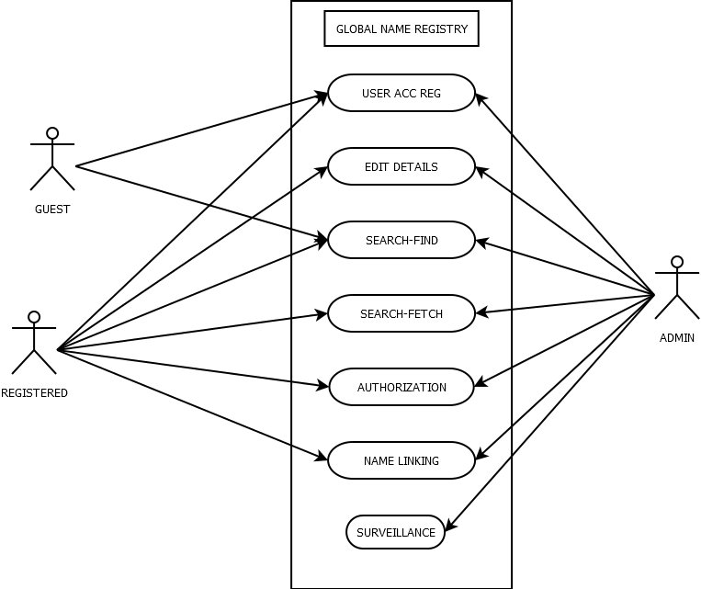

# Non-Functional Requirements

## Performance Requirements

The Global Name Registry shall be built upon an internet connection of server. The processor must be capable of handling real-time functionality activated by the defined users and communication medium. In addition, the system must be safety-critical. All failures reported by the communication medium must be handled instantaneously to allow for user and system safety.

The software shall control n-user in a building with m-services. The maximum number of commands the software shall handle is (m*n) +2*(m-1) +n, where m is the number of services and n is the number of users. The software shall have a communication time variable of x seconds, based on signal or web based inputs, which if exceeded, the software shall recognize an error and take corrective action

## Security Requirements

There shall be no security mechanisms in place to keep unwanted users out of the system. However, all users of the system shall not be able to perform actions or request actions, which will cause harm to any person or damage to the system or its environment.

# External Interface Requirements

## User Interfaces

The User Interface defines the human-computer interaction of the Global Name Registry. The system requires interaction from various users:

• The standard existing users interact with the online interface while searching for information.

• The existing user interacts with the system to add/editregistrations and links, or authenticate link requests.

• The new user interacts with the system to register.

• The Administrator interacts with the system within the master control unit. These people are given special preference privileges (usually reserved for maintenance crew or building databases) and manage all type of users.

## Hardware Interfaces

The software shall interface with the electromechanical that controls the online connection systems. The software shall interface with a breaking mechanism in case of emergencies. The transactions and accesses shall be controlled by the software based on command and graphical user inputs. The hardware interface is supported by the main control panels (buttons, keyboard, mouse and communication mediums).

## Software Interfaces

Software interface is supported by the main control panels and operating system in which hosts the algorithms for calculating distributed travel and wait time information. Additionally, the algorithms define and export system commands for main control panels, and communication mediums. For testing purposes, the software shall be capable of interfacing with software simulators on a PC computer using GUI applications of webpages.