Scrcpy Monitor
How-to Guide for macOS and Linux
Author: Charles Manalo
Applies to version 5.0.1.12 and later
https://github.com/cktmanalo/scrcpy

1. Overview
Scrcpy Monitor mirrors one or more Android devices connected over USB or Wi-Fi/TCP, each in its own window, and records their screens. It is built on scrcpy by Genymobile. On macOS it runs from the menu bar (it has no Dock icon); on Linux it runs from the system tray. It has the same features as the Windows version, which has its own guide.
- One window per device. Every connected device is mirrored automatically, including devices connected after the monitor started. The Connection column shows whether each device uses USB or Wi-Fi.
- Survives device restarts. When a device restarts or drops off Wi-Fi, its window stays open and mirroring resumes in the same window when the device is back. A device that is turned off, unplugged or closed is removed from the list.
- Wi-Fi devices. Find devices on the local network with Refresh, connect one by IP address and port, disconnect and reconnect it. Wi-Fi devices are remembered and reconnected automatically.
- USB or Wi-Fi. Switch a device between USB and Wi-Fi with one click. A device connected over both is mirrored over USB, with Wi-Fi kept on standby.
- Screen recording. Start and stop recording per device or for all devices from the device window, the control panel or the menu bar/tray icon. A recording continues across device restarts and is saved as a single MP4.
- Combined recording. Record several devices at once and get one side-by-side video of all of them, in addition to each device's own recording.
- Self-updating. The monitor checks GitHub Releases for a newer version and updates itself.

Version number
The version is shown in the control panel title and in About, for example 5.0.1.11: the first three numbers are the scrcpy release the monitor is built on (5.0.1) and the last number is the Scrcpy Monitor build number (11). Include this version when you report a problem.

2. Requirements
 | macOS | Linux
Computer | Mac with Apple silicon (M1 or later) or Intel | 64-bit x86 PC (x86_64) with a desktop session
System | A recent macOS version | Ubuntu 22.04 or newer, or a distribution of similar age
Package | scrcpy-monitor-macos-arm64-<version>.zip (Apple silicon)  scrcpy-monitor-macos-x86_64-<version>.zip (Intel) | scrcpy-monitor-linux-x86_64-<version>.tar.gz
Included | scrcpy, scrcpy-server, adb | scrcpy, scrcpy-server, adb
Install separately | ffmpeg (see below) | ffmpeg (see below)

- Android device with Developer options > USB debugging enabled. Audio is recorded on Android 11 and later; older devices are recorded without audio.
- For Wi-Fi/TCP: the computer and the device on the same network.
- To find out which Mac you have: Apple menu > About This Mac. "Chip: Apple M..." means Apple silicon; "Processor: Intel" means Intel.

ffmpeg
ffmpeg is not included in the macOS and Linux packages. Install it once; the monitor finds it automatically. It is needed to join the parts of a recording that continued across a device restart into one MP4, and for Record combined.
macOS (Homebrew, https://brew.sh): brew install ffmpeg
Ubuntu / Debian: sudo apt install ffmpeg
Fedora: sudo dnf install ffmpeg

Note: Without ffmpeg, recording still works, but a recording that was interrupted by a restart is saved as separate part files, recordings have no device name header, and Record combined is skipped with a notification.

3. Installation

macOS
1. Download the ZIP for your Mac from the Releases page (https://github.com/cktmanalo/scrcpy/releases).
2. Double-click the ZIP to extract "Scrcpy Monitor.app" and drag it into the Applications folder.
3. The app is not signed by Apple, so macOS blocks it the first time. Open Terminal and run the command below once, or right-click the app in Applications, choose Open, and confirm Open.
xattr -dr com.apple.quarantine "/Applications/Scrcpy Monitor.app"

- Start Scrcpy Monitor from Applications or Launchpad. Its icon appears in the menu bar at the top right of the screen, and the control panel opens.
- If macOS asks for permission (for example to access the Movies folder for recordings), allow it.

Linux
1. Download scrcpy-monitor-linux-x86_64-<version>.tar.gz from the Releases page.
2. Open a terminal in the download folder, then extract and install:
tar -xzf scrcpy-monitor-linux-x86_64-*.tar.gz
./scrcpy-monitor/install.sh

- install.sh copies the app to ~/.local/opt/scrcpy-monitor and adds "Scrcpy Monitor" to the applications menu. No administrator rights are needed.
- Start Scrcpy Monitor from the applications menu, or run ~/.local/opt/scrcpy-monitor/scrcpy-monitor.
- To remove it, run ~/.local/opt/scrcpy-monitor/install.sh --uninstall. Settings and recordings are kept.
- For USB devices, Linux needs udev rules for Android. On Ubuntu/Debian install them with: sudo apt install android-sdk-platform-tools-common, then unplug and replug the device.
Note: Some desktops have no system tray, for example GNOME without the AppIndicator extension. There the control panel opens at startup. On GNOME, installing the "AppIndicator and KStatusNotifierItem Support" extension adds the tray icon.

4. Connecting devices

USB
1. On the device: Settings > About > tap Build number 7 times to enable Developer options.
2. Settings > Developer options > enable USB debugging.
3. Connect the device with a USB cable and allow the "Allow USB debugging?" prompt on the device (select "Always allow from this computer").
4. The device appears in the control panel and its window opens.
Note: Until the prompt is allowed, the device shows as "unauthorized". Recording starts only after it is allowed.

Wi-Fi
A device must have adb over TCP enabled. Connect it by USB once, then run the bundled adb with "tcpip 5555" (the commands below), unplug it, and connect it over Wi-Fi:
macOS: "/Applications/Scrcpy Monitor.app/Contents/Resources/bin/adb" tcpip 5555
Linux: ~/.local/opt/scrcpy-monitor/bin/adb tcpip 5555

- Connect Wi-Fi device... enter the device IP address and port (for example 192.168.1.20:5555). Any port works, and ports that work are remembered for Refresh. If the connection fails, a message shows the reason with a Retry button.
- Refresh looks for devices on the local network (ports 5555, 5037 and any port you connected with) and connects them automatically. The monitor also scans by itself from time to time.
- Disconnect disconnects a Wi-Fi device and closes its window; Reconnect connects it again.

5. Control panel
The control panel lists every device and is where most actions are done. Open it from the menu bar/tray icon (Show control panel). Closing it exits the monitor, the same as Exit: recordings are saved and every device window is closed. Select several rows with Shift or Cmd/Ctrl to act on several devices at once. Click a column header to sort the list by that column; click it again to reverse the order (the arrow in the header shows the direction).
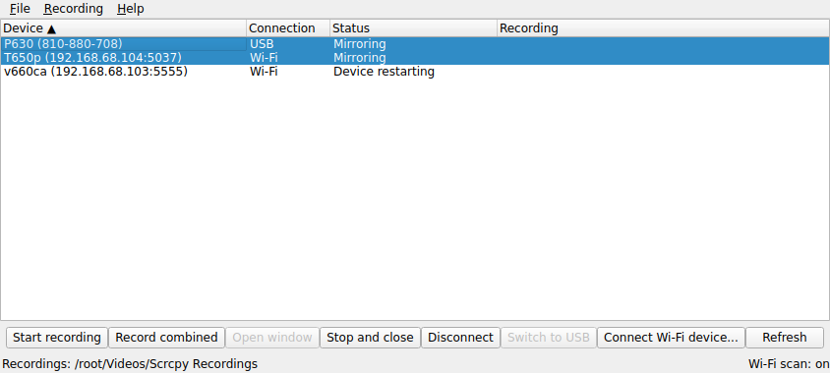
Figure 1 - Control panel on Linux with two devices selected
Column | Meaning
Device | Device model and serial (USB serial or IP:port).
Connection | USB or Wi-Fi.
Status | Mirroring, Waiting for device, Device restarting, Shutting down, Unauthorized, Standby (Wi-Fi kept while USB is used), Disconnected.
Recording | REC and the elapsed time while recording; REC combined for a combined recording.

Button | What it does
Start recording / Stop recording | Starts or stops recording the selected devices.
Record combined | Records the selected devices (two or more) and joins them into one video. See section 7.
Open window / Reconnect | Reopens a device window, or reconnects a disconnected Wi-Fi device.
Stop and close | Stops the recording of the selected devices (you are asked first), closes their windows and removes them from the list. Refresh shows them again.
Disconnect | Disconnects the selected Wi-Fi devices.
Switch to USB / Switch to Wi-Fi | Moves the selected device to the other connection. See section 8.
Connect Wi-Fi device... | Connects a device by IP address and port.
Refresh | Shows closed devices again and looks for Wi-Fi devices on the local network now.

The other actions are in the control panel menus (on macOS, in the menu bar at the top of the screen while the control panel is active):
Menu | Items
File | Open recordings folder (in Finder or the file manager); Change recordings folder...; Open log (useful when reporting a problem); Exit (stops and saves all recordings, closes all device windows and quits).
Recording | Start all / Stop all: starts or stops recording on every open device.
Window | Arrange windows (puts the device windows back in their places; see below).
Help | User guide (shows this guide in a window of the monitor; links to web pages open in your browser); Check for updates; Check for updates automatically (on or off, see section 9); About.

On macOS, About and Exit appear in the Scrcpy Monitor application menu (as "About" and "Quit") instead of the Help and File menus.

When a device is removed from the list
- A restarting device stays in the list as "Device restarting" and its window reconnects when it is back (removed if it is not back within 5 minutes).
- A device that is turned off is removed right away; one that is unplugged or drops off Wi-Fi is removed after 30 seconds. A device that is recording is not removed: its recording waits for the device and continues if it comes back. Stop recording to save it; the device is then removed.
- Closing a device window or clicking Stop and close removes the device. Click Refresh to show it again; a device that comes back by itself reappears automatically.
Note: A restart started with "adb reboot" is not detected as a restart, so the device is removed after 30 seconds and reappears when it is back. Restarting from the device power menu is detected.

Where device windows open
Device windows are arranged on the screen where the control panel is (the main screen when the panel is closed). One device is centered; several devices are placed side by side, or in rows, around the center without overlapping. A window shows the device at full resolution (100%) when it fits; a larger device screen is scaled down to fit and is never cropped. The windows are arranged again whenever a device window opens or closes. Minimized, maximized and fullscreen windows are left in place. After moving windows yourself, click Window > Arrange windows in the control panel (or Arrange device windows in the menu bar/tray menu) to put them back.
Note: macOS: allow Scrcpy Monitor in System Settings > Privacy & Security > Accessibility so it can move the device windows. Until it is allowed, windows open where macOS puts them; Arrange windows shows the permission prompt. Linux: windows are moved through X11. On a Wayland desktop the device windows use XWayland so they can be moved (they can look slightly blurry with fractional scaling).

6. Menu bar / tray icon
Click (macOS) or right-click (Linux) the Scrcpy Monitor icon to open its menu:
- Show control panel.
- One submenu per device: Start/Stop recording, Open window or Reconnect, Switch to USB/Wi-Fi, Disconnect, Stop and close.
- Start recording on all devices / Stop recording on all devices.
- Connect Wi-Fi device..., Refresh devices, Arrange device windows, Open recordings folder, Change recordings folder..., Open log, Check for updates, Check for updates automatically, Exit.

7. Recording
Start and stop a recording in any of these ways:
- Device window: click the record button in the window, or press Cmd+E (macOS) / Alt+E (Linux). A red border shows that the device is recording.
- Control panel: select devices and click Start recording, or use Recording > Start all / Stop all.
- Menu bar/tray icon: the device submenu, or Start/Stop recording on all devices.
 | macOS | Linux
Default folder | ~/Movies/Scrcpy Recordings | ~/Videos/Scrcpy Recordings
File | <folder>/<device>/Screen_Recording_<device>_<date>_<time>.mp4 | <folder>/<device>/Screen_Recording_<device>_<date>_<time>.mp4
Combined video | <folder>/Combined/Screen_Recording_Combined_<date>_<time>.mp4 | <folder>/Combined/Screen_Recording_Combined_<date>_<time>.mp4

- If the device restarts or disconnects while recording, recording resumes when it is back, and all parts are joined into one MP4 when you stop (needs ffmpeg).
- Each saved recording has a header with the device name and serial above the screen (needs ffmpeg). It is added in a few seconds after you stop; the status bar shows "Adding device name header to <n> recording(s)..." meanwhile. If it cannot be added, the recording is kept without it and the notification says "Recording saved without the device name header".
- If the device's hardware video encoder is busy, the monitor switches to the software encoder automatically.
- Closing a device window or exiting the monitor stops and saves its recording. If a header is still being added, exit waits up to 2 minutes for it; a recording not finished by then is kept without the header.

Combined recording
1. In the control panel, select two or more devices that are not recording (Shift or Cmd/Ctrl-click).
2. Click Record combined. The Recording column shows "REC combined".
3. Stop them with Stop recording, Recording > Stop all, or each device separately.
4. When all of them have stopped, the monitor joins their recordings into one grid video in the Combined folder and shows a notification. Each device's own recording is saved as well.
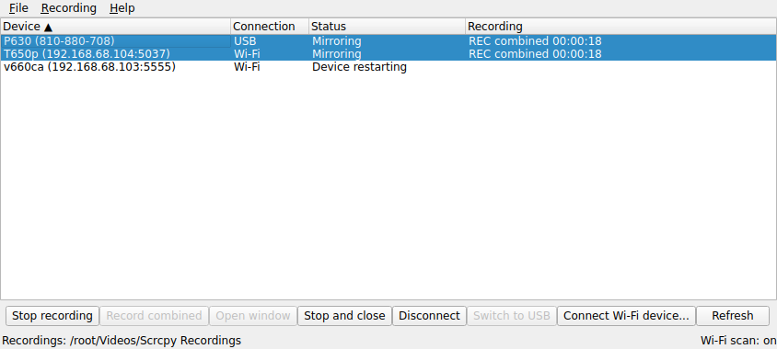
Figure 2 - Two devices recording combined
- Up to three devices are placed side by side; four or more are arranged in a grid. A device that was not recording at some moment (for example during a restart) shows black at that time.
- Every device keeps its own proportions and relative size: all screens are scaled by the same amount, so a smaller screen is not stretched to match the others.
- Each screen has a header with its device name and serial. The combined video has no audio, and devices are synchronized to about one second.
- Joining takes from a few seconds to a few minutes depending on length. If the control panel is hidden and every device window is closed, the monitor waits for the combined video and the device name headers, then quits. Exit waits up to 2 minutes; if it is still not finished, it is cancelled and a notification says so.
- If a Wi-Fi device falls back to USB while recording (see section 8), both parts are in the combined video.
- Record combined needs ffmpeg. If fewer than two devices recorded anything, no combined video is made. The device recordings are kept either way.

8. USB and Wi-Fi
- USB priority. A device connected over both USB and Wi-Fi is mirrored over USB. Its Wi-Fi connection is kept on standby (shown in gray) and is used if USB is unplugged.
- Wi-Fi to USB fallback. When a device mirrored over Wi-Fi is plugged in by USB, it moves to USB within 30 seconds; a recording in progress continues over USB.
- Switch to USB / Switch to Wi-Fi. Moves a device to the other connection. The old entry is removed; if the switch fails, the previous connection is restored.

9. Updates
- The monitor checks for a new version at startup. Help > Check for updates in the panel, or Check for updates in the menu bar/tray menu, checks now.
- To stop the check at startup, turn off Check for updates automatically (Help menu or menu bar/tray menu). The choice is remembered; turning it back on checks right away.
- When an update is found, confirm it: the monitor downloads the package for your Mac or Linux PC, quits, replaces the installed app, and starts again. Settings and recordings are kept.
- If a recording or a combined video is in progress, it is stopped and saved first. A combined video that is not finished within 2 minutes is cancelled.
- On macOS the updated app is unblocked automatically; the xattr step is needed only for the first install.

10. Files and logs
 | macOS | Linux
App | /Applications/Scrcpy Monitor.app | ~/.local/opt/scrcpy-monitor
Settings and Wi-Fi devices | ~/Library/Application Support/Scrcpy Monitor | ~/.local/share/scrcpy-monitor
Log | ~/Library/Logs/Scrcpy Monitor | ~/.local/state/scrcpy-monitor/logs
Recordings | ~/Movies/Scrcpy Recordings | ~/Videos/Scrcpy Recordings

11. Command line (optional)
The app can also be started from a terminal with options. Run it with --help for the full list.
macOS: "/Applications/Scrcpy Monitor.app/Contents/MacOS/scrcpy-monitor" [options]
Linux: ~/.local/opt/scrcpy-monitor/scrcpy-monitor [options]

Option | Purpose
--serial S | Monitor only these devices (repeat, or separate serials with commas).
--record | Start recording every device right away.
--record-dir PATH | Save recordings in this folder.
--command start-recording | stop-recording | show-panel | exit | Send a command to the running monitor.

12. Troubleshooting
Problem | What to do
macOS says the app "cannot be opened" or "is damaged" | Run the xattr command in section 3, or right-click the app > Open.
No icon in the Linux top bar | Your desktop has no tray. Use the control panel and its Exit button, or install the AppIndicator extension (section 3).
USB device not shown on Linux | Install the udev rules (section 3), replug the device, and allow the USB debugging prompt.
Device shows Unauthorized | Unlock the device and allow the USB debugging prompt.
Recording saved in several part files | ffmpeg is not installed. Install it (section 2).
Recording has no device name header | ffmpeg is not installed (section 2), or the notification says "saved without the device name header"; the recording is complete and Open log shows the reason.
No combined video | Check that ffmpeg is installed and that at least two devices recorded. The notification gives the reason.
Wi-Fi device does not connect | Check that the computer and device are on the same network and that "adb tcpip" was run after the last device restart (section 4).
A device disappeared from the list | It was closed, turned off or disconnected (section 5). Click Refresh to show it again.
Device windows are not arranged | macOS: allow Scrcpy Monitor in System Settings > Privacy & Security > Accessibility, then click Window > Arrange windows. Linux: X11 or XWayland is needed. File > Open log shows the reason.
Anything else | Click File > Open log and send the log with the version number from About.

13. Version history
Version | Date | Changes
5.0.1.12 | 2026-11-09 | Added: a restarting device stays in the list as "Device restarting"; devices that are turned off, unplugged or closed are removed; Stop and close; Refresh (replaces Scan now); device name headers in single-device and combined recordings; combined recordings keep the real size and proportions of each device (a smaller screen is not stretched); column sorting; a menu bar (File, Recording, Window, Help) with the device buttons on one row; Check for updates automatically; device windows are arranged centered without overlapping, at 100% when they fit, and again when a window opens or closes, the same as on Windows (Window > Arrange windows, or Arrange device windows in the menu bar/tray menu; macOS needs the Accessibility permission); Help > User guide shows this guide inside the monitor; closing the control panel exits the monitor and closes every device window.  Fixed: an older release is no longer offered as an update; a Wi-Fi device that went offline is connected again by Refresh; with --no-discovery a Wi-Fi device that is away for a while is no longer removed.
5.0.1.11 | 2026-11-05 | First macOS and Linux release, with the same features as the Windows version: mirroring that survives restarts, Wi-Fi connect and Scan now, USB priority and switching, recording, Record combined, and self-update.

