scrcpy monitor
How-to Guide
Author: Charles Manalo
Applies to version 5.0.1.x (portable package)
https://github.com/cktmanalo/scrcpy

1. Overview
scrcpy monitor mirrors one or more Android devices connected over USB or Wi-Fi/TCP, each in its own window, and records their screens. It is built on scrcpy by Genymobile and runs from the Windows notification area (tray) without any console window.
- One window per device. Every connected device is mirrored automatically, including devices connected after the monitor started.
- Survives device restarts. When a device restarts or drops off Wi-Fi, its window stays open and mirroring resumes in the same window when the device is back.
- Screen recording. Start and stop recording per device or for all devices from the device window, the control panel or the tray icon. A recording continues across device restarts and is saved as a single MP4.
- Self-updating. The monitor checks GitHub Releases for a newer version and updates itself.

Version number
The version is shown in the control panel title and in About, for example 5.0.1.7: the first three numbers are the scrcpy release the monitor is built on (5.0.1) and the last number is the scrcpy monitor build number (7). Include this version when you report a problem.

2. Requirements
- Windows 10 or 11 (64-bit).
- Android device with Developer options > USB debugging enabled. Audio is recorded on Android 11 and later; older devices are recorded without audio.
- For Wi-Fi/TCP: the PC and the device on the same network.
- Nothing else to install: scrcpy, adb and ffmpeg are included in the package.

3. Installation
1. Download scrcpy-monitor-portable-<version>.zip from the Releases page (https://github.com/cktmanalo/scrcpy/releases).
2. Right-click the ZIP > Properties > select Unblock (if shown) > OK.
3. Extract the whole ZIP to a folder of your choice, for example C:\Tools\scrcpy-monitor. Do not run it from inside the ZIP.
4. Optional: double-click "Create Desktop Shortcut.vbs" in that folder to add a "scrcpy monitor" shortcut to your desktop.
File | Purpose
scrcpy-monitor.vbs | Starts the monitor (no console window). The desktop shortcut runs this file.
scrcpy-monitor.ps1 | The monitor itself.
Create Desktop Shortcut.vbs | Adds the desktop shortcut.
README-QA.txt | Quick reference.
scrcpy-monitor-guide.docx | This guide.
scrcpy.exe, scrcpy-server | Mirroring engine (scrcpy).
adb.exe, AdbWin*.dll | Android Debug Bridge, used to find and connect devices.
ffmpeg.exe, ffprobe.exe | Join and check recording parts.
update.json | Version and update source. Do not edit.

4. Connecting devices

USB
1. On the device: Settings > About > tap Build number 7 times to enable Developer options.
2. Settings > Developer options > enable USB debugging.
3. Connect the device with a USB cable and accept the "Allow USB debugging" prompt (tick "Always allow from this computer").

Wi-Fi / TCP
Connect the device with USB first, then open PowerShell in the scrcpy monitor folder (Shift + right-click the folder > Open PowerShell window here) and run:
.\adb.exe tcpip 5555
.\adb.exe connect <device IP address>:5555
.\adb.exe devices

You can then unplug the USB cable. The device is listed as <IP>:5555. If a Wi-Fi device drops off the network, the monitor reconnects it automatically.
Note: Most devices turn off ADB over Wi-Fi when they reboot. If a Wi-Fi device stays in "Waiting for device" after a reboot, connect it with USB and run the two commands above again.

5. Starting the monitor
- Double-click the "scrcpy monitor" desktop shortcut (or scrcpy-monitor.vbs).
- A window opens for every connected device. The scrcpy monitor control panel appears as soon as the first device screen starts sharing, and the scrcpy monitor icon appears in the tray.
- Devices connected later get their own window automatically.
- Starting the monitor again while it is running shows the control panel and reopens any device window you closed; it does not start a second copy.

6. The control panel
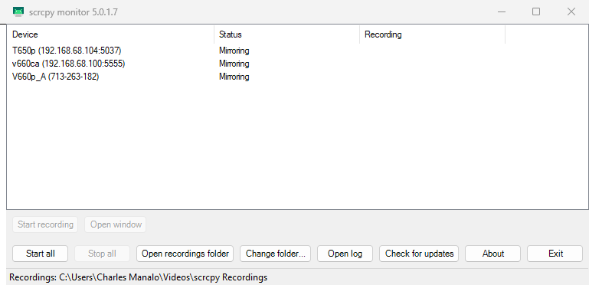
Figure 1 - Control panel
The list shows one row per device with its Status and Recording state.

Status column
Status | Meaning
Opening window | The device is ready and its window is starting.
Mirroring | The device screen is shown in its window.
Waiting for device (missing) | The device is not connected, or is restarting. The window stays open and mirroring resumes automatically.
Waiting for device (offline) | adb sees the device but cannot talk to it yet (for example while it boots). Wi-Fi devices are reconnected automatically.
Waiting for device (unauthorized) | Accept the "Allow USB debugging" prompt on the device.
Waiting for device (recovery / bootloader / ...) | The device is in a special boot mode.
Window closed | You closed the device window. Use "Open window" to reopen it.

Recording column
Recording | Meaning
(empty) | Not recording.
REC 00:01:23 | Recording; the time since recording was started.
REC ... (waiting for device) | Recording was requested and is starting, or the device is restarting. Recording continues when the device is ready.
REC ... (part 2) | The device restarted during the recording; the recording continues in a new part. All parts are joined into one MP4 when you stop.
REC ... (saving previous) | A new recording started while the previous one is still being saved.
Saving... | Recording stopped; the MP4 is being finalized.

Buttons
Button | Action
Start recording / Stop recording | Starts or stops recording on the selected device(s). Select one or more rows first (Ctrl+click or Shift+click for several). Double-clicking a row does the same.
Open window | Reopens the window of a selected device that was closed.
Start all | Starts recording on every device that is not recording. Disabled when all are recording.
Stop all | Stops every recording. Disabled when nothing is recording.
Open recordings folder | Opens the folder where recordings are saved.
Change folder... | Chooses another recordings folder (shown at the bottom of the panel).
Open log | Opens the monitor log, useful when reporting a problem.
Check for updates | Checks GitHub for a newer version (see section 11).
About | Shows the version, author and a summary (see section 12).
Exit | Stops all recordings (they are saved), closes all device windows and quits.

7. Recording
Start or stop a recording in any of these ways:
- Device window: click the round button in the top-right corner (red dot = start, white square = stop), or press Alt+E while the window is active.
- Control panel: select device(s) and click Start recording / Stop recording, or use Start all / Stop all.
- Tray icon: right-click the scrcpy monitor icon and choose a device, or Start/Stop recording on all devices.
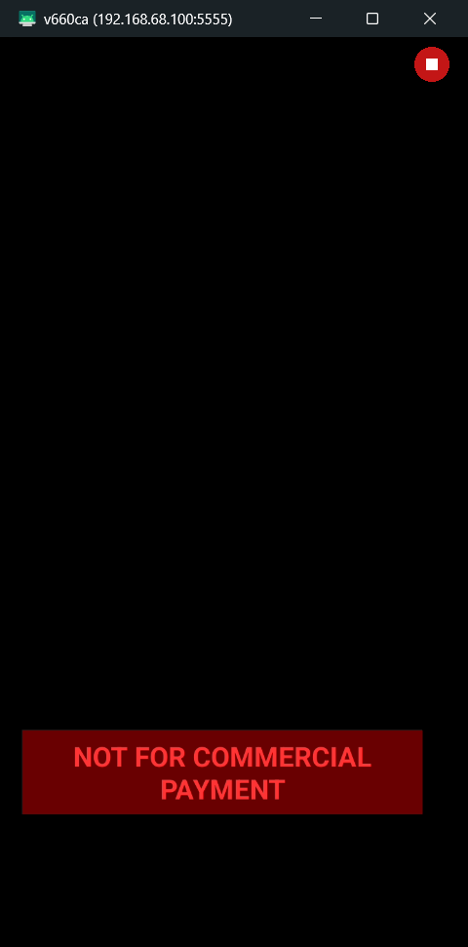
Figure 2 - Device window while recording (stop button in the top-right corner)
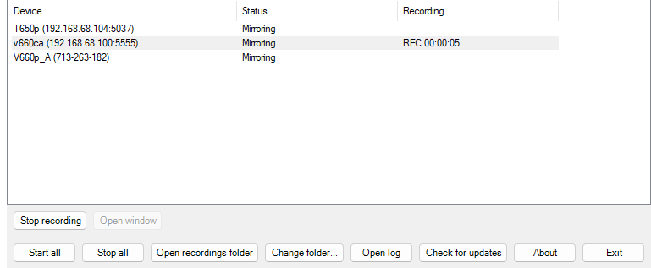
Figure 3 - Recording shown in the control panel
Recordings are saved as:
<Recordings folder>\<Device Name>\Screen_Recording_<Device Name>_<yyyyMMdd_HHmmss>.mp4

- A notification shows the file name when the recording is saved.
- The recorder takes a few seconds to start, so the first 2-5 seconds after you press start are not in the video. Start recording a moment before the step you want to capture.
- If the device restarts or disconnects, the part recorded so far is kept, recording resumes automatically when the device is back, and all parts are joined into one MP4 when you stop. The time the device was unavailable is not in the video.
- Exiting the monitor stops and saves all recordings.

8. Device restarts
When a device restarts (or a Wi-Fi device drops off the network), its window stays open and the Status changes to "Waiting for device". When the device is back, mirroring resumes in the same window, and a recording in progress continues in a new part. No action is needed.

9. Windows, tray and exit
- Closing a device window stops mirroring that device (Status: Window closed). Reopen it with Open window in the panel, from the tray menu, or by starting the monitor again.
- Closing the control panel keeps the monitor running in the tray. Double-click the tray icon to show the panel again.
- The monitor exits by itself when every device window is closed and the control panel is closed.
- Exit (panel or tray menu) saves recordings, closes all windows and quits.
The tray menu (right-click the tray icon) contains:
- Show control panel
- One item per device (open its window, start or stop its recording)
- Start recording on all devices / Stop recording on all devices
- Open recordings folder / Change recordings folder...
- Open log / Check for updates / About / Exit

10. Recordings folder
The default folder is Videos\scrcpy Recordings in your user profile. Click Change folder... in the control panel (or Change recordings folder... in the tray menu) to choose another folder; the choice is remembered, including after updates. The current folder is shown at the bottom of the control panel.

11. Updates
- The monitor checks for a newer version at startup and when you click Check for updates.
- When a newer version is found, accept the prompt to download it. The monitor stops (saving any recording), updates its folder and restarts.
- If you are on the latest version, a message says "You have the latest version".
- Your recordings folder setting is kept.

12. About
About (control panel or tray menu) shows the scrcpy monitor version, the scrcpy mirroring engine version, the author, a summary of the application and a link to the project.
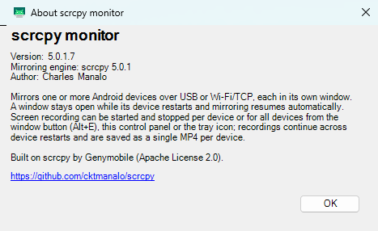
Figure 4 - About scrcpy monitor

13. Troubleshooting
Problem | What to do
No device window opens | Check the USB cable and that USB debugging is enabled. Run ".\adb.exe devices" in the monitor folder; the device must be listed as "device".
Status: Waiting for device (unauthorized) | Unlock the device and accept the "Allow USB debugging" prompt. If no prompt appears, unplug and plug the cable again.
Wi-Fi device stays "Waiting for device" after a reboot | ADB over Wi-Fi was turned off by the reboot. Connect with USB and run ".\adb.exe tcpip 5555" and ".\adb.exe connect <IP>:5555".
Recording misses the first seconds | Expected: the recorder takes a few seconds to start. Start recording slightly earlier.
"Recording ... keeps failing" notification | Click Open log and check the per-device logs in %TEMP%\scrcpy-monitor\logs. Restarting the device usually helps.
Windows blocks the files after download | Right-click the ZIP > Properties > Unblock, then extract it again.
Reporting a problem | Include the version from About and the log (Open log); per-device logs are in %TEMP%\scrcpy-monitor\logs.

14. Command line (advanced)
Run these from PowerShell in the monitor folder:
powershell -ExecutionPolicy Bypass -File .\scrcpy-monitor.ps1 <options>

Option | Description
-List | Lists the connected devices and exits.
-Serial <s1>,<s2> | Mirrors only the given devices.
-Record | Starts recording every device at startup.
-RecordDir <folder> | Saves recordings to this folder for this run.
-Command StartRecording [-Serial <s>] | Starts recording in the running monitor (all devices, or the given ones).
-Command StopRecording [-Serial <s>] | Stops recording in the running monitor.
-Command ShowPanel | Shows the control panel of the running monitor.
-Command Exit | Exits the running monitor (recordings are saved).
-NoUpdateCheck | Skips the update check at startup.
-KeepParts | Keeps the individual recording parts after joining them.
Other scrcpy options | Extra options (for example --max-size=1024 --stay-awake) are passed to the device windows.

15. Credits and license
scrcpy monitor was created by Charles Manalo. It is built on scrcpy by Genymobile, licensed under the Apache License 2.0 (see LICENSE). adb, FFmpeg and the bundled libraries are distributed under their own licenses.

