HW 3

Brief Explanation of Part 2 Dataset Analysis →
Dataset Overview – Dataset Structure:
- Dimensions: 5 rows × 95 columns (showing first 5 rows of the full dataset)
- Columns:
  - id: Unique identifier for each sample
  - feat_1 to feat_93: 93 numerical features (input variables)
  - target: Class labels (classification target variable)
Q1 → Key Observations:
- Feature values: Mostly integers (0s and 1s with some other small integers)
- Target variable: Contains class labels ("Class_1" shown in sample)
- Data type: All features are numeric integers, suitable for machine learning
- Pattern: Sparse data with many zero values, suggesting the features might be binary or count-based
Data Types:
- id: int64 - Integer identifier
- feat_1 to feat_93: int64 - All features are integer type
- target: object - Categorical string labels (needs encoding for ML)
Implications for Part 2:
- ✅ No data cleaning needed - No missing values to handle
- ⚠️ Label encoding required - Target is object type, must convert to integers for XGBoost
- ✅ Features ready - All 93 features are already numeric
- 📊 Dataset size: 95 columns total (1 id + 93 features + 1 target)

Overall Performance →
Model Accuracy:
- Training Accuracy: 84.24% (0.8424)
- Test Accuracy: 79.92% (0.7992)
- Gap: ~4.3% difference - indicates good generalization, minimal overfitting
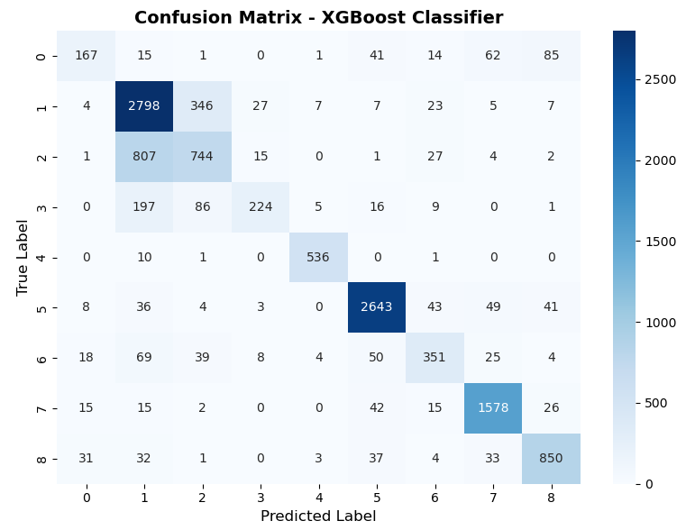
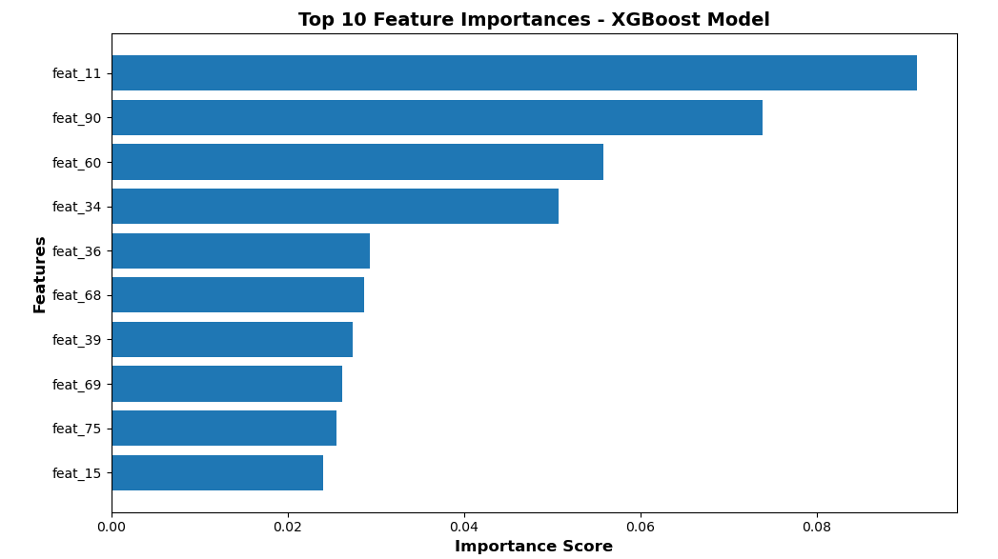
Q2 → Set a timer to train the xgboost model by setting the n_jobs to get the calculation time on CPU=1, 2, 4, 8; and plot the time varies on the number of CPUs
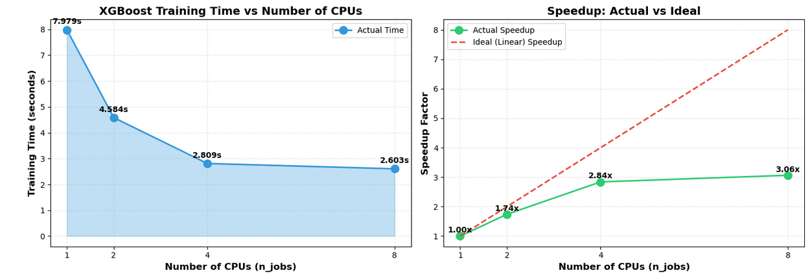

Q4 → Use dask xgboost on 4 CPUs and dask distributed scheduler with n_workers=4, threads_per_worker=1 to train the model and get the calculation time. Compare (3 pts) the calculation time of dask xgboost with the time of xgboost model on 4 CPUs.
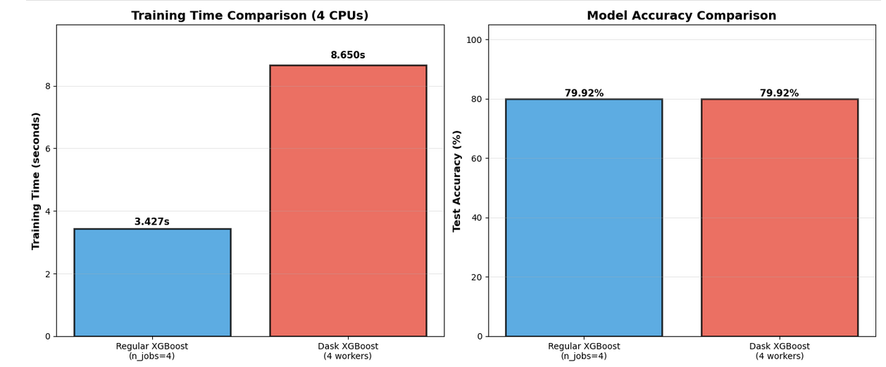

Brief Explanation of Part 3 Dataset Analysis →

Q1 → Original Dataset Overview
NYC Flights Dataset:
- Shape: 336,776 rows × 19 columns
- Description: Flight departure and arrival data from NYC airports (2013)
- Key columns:
  - Flight scheduling: dep_time, sched_dep_time, arr_time, sched_arr_time
  - Delays: dep_delay, arr_delay (in minutes)
  - Flight info: carrier, flight, tailnum, origin, dest
  - Duration/Distance: air_time, distance

Missing Value Analysis →
Total Missing Values in Target Column:
- Column: dep_delay (departure delay in minutes)
- Missing count: 8,255 values
- Percentage: 2.45% of total dataset

Impact and Justification →
Why Remove These Rows?
- ✅ Cannot compute delay statistics for flights that never departed
- ✅ Invalid for analysis - Missing dep_delay means no departure occurred
- ✅ Clean dataset requirement - Dask computations need complete data for the target column
Result:
- Original: 336,776 flights (including cancelled)
- Cleaned: 328,521 flights (only flights that actually departed)
- Removed: 8,255 cancelled flights (2.45%)
Data Quality After Cleaning:
- ✅ All remaining flights have valid departure delay values
- ✅ No missing values in dep_delay column
- ✅ Dataset ready for statistical analysis in Questions 2-4
- 📊 Still have 328,521 samples - sufficient for robust analysis

Q3 →
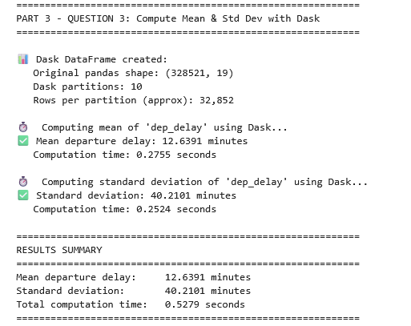

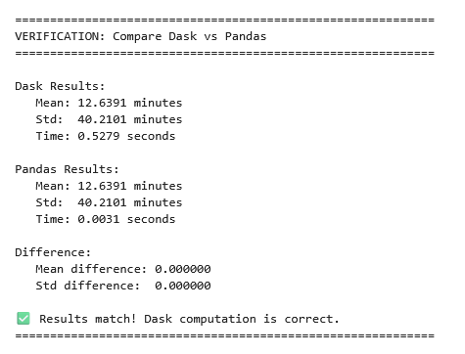

Dask DataFrame Results
Statistics Computed:
- Mean departure delay: 12.6391 minutes
- Standard deviation: 40.2101 minutes
- Computation time: 0.5279 seconds
Method: Distributed computation across 4 workers with 10 partitions

Pandas Verification (Ground Truth)
Statistics Computed:
- Mean departure delay: 12.6391 minutes
- Standard deviation: 40.2101 minutes
- Computation time: 0.0031 seconds
Method: Traditional in-memory pandas computation

Q4 →
