CSYE7105 - HW4

1. Please explain the difference between CPU and GPU based on the class lecture. [5 points]
Answer-
CPUs and GPUs have fundamentally different design philosophies and purposes.
CPUs are designed to control the logical flow of general-purpose programs, featuring more complex instruction processing, faster clock speeds, and latency-oriented cores. They have a large control unit, substantial cache memory, and fewer but more capable ALUs/FPUs. In contrast, GPUs were originally designed for rendering graphics and are optimized for highly parallel processing with more processing units and higher total memory bandwidth. GPUs feature small control units, minimal cache, and hundreds of small processing units organized in SIMD (Single Instruction, Multiple Data) units, making them throughput-oriented cores.
The key performance distinction is that CPUs excel at multitasking and fast serial processing, handling complex workflows with individually more capable processing units and more cache memory. GPUs, however, are designed for workloads that can be parallelized to a significant degree, producing high computational throughput using massively parallel architectures. This architectural difference means CPUs use traditional serial programming models, while GPUs rely on specialized programming models like NVIDIA CUDA that differ substantially from traditional CPU programming approaches.

Aspect | CPU | GPU
Cache/Local Memory | More (CPU > GPU) | Less
Threads | Fewer | More (GPU > CPU)
Registers | Fewer | More (GPU > CPU)
SIMD Units | Fewer | More (GPU > CPU)
Workload Type | Multitasking & Serial | Parallel & Throughput

2. Please explain GPU memory hierarchy. [5 points]
Answer -

Memory Types and Speed Ranking –
The GPU memory hierarchy consists of multiple memory types organized by their proximity to compute cores and access speed. Based on the class lecture, if all memory types were to race, the speed ranking would be:
- 1st place: Register File - Fastest memory, located within multiprocessors
- 2nd place: Shared Memory - Fast on-chip memory within multiprocessors
- 3rd place: Constant Memory - Cached read-only memory
- 4th place: Texture Memory - Cached memory optimized for spatial locality
- Last place: Local Memory and Global Memory - Slowest, located in device DRAM
Memory Organization
GPU memory is divided into two main regions: Device DRAM and On-Chip Multiprocessor Memory. Device DRAM (located on the device/host side) contains Local Memory, Global Memory, Constant Memory, and Texture Memory, which are accessible but slower. The GPU multiprocessors contain the fastest memory types: Registers (private to each thread), Shared Memory (shared within a thread block), and Constant and Texture Caches. This hierarchical organization allows programmers to optimize performance by strategically placing frequently accessed data in faster memory types closer to the compute cores.
Memory Bandwidth
Memory bandwidth measures how fast the GPU can move data between memory and compute cores (CUDA/Tensor Cores), measured in GB/s. During training, performance is bottlenecked by memory bandwidth and compute, as large models, huge batches, gradients, and optimizer states need to read/write gigabytes quickly. During inference, performance is bottlenecked by latency, compute, and cache, as smaller batches often use batched INT8 or FP16 operations, making them less reliant on bandwidth and more dependent on efficient core usage.

3. On Explorer, request a CPU node, on the node, complete the following tasks: [10 points]
Answer -

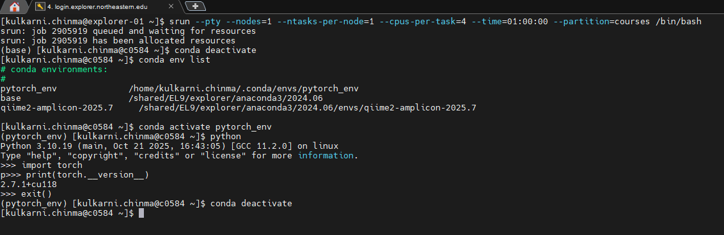

4. On Explorer, request a GPU node (any type of GPU), on the node, complete the following tasks:
Answer -

- Load the module of cuda (any version of cuda on Explorer)

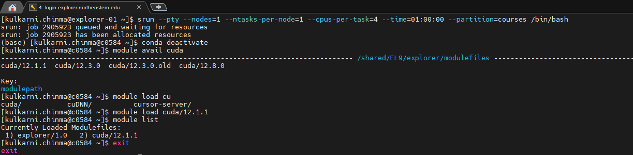

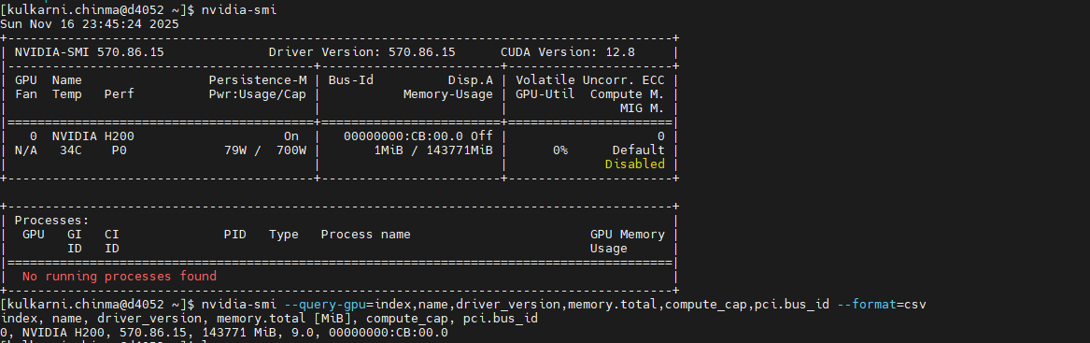
Static Information (Screenshot 1) - 4 points:
- Describes GPU hardware: H200 with 140GB memory
- Identifies driver version 570.86.15 and CUDA 12.8
- Explains that the 143,771 MiB is Global Memory (bottom of hierarchy)
- Notes compute capability and persistence mode
Memory Hierarchy Context: The 143,771 MiB shown represents the Global Memory tier, which is the slowest in the GPU memory hierarchy but has the largest capacity. Faster memory types like registers, shared memory, and caches are not visible in nvidia-smi as they are managed at the programming level.

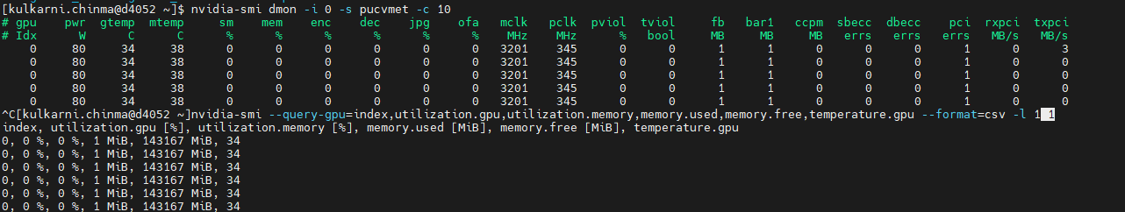
Dynamic Information (Screenshot 2) - 4 points:
- Shows real-time metrics: 0% GPU and memory utilization
- Reports temperature (34°C), power (80W), and clocks
- Explains memory bandwidth at 0% means no active transfers
- Connects to memory hierarchy: Global Memory bandwidth shown, faster tiers (registers/shared) not visible in nvidia-smi
Memory Hierarchy in Action: The dynamic monitoring shows Global Memory bandwidth utilization (mem column at 0%). When GPU kernels execute, this metric increases as data moves between Global Memory and the compute cores. The memory hierarchy's faster tiers (registers, shared memory) reduce pressure on Global Memory bandwidth by keeping frequently accessed data closer to the compute units. Currently, with 0% utilization, no data movement is occurring through any memory tier.
Last Screenshot -

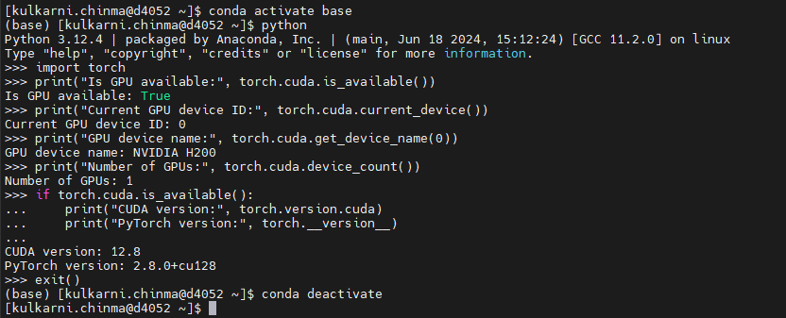

1. Is the GPU available? [2 points] - Answer: True
2. Current GPU device ID [2 points] - Answer: 0
3. GPU device name: Answer: NVIDIA H200
4. Additional Info:
- Number of GPUs: 1
- CUDA version: 12.8
- PyTorch version: 2.8.0+cu128

