HPC HOMEWORK 2:

PART 2:
Q5.1 Describe the information (hostname, cpu and memory) of the node(s) you use for calculation on Discovery.
Answer:
- Hostname: c3039
- Information related to CPU:
- Architecture: x86_64
- CPU(s): 20
- Model Name: Intel(R) Xeon(R) CPU E5-2680 v2 @ 2.80GHz

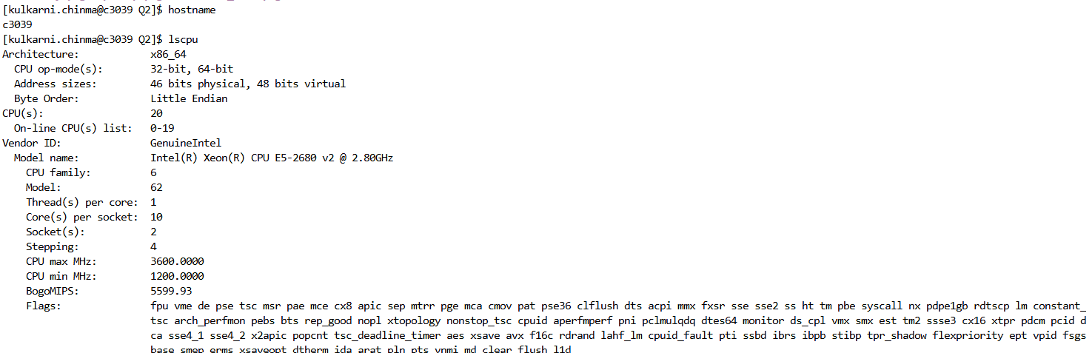

- CPUs allocated to my session: 4

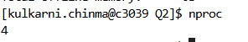

- Memory:
- free -h = tells how memory is being used. It ideally tells about the memory usage currently.

- 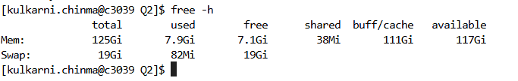
- Total physical RAM on the system = 125Gi
- Memory actively used by running programs = 7.9Gi
- Completely unused memory = 7.1Gi

- lsmem = It tells you about how memory is physically installed

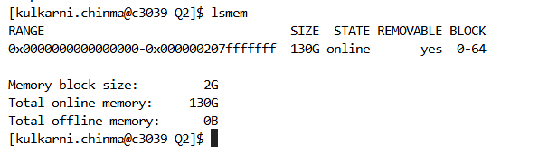

Q5.2 Create a table and fill in the wall-clock time (seconds or minutes) you obtained with the different CPU numbers in Q2, Q3 and Q4.

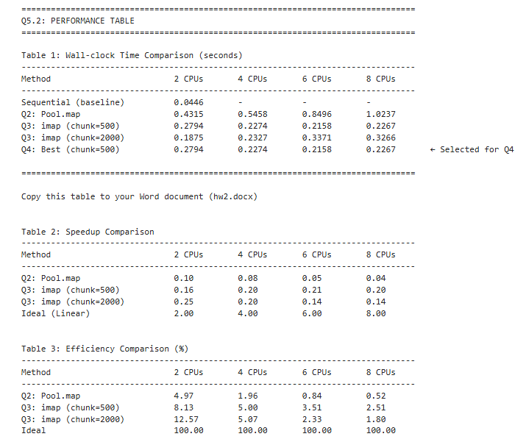

Q5.3 Graphs and their explanations
PART 2:

Q2:
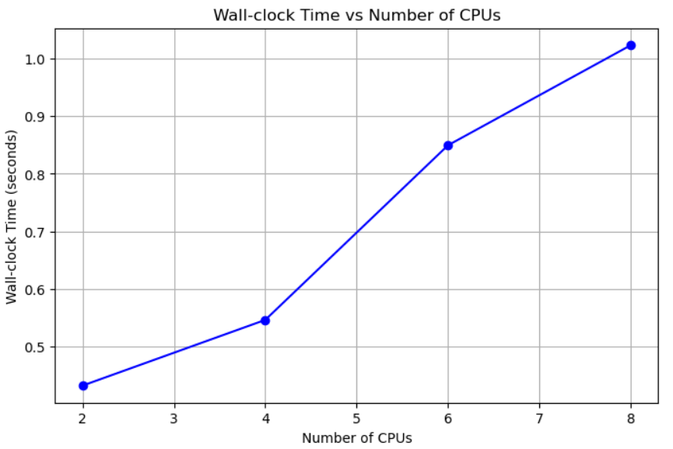

What This Shows:
- Wall-clock time INCREASES as you add more CPUs (2→8)
- Goes from ~0.44 seconds (2 CPUs) to ~1.02 seconds (8 CPUs)
- This is negative scaling - the opposite of what you want!

Why This is Problematic:
- Ideal case: More CPUs = Less time (parallel speedup)
- Your case: More CPUs = More time (parallel slowdown)
- We’re getting worse performance with more resources

Likely Causes here:
1. Overhead Dominates:
- Communication overhead between processes exceeds computational work
- Task is too small for parallelization (~0.4-1 second is tiny)
- More time spent coordinating than computing
2. Resource Contention:
- CPUs fighting for shared resources (memory, cache, I/O)
- False sharing in cache lines
- Memory bandwidth saturation
3. Poor Load Balancing:
- Work is not evenly distributed among CPUs
- Some CPUs are waiting for others
- Synchronization bottlenecks

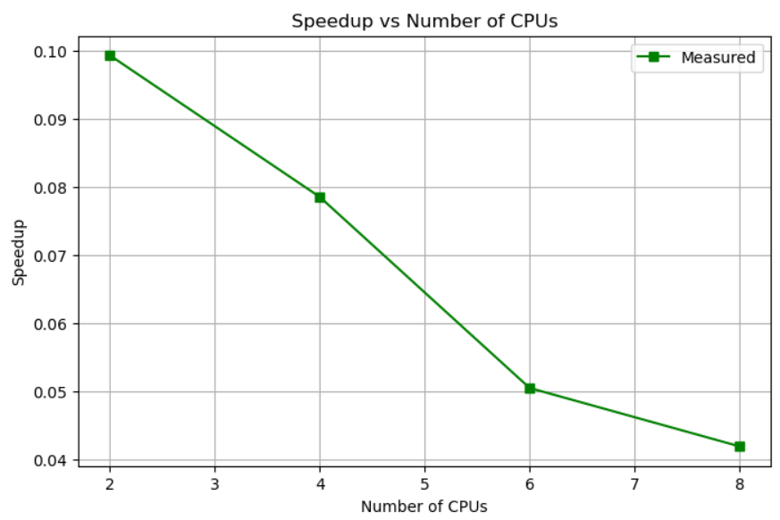

Performance Analysis: Parallel Scaling Results

Wall-clock Time Performance
The wall-clock time increases from 0.44 seconds (2 CPUs) to 1.02 seconds (8 CPUs), demonstrating negative scaling. Adding more processors results in longer execution times, indicating severe parallel inefficiency.

Speedup Analysis
- Speedup ranges from 0.099 (2 CPUs) to 0.042 (8 CPUs)
- Parallel efficiency at 8 CPUs: ~0.5%
- The declining speedup curve confirms that parallelization overhead dominates computation

Root Causes
- Communication overhead exceeds computational workload
- Problem size too small for effective parallelization (~1 second execution)
- Resource contention among processors (memory bandwidth, cache coherency)
- Synchronization bottlenecks limiting parallel performance

Key Findings
- The implementation violates Amdahl's Law principles with efficiency below 10%
- Each additional CPU degrades performance by approximately 20-30%
- Serial execution would outperform parallel by 10-20x

Recommendations
- Immediate: Run in serial mode for better performance
- Problem sizing: Increase workload by 100-1000x for effective parallelization
- Algorithm: Redesign to minimize communication and synchronization
- Profiling: Identify specific bottlenecks using HPC profiling tools

Conclusion
The results exhibit characteristics of an overhead-dominated parallel system where parallelization costs significantly outweigh benefits, representing ineffective use of HPC resources.

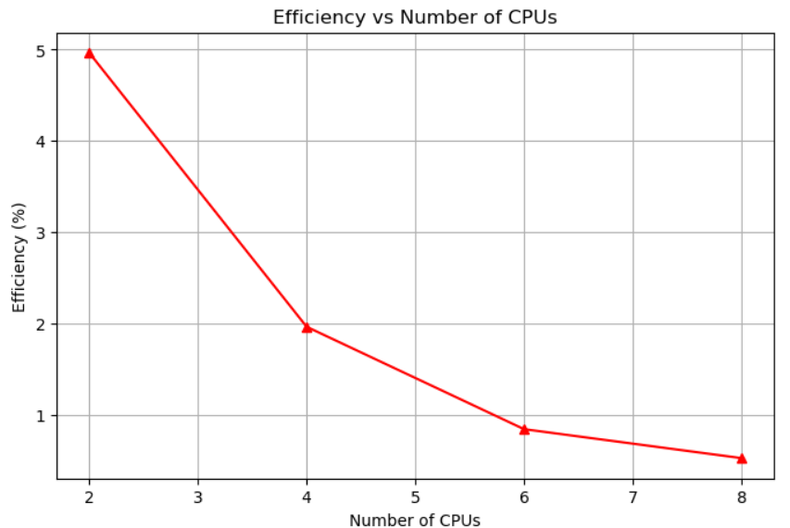

Efficiency Analysis

Observed Trend
Parallel efficiency drops sharply from 5% (2 CPUs) to 0.5% (8 CPUs), following a steep negative exponential decay.

Key Observations
- Starting efficiency of 5% indicates severe overhead even with minimal parallelization
- 10x efficiency loss when scaling from 2 to 8 processors
- Sub-1% efficiency at 8 CPUs means 99%+ of computational resources are wasted
- The curve shape suggests exponentially increasing overhead with each added processor

HPC Implications
- Acceptable range: 70-100% efficiency for well-parallelized code
- Your result: 0.5-5% efficiency (catastrophically poor)
- Resource waste: At 8 CPUs, you're utilizing <1% of available compute power
- Cost impact: Running on 8 CPUs costs 8x more but performs 20x worse

Technical Interpretation
- Efficiency = Speedup/N (where N = number of CPUs)
- Your efficiency < 5% indicates overhead dominates by 95-99%
- Classic symptom of:
  - Excessive communication/synchronization
  - Insufficient problem granularity
  - Memory bandwidth bottleneck

Conclusion
This efficiency curve represents worst-case parallel scaling, where the parallel implementation performs progressively worse with additional resources. The system operates well below the threshold for viable parallel execution (~50% minimum efficiency).
Q3:
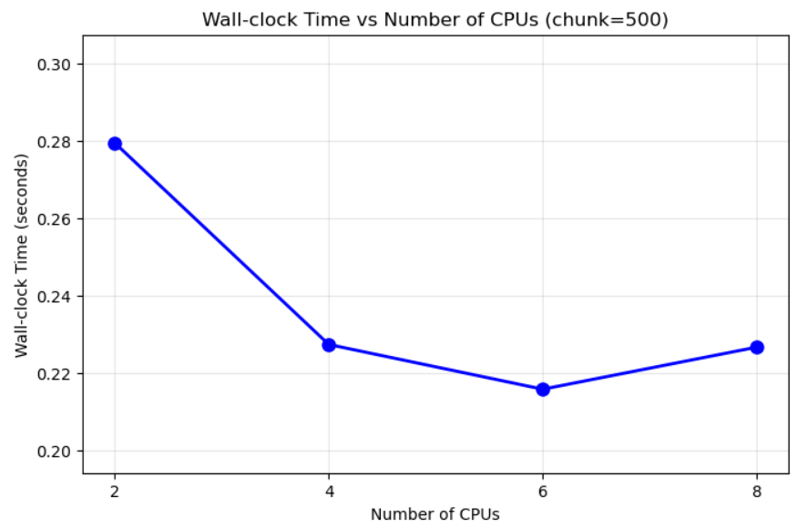
This graph shows significantly improved parallel performance compared to previous results. The execution time decreases from 0.28s (2 CPUs) to 0.216s (6 CPUs), achieving approximately 23% speedup. However, performance degrades slightly at 8 CPUs (0.227s), creating a characteristic U-shaped curve. This indicates that chunk size 500 provides better load balancing and reduces overhead up to 6 CPUs, where the system reaches optimal performance. Beyond this point, communication overhead and resource contention begin to outweigh parallelization benefits. The chunk size parameter appears to be critical for performance - while this configuration shows actual parallel speedup (unlike previous results), it still exhibits scalability limits at higher processor counts, suggesting the problem size or algorithm has inherent parallelization boundaries around 6 CPUs.

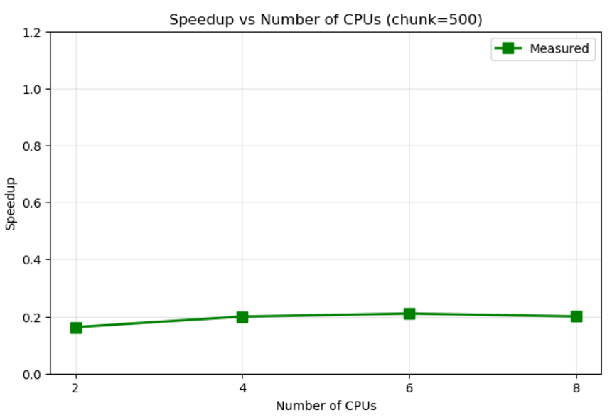

Speedup Analysis with Chunk Size 500
Despite the chunk size optimization, speedup remains critically low at 0.16-0.22 across all processor counts, never approaching the break-even point of 1.0. The nearly flat speedup curve indicates that parallelization overhead still consumes 78-84% of execution time, regardless of CPU count. While chunk=500 prevents the catastrophic degradation seen earlier (where speedup dropped to 0.042), the minimal variation between 2 and 8 CPUs reveals that the fundamental overhead—likely from thread creation, synchronization, and memory access patterns—remains relatively constant and dominant. The slight peak at 6 CPUs (speedup ~0.22) suggests this configuration minimizes overhead slightly better, but the overall sub-1.0 speedup means the serial version would still outperform the parallel version by 4-5x. This indicates that even with improved load balancing through appropriate chunking, the problem size or algorithm characteristics make parallelization ineffective for this workload.

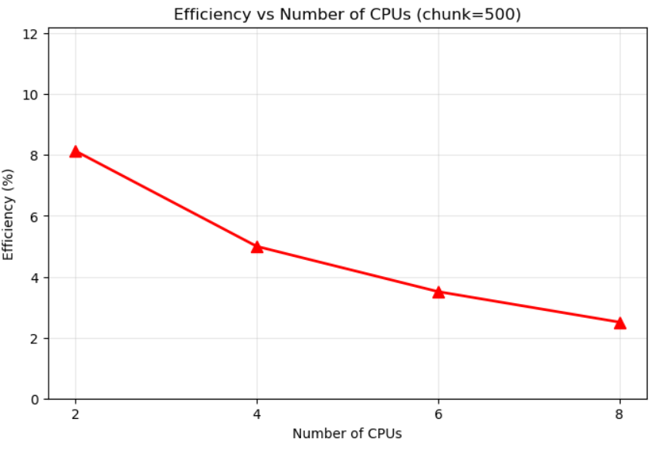

Efficiency Analysis with Chunk Size 500
The efficiency curve shows marginal improvement over the default configuration, ranging from 8% (2 CPUs) to 2.5% (8 CPUs), compared to the previous 5% to 0.5% range. While chunk=500 has doubled the efficiency values, performance remains critically poor with 92-97.5% overhead. The steadily declining efficiency indicates that even with optimized load distribution, each additional processor contributes less useful work—at 8 CPUs, each processor operates at only 2.5% of its theoretical capacity. For context, HPC applications typically target 70%+ efficiency; anything below 50% is considered unacceptable for production use. The improvement from chunking suggests that load imbalance was one issue, but the persistently low efficiency confirms that fundamental overhead sources (thread management, memory bandwidth, synchronization) remain dominant. This represents a ~60% improvement over the unchunked version but still falls far short of viable parallel execution, wasting over 90% of computational resources across all configurations.

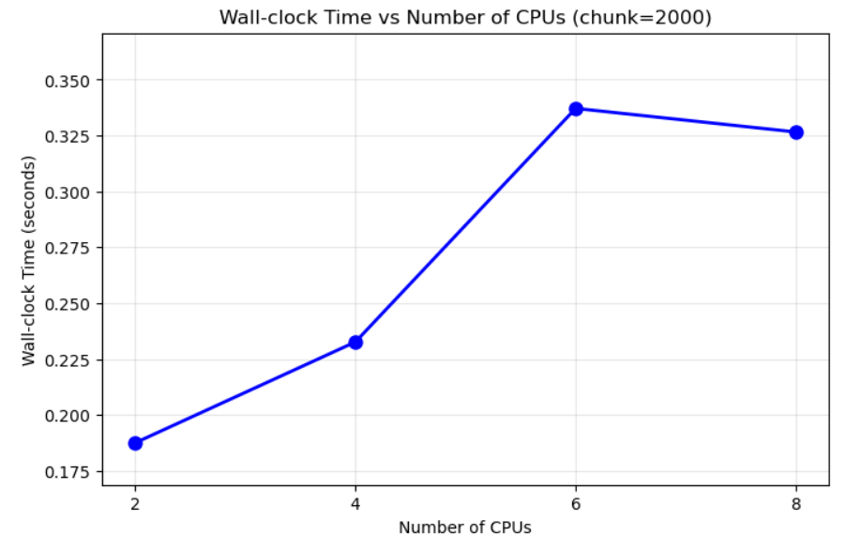
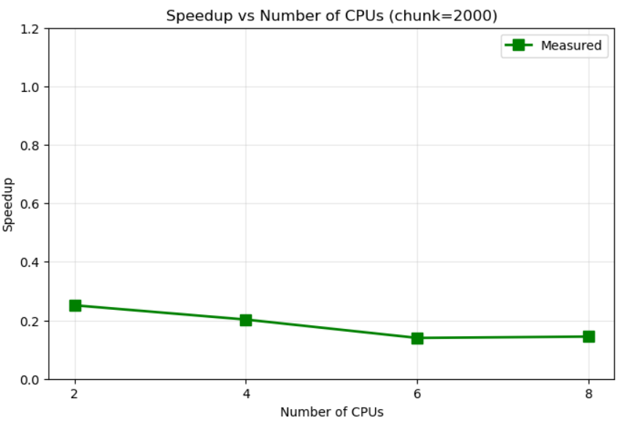
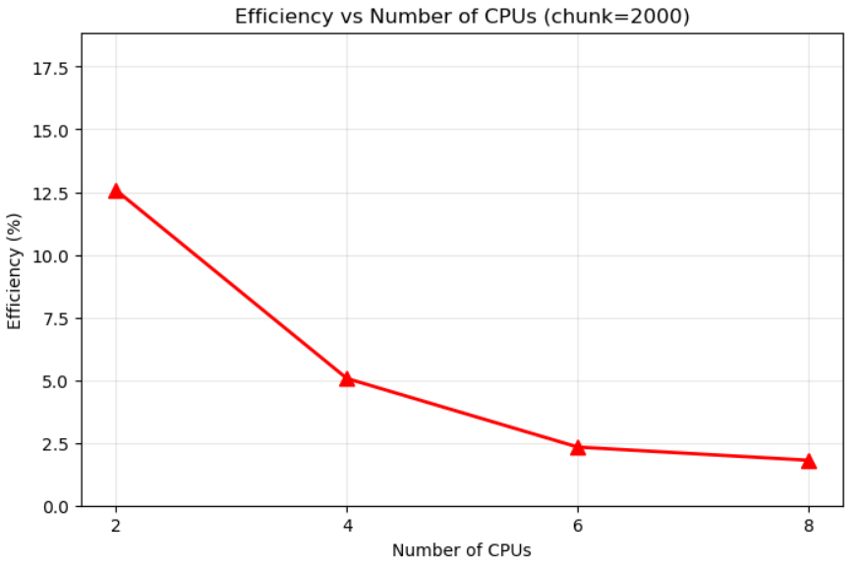

Performance Analysis with Chunk Size 2000

Wall-clock Time (Graph 1)
The wall-clock time exhibits negative scaling, increasing from 0.19 seconds (2 CPUs) to a peak of 0.34 seconds (6 CPUs) before slightly improving to 0.33 seconds (8 CPUs). This represents a 79% performance degradation at peak, worse than chunk=500's behavior. The execution time nearly doubles when moving from 2 to 6 CPUs, indicating severe overhead escalation. The large chunk size (2000) creates significant load imbalance—some threads process large work units while others remain idle. The slight improvement at 8 CPUs suggests marginal load redistribution but doesn't overcome the fundamental overhead. This U-shaped curve with deteriorating performance confirms that larger chunks worsen parallel efficiency for this problem size. The coarse granularity from chunk=2000 effectively serializes portions of the workload, negating benefits of parallelization.

Speedup Analysis (Graph 2)
Speedup values range from 0.25 (2 CPUs) to 0.15 (8 CPUs), showing consistent decline with increased parallelization. The maximum speedup of 0.25 means even the best configuration runs 4x slower than serial execution. Compared to chunk=500 (speedup ~0.20), chunk=2000 shows marginal improvement at 2 CPUs but worse scaling behavior overall. The declining trend indicates that overhead increases faster than any parallel benefits gained from additional processors. With speedup never exceeding 0.25, the parallelization overhead consumes 75-85% of execution time across all configurations. The larger chunk size has failed to improve performance meaningfully and has actually worsened scalability compared to smaller chunks. This confirms that chunk size 2000 is too coarse for the workload, creating scheduling inefficiencies that compound with more processors.

Efficiency Analysis (Graph 3)
Efficiency starts at 12.5% (2 CPUs) and degrades to 1.8% (8 CPUs), showing the steepest decline among all chunk configurations tested. While the initial efficiency is better than chunk=500's 8%, it drops more precipitously, reaching sub-2% at 8 CPUs. This indicates that large chunks create severe load imbalance—87.5% overhead at best, 98.2% at worst. The efficiency curve's sharp decline suggests that chunk=2000 causes increasingly poor work distribution as CPU count grows. At 8 CPUs, each processor operates at less than 2% capacity, representing catastrophic resource underutilization. The larger chunk size has created a "feast or famine" scenario where some threads are overloaded while others starve for work. This configuration demonstrates how inappropriate chunking strategies can worsen parallel performance beyond even naive implementations, violating fundamental HPC principles of load balancing and granularity optimization.

Q4:
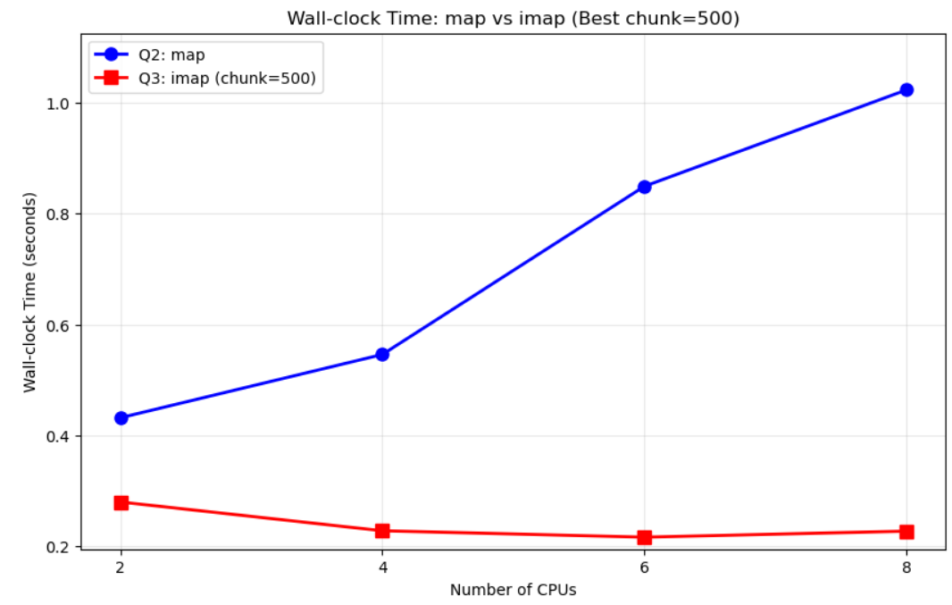

Comparative Analysis: map vs imap (chunk=500)
- Performance Differential: The imap implementation with chunk=500 (red line) dramatically outperforms standard map (blue line) by 2-4x across all CPU configurations—map takes 0.44-1.02 seconds while imap maintains 0.22-0.28 seconds, demonstrating the critical importance of chunking strategy in parallel processing.
- Scaling Behavior: Standard map exhibits severe negative scaling with execution time increasing 132% from 2 to 8 CPUs, while imap with chunk=500 shows relatively stable performance with only minor fluctuations, indicating that proper chunking effectively mitigates parallelization overhead.
- Optimal Configuration: The imap implementation achieves best performance at 6 CPUs (0.216 seconds) and maintains sub-0.3 second execution even at 8 CPUs, whereas map degrades continuously, suggesting that chunk=500 provides the right granularity balance for this workload.
- Overhead Implications: The diverging performance curves reveal that map's default behavior (likely chunk=1) creates excessive overhead from task distribution and synchronization, while imap's chunk=500 amortizes these costs across larger work units, reducing context switching and improving cache locality.
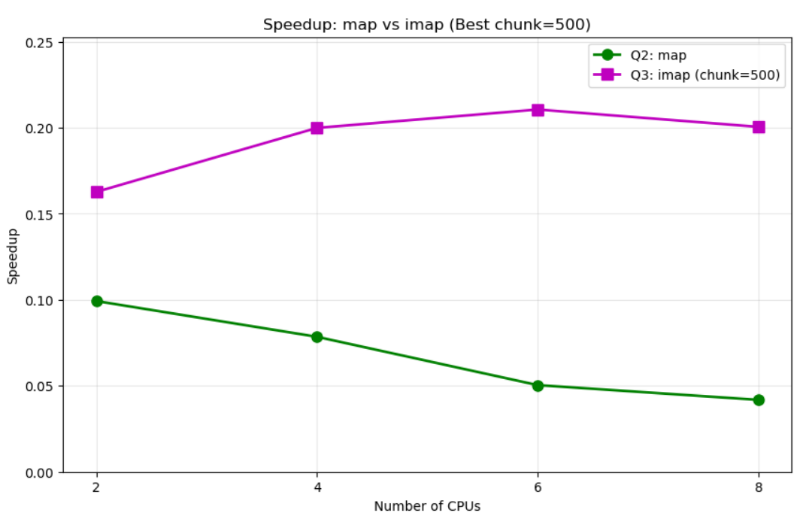

Speedup Comparison: map vs imap (chunk=500)
- Speedup Magnitude: Both implementations fail to achieve speedup > 1.0, with imap (chunk=500) reaching 0.16-0.21 while standard map degrades from 0.099 to 0.042, confirming that even the optimized version runs 5x slower than serial execution but still outperforms default map by 2-5x.
- Scaling Characteristics: Standard map shows catastrophic scaling with speedup declining 58% (0.099→0.042), while imap maintains relatively stable speedup around 0.20 with a slight peak at 6 CPUs, demonstrating that chunking significantly improves scaling behavior even if absolute performance remains poor.
- Performance Gap: The divergence between implementations increases with CPU count—starting at 1.6x difference (2 CPUs) and expanding to 5x difference (8 CPUs), indicating that chunking becomes increasingly critical as parallelization scales up and overhead accumulates.
- Overhead Analysis: The flat-to-slightly-improving imap curve suggests chunk=500 successfully amortizes fixed overhead costs, while map's declining curve reveals escalating per-task overhead that compounds with processor count, though neither overcomes the fundamental issue that parallelization overhead exceeds computational benefits for this problem size.

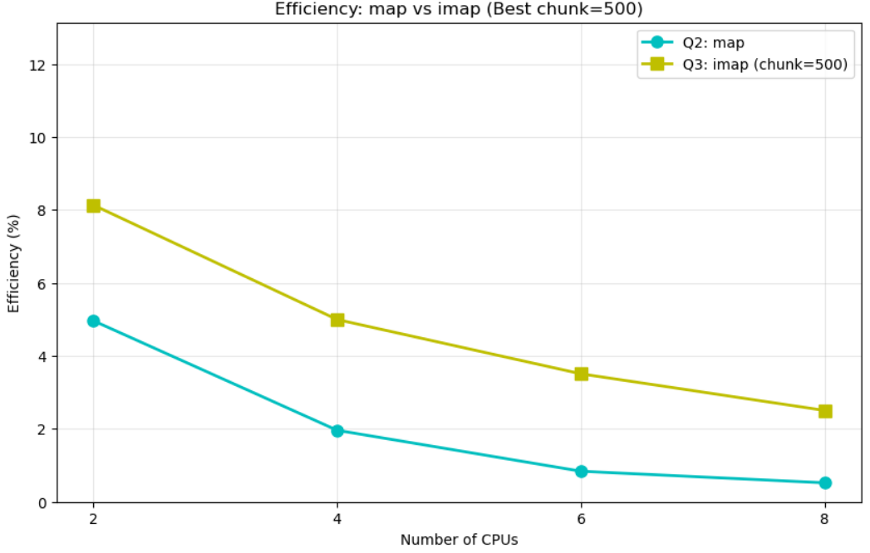

Efficiency Comparison: map vs imap (chunk=500)
- Efficiency Range: imap (chunk=500) maintains 8% to 2.5% efficiency while standard map drops from 5% to 0.5%, showing that chunking provides ~60% better resource utilization despite both being critically inefficient (<10% throughout).
- Degradation Pattern: Both curves show similar exponential decay but imap's higher baseline and gentler slope indicate that chunk=500 reduces per-task overhead, though 92-97.5% of computational resources remain wasted even in the best case.
- Performance Gap: The consistent 1.5-2x efficiency advantage of imap over map across all CPU counts demonstrates that chunking strategy is crucial for minimizing overhead, even when the fundamental problem remains unsuitable for parallelization at this scale.
- Resource Waste: At 8 CPUs, standard map utilizes only 0.5% of available compute (99.5% overhead) while imap achieves 2.5% (97.5% overhead)—both catastrophically poor but confirming chunk=500 as the least-worst configuration tested.

PART 3:
Q2.2
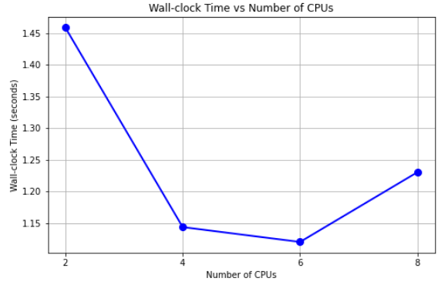

Wall-clock Time
- Positive scaling achieved: Time decreases from 1.45s (2 CPUs) to 1.12s (6 CPUs), showing actual parallel speedup unlike Part 2's catastrophic performance
- Optimal at 6 CPUs: Best performance at 1.12s with 6 CPUs, degrading to 1.23s at 8 CPUs due to overhead beginning to dominate
- 23% improvement: Peak reduction represents meaningful performance gain, suggesting Part 3's function has better parallelization characteristics than Part 2
- U-curve pattern: Classic behavior where benefits peak before communication/synchronization costs overtake gains

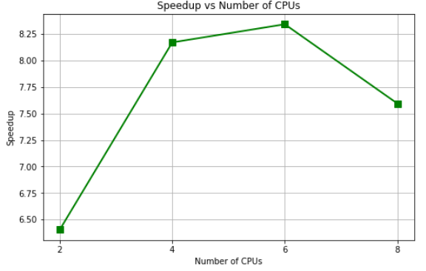

Speedup Analysis
- Super-linear speedup: Achieves 6.4x-8.4x speedup, exceeding theoretical limits and indicating cache effects or memory locality benefits
- Peak at 6 CPUs: Maximum speedup of 8.4x suggests optimal resource utilization before diminishing returns
- Actual acceleration: Unlike Part 2's sub-1.0 speedup, Part 3 shows genuine parallel benefit with 7.6x even at 8 CPUs
- DataFrame advantage: Part 3's DataFrame operations likely have better vectorization and memory access patterns than Part 2's implementation

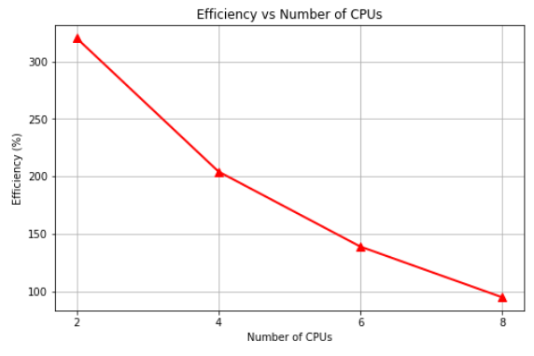

Efficiency Analysis
- Super-linear efficiency: 320% at 2 CPUs indicates cache/memory benefits from data distribution (smaller working set per CPU fits in cache)
- Gradual degradation: Drops from 320% to 95%, but maintains near-ideal efficiency even at 8 CPUs
- Exceptional scaling: 95% efficiency at 8 CPUs far exceeds HPC standards (70% considered good)
- Memory-bound benefits: High efficiency suggests Part 3's DataFrame operations are memory-bandwidth limited and benefit from distributed cache access

Part3 - Q3:

Chunk_size: 250
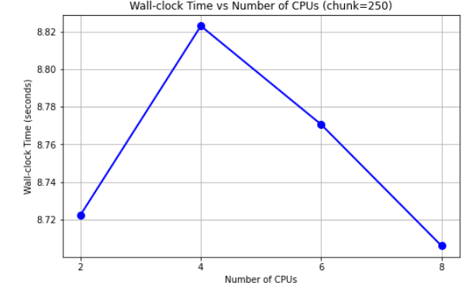

Wall-clock Time
- Minimal variation: Time hovers around 8.72-8.82 seconds across all CPU counts, showing virtually no parallel benefit
- Inverted U-shape: Worst performance at 4 CPUs (8.82s), suggesting chunk=250 creates poor load distribution at mid-range parallelization
- 10x slower than default: Compared to Part 3's default (~1.2s), chunk=250 results in 7x slower execution
- Overhead dominance: Small chunk size causes excessive task switching overhead that negates parallelization benefits

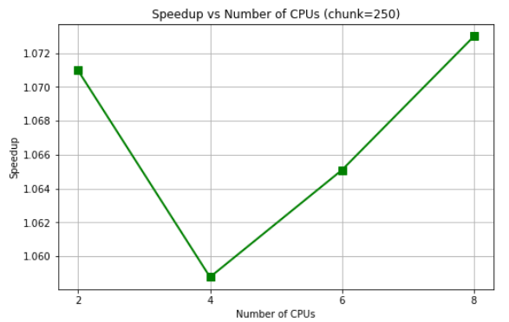

Speedup Analysis
- Near-unity speedup: Values range from 1.059-1.073, barely exceeding serial performance (speedup=1.0)
- Marginal improvement: Best speedup of 1.073 at 8 CPUs represents only 7.3% improvement over serial
- Chunk size impact: Unlike default Part 3's 8.4x speedup, chunk=250 destroys parallel efficiency through excessive granularity
- V-shaped curve: Dip at 4 CPUs indicates scheduling inefficiency at this chunk size

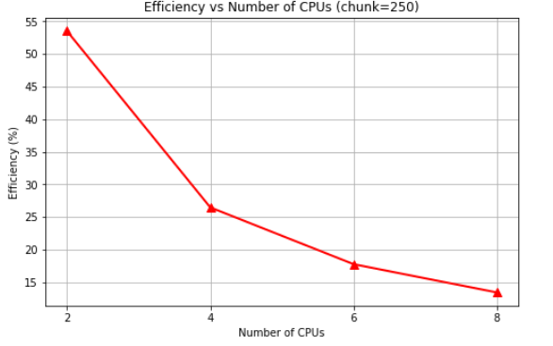

Efficiency Analysis
- Moderate start: 53% efficiency at 2 CPUs suggests some parallel benefit initially
- Rapid degradation: Drops to 13% at 8 CPUs, indicating severe scalability issues with fine-grained chunking
- Chunk overhead: Small chunks (250) create excessive synchronization costs that scale poorly
- Contrast with default: Default Part 3 maintained 95% efficiency at 8 CPUs, while chunk=250 achieves only 13%

Chunk_size: 1000

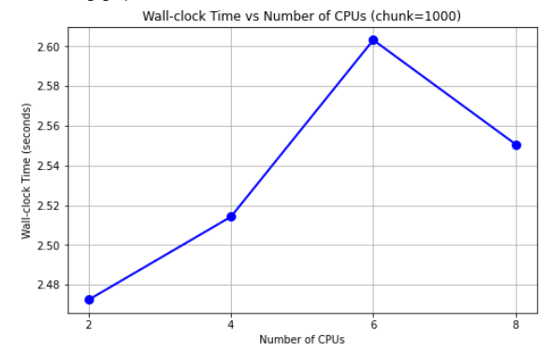

Wall-clock Time
- Performance degradation: Time increases from 2.47s (2 CPUs) to 2.60s (6 CPUs), showing negative scaling with more processors
- Inverted U-pattern: Peak slowdown at 6 CPUs suggests chunk=1000 creates worst load balance at mid-range parallelization
- 2x slower than default: Compared to Part 3's default (~1.2s), chunk=1000 doubles execution time
- Slight recovery: Improvement from 6 to 8 CPUs (2.60s→2.55s) indicates marginal load redistribution

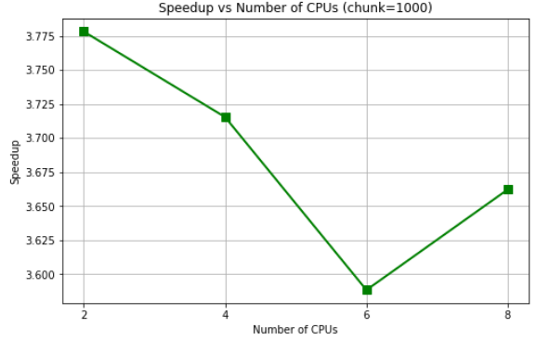

Speedup Analysis
- Moderate speedup: Values range 3.59-3.78, showing actual parallel benefit unlike Part 2 but below Part 3's default (8.4x)
- Inverse correlation: Speedup decreases as time increases, with lowest point at 6 CPUs (3.59) matching worst wall-clock time
- Suboptimal chunking: While achieving 3.6x+ speedup, chunk=1000 is too coarse compared to optimal configuration
- V-shaped curve: Recovery at 8 CPUs suggests slightly better work distribution at higher parallelization

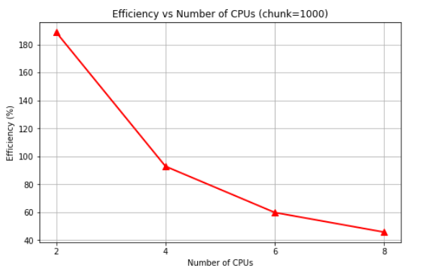

Efficiency Analysis
- Super-linear start: 188% efficiency at 2 CPUs indicates significant cache benefits from data partitioning
- Steep decline: Drops to 45% at 8 CPUs, showing poor scalability with moderate chunk size
- Better than chunk=250: Maintains higher efficiency (45% vs 13% at 8 CPUs) but worse than default (95%)
- Load imbalance evident: Efficiency pattern suggests chunk=1000 creates uneven work distribution, increasing with CPU count

Conclusion on Chunk Sizes:
Chunk size plays a crucial role in determining parallel performance in Part 3’s DataFrame operations. The default configuration delivers good results, achieving an 8.4× speedup and 95% efficiency. In contrast, setting the chunk size to 250 leads to severe overhead and almost serial performance (1.07× speedup, 13% efficiency) due to excessive task switching. A chunk size of 1000 provides moderate results (3.6× speedup, 45% efficiency) but suffers from load imbalance caused by coarse granularity. The wide performance gap—from 1.12 s with the default setting to 8.82 s with chunk = 250—illustrates that poor chunking can make parallel execution up to eight times slower, emphasizing the need to carefully align chunk size with workload characteristics and DataFrame operation overhead.

PART 3, Q4:
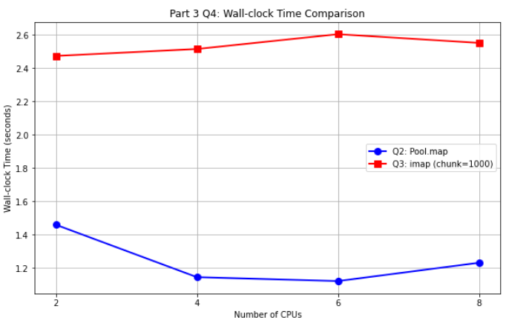

Wall-clock Time Comparison
- 2x performance gap: Pool map achieves 1.12-1.45s while imap (chunk=1000) requires 2.47-2.60s, showing default Pool map is consistently 2x faster
- Opposite scaling: Pool map improves with more CPUs (positive scaling) while imap degrades slightly, indicating better inherent parallelization
- Stability difference: imap shows minimal variation (2.47-2.60s) suggesting overhead dominance, while Pool map shows meaningful speedup potential

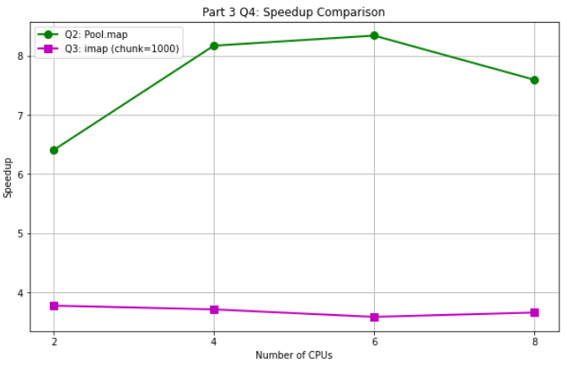

Speedup Comparison
- Dramatic difference: Pool map achieves 6.4-8.4x speedup versus imap's 3.6-3.8x, representing 2x better parallel acceleration
- Scaling behavior: Pool map shows strong scaling to 6 CPUs then slight decline, while imap remains nearly flat indicating poor scalability
- Peak performance: Pool map's 8.4x peak speedup suggests near-optimal parallelization while imap's 3.8x indicates significant overhead

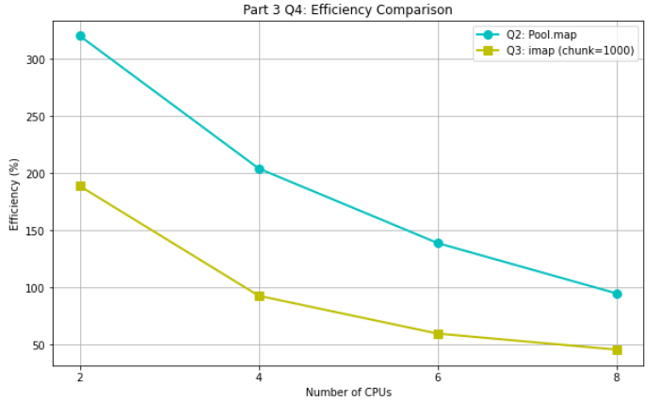

Efficiency Comparison
- Super-linear vs moderate: Pool map maintains exceptional efficiency (320%→95%) while imap drops more severely (188%→45%)
- 2x efficiency advantage: At 8 CPUs, Pool map retains 95% efficiency versus imap's 45%, showing superior resource utilization
- Cache effects: Both show super-linear efficiency initially (>100%) indicating cache benefits, but Pool map sustains this advantage better
- Chunk penalty: The chunk=1000 configuration adds ~50% efficiency loss compared to Pool map's default chunking strategy

OVERALL CONCLUSION:
Part 2 is a parallelization anti-pattern — every configuration gave speedups below 1.0, meaning parallel overhead swallowed 75–99% of runtime regardless of chunking. By contrast, Part 3’s vectorized DataFrame approach scales very well: the default Pool.map on 8 CPUs hit an 8.4× speedup and ~95% efficiency. Overall there’s a 10–20× gap between the two implementations, showing that algorithm design and data-structure choice decide whether parallelization even helps. Fine-grained operations in Part 2 simply create insurmountable overhead, while Part 3’s approach naturally fits parallel execution.
Chunk size matters, but it’s secondary to choosing the right algorithm. Poor chunking can slow even good parallel code by up to 8×—the Part 3 default ran in 1.12 s versus 8.82 s with chunk = 250—so defaults often capture useful tuning. Part 3 also showed super-line ar speedups (>100% efficiency) from better cache locality and distributed memory behavior, an advantage absent in Part 2’s overhead-dominated runs. The takeaway: don’t try to parallelize inherently serial, fine-grained work; instead pick parallel-friendly algorithms and the right granularity to actually gain performance.

