HPC HW 1 Essay Questions

Q1. Explain the differences between serial and parallel code?
Answer: Serial computing refers to the traditional way of writing software where a problem is divided into a set of instructions that are executed sequentially, one after the other, on a single processor. At any given moment, only one instruction is being processed.
In contrast, parallel computing makes use of multiple computing resources at the same time to solve a problem. In this approach, the problem is divided into smaller parts that can be worked on concurrently, and each part is further broken down into instructions that execute simultaneously across different processors.

Q2. What is the FLOPS and its usage in parallel computing?
Answer:
FLOPS (Floating-point Operations per Second)
- Represents the number of floating-point operations a computer can perform per second
- Common usage is to report overall efficiency of parallel code by comparing achieved FLOPS to the peak possible performance
- Peak performance is estimated assuming each processor core executes every possible floating-point operation during each clock cycle
- Serves as a performance measure in computing, especially for scientific computations requiring floating-point calculations
- Considered more accurate than measuring instructions per second for such cases
Q3. Simply explain the computer architecture of von Neumann?
Answer: The von Neumann architecture, often referred to as the “stored-program computer,” is a design where both program instructions and data are stored together in electronic memory. This marked a significant shift from earlier computers, which were programmed through hard wiring, as it allowed for greater flexibility and efficiency in executing programs.
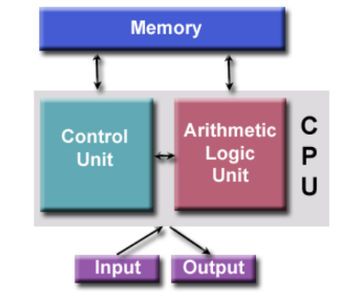

Q4. Simply explain: what is shared memory architecture and what is distributed memory architecture?
Answer:
Shared Memory Architecture
Shared memory architecture allows multiple processors to access a common memory space, often referred to as a global address space. This design makes programming more user-friendly, as all processors can directly share data. However, it also requires the programmer to implement synchronization constructs to ensure correct access to memory.
- Advantages:
  - Global address space provides a user-friendly programming perspective to memory
  - Data sharing between tasks is fast and uniform due to the proximity of memory to CPUs
- Disadvantages:
  - Limited scalability between memory and CPUs
  - Programmer must handle synchronization for correct memory access
Distributed Memory Architecture
In distributed memory architecture, each processor has its own local memory, and processors communicate with one another through message passing over a network. This approach requires programmers to manage synchronization between tasks, making it more complex but also scalable as the number of processors increases.
- Advantages:
  - Memory is scalable with the number of processors
  - Processors access their own memory without overhead
  - Cost-effective design
- Disadvantages:
  - Requires high programmer skills
  - Converting serial code to distributed memory systems is difficult
  - Non-uniform memory access times
Q5. Please give the parallel programming models in common use and simply explain.
Answer: Parallel programming models provide an abstraction that defines how tasks in a parallel program communicate and share data across hardware and memory architectures.
Parallel Programming Models in Common Use:-
- Shared Memory Model (without threads): Multiple processors access a common memory space to share data.
- Threads Model: Uses multiple threads within a process to run tasks in parallel while sharing memory.
- Distributed Memory Model: Each processor has its own local memory, and communication happens through message passing.
- Hybrid Model: Combines shared memory and distributed memory models for greater flexibility and scalability.

Q6. According to the lectures, how to evaluate your parallel performance practically? List the calculating formulas and explain.
Answer:
Speedup: This metric shows how much faster a parallel program performs compared to its serial counterpart. It is calculated as:
Speedup (S) = Wall-clock time of serial execution (Tserial) / Wall-clock time of parallel execution (Tparallel)
- Tserial​: Execution time on a single core (serial execution).
- Tparallel​: Execution time on multiple cores (parallel execution).
A value of Speedup > 1 indicates that the parallel program runs faster than the serial version.
Parallel Efficiency: This measures how effectively the available processors are being used. It is defined as:
Efficiency = Speedup / Number of cores
The efficiency ranges between 0 and 1 (or 0–100%). An efficiency value close to 1 means the processors are being utilized very effectively.
FLOPS-based Efficiency: This compares the number of floating-point operations actually achieved by the program against the peak theoretical performance of the system. It provides a way to evaluate how well the hardware’s computational capacity is being used.
Interpretation:
- Speedup greater than 1 → parallelization improves performance.
- Efficiency closer to 1 → better utilization of CPU resources.
Q7. Briefly explain the hybrid parallel programming model on current supercomputers (HPC clusters)?
Answer: The hybrid parallel programming model is widely used in today’s supercomputers and HPC clusters because it combines the strengths of different programming approaches to achieve better performance. Instead of relying on just one model, it mixes shared-memory programming and distributed-memory programming. This allows systems to make efficient use of both multiple cores within a node and multiple nodes across a cluster.
- MPI (Message Passing Interface): Used for communication between different nodes in the cluster. Each node has its own memory, so MPI handles the data exchange over the network.
- OpenMP or CUDA: Within a single node, OpenMP is used to parallelize tasks across multiple CPU cores, while CUDA can be used for GPU acceleration. This ensures that both CPUs and GPUs are effectively utilized.
By combining MPI with OpenMP or CUDA, the hybrid model balances work across nodes and within nodes, making it highly scalable and efficient for large scientific and engineering applications.

Q8. Explain the elements of Flynn's taxonomy?
Answer: Flynn’s taxonomy, introduced in 1966, is a classification system for different types of parallel computer architectures based on the number of instruction streams and data streams. It is represented as a two-by-two model with four categories.
- Single Instruction Single Data (SISD): Represents the typical CPU thread where a single instruction operates on a single data stream.
- Single Instruction Multiple Data (SIMD): A single instruction operates on multiple data streams, commonly found in vector processors and modern GPUs.
- Multiple Instruction Single Data (MISD): A rare model in which multiple instructions operate on a single data stream, possibly used in specialized systems such as filters.
- Multiple Instruction Multiple Data (MIMD): Involves multiple processors or clusters, where each processor executes different instructions on different data streams, often connected through high-speed communication networks for coordinated work.
Q9. Explain the terms of nodes and cluster?
Answer: A node is a standalone physical computer unit that has its own network connection and typically runs its own copy of the operating system. In supercomputers, nodes are connected together through a communications network. For example, in clusters like the NEU Discovery cluster, nodes are designed in compact units that ensure proper power, cooling, and connectivity.
A cluster is a collection of such nodes that together function as a single resource. Clusters may be managed as a unit, provide a consistent environment for running tasks, or work in collaboration to deliver services such as fault-tolerant access to file storage.
Q10. Please list the three primary API components in OpenMP and give simple examples?
Answer: OpenMP provides three primary API components that help programmers write parallel applications in C and C++. These components work together to control how parallelism is created, managed, and executed.
- Compiler Directives – These are special instructions added to the source code using pragmas. For example,
#pragma omp parallel for tells the compiler to run the following loop in parallel across multiple threads.
- Runtime Library Routines – These are functions that allow the program to interact with the OpenMP runtime system.
Examples include omp_get_thread_num(), which returns the thread ID, and omp_get_num_threads(), which returns the total number of threads in the team.
- Environment Variables – These control the execution environment without changing the code. For example,
export OMP_NUM_THREADS=4 sets the number of threads to 4 when running the program.

Together, these components give flexibility: compiler directives define parallel regions, runtime routines help manage execution during runtime, and environment variables let users tune performance easily without recompiling.
Q11. Please write the steps to use gcc compiler to compile a C file “hello_omp.c” with OpenMP flag and get the executable file “hello_omp”. On Linux bash shell system, set 4 threads by using the environment variable; then run this executable.
Answer: To compile and run an OpenMP program using the GNU compiler, we need to follow a few simple steps. First, the C file is compiled with the OpenMP flag to enable parallel programming support. Next, we set the number of threads using an environment variable. Finally, we execute the compiled file. The steps are:
- Compile the C file using the gcc compiler with the OpenMP flag:
gcc -o hello_omp -fopenmp hello_omp.c
- Set the number of threads to 4 by exporting the environment variable:
export OMP_NUM_THREADS=4
- Run the executable file:
./hello_omp
Q12. In HPC, there are two main ways of scaling a program. Please explain them?
Answer: In High Performance Computing, scaling refers to the ability to handle larger problems or more parallel tasks efficiently. The scalability of a program is measured by how the time-to-results changes with the problem size and the number of workers. This relationship can be complex, as it depends on factors such as the characteristics of the problem, the algorithms used, and the specifics of the hardware and network. There are two main ways of scaling a program in HPC.

Strong scaling: keeps the problem size fixed while increasing the number of tasks, with the goal of reducing the overall execution time.
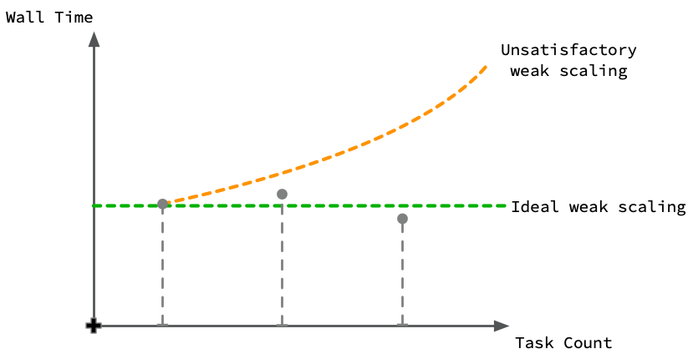

Weak scaling: on the other hand, increases the problem size along with the number of tasks so that the computation per task remains constant. Both approaches are essential for evaluating the efficiency and performance of parallel programs.
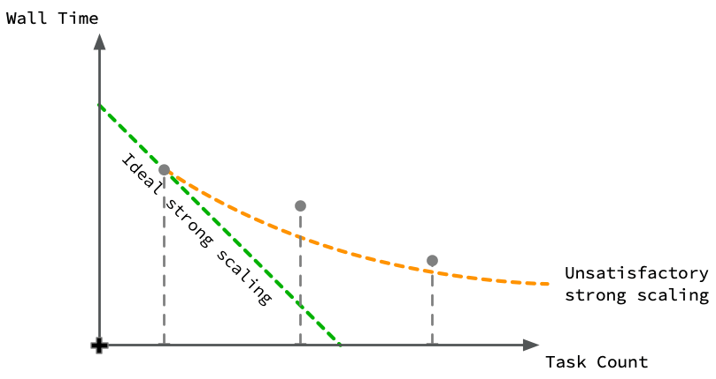
Q13. When you run your serial code on multiple cores (CPUs), you can employ two different approaches. Please explain these two approaches. Two theoretical results (laws) describe the conditions for the success of each approach. Please explain the two corresponding laws?
Answer: When we run serial code on multiple cores, there are two main approaches we can use. One option is to split the original computation across the available cores to make the program run faster. The Second option is to use the extra cores to scale up the problem so that we can solve a larger version of it in the same time. Both of these ideas are explained by two important laws.
- Amdahl’s Law (Fixed Problem Size): This law explains that the speedup of a program is limited by the part of the code that cannot be parallelized. Even if we keep adding more cores, the serial portion will always set a limit on how much faster the program can run.
Speedup S = Serial run time / Parallel run time
- Gustafson’s Law (Scaled Problem Size): This law focuses on scaling the problem size. It shows that as we increase the number of cores, we can solve bigger problems in the same amount of time, and the main limitation comes from how many cores are available.
Speedup S = N × Parallel fraction + Serial fraction
In both cases, the non-parallelizable part of the program ends up restricting the performance, but each law gives us a different way of looking at the benefits of parallel computing.

