

**Navigating Crime Incident Data**

**In dataMontgomery**

Table of Contents

Background: 3

Accessing the Dataset: 4

Basic navigation: 4

Search for data: 4

Filter and Sort Information: 5

Visual Forms of the Crime Data (Maps, Charts, Graphs) 7

Using the data outside of dataMontgomery 8

Questions? 9

Appendix – Overview of Data Included in Crime Dataset 10

Document Creation Date: June 2015

# Background:

The Open Data Act, passed by County Council in 2012, requires Montgomery County to make all publishable data available in an open, consumable format on a centralized public site. To accomplish this, a site called [dataMontgomery](https://data.montgomerycountymd.gov/) was created and will eventually showcase a countywide inventory of over 600 datasets representing every department in the Executive Branch. Data such as restaurant inspections, traffic violations, County maps and Council bills have already been published. The FY15 publishing plan includes the publishing of crime incident data that was published on June 30, 2015.

Things you should know about the data:

* This data includes crime incidents from 2013-present and comes from eJustice, not CAD.
* All incident locations are listed at the 100 block level.  No specific address or victim information will be released
* The data will be updated daily and fully refreshed a few times a year

Notes about this guide:

* This document provides basic instructions on how to search, filter and utilize functionality in dataMontgomery, specifically for crime incident data.
* The scenarios in this guide use Bethesda crime data, but this could be substituted for the city or district of your choosing
* When using this, please view it in an electronic format to be able to easily utilize the built-in website links for each exercise.
* Keep in mind that whenever you want to undo an action, select “Revert” in the yellow section above the dataset to return back to the original state. It is recommended to do this after each exercise)

## 

# Accessing the Dataset:

**All users can the data in multiple ways:**

1. During the initial release, the crime data will be highlighted with a graphic on dataMontgomery
2. Search the overall site using the search term “crime”
3. Click on the public safety category and scroll the results for crime
4. Access the direct link: <https://data.montgomerycountymd.gov/Public-Safety/Crime-Data/icn6-v9z3>

Basic navigation:

## Search for data:

Enter a keyword to search the entire dataset:

For example, enter “Dickens” in the search box



View results for incidents occurring on Dickens Avenue:

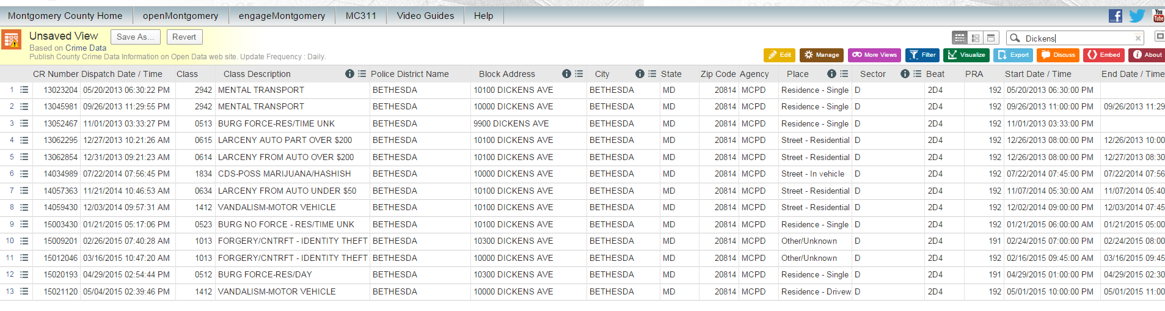

## Filter and Sort Information:

Searching and filtering data can be performed using two different options.

* 1. **Filter within a dataset**. Let’s say you want to look at crime in Bethesda starting with the most recent incidents.
     1. Look for the “City” column. Click on the image that looks like a shopping list:

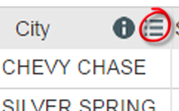

* + 1. Select “Filter this Column” and then Scroll to Select “Bethesda” from the list

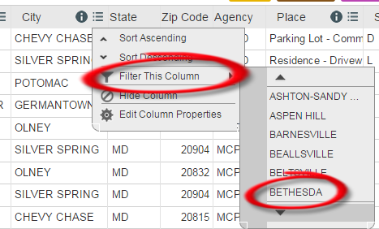

You now will see only crime incidents in Bethesda.



* + 1. To see the most recent incidents first, look for the Dispatch Data/Time column (2nd from the left). Select the shopping list image again  and Select “Sort Descending.”

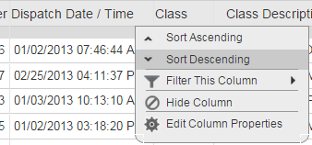

You now can see crime incidents in Bethesda, sorted chronologically in descending order:

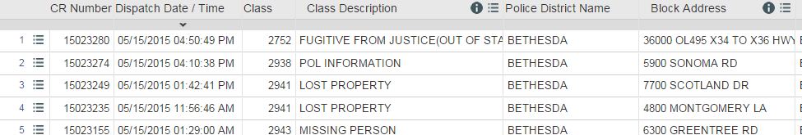

* 1. **Filter using a menu**. Let’s say you want to look at crime in Bethesda that occurred in 2015.
     1. Look to the colored menu tabs above the dataset table and click on “Filter” 
     2. Select “Add a New Filter Condition” 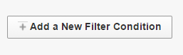
     3. Click on the left blue link listed to pick what field you want to filter ( “Dispatch Date/Time” from the listing) and what type of filter you want (“is after”) and check the checkbox. Click “Add a New Filter Condition” to select the field “City” and enter “Bethesda” in the options box and check the box.

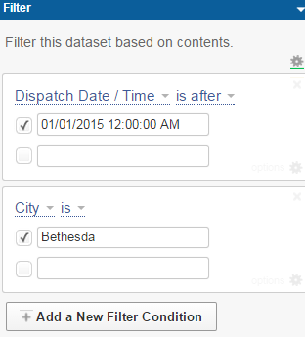

You now should see incidents in Bethesda that occurred in 2015.

* + 1. To sort this data in descending order, in the same menu, Select the “Sort and Roll-up” submenu, Click “Sort” and Select what field(s) you want to sort on (Dispatch Date/Time in the direction of descending order):

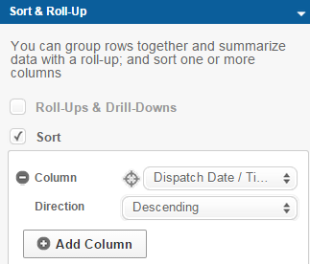

You now should see 2015 crime incidents in Bethesda, with the most recent incidents listed first:

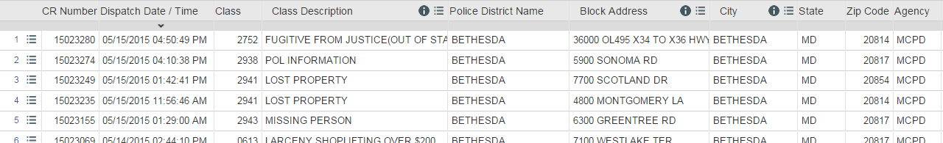

To assist you with viewing possible visualizations that can be created using dataMontgomery, some samples have been created for you to view. To view them, Select “More Views”  from the upper right hand menu. Click on the titles on the listing to view different visual representations of data.

Note for Generating Maps, Charts and other Visualizations: Please see the instructional videos for creating point maps and charts and other dataMontgomery functions at: <https://data.montgomerycountymd.gov/videos>. Videos specific to crime data will be coming soon. All maps and visuals created are only visible to the user that created it (plus whom it has been shared with, using the “Manage” menu), but it could be potentially published by the dataMontgomery team. If there is a visual aide you would like to have created and even potentially published, please contact dataMontgomery via the Suggest a Dataset option in the top navigation bar of the dataMontgomery site.

Visual Forms of the Crime Data (Maps, Charts, Graphs)

Maps, charts and graphs can be an additional reference to the data and help users frame out and better understand data. For example, here is a map of crime in Bethesda:

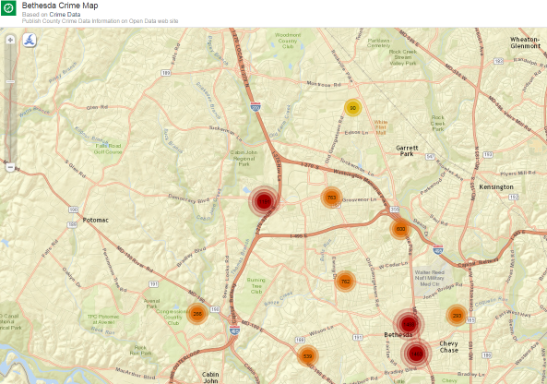

To look at data at or around a specific address, select the “X” symbol in the upper left hand corner 

Enter an address, and either select a radius where you want to see data points, or let the map auto generate.

This shows crime within an address entered in Bethesda:

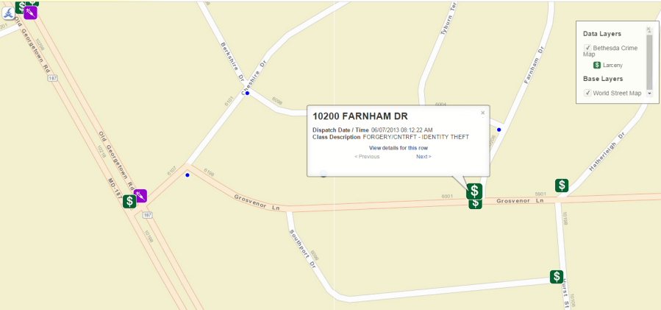

Using the data outside of dataMontgomery

(Exporting, printing or using this feed of data).

1. **Exporting the data.**  If you would like to use the crime data outside of dataMontgomery (such as in Excel), go ahead and search, filter and/or sort your data to find the data you need.
2. **Select the “**Export” menu option.

Select how you would like to receive this data. Here are some options:

* + - * 1.  is used by developers to link to the dataset to populate their websites, etc.
        2.  is an option for late versions of Microsoft Excel. This allows you to update your spreadsheet with the latest data every time you open your spreadsheet
        3.  simply prints the data
        4.  allows you to export your data in various formats (CSV is preferred for large amounts of data due to Excel record limit limitations)

1. **Embedding the data.** If you would like to show a live view of the crime dataset, map or chart that you’ve created on dataMontgomery on your website, you can “embed” it in your website. That means that, anytime a user loads your webpage, the dataset or map you embed will show as part of your webpage and will automatically update with the latest data. Users can then use the dataset within your page, without necessarily having the need to leave your webpage.

To embed data, search, sort, filter or visualize the data to create what you would like to show on your webpage.  [Here](https://data.montgomerycountymd.gov/Community/autism/q55t-udy3) is an example of a view a user created that shows autism-related requests in our MC311 request dataset. To embed this, the user would:

1. **Select the “Embed” menu option **
2. Select how big you want this embed to be on your webpage:

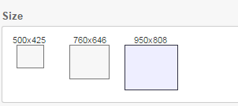

1. Select “Preview” to see how it would look on a webpage once embedded:

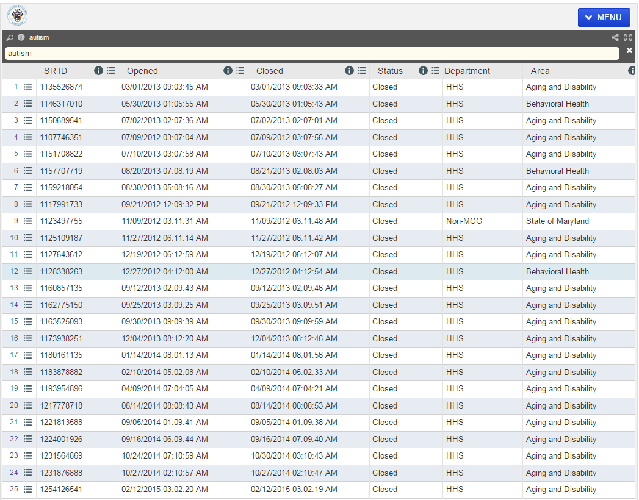

1. Once the preview shows what you want, have your website administrator copy the HTML on this page and include it on your website page:

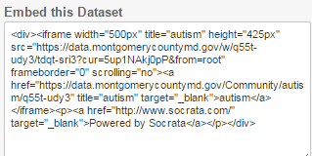

# Questions?

This is meant as a quick start guide to exploring crime data. If you need something further, let us help you. If you have questions, issues or great ideas on specific items, please pursue the following routes:

* + Please have the public contact MC311 for data related questions
  + For suggestions of more data you would like to see, use the “Suggest a Dataset” menu option on the dataMontgomery top navigation menu to submit your idea.

# Appendix – Overview of Data Included in Crime Dataset

|  |  |  |
| --- | --- | --- |
| **Display Order** | **Column** | **Field Description** |
| 1 | Incident ID | Police Incident Number |
| 2 | CR Number | Police Report Number |
| 3 | Dispatch Date / Time | The actual date and time a Officer was dispatched |
| 4 | Class | Four digit code identifying the crime type of the incident |
| 5 | Class Description | Common name description of the incident class type |
| 6 | Police District Name | Name of District (Rockville, Wheaton etc.) |
| 7 | Block Address | Address in 100 block level |
| 8 | City | City |
| 9 | State | State |
| 10 | Zip Code | Zip code |
| 11 | Agency | Assigned Police Department |
| 12 | Place | Place description |
| 13 | Police Sector | Police Sector Name |
| 14 | Beat | Police patrol area subset within District |
| 15 | PRA | Police patrol are subset within Beat |
| 16 | Start Date / Time | Occurred from date/time |
| 17 | End Date / Time | Occurred to date/time |
| 18 | Latitude | Latitude |
| 19 | Longitude | Longitude |
| 20 | Police District Number | Major Police Boundary |
| 21 | Location | Location |