http://www.sthda.com/english/wiki/ggplot2-barplots-quick-start-guide-r-software-and-data-visualization

Basic barplots

Data
Data derived from ToothGrowth data sets are used. ToothGrowth describes the effect of Vitamin C on Tooth growth in Guinea pigs.
df <- data.frame(dose=c("D0.5", "D1", "D2"),
len=c(4.2, 10, 29.5))head(df)
## dose len
## 1 D0.5 4.2
## 2 D1 10.0
## 3 D2 29.5
- len : Tooth length
- dose : Dose in milligrams (0.5, 1, 2

Create barplots
library(ggplot2)
# Basic barplot
p<-ggplot(data=df, aes(x=dose, y=len)) +
geom_bar(stat="identity")p
# Horizontal bar plot
p + coord_flip()
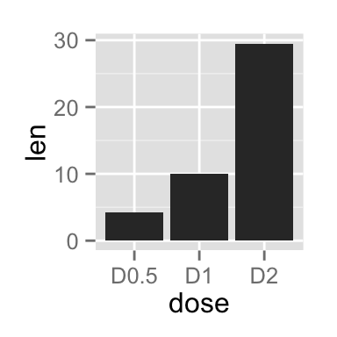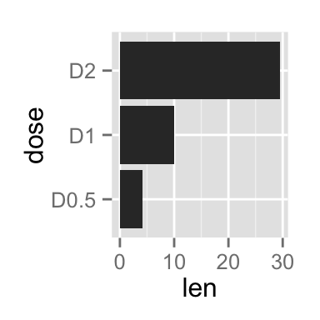
Change the width and the color of bars :
# Change the width of bars
ggplot(data=df, aes(x=dose, y=len)) +
geom_bar(stat="identity", width=0.5)
# Change colors
ggplot(data=df, aes(x=dose, y=len)) +
geom_bar(stat="identity", color="blue", fill="white")
# Minimal theme + blue fill color
p<-ggplot(data=df, aes(x=dose, y=len)) +
geom_bar(stat="identity", fill="steelblue")+
theme_minimal()p
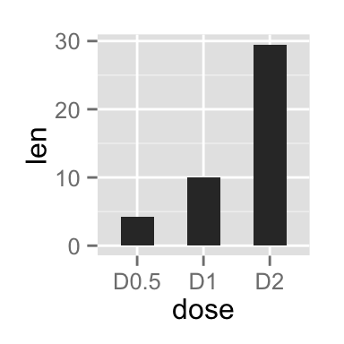
http://t-redactyl.io/blog/2016/01/creating-plots-in-r-using-ggplot2-part-4-stacked-bar-plots.html
Adjusting data labels position
To adjust the position of the data labels from the default placement, we use the ddply function on the data, and create a new variable called pos. This variable is at the centre of each bar and can be used to specify the position of the labels by assigning it to the y argument in
geom_text(aes()).
charts.data <- ddply(charts.data, .(year),
transform, pos = cumsum(percentage) - (0.5 * percentage))

p4 <- ggplot() + geom_bar(aes(y = percentage, x = year, fill = product), data = charts.data,
stat="identity")
p4 <- p4 + geom_text(data=charts.data, aes(x = year, y = pos, label = paste0(percentage,"%")),
size=4)
p4

https://rstudio-pubs-static.s3.amazonaws.com/329677_8f579b9e46284caeb9d3a72b7fdb7ac3.html
You can to make labels with ratios instead of counts with the following code.
ggplot(mtcars,aes(x=factor(cyl),fill=factor(gear)))+
geom_bar(position="fill")+
geom_text(aes(label=scales::percent(..count../sum(..count..))),
stat='count',position=position_fill(vjust=0.5))

To add labels with columnwise ratios, the first thing to do is to make another data summarizing columnwise ratio.

percentData <- mtcars %>% group_by(cyl) %>% count(gear) %>%
mutate(ratio=scales::percent(n/sum(n)))
percentData

# A tibble: 8 x 4
# Groups: cyl [3]
cyl gear n ratio
<dbl> <dbl> <int> <chr>
1 4 3 1 9.1%
2 4 4 8 72.7%
3 4 5 2 18.2%
4 6 3 2 28.6%
5 6 4 4 57.1%
6 6 5 1 14.3%
7 8 3 12 85.7%
8 8 5 2 14.3%
With this data, make a label with geom_text() function.

ggplot(mtcars,aes(x=factor(cyl),fill=factor(gear)))+
geom_bar(position="fill")+
geom_text(data=percentData, aes(y=n,label=ratio),
position=position_fill(vjust=0.5))

