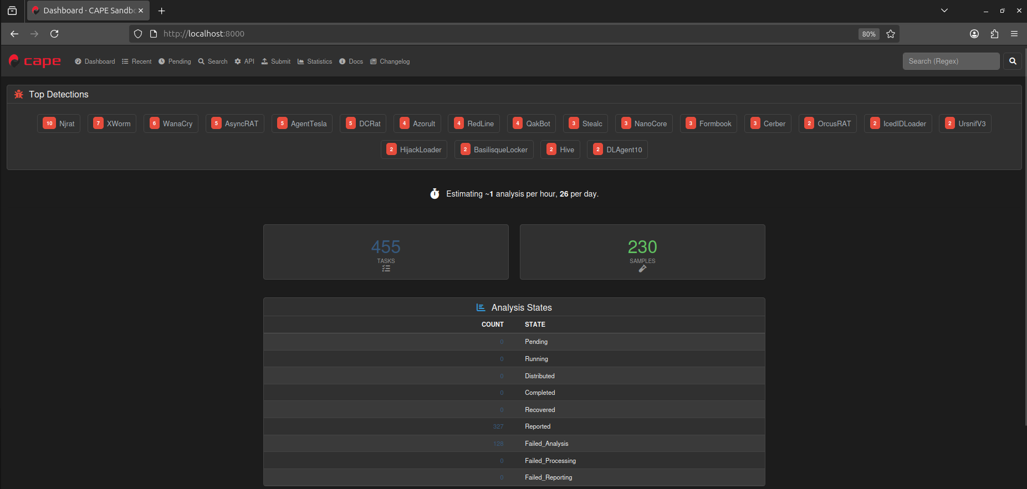
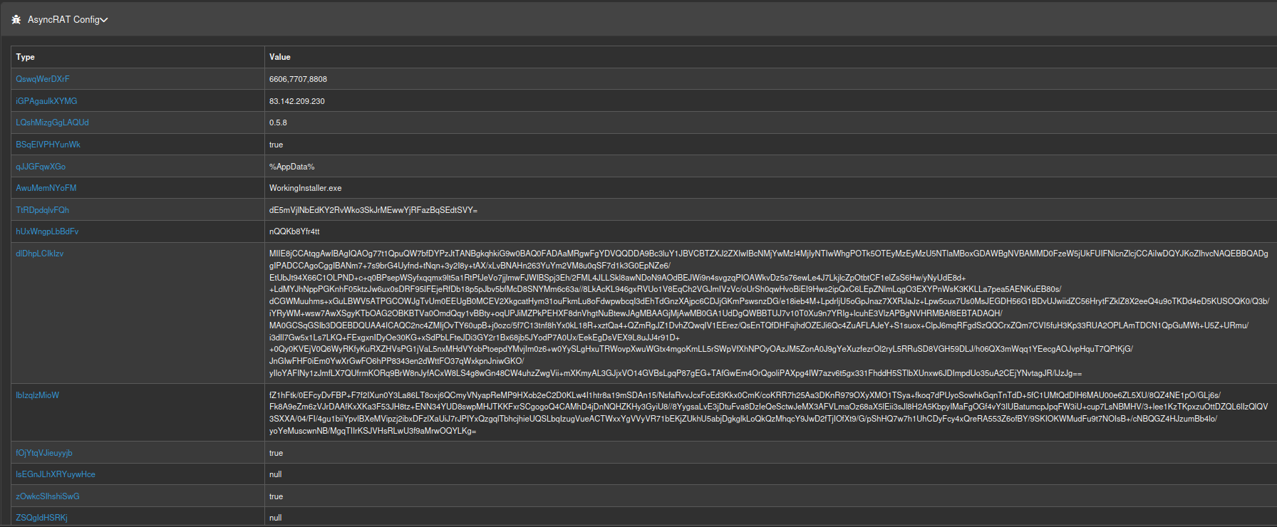

1️⃣ Fixing the GitHub Repo
Goal: Make it usable, safe, and professional for researchers or other devs.
Checklist:
- Improve Documentation
  - Update README:
    - Short description (1–2 sentences)
    - Installation instructions (dependencies, Python version, sandbox setup)
    - Quick start example (run on sample malware traces)
    - Output explanation (what the user will get)
  - Add “Project Overview” diagram: pipeline from sandbox → feature extraction → ML → explainability
- Code Hygiene
  - Standardize code formatting (PEP8 for Python)
  - Add inline comments explaining tricky parts (feature extraction, SHAP interpretation)
  - Split code into modules:
    - data_processing.py
    - ml_model.py
    - explainability.py
    - utils.py
  - Add requirements.txt or pyproject.toml for dependencies
- Make It Safer / Simpler
  - Provide a mock dataset or sanitized samples so users can run it safely without touching real malware
  - Wrap potentially dangerous calls (subprocess, shell execution) with warnings or checks
- Evaluation Metrics
  - Add a dedicated script for train/test evaluation
  - Include F1, precision, recall, confusion matrix
  - Discuss limitations (false positives, family hold-out evaluation)
- Optional: Packaging
  - Allow users to run via python -m maltrace or CLI commands
  - Include sample configs to make setup painless

2️⃣ Fixing the Medium Article
Goal: Make it technically strong, educational, and credible — no fluff.
Checklist:
- Add Real Examples
  - Include screenshots of:
    - Sandbox traces
    - Feature extraction outputs
    - ML predictions + SHAP plots
  - Example of MITRE ATT&CK mapping
- Deepen Technical Discussion
  - Explain why Random Forest was chosen
  - Discuss dataset size, imbalance, train/test splits
  - Talk about limitations: generalization, noisy features, risks
- Link to Repo
  - Add a “Try it yourself” section linking the GitHub repo
  - Include instructions for safe experimentation (mock dataset, warnings)
- Explain ML Explainability Clearly
  - Walk the reader through a SHAP explanation step-by-step
  - Explain what the output tells you about malware behavior
- Polish Writing & Visuals
  - Add diagrams for:
    - Full pipeline
    - ML + explainability process
  - Keep language professional but approachable

3️⃣ Extra: Make it Portfolio-Ready
- Add badges to repo (Python version, license, build status if you add CI)
- Include a “Key Learnings” section in README and article:
  - What worked
  - What was challenging
  - What you would improve next
- Include a future work section:
  - Scaling to new malware families
  - Adding other ML models
  - Improving sandbox automation

If you follow this, your project and article will go from “academic prototype + blog fluff” → polished portfolio-ready work that shows off your technical skills, research ability, and professionalism.

If you want, I can rewrite your Medium article outline brutally and professionally, with headings, flow, and examples that match your upgraded repo — so your first post after your master’s looks amazing.
Do you want me to do that next?

