2. Production Architecture (FastAPI + Streamlit)
This is the architecture I recommend — clean, scalable, and easy to deploy:
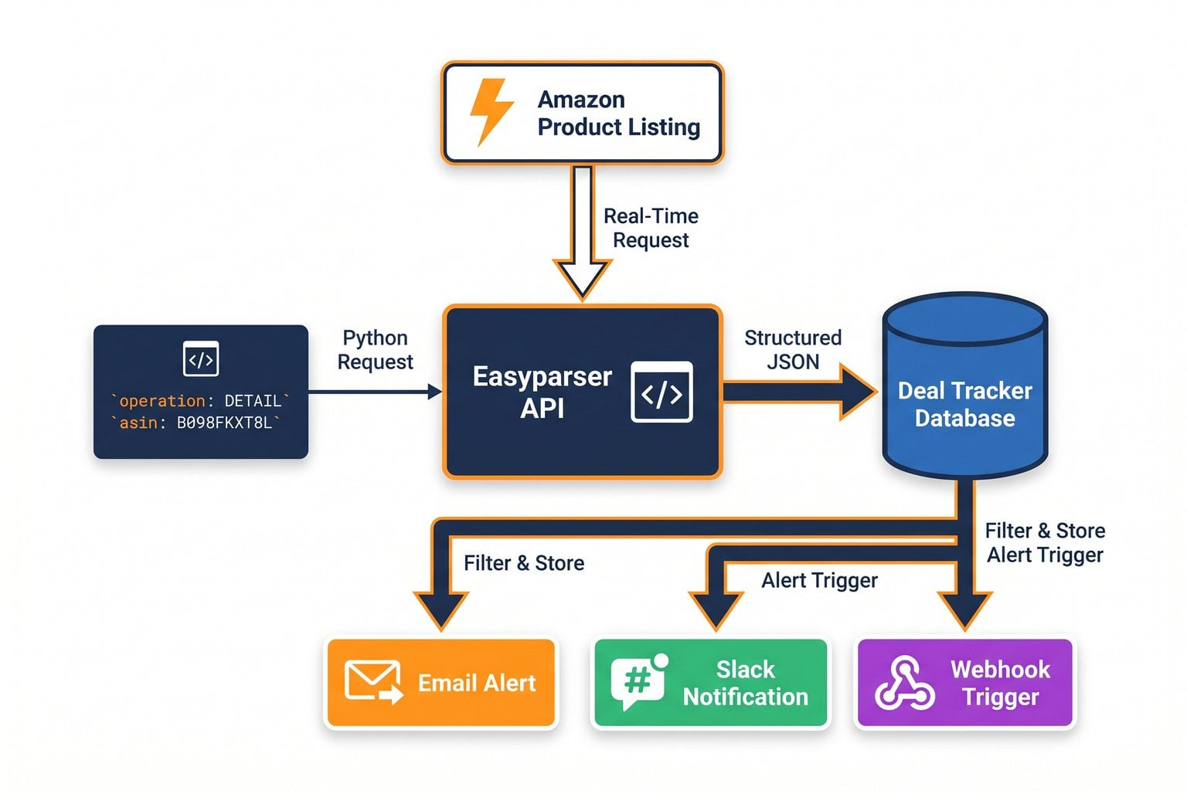
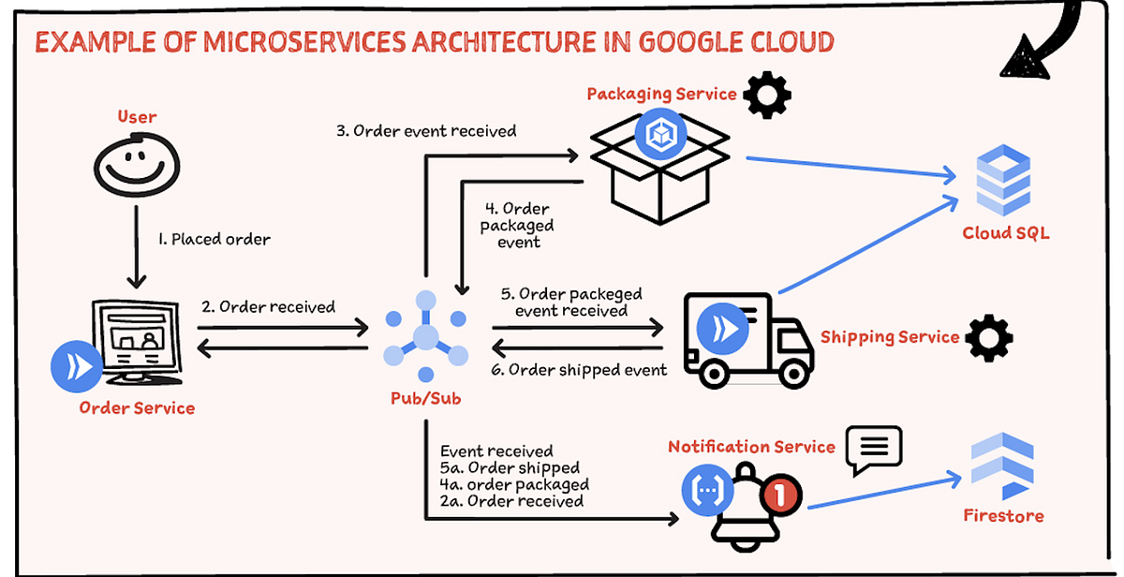

Backend (FastAPI)
Handles:
- LLM calls
- JD parsing
- Resume evaluation
- Ranking
- File ingestion
- Logging + observability
- Background jobs (Celery optional)

Frontend (Streamlit)
Handles:
- UI
- File uploads
- Progress display
- Calling backend endpoints
- Rendering results

Optional Worker Layer
- Celery + Redis for long-running tasks
- Lets you evaluate 50–500 resumes asynchronously

3. Recommended Folder Structure
Code
project_root/
│
├── backend/
│ ├── main.py # FastAPI entrypoint
│ ├── models.py # Pydantic models
│ ├── llm_service.py # LLM wrapper + retry logic
│ ├── pipeline.py # JD → Eval → Rank logic
│ ├── document_loader.py # Secure PDF/DOCX loader
│ ├── config.py # Env config + constants
│ └── requirements.txt
│
├── frontend/
│ ├── streamlit_app.py # UI only
│ └── requirements.txt
│
├── worker/ # Optional
│ ├── tasks.py
│ └── celeryconfig.py
│
└── README.md

4. Next Step: Build the FastAPI Backend
Below is the first backend file: backend/main.py.
This is the core API that your Streamlit frontend will call.
It includes:
- /analyze_jd
- /evaluate
- /rank
- /pipeline (full end-to-end)
- Proper models
- Error handling
- Logging
- CORS for Streamlit

backend/main.py (FastAPI backend)

This is the core backend. Next, we generate:
- models.py
- llm_service.py
- pipeline.py
- document_loader.py
Then we update your Streamlit frontend to call these endpoints.

🎯 5. What’s the next step?
I can now generate the entire backend folder, including:
- models.py
- llm_service.py
- pipeline.py
- document_loader.py
- config.py

FRONTEND
— a clean, production-aligned Streamlit UI that talks to your FastAPI backend.
This frontend:
- Uploads JD + resumes
- Calls your backend endpoints
- Shows progress + results
- Handles errors gracefully
- Uses a clean two-column layout
- Keeps the UI thin (all logic stays in backend)
Below is the complete frontend/streamlit_app.py file.

Folder Structure (Frontend)
Code
frontend/
│
├── streamlit_app.py
└── requirements.txt

How to run the full system

1. Start backend
Code
cd backend
uvicorn main:app --reload --port 8000

2. Start frontend
Code
cd frontend
streamlit run streamlit_app.py

What you have now
You now have a full production-aligned architecture:
- FastAPI backend (secure, parallel, validated, robust)
- Streamlit frontend (clean UI, uploads, progress, ranking)
- Clear separation of concerns
- Ready for Docker, Azure App Service, or on-prem deployment

If you want, I can now generate:
- Dockerfiles for backend + frontend
- A docker-compose.yml
- A Kubernetes deployment
- A CI/CD pipeline (GitHub Actions)

