Assignment 4 - Multivariate Models

Chelsea Woodruff

2/7/2019

plot(dune_mds, type='n')  
 text(dune_mds, 'sp', cex=.5)  
 # generate vector of colors   
 color_vect = rev(terrain.colors(6))[-1]  
 points(dune_mds, 'sites', pch=19,   
 col=color_vect[dune.env$Moisture])  
 legend('topright', paste("Moisture =", 1:5, sep=''),   
 col=color_vect, pch=19)

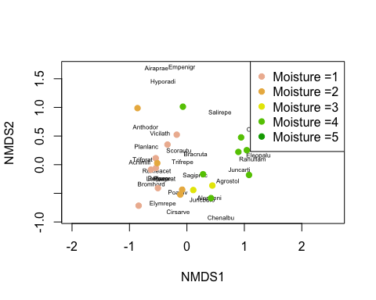 The axes are applied for explained variance. Firstly, the species abundance is plotted by name. Those in clusters are more abundant and those that are more rare are a farther distance from the clusters (note Airaprae, Empenigr, and Hyporadi near the top). Sites that are different are further apart. Vice versa, those that are similar are closer together. Moisture values are then plotted over that, and they fall over some clusters of species. The goal of creating a plot like this is to gain a first-impression visual sense if moisture is related to species site differences. By first glance, there is a relationship with moisture related to the similaries or differences of sites.

plot(cca(dune, dune.env))

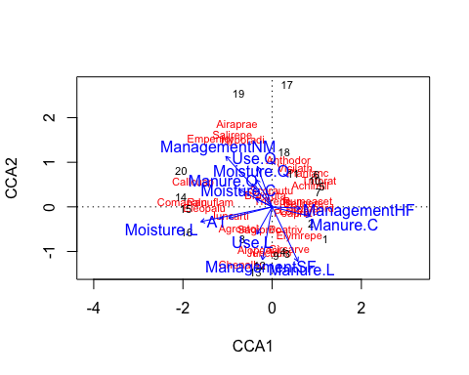

plot(cca(dune, dune.env$Moisture))

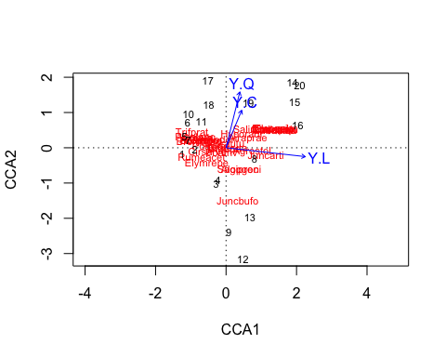

plot(cca(dune ~ dune.env$Moisture))

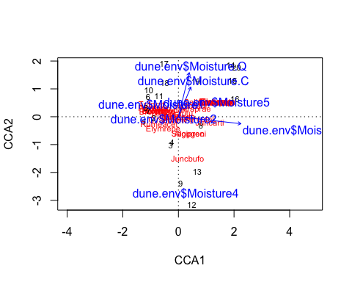

cca_dune = cca(dune ~ ., data=dune.env)  
RsquareAdj(cca_dune, 100)

## $r.squared  
## [1] 0.7106267  
##   
## $adj.r.squared  
## [1] 0.214368

anova(cca_dune, permutations=999)

## Permutation test for cca under reduced model  
## Permutation: free  
## Number of permutations: 999  
##   
## Model: cca(formula = dune ~ A1 + Moisture + Management + Use + Manure, data = dune.env)  
## Df ChiSquare F Pr(>F)   
## Model 12 1.5032 1.4325 0.029 *  
## Residual 7 0.6121   
## ---  
## Signif. codes: 0 '***' 0.001 '**' 0.01 '*' 0.05 '.' 0.1 ' ' 1

anova(cca_dune, by = "margin", permutations=999)

## Permutation test for cca under reduced model  
## Marginal effects of terms  
## Permutation: free  
## Number of permutations: 999  
##   
## Model: cca(formula = dune ~ A1 + Moisture + Management + Use + Manure, data = dune.env)  
## Df ChiSquare F Pr(>F)  
## A1 1 0.11070 1.2660 0.225  
## Moisture 3 0.31587 1.2041 0.205  
## Management 2 0.15882 0.9081 0.570  
## Use 2 0.13010 0.7439 0.761  
## Manure 3 0.25490 0.9717 0.486  
## Residual 7 0.61210

cca(formula = dune ~ Moisture, data = dune.env)

## Call: cca(formula = dune ~ Moisture, data = dune.env)  
##   
## Inertia Proportion Rank  
## Total 2.1153 1.0000   
## Constrained 0.6283 0.2970 3  
## Unconstrained 1.4870 0.7030 16  
## Inertia is scaled Chi-square   
##   
## Eigenvalues for constrained axes:  
## CCA1 CCA2 CCA3   
## 0.4187 0.1330 0.0766   
##   
## Eigenvalues for unconstrained axes:  
## CA1 CA2 CA3 CA4 CA5 CA6 CA7 CA8 CA9 CA10   
## 0.4098 0.2259 0.1761 0.1234 0.1082 0.0908 0.0859 0.0609 0.0566 0.0467   
## CA11 CA12 CA13 CA14 CA15 CA16   
## 0.0419 0.0201 0.0143 0.0099 0.0085 0.0080

cca(formula = dune ~ Moisture + Management + Manure, data = dune.env)

## Call: cca(formula = dune ~ Moisture + Management + Manure, data =  
## dune.env)  
##   
## Inertia Proportion Rank  
## Total 2.1153 1.0000   
## Constrained 1.2214 0.5774 9  
## Unconstrained 0.8939 0.4226 10  
## Inertia is scaled Chi-square   
## Some constraints were aliased because they were collinear (redundant)  
##   
## Eigenvalues for constrained axes:  
## CCA1 CCA2 CCA3 CCA4 CCA5 CCA6 CCA7 CCA8 CCA9   
## 0.4464 0.3100 0.1603 0.0928 0.0734 0.0614 0.0392 0.0246 0.0135   
##   
## Eigenvalues for unconstrained axes:  
## CA1 CA2 CA3 CA4 CA5 CA6 CA7 CA8 CA9 CA10   
## 0.3416 0.1258 0.1064 0.0950 0.0679 0.0587 0.0395 0.0309 0.0181 0.0100

*In the first plot, the take home message appears to be that Management and Moisture had affect on the dispersal of the variety of dune vegetation species, due to the variance. In the last plot, the quadratic function of moisture seemingly has the highest explained variance among the functions. This isn’t much different from the first plot but it much easier to interpret by eliminating the other variable functions.*