Assignment 1 Part 1
By: Cristan Lansang

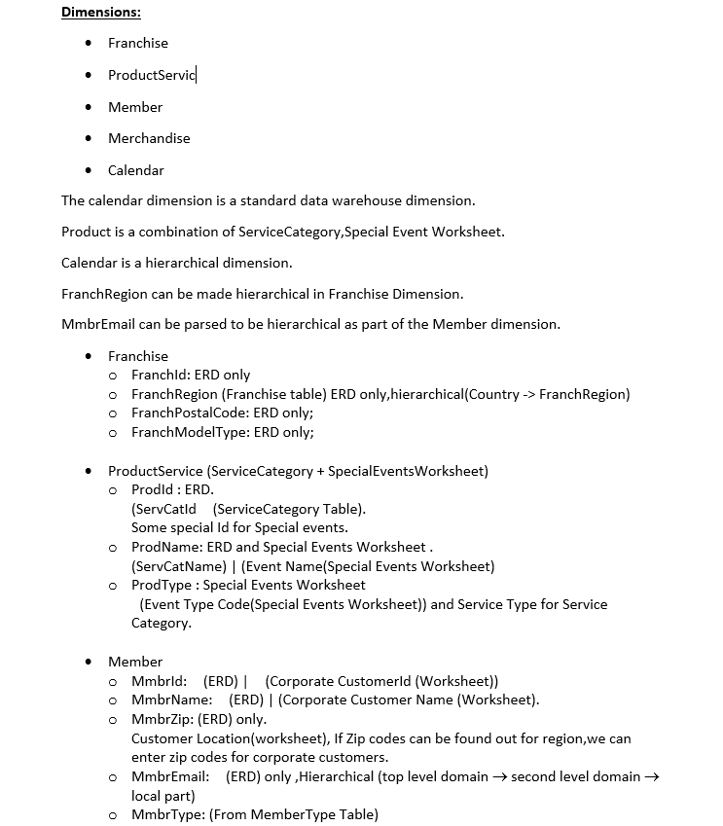

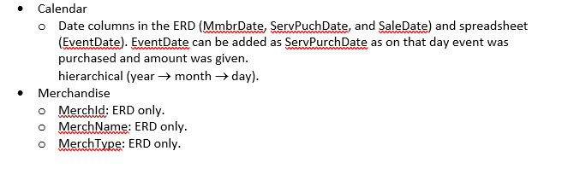
I would like to create a text file (the format doesn't matter) whose text is invisible. I don't mean a hidden file. A normal file with invisible, copiable text. Or could it be displayed the way passwords are displayed, as asterisks or dots? Any ideas would be greatly appreciated!
Basically I want to keep myself from acessing certain websites (you're free to guess). I guess I need to find a different way of solving this.

I don't quite understand what you want, but what's wrong with an office or web document with the text the same colour as the background?
Thanks for your answer. I want to keep myself from acessing certain websites (you're free to guess). I guess I need to find a different way of solving this.
– What's my name
Dec 5 '15 at 21:00

