Assignment 1 Part 3
By: Cristan Lansang

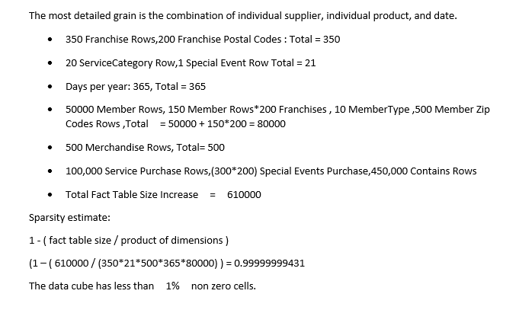
OK, it sounds like you may need to use some web type environment. Here's some food for thought, based on your idea of asterisks. Copy the code below into a notepad, and save it as whateveryouwant.hta (file extension must be hta): The textbox is set as password type which results in the masking, but it also forbids the user from using a normal copy command. So you have to get the text programmatically and set it to the clipboard - hence the 'Copy Text' button.

