Assignment 1 Part 4
By: Cristan Lansang

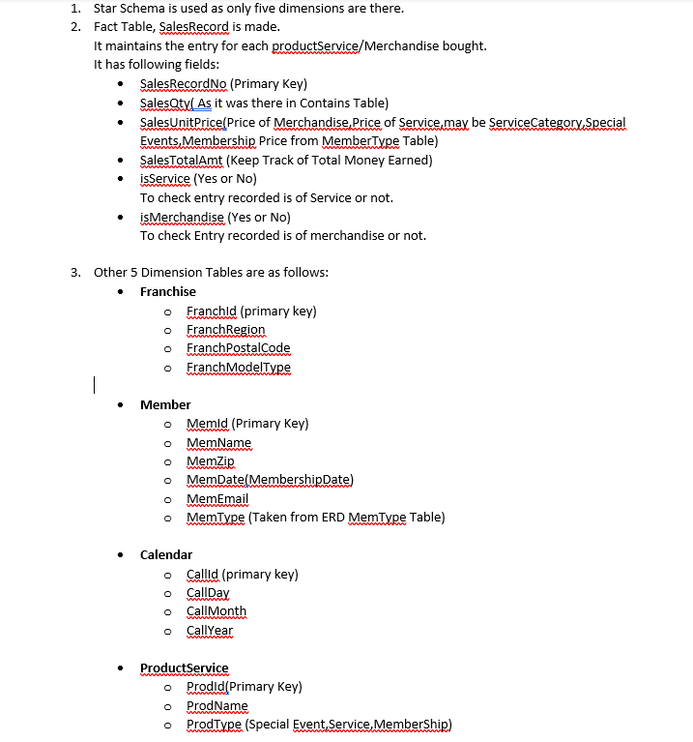
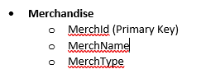

Use text-ident CSS property
You can achieve the same effect as in two previo

Daniel Vestøl

, Writing HTML since I was 11
Updated September 13, 2016
<p style=”display:none;”></p>
Removes the element from the visible page, other elements takes its place
<p style=”visibility:none;”></p>
Variant of the same thing
<p style=”opacity:0;”></p>
Makes the element 100% transparent
11K views
View 2 upvotes
2
1
1 comment from
Hasan Al-Yazidi

