Assignment 1 Part 6
By: Cristan Lansang

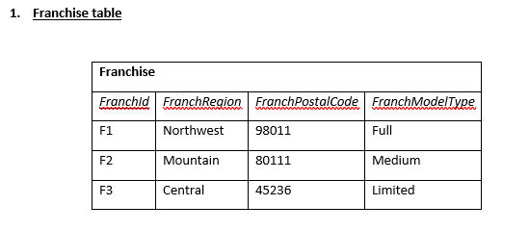
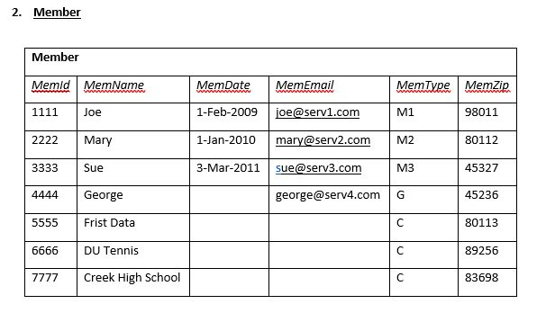

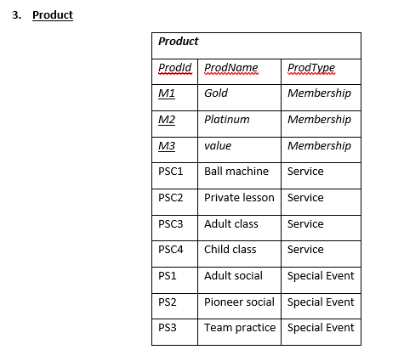
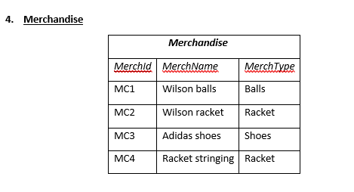

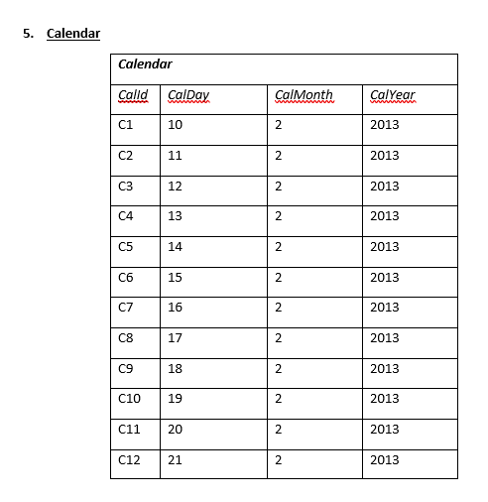
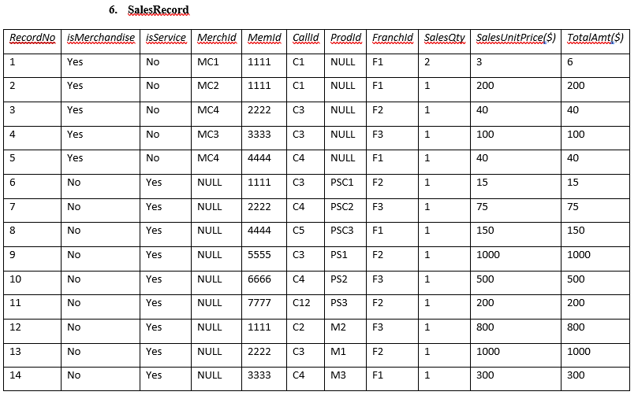
While it's annoying to do on a touchscreen, you should still be able to highlight invisible text. As in the title. I was reading a quest that used quite a bit of invisitext on my laptop. When I got to my Iphone later I realized I couldn't figure out how to display the invisible text. I know that in order to see it on safari, I have to quote the post, and then go into the mode that lets you see BBcode. Which is....suboptimal, and assumes you know that it's even there.

EDIT: E.g: Some mobile browsers interpret highlighting differently. The way it works on desktop and some mobile browsers is that highlighting changes the background but keeps the foreground color the same or makes it the inverse of the highlight color. With transparent text that means the text will have the color of the previous background. This seems to be a bit of an ascended bug because it doesn't make much sense when you look at it from this perspective.

Mobile browsers that don't just blindly copy a desktop browser implement it slightly differently and recalculate the text color after highlighting. That is technically a little more correct but it completely wrecks attempts to reveal invisitext by highlighting.

