 

**SCHOOL OF COMPUTING, ENGINEERING AND BUILT ENVIRONMENT**

**Department of Computing**

**BSc/BSc (Hons) Computing**

**Mobile Platform Development**

**Module code (MH1324189-19-B)**

**Individual Coursework Report**

**“I declare that all work submitted for this coursework is the work of Cyrose Kyalo except where explicitly stated otherwise.”**

**Student ID: S1803439**

**Table of contents**

**Introduction** **3**

**Design Report** **3**

The development approach 3

Goals for the design 3

HCI design principles. 3

Screens 4

**Testing Report** **6**

Table 6

Figures 7

**Test Strategy** **12**

Unit testing. 12

Integration testing 13

System testing 13

Acceptance testing 13

**Conclusion** **13**

# **Introduction**

This report is based on the creation of a mobile application that displays earthquake information on various places. The report is divided into 3 sections:

* Design Report
* Testing Report
* Written documented test strategy

Each of the above sections will be justified and images used for further explanation. The report also has links to the github video, android project and project.apk attached as seen below.

* Project.apk

[**https://github.com/ckyalo/mpd_coursework/blob/master/SeismicApp.apk**](https://github.com/ckyalo/mpd_coursework/blob/master/SeismicApp.apk)

* Github video

[**https://github.com/ckyalo/mpd_coursework/blob/master/SeismicAppVideo.mp4**](https://github.com/ckyalo/mpd_coursework/blob/master/SeismicAppVideo.mp4)

* Android project

[**https://github.com/ckyalo/mpd_coursework/tree/master/SeismicInformationAndroid**](https://github.com/ckyalo/mpd_coursework/tree/master/SeismicInformationAndroid)

# **Design Report**

During the design process,the following were considered:

## **The development approach**

Agile because it is considered a continuous incremental approach that has tests done at every stage.

## **Goals for the design**

* + Ensure that the user interface is simple
  + Provide an ease of navigation interface across all pages.
  + Colors- Bright colors so that the users are able to enjoy the feel of the website

## **HCI design principles.**

* + Consistency-Actions such as menus, colors, prompts need to be uniform to ensure that users
  + Perceivability-This was important so that users can be able to understand what needs to be done and when next. This is always aided with visual clues. In this design, it was implemented using the search button using date ranges as it is known by different users that it aids to search items.

## **Screens**

There was creation of four pages each with a design and purpose. Below are justifications and with a clear reasoning.

* **Splash screen**

This approach was to display the logo of the application and load before the other screens are seen. This takes 2 seconds to load.

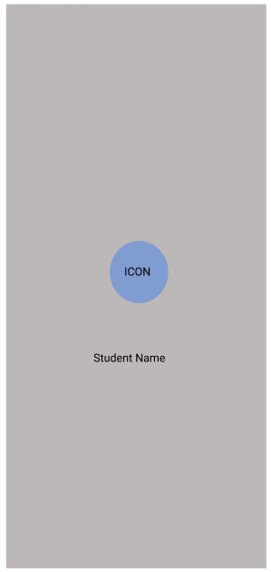

* **Siesmology screen**

This was designed based on a scrollable list concept known as recycler view. The goal of the page was so that users can see all the earthquakes and also the magnitude of the earthquakes. Buttons and the maps were cleared separated until the button was clicked, only then is a map seen to create an ease of navigation for the users

* Buttons- represented in different colors.

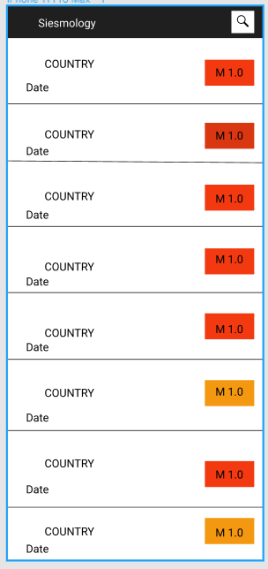

* **SisemicInformation screen**

The design was based on separation between a country and a map. The concept was done using just meant to display the data of the country on the upper part of the page and the map at the bottom using graphic images.

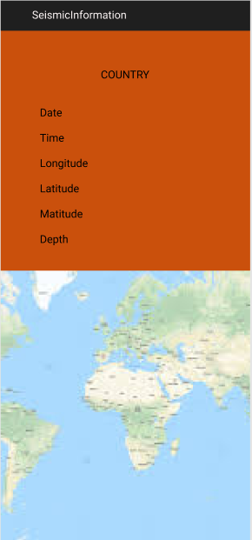

* **Search screen**

This was to display information about earthquakes based on creating cards and using colors. There was the use of the search area that enabled users to insert the information needed. For this illustration, dates were used as the information there. Cards were designed to be used for the different nearest locations.

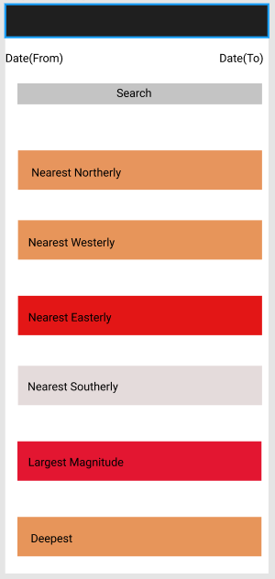

# **Testing Report**

One of the key tasks for the report is to explain the functionality of the application. This is mainly proven using tests to show that it was successful. Below are the tests that were done during the implementation.

The figures will be located at the bottom of the table to show the effectiveness.

## **Table**

|  |  |  |  |
| --- | --- | --- | --- |
| Tests | Expected Outcome | Actual Results | **Figures** |
| Display all earthquake occurrences | The earthquakes are displayed on the user interface with a date at the bottom. | This test is successful.  -There is a list of all the earthquakes  -Each earthquake has a date at the bottom | ***Figure 1*** |
| Display location (maps )of the earthquake occurrences | Upon clicking the magnitude on the earthquakes display, the map should be visible. | The test if successful  -Each earthquake location displays on a map | ***Figure 2*** |
| Display of finding the nearest location of the earthquake occurrence from mauritius | Descriptive data on earthquakes is received upon searching | The test is successful  -The deepest earthquake  -The largest earthquake  -Nearest northerly, southerly, westerly and easterly earthquake | ***Figure 3***  ***Figure 4-Example(Southerly)*** |
| Using dates to search for the nearest earthquakes | Specific dates are entered in the search button to determine the earthquakes based on cardinality | The test is successful  -Date example is used | ***Figure 5*** |
| Using URL to parse data | The earthquakes data available in the XML feed in the URL should be able to be displayed in the mobile interface | The test is successful | ***Figure 6*** |
| Display of portrait and landscape | Upon user placing the mobile application in the portrait and landscape layouts, the search button,seismic and the siesmology should be displayed and viewed well | This test is successful and both layouts are possible | ***Figure 7-example 1***  ***Figure 8-example 2*** |
| Display of menu | The search button should give users an option to input fields such as dates | The test is successful | ***Figure 9*** |

## **Figures**

**Display all earthquake occurrences**

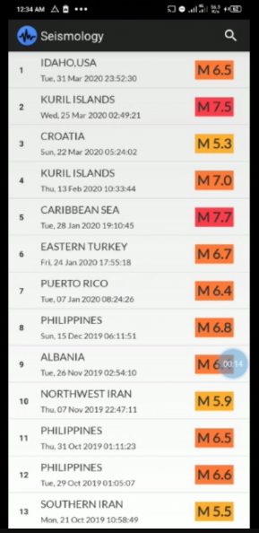

***Figure 1***

**Display location (maps )of the earthquake occurrences**

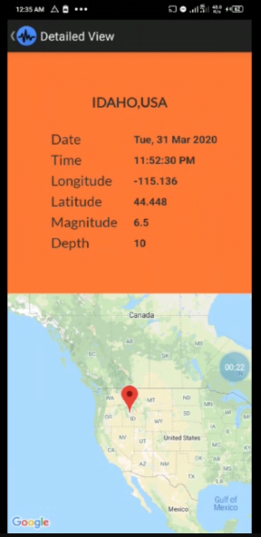

***Figure 2***

**Display of finding the nearest location of the earthquake occurrence**

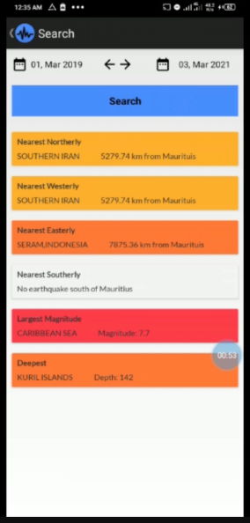

***Figure 3***

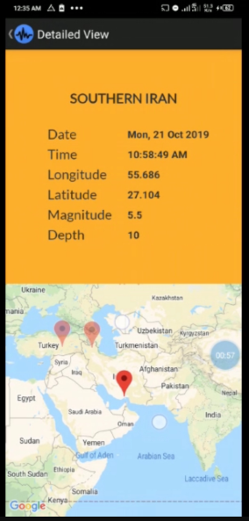

***Figure 4-Example(Southerly)***

**Using dates to search for the nearest earthquakes**

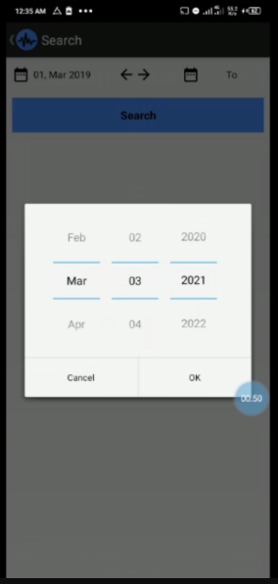

***Figure 5***

**Using URL to parse data**

**Display of portrait and landscape**

**Portrait Landscape**

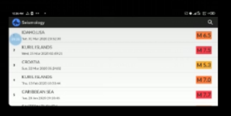

***Figure 7-example 1***

**Portrait Landscape**

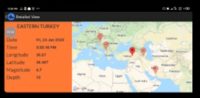

***Figure 8-example 2***

**Display of menu**



***Figure 9***

# **Test Strategy**

The main reason for this part of documentation is to explain how the tests above were conducted.

The main purpose for this is always to ensure quality, functionality and usability. The methodology of the mobile application was using an agile development. The following technique strategies were used.

Below is an image of the testing strategies that were implemented.

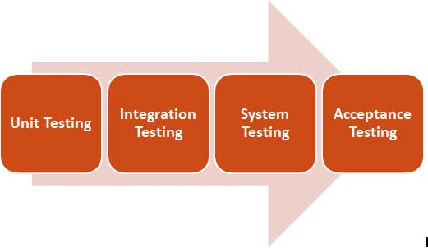

## **Unit testing.**

This was carried out at every stage of the development. For instance, in creating the first part which was the siesmology screen, a test was done to show that upon clicking, a map and a country was displayed as seen in ***figure 2***

## **Integration testing**

Upon getting to testing ***figure 3*** and ***figure 5***, there was a need to first test ***figure 5*** which shows the dates and if it works, then that was when ***figure 3*** (displays the nearest location of earthquakes) works too and the tests are seen. This means that two different tests were conducted first together so that there was a result for the location of earthquakes. This test basically was used since it combines two tests or units to make work easier.

## **System testing**

Upon finishing the development of the application, there was testing for the whole system with both me(the developer) and a group of people who I asked to use it on my emulator.

## **Acceptance testing**

This testing is always done to ensure that the application meets the stipulated requirements. All the above tests were meeting the assignment requirements and thus effective.

Another important test strategy was getting feedback from people after each stage of testing so that any relevant information not included is done.

# **Conclusion**

The design, testing report and test strategy were done effectively allowing the user of the application to navigate the application easily and freely understand the use of the application.