Clustering Methods

This report consists of the description of following tasks:

1. Implement K-means for clustering
2. Implement Fuzzy Clustering EM for clustering
3. Use a DBSCAN model for clustering

Environment

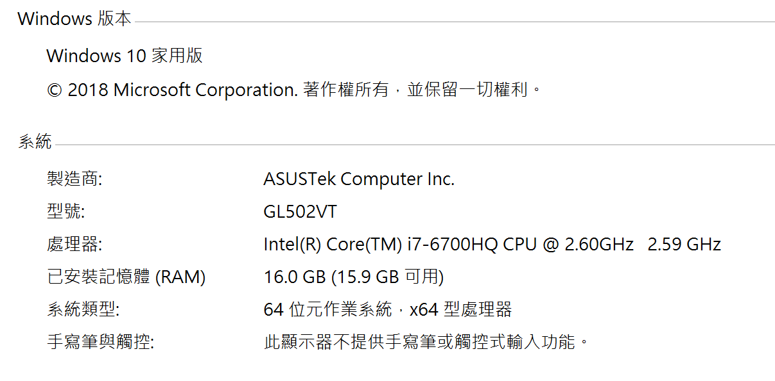

|  |  |
| --- | --- |
| RAM | 16GB |
| CPU | Intel i7-6700HQ |
| System | Windows 10 64 bit |

Run time

|  |  |
| --- | --- |
| Program | Run time(s) |
| K-means 2 | 0.12796807289123535 |
| K-means 10 | 0.2534496784210205 |
| K-means 20 | 0.24307751655578613 |
| K-means 30 | 0.3913440704345703 |
| Fuzzy Clustering EM | 0.24750280380249023 |
| DBSCAN | 0.20087909698486328 |

K-means (k=2) refer to kmean_2.txt

Center [[-0.18421144 -0.46605737]

[-0.43835799 0.91025437]]

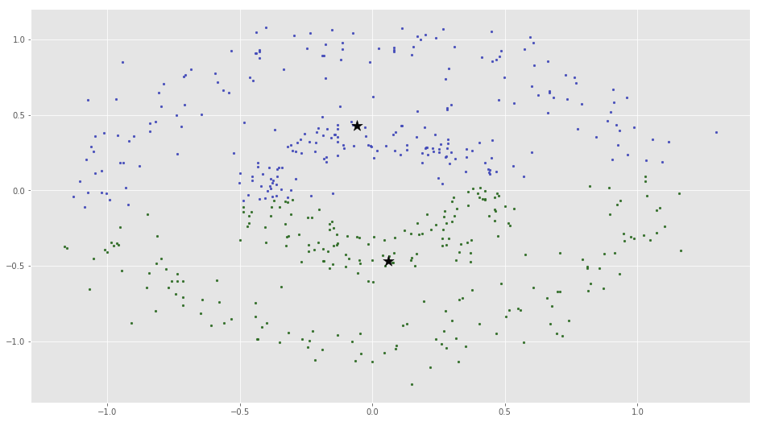

K-means (k=10) refer to kmean_10.txt

Center [[-0.20958667 0.38720792]

[ 0.42479782 -0.05439456]

[-0.2403638 -0.35939696]

[ 0.07805287 0.36933192]

[-0.4510807 0.73076186]

[-1.07252765 -0.01373317]

[-0.80712416 0.64770784]

[ 0.02351901 0.9451317 ]

[ 0.08108896 0.93258506]

[ 0.0373065 -0.42958236]]

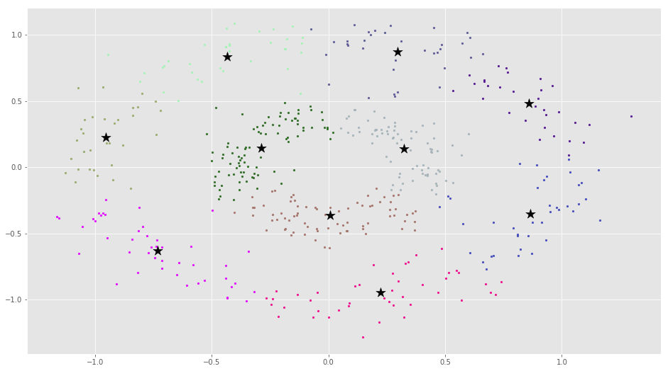

K-means (k=20) refer to kmean_20.txt

Center [[ 2.74207841e-01 -8.00677814e-01]

[ 4.61855631e-01 -2.02318684e-01]

[-3.83607835e-01 7.81352798e-02]

[ 3.01073351e-01 -7.29054555e-02]

[ 5.75575150e-01 -4.26986376e-01]

[ 6.61033170e-01 5.17466336e-01]

[-8.17684037e-01 -7.98273718e-01]

[ 5.58206194e-01 -7.95469046e-01]

[ 2.52154324e-01 2.51152692e-01]

[ 4.50043967e-04 -1.13586517e+00]

[-4.96340214e-02 -3.14742346e-01]

[-1.10278230e+00 6.37123993e-02]

[ 8.87166903e-01 4.60949301e-01]

[ 4.68639373e-01 -9.46802865e-01]

[ 2.51400653e-01 2.75898444e-01]

[-2.15091718e-01 -1.12659938e+00]

[ 7.61587119e-01 7.50347508e-01]

[-1.41955351e-01 3.70879736e-01]

[ 6.83118004e-01 6.18524613e-01]

[-4.40173179e-01 -7.43203137e-01]]

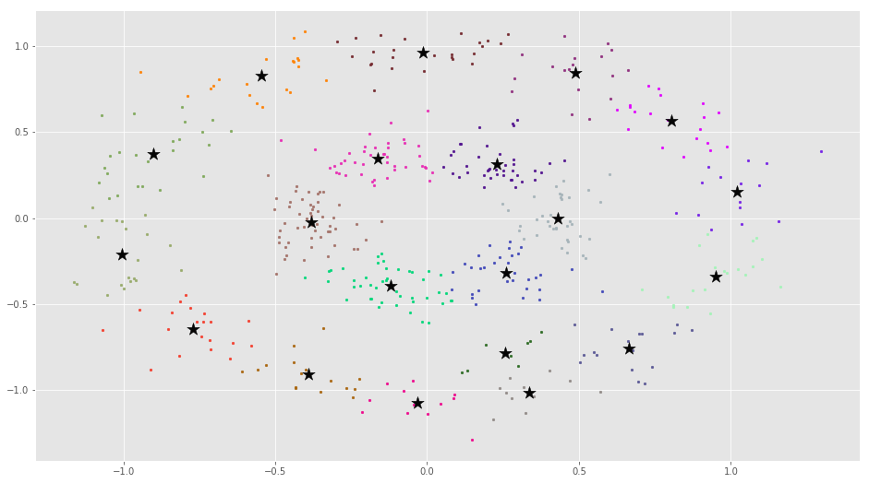

K-means (k=30) refer to kmean_30.txt

Center [[-0.24695725 0.94264774]

[-0.36371478 -0.03451654]

[-0.26830619 0.25057784]

[ 0.15922578 -0.50132728]

[ 0.2783253 -0.21545749]

[-0.27226558 0.33692506]

[-0.5944164 0.77921429]

[-1.02125731 0.12962746]

[ 0.27091499 -0.93176938]

[-0.13418414 -0.3635939 ]

[-0.16118481 -0.22332106]

[-0.79834692 0.55813119]

[ 0.48386878 -0.61613589]

[ 0.73968894 -0.8642904 ]

[-0.37815001 0.05201341]

[-1.15312814 -0.38334092]

[-0.57906663 -0.74006418]

[-0.10879303 0.30217701]

[ 0.46685322 0.86600527]

[-0.07478098 1.04432574]

[ 0.94625655 -0.28819109]

[-0.14195535 0.37087974]

[-0.30650816 -0.15768261]

[ 0.44025975 0.11828595]

[-0.9435051 0.85046415]

[ 0.14722141 0.89996444]

[-0.22008044 -0.39427673]

[-0.54241615 0.6481217 ]

[-0.29568659 1.02588869]

[ 0.18692782 -0.28609563]]

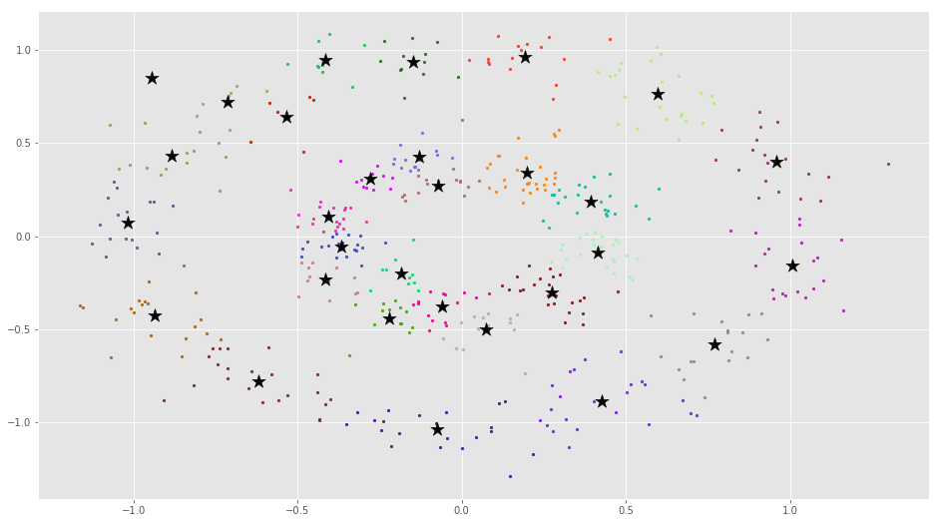

Fuzzy Clustering EM with 202 iteration refer to fcem.txt

the final SSE(sum of squared error) is:

270.953894154227

After iteration 1:

C1 is:[[ 0.16290242 -0.01417177]]C2 is:[[-0.13111815 0.02051548]]

After iteration 2:

C1 is:[[ 0.24439234 -0.03725748]]C2 is:[[-0.23632971 0.01523678]]

After iteration 3:

C1 is:[[ 0.32575666 -0.044721 ]]C2 is:[[-0.31897307 0.0203122 ]]

After iteration 4:

C1 is:[[ 0.37188705 -0.04655968]]C2 is:[[-0.3650581 0.02192936]]

After iteration 5:

C1 is:[[ 0.39161939 -0.04536535]]C2 is:[[-0.38483411 0.02070001]]

After iteration 6:

C1 is:[[ 0.39911191 -0.04286704]]C2 is:[[-0.39243167 0.01824383]]

After iteration 7:

C1 is:[[ 0.40190408 -0.03987205]]C2 is:[[-0.39533001 0.01534502]]

After iteration 8:

C1 is:[[ 0.40300815 -0.03668631]]C2 is:[[-0.39652823 0.0122819 ]]

After iteration 9:

C1 is:[[ 0.40351184 -0.03341522]]C2 is:[[-0.39711668 0.00914406]]

After iteration 10:

C1 is:[[ 0.4037938 -0.03009376]]C2 is:[[-0.39747818 0.00595969]]

After iteration 11:

C1 is:[[ 0.40398381 -0.02673359]]C2 is:[[-0.39774526 0.0027379 ]]

After iteration 12:

C1 is:[[ 0.40412577 -0.0233389 ]]C2 is:[[-0.39796326 -0.00051806]]

After iteration 13:

C1 is:[[ 0.4042342 -0.0199116]]C2 is:[[-0.39814733 -0.00380667]]

After iteration 14:

C1 is:[[ 0.40431353 -0.01645292]]C2 is:[[-0.39830218 -0.00712687]]

After iteration 15:

C1 is:[[ 0.40436478 -0.01296392]]C2 is:[[-0.39842893 -0.01047773]]

After iteration 16:

C1 is:[[ 0.40438782 -0.00944565]]C2 is:[[-0.39852743 -0.01385831]]

After iteration 17:

C1 is:[[ 0.40438213 -0.00589919]]C2 is:[[-0.39859715 -0.01726761]]

After iteration 18:

C1 is:[[ 0.4043471 -0.00232568]]C2 is:[[-0.39863742 -0.0207046 ]]

After iteration 19:

C1 is:[[0.40428208 0.0012737 ]]C2 is:[[-0.39864754 -0.02416818]]

After iteration 20:

C1 is:[[0.40418643 0.00489771]]C2 is:[[-0.39862683 -0.02765721]]

After iteration 21:

C1 is:[[0.40405954 0.00854507]]C2 is:[[-0.39857461 -0.03117051]]

After iteration 22:

C1 is:[[0.40390084 0.01221443]]C2 is:[[-0.39849025 -0.03470683]]

After iteration 23:

C1 is:[[0.40370977 0.01590441]]C2 is:[[-0.39837315 -0.03826488]]

After iteration 24:

C1 is:[[0.40348584 0.01961359]]C2 is:[[-0.39822274 -0.04184333]]

After iteration 25:

C1 is:[[0.40322856 0.02334049]]C2 is:[[-0.39803851 -0.0454408 ]]

After iteration 26:

C1 is:[[0.40293751 0.0270836 ]]C2 is:[[-0.39781996 -0.04905587]]

After iteration 27:

C1 is:[[0.4026123 0.03084137]]C2 is:[[-0.39756665 -0.05268709]]

After iteration 28:

C1 is:[[0.4022526 0.0346122]]C2 is:[[-0.39727819 -0.05633296]]

After iteration 29:

C1 is:[[0.40185809 0.03839449]]C2 is:[[-0.39695424 -0.05999195]]

After iteration 30:

C1 is:[[0.40142855 0.04218658]]C2 is:[[-0.3965945 -0.06366249]]

After iteration 31:

C1 is:[[0.40096376 0.04598679]]C2 is:[[-0.39619871 -0.06734301]]

After iteration 32:

C1 is:[[0.40046358 0.04979343]]C2 is:[[-0.39576669 -0.07103188]]

After iteration 33:

C1 is:[[0.39992791 0.05360478]]C2 is:[[-0.3952983 -0.07472746]]

After iteration 34:

C1 is:[[0.39935672 0.05741909]]C2 is:[[-0.39479344 -0.07842811]]

After iteration 35:

C1 is:[[0.39875 0.06123463]]C2 is:[[-0.3942521 -0.08213215]]

After iteration 36:

C1 is:[[0.39810783 0.06504964]]C2 is:[[-0.3936743 -0.0858379]]

After iteration 37:

C1 is:[[0.39743032 0.06886236]]C2 is:[[-0.39306012 -0.08954367]]

After iteration 38:

C1 is:[[0.39671764 0.07267103]]C2 is:[[-0.3924097 -0.09324778]]

After iteration 39:

C1 is:[[0.39597002 0.07647389]]C2 is:[[-0.39172324 -0.09694852]]

After iteration 40:

C1 is:[[0.39518775 0.08026919]]C2 is:[[-0.39100099 -0.1006442 ]]

After iteration 41:

C1 is:[[0.39437115 0.08405519]]C2 is:[[-0.39024326 -0.10433315]]

After iteration 42:

C1 is:[[0.39352061 0.08783017]]C2 is:[[-0.38945042 -0.1080137 ]]

After iteration 43:

C1 is:[[0.39263658 0.09159243]]C2 is:[[-0.38862289 -0.11168418]]

After iteration 44:

C1 is:[[0.39171953 0.09534027]]C2 is:[[-0.38776115 -0.11534296]]

After iteration 45:

C1 is:[[0.39077002 0.09907204]]C2 is:[[-0.38686571 -0.11898842]]

After iteration 46:

C1 is:[[0.38978863 0.10278612]]C2 is:[[-0.38593715 -0.12261898]]

After iteration 47:

C1 is:[[0.38877598 0.10648092]]C2 is:[[-0.38497611 -0.12623307]]

After iteration 48:

C1 is:[[0.38773277 0.11015486]]C2 is:[[-0.38398325 -0.12982916]]

After iteration 49:

C1 is:[[0.3866597 0.11380644]]C2 is:[[-0.38295929 -0.13340576]]

After iteration 50:

C1 is:[[0.38555755 0.11743418]]C2 is:[[-0.381905 -0.13696141]]

After iteration 51:

C1 is:[[0.3844271 0.12103665]]C2 is:[[-0.38082117 -0.14049468]]

After iteration 52:

C1 is:[[0.38326921 0.12461245]]C2 is:[[-0.37970864 -0.14400422]]

After iteration 53:

C1 is:[[0.38208472 0.12816026]]C2 is:[[-0.37856829 -0.14748869]]

After iteration 54:

C1 is:[[0.38087455 0.1316788 ]]C2 is:[[-0.37740102 -0.15094681]]

After iteration 55:

C1 is:[[0.37963961 0.13516682]]C2 is:[[-0.37620778 -0.15437735]]

After iteration 56:

C1 is:[[0.37838087 0.13862317]]C2 is:[[-0.37498953 -0.15777913]]

After iteration 57:

C1 is:[[0.3770993 0.14204672]]C2 is:[[-0.37374725 -0.16115102]]

After iteration 58:

C1 is:[[0.37579589 0.1454364 ]]C2 is:[[-0.37248197 -0.16449194]]

After iteration 59:

C1 is:[[0.37447166 0.14879122]]C2 is:[[-0.3711947 -0.16780088]]

After iteration 60:

C1 is:[[0.37312764 0.15211024]]C2 is:[[-0.36988651 -0.17107688]]

After iteration 61:

C1 is:[[0.37176486 0.15539257]]C2 is:[[-0.36855843 -0.17431902]]

After iteration 62:

C1 is:[[0.37038438 0.15863739]]C2 is:[[-0.36721156 -0.17752646]]

After iteration 63:

C1 is:[[0.36898725 0.16184394]]C2 is:[[-0.36584695 -0.1806984 ]]

After iteration 64:

C1 is:[[0.36757453 0.16501152]]C2 is:[[-0.3644657 -0.18383411]]

After iteration 65:

C1 is:[[0.36614728 0.16813947]]C2 is:[[-0.36306889 -0.1869329 ]]

After iteration 66:

C1 is:[[0.36470657 0.17122723]]C2 is:[[-0.36165759 -0.18999416]]

After iteration 67:

C1 is:[[0.36325345 0.17427425]]C2 is:[[-0.3602329 -0.19301731]]

After iteration 68:

C1 is:[[0.36178897 0.17728009]]C2 is:[[-0.35879589 -0.19600184]]

After iteration 69:

C1 is:[[0.36031418 0.18024432]]C2 is:[[-0.35734763 -0.1989473 ]]

After iteration 70:

C1 is:[[0.35883012 0.1831666 ]]C2 is:[[-0.35588917 -0.20185328]]

After iteration 71:

C1 is:[[0.3573378 0.18604661]]C2 is:[[-0.35442156 -0.20471943]]

After iteration 72:

C1 is:[[0.35583823 0.18888412]]C2 is:[[-0.35294584 -0.20754545]]

After iteration 73:

C1 is:[[0.35433241 0.19167893]]C2 is:[[-0.35146302 -0.21033108]]

After iteration 74:

C1 is:[[0.35282132 0.19443089]]C2 is:[[-0.34997411 -0.21307613]]

After iteration 75:

C1 is:[[0.35130591 0.19713991]]C2 is:[[-0.34848008 -0.21578045]]

After iteration 76:

C1 is:[[0.34978713 0.19980593]]C2 is:[[-0.34698191 -0.21844391]]

After iteration 77:

C1 is:[[0.3482659 0.20242895]]C2 is:[[-0.34548053 -0.22106645]]

After iteration 78:

C1 is:[[0.3467431 0.205009 ]]C2 is:[[-0.34397686 -0.22364805]]

After iteration 79:

C1 is:[[0.34521962 0.20754616]]C2 is:[[-0.34247181 -0.22618873]]

After iteration 80:

C1 is:[[0.34369631 0.21004056]]C2 is:[[-0.34096623 -0.22868855]]

After iteration 81:

C1 is:[[0.34217398 0.21249234]]C2 is:[[-0.33946098 -0.23114758]]

After iteration 82:

C1 is:[[0.34065345 0.21490169]]C2 is:[[-0.33795688 -0.23356597]]

After iteration 83:

C1 is:[[0.33913548 0.21726884]]C2 is:[[-0.33645473 -0.23594387]]

After iteration 84:

C1 is:[[0.33762083 0.21959405]]C2 is:[[-0.33495529 -0.23828148]]

After iteration 85:

C1 is:[[0.33611021 0.22187759]]C2 is:[[-0.3334593 -0.24057902]]

After iteration 86:

C1 is:[[0.33460432 0.22411979]]C2 is:[[-0.33196748 -0.24283673]]

After iteration 87:

C1 is:[[0.33310383 0.22632097]]C2 is:[[-0.33048052 -0.24505491]]

After iteration 88:

C1 is:[[0.33160938 0.22848152]]C2 is:[[-0.32899907 -0.24723384]]

After iteration 89:

C1 is:[[0.33012158 0.2306018 ]]C2 is:[[-0.32752377 -0.24937386]]

After iteration 90:

C1 is:[[0.32864102 0.23268223]]C2 is:[[-0.32605521 -0.25147531]]

After iteration 91:

C1 is:[[0.32716826 0.23472323]]C2 is:[[-0.32459398 -0.25353855]]

After iteration 92:

C1 is:[[0.32570384 0.23672526]]C2 is:[[-0.32314063 -0.25556398]]

After iteration 93:

C1 is:[[0.32424826 0.23868875]]C2 is:[[-0.32169567 -0.257552 ]]

After iteration 94:

C1 is:[[0.322802 0.2406142]]C2 is:[[-0.32025961 -0.25950302]]

After iteration 95:

C1 is:[[0.32136551 0.24250209]]C2 is:[[-0.31883292 -0.26141747]]

After iteration 96:

C1 is:[[0.31993924 0.24435292]]C2 is:[[-0.31741603 -0.2632958 ]]

After iteration 97:

C1 is:[[0.31852358 0.24616719]]C2 is:[[-0.31600937 -0.26513847]]

After iteration 98:

C1 is:[[0.31711891 0.24794543]]C2 is:[[-0.31461334 -0.26694593]]

After iteration 99:

C1 is:[[0.3157256 0.24968815]]C2 is:[[-0.31322829 -0.26871867]]

After iteration 100:

C1 is:[[0.31434397 0.2513959 ]]C2 is:[[-0.31185459 -0.27045716]]

After iteration 101:

C1 is:[[0.31297435 0.25306921]]C2 is:[[-0.31049255 -0.2721619 ]]

After iteration 102:

C1 is:[[0.31161701 0.25470862]]C2 is:[[-0.30914248 -0.27383338]]

After iteration 103:

C1 is:[[0.31027222 0.25631467]]C2 is:[[-0.30780465 -0.2754721 ]]

After iteration 104:

C1 is:[[0.30894025 0.25788792]]C2 is:[[-0.30647933 -0.27707856]]

After iteration 105:

C1 is:[[0.3076213 0.25942891]]C2 is:[[-0.30516674 -0.27865327]]

After iteration 106:

C1 is:[[0.30631559 0.2609382 ]]C2 is:[[-0.30386711 -0.28019673]]

After iteration 107:

C1 is:[[0.30502331 0.26241633]]C2 is:[[-0.30258064 -0.28170946]]

After iteration 108:

C1 is:[[0.30374462 0.26386386]]C2 is:[[-0.30130751 -0.28319196]]

After iteration 109:

C1 is:[[0.30247969 0.26528132]]C2 is:[[-0.30004787 -0.28464474]]

After iteration 110:

C1 is:[[0.30122864 0.26666927]]C2 is:[[-0.29880188 -0.28606832]]

After iteration 111:

C1 is:[[0.2999916 0.26802825]]C2 is:[[-0.29756966 -0.2874632 ]]

After iteration 112:

C1 is:[[0.29876868 0.2693588 ]]C2 is:[[-0.29635133 -0.28882988]]

After iteration 113:

C1 is:[[0.29755995 0.27066145]]C2 is:[[-0.29514698 -0.29016887]]

After iteration 114:

C1 is:[[0.29636549 0.27193674]]C2 is:[[-0.29395669 -0.29148067]]

After iteration 115:

C1 is:[[0.29518537 0.27318519]]C2 is:[[-0.29278054 -0.29276577]]

After iteration 116:

C1 is:[[0.29401963 0.27440733]]C2 is:[[-0.29161857 -0.29402467]]

After iteration 117:

C1 is:[[0.29286832 0.27560367]]C2 is:[[-0.29047083 -0.29525785]]

After iteration 118:

C1 is:[[0.29173144 0.27677472]]C2 is:[[-0.28933735 -0.29646581]]

After iteration 119:

C1 is:[[0.29060901 0.27792099]]C2 is:[[-0.28821815 -0.29764901]]

After iteration 120:

C1 is:[[0.28950104 0.27904297]]C2 is:[[-0.28711324 -0.29880793]]

After iteration 121:

C1 is:[[0.28840751 0.28014116]]C2 is:[[-0.2860226 -0.29994304]]

After iteration 122:

C1 is:[[0.2873284 0.28121604]]C2 is:[[-0.28494623 -0.30105481]]

After iteration 123:

C1 is:[[0.28626369 0.2822681 ]]C2 is:[[-0.28388411 -0.30214369]]

After iteration 124:

C1 is:[[0.28521334 0.2832978 ]]C2 is:[[-0.2828362 -0.30321013]]

After iteration 125:

C1 is:[[0.2841773 0.2843056]]C2 is:[[-0.28180246 -0.30425458]]

After iteration 126:

C1 is:[[0.28315551 0.28529197]]C2 is:[[-0.28078285 -0.30527747]]

After iteration 127:

C1 is:[[0.28214792 0.28625735]]C2 is:[[-0.27977731 -0.30627924]]

After iteration 128:

C1 is:[[0.28115446 0.28720219]]C2 is:[[-0.27878576 -0.30726031]]

After iteration 129:

C1 is:[[0.28017505 0.28812693]]C2 is:[[-0.27780816 -0.30822111]]

After iteration 130:

C1 is:[[0.27920962 0.28903198]]C2 is:[[-0.27684441 -0.30916204]]

After iteration 131:

C1 is:[[0.27825807 0.28991777]]C2 is:[[-0.27589443 -0.31008352]]

After iteration 132:

C1 is:[[0.27732031 0.29078471]]C2 is:[[-0.27495815 -0.31098594]]

After iteration 133:

C1 is:[[0.27639625 0.2916332 ]]C2 is:[[-0.27403546 -0.31186969]]

After iteration 134:

C1 is:[[0.27548579 0.29246365]]C2 is:[[-0.27312626 -0.31273515]]

After iteration 135:

C1 is:[[0.27458881 0.29327645]]C2 is:[[-0.27223046 -0.31358272]]

After iteration 136:

C1 is:[[0.27370521 0.29407196]]C2 is:[[-0.27134795 -0.31441276]]

After iteration 137:

C1 is:[[0.27283488 0.29485058]]C2 is:[[-0.27047862 -0.31522564]]

After iteration 138:

C1 is:[[0.27197769 0.29561267]]C2 is:[[-0.26962235 -0.3160217 ]]

After iteration 139:

C1 is:[[0.27113353 0.29635858]]C2 is:[[-0.26877903 -0.31680132]]

After iteration 140:

C1 is:[[0.27030227 0.29708868]]C2 is:[[-0.26794854 -0.31756483]]

After iteration 141:

C1 is:[[0.26948379 0.2978033 ]]C2 is:[[-0.26713075 -0.31831257]]

After iteration 142:

C1 is:[[0.26867795 0.29850279]]C2 is:[[-0.26632554 -0.31904487]]

After iteration 143:

C1 is:[[0.26788464 0.29918747]]C2 is:[[-0.26553279 -0.31976206]]

After iteration 144:

C1 is:[[0.26710371 0.29985768]]C2 is:[[-0.26475235 -0.32046446]]

After iteration 145:

C1 is:[[0.26633503 0.30051373]]C2 is:[[-0.26398411 -0.32115239]]

After iteration 146:

C1 is:[[0.26557847 0.30115593]]C2 is:[[-0.26322792 -0.32182614]]

After iteration 147:

C1 is:[[0.26483389 0.30178458]]C2 is:[[-0.26248366 -0.32248602]]

After iteration 148:

C1 is:[[0.26410115 0.30239999]]C2 is:[[-0.26175119 -0.32313232]]

After iteration 149:

C1 is:[[0.26338011 0.30300245]]C2 is:[[-0.26103037 -0.32376534]]

After iteration 150:

C1 is:[[0.26267063 0.30359223]]C2 is:[[-0.26032106 -0.32438535]]

After iteration 151:

C1 is:[[0.26197257 0.30416963]]C2 is:[[-0.25962313 -0.32499263]]

After iteration 152:

C1 is:[[0.2612858 0.30473491]]C2 is:[[-0.25893643 -0.32558746]]

After iteration 153:

C1 is:[[0.26061016 0.30528834]]C2 is:[[-0.25826084 -0.3261701 ]]

After iteration 154:

C1 is:[[0.25994553 0.30583018]]C2 is:[[-0.2575962 -0.3267408]]

After iteration 155:

C1 is:[[0.25929175 0.30636069]]C2 is:[[-0.25694238 -0.32729982]]

After iteration 156:

C1 is:[[0.25864868 0.30688012]]C2 is:[[-0.25629924 -0.32784742]]

After iteration 157:

C1 is:[[0.25801619 0.3073887 ]]C2 is:[[-0.25566664 -0.32838383]]

After iteration 158:

C1 is:[[0.25739412 0.30788668]]C2 is:[[-0.25504443 -0.32890929]]

After iteration 159:

C1 is:[[0.25678235 0.3083743 ]]C2 is:[[-0.25443249 -0.32942404]]

After iteration 160:

C1 is:[[0.25618073 0.30885178]]C2 is:[[-0.25383067 -0.3299283 ]]

After iteration 161:

C1 is:[[0.25558912 0.30931933]]C2 is:[[-0.25323883 -0.3304223 ]]

After iteration 162:

C1 is:[[0.25500738 0.30977719]]C2 is:[[-0.25265684 -0.33090625]]

After iteration 163:

C1 is:[[0.25443537 0.31022557]]C2 is:[[-0.25208455 -0.33138038]]

After iteration 164:

C1 is:[[0.25387296 0.31066466]]C2 is:[[-0.25152184 -0.33184488]]

After iteration 165:

C1 is:[[0.25332 0.31109468]]C2 is:[[-0.25096856 -0.33229997]]

After iteration 166:

C1 is:[[0.25277636 0.31151582]]C2 is:[[-0.25042458 -0.33274584]]

After iteration 167:

C1 is:[[0.2522419 0.31192827]]C2 is:[[-0.24988976 -0.33318269]]

After iteration 168:

C1 is:[[0.2517165 0.31233224]]C2 is:[[-0.24936398 -0.33361071]]

After iteration 169:

C1 is:[[0.25120001 0.31272789]]C2 is:[[-0.2488471 -0.33403008]]

After iteration 170:

C1 is:[[0.25069231 0.31311542]]C2 is:[[-0.24833898 -0.334441 ]]

After iteration 171:

C1 is:[[0.25019325 0.313495 ]]C2 is:[[-0.2478395 -0.33484364]]

After iteration 172:

C1 is:[[0.24970272 0.31386681]]C2 is:[[-0.24734853 -0.33523817]]

After iteration 173:

C1 is:[[0.24922058 0.314231 ]]C2 is:[[-0.24686594 -0.33562476]]

After iteration 174:

C1 is:[[0.24874671 0.31458775]]C2 is:[[-0.2463916 -0.33600359]]

After iteration 175:

C1 is:[[0.24828097 0.31493722]]C2 is:[[-0.24592539 -0.33637482]]

After iteration 176:

C1 is:[[0.24782325 0.31527956]]C2 is:[[-0.24546718 -0.3367386 ]]

After iteration 177:

C1 is:[[0.24737342 0.31561494]]C2 is:[[-0.24501685 -0.3370951 ]]

After iteration 178:

C1 is:[[0.24693135 0.31594349]]C2 is:[[-0.24457428 -0.33744447]]

After iteration 179:

C1 is:[[0.24649692 0.31626537]]C2 is:[[-0.24413935 -0.33778685]]

After iteration 180:

C1 is:[[0.24607002 0.31658072]]C2 is:[[-0.24371193 -0.33812239]]

After iteration 181:

C1 is:[[0.24565052 0.31688969]]C2 is:[[-0.24329191 -0.33845125]]

After iteration 182:

C1 is:[[0.24523831 0.3171924 ]]C2 is:[[-0.24287917 -0.33877355]]

After iteration 183:

C1 is:[[0.24483328 0.31748899]]C2 is:[[-0.24247359 -0.33908943]]

After iteration 184:

C1 is:[[0.24443529 0.3177796 ]]C2 is:[[-0.24207507 -0.33939903]]

After iteration 185:

C1 is:[[0.24404425 0.31806434]]C2 is:[[-0.24168349 -0.33970248]]

After iteration 186:

C1 is:[[0.24366005 0.31834335]]C2 is:[[-0.24129873 -0.33999991]]

After iteration 187:

C1 is:[[0.24328256 0.31861676]]C2 is:[[-0.2409207 -0.34029144]]

After iteration 188:

C1 is:[[0.24291168 0.31888466]]C2 is:[[-0.24054927 -0.3405772 ]]

After iteration 189:

C1 is:[[0.2425473 0.3191472]]C2 is:[[-0.24018434 -0.3408573 ]]

After iteration 190:

C1 is:[[0.24218933 0.31940447]]C2 is:[[-0.23982581 -0.34113186]]

After iteration 191:

C1 is:[[0.24183764 0.31965659]]C2 is:[[-0.23947356 -0.341401 ]]

After iteration 192:

C1 is:[[0.24149214 0.31990367]]C2 is:[[-0.23912751 -0.34166483]]

After iteration 193:

C1 is:[[0.24115273 0.32014581]]C2 is:[[-0.23878754 -0.34192346]]

After iteration 194:

C1 is:[[0.24081931 0.32038312]]C2 is:[[-0.23845356 -0.34217699]]

After iteration 195:

C1 is:[[0.24049176 0.32061571]]C2 is:[[-0.23812546 -0.34242554]]

After iteration 196:

C1 is:[[0.24017001 0.32084366]]C2 is:[[-0.23780315 -0.3426692 ]]

After iteration 197:

C1 is:[[0.23985395 0.32106709]]C2 is:[[-0.23748654 -0.34290808]]

After iteration 198:

C1 is:[[0.23954348 0.32128607]]C2 is:[[-0.23717552 -0.34314226]]

After iteration 199:

C1 is:[[0.23923852 0.32150071]]C2 is:[[-0.23687 -0.34337186]]

After iteration 200:

C1 is:[[0.23893896 0.3217111 ]]C2 is:[[-0.23656989 -0.34359696]]

After iteration 201:

C1 is:[[0.23864472 0.32191732]]C2 is:[[-0.23627511 -0.34381765]]

After iteration 202:

C1 is:[[0.23835571 0.32211946]]C2 is:[[-0.23598555 -0.34403403]]

After 202 iterations, with L1_sum=0.000997087500248156,the clusters converge.

Converged C1:[[0.23835571 0.32211946]]

Converged C2:[[-0.23598555 -0.34403403]]

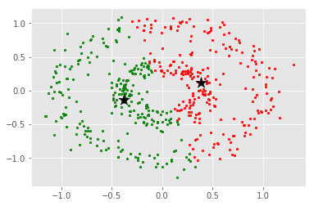

DBSCAN with eps = 0.12, min_samples = 3 refer to dbscan,txt

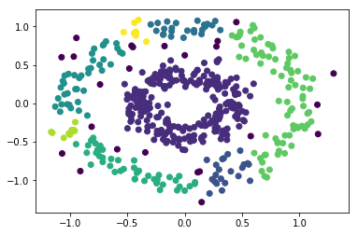

Reference

<https://mubaris.com/posts/kmeans-clustering/>

<https://scikit-learn.org/stable/modules/generated/sklearn.cluster.DBSCAN.html>