

## STUDENT MANAGEMENT

PRJ321-ASSIGNTMENT

## Student Name: BUI NHAT HOANG

## Roll Number: SE04578

### MENU.

#### Self-Introduction

* 1. Purpose
  2. Scope

#### Case study

* 1. Overview
  2. Use case diagram

#### 3. Database design

3.1. Database Diagram

3.2. Table Description

#### 4. ***System design***

#### 5. Screenshot

#### Self-Introduction

* 1. Purpose

This document aims at describing the details of technical design and how users interact with application (case study, system design, application’s functions) of the **Student Management** application.

By using this document , you will have a full view about how the application work, the database design of **Student Management** application.

* 1. Scope

This document provides the detailed in database design, MVC model, technology are used in application.

#### Case study

* 1. Overview

**Student Management** required log in an account . If users don’t have an account , they must sign up an student account. Student accounts can joining a course , view timetable and edit their account’s information. Teacher accounts only created by administration by using database. Teacher accounts can view their teaching schedule, check attendance for students in their course and edit their account’s information.

* 1. Use-case Diagram

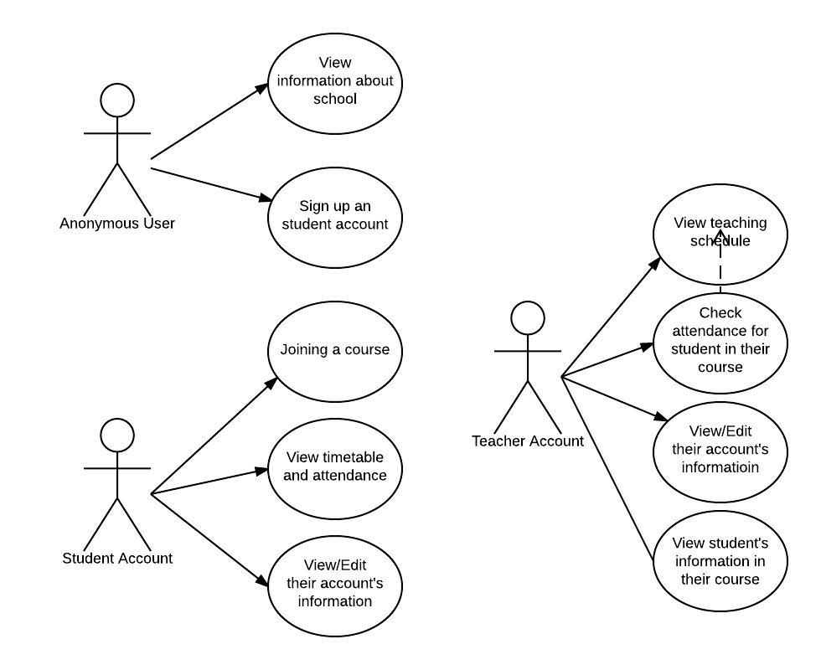

#### Database design

* 1. Database

#### 

* 1. Table Description

**COURSES:**

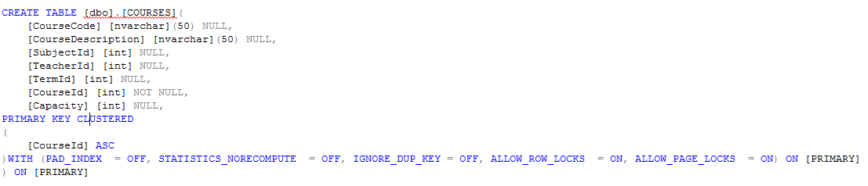

|  |  |
| --- | --- |
| Field | Description |
| CourseCode | String type , contains course code |
| CourseDescription | String type, contains description of course |
| SubjectId | Integer type, contains subject id |
| TeacherId | Integer type, contains teacher id |
| TermId | Integer type, contains term id |
| CourseId | Integer type , primary key , contains course Id |
| Capacity | Integer type, contains capacity of course |

**TEACHERS:**

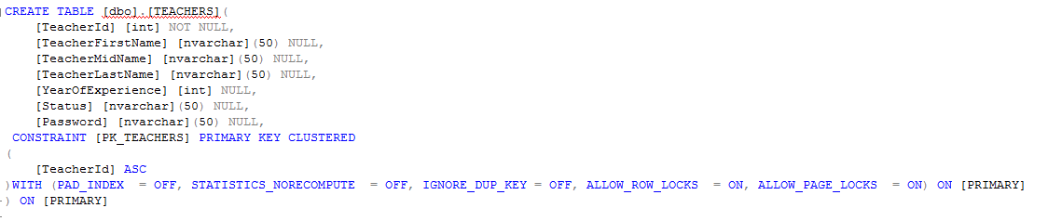

|  |  |
| --- | --- |
| Field | Description |
| TeacherId | Integer type, primary key, contains teacher Id |
| TeacherFirstName | String type, contains teacher’s first name |
| TeacherMidName | String type, contains teacher’s mid name |
| TeacherLastName | String type, contains teacher’s last name |
| YearOfExperience | Integer type, contains year of experience |
| Status | String type, contains teacher’s status |
| Password | String type, contains password |

**STUDENTS**

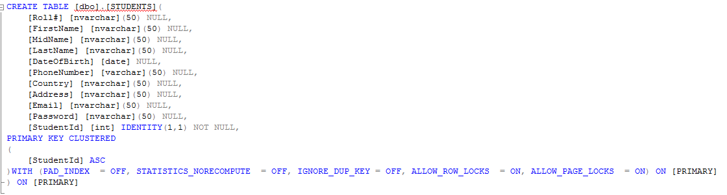

|  |  |
| --- | --- |
| Field | Description |
| Roll# | String type, contains roll number |
| FirstName | String type, contains student’s first name |
| MidName | String type, contains student’s mid name |
| LastName | String type, contains student’s mid name |
| DateOfBirth | Date type, contains student’s Date Of Birth |
| Phone Number | String type, contains student’s phone number |
| Country | String type, contains student’s country |
| Address | String type, contains student’s address |
| Email | String type, contains student’s email |
| Password | String type, contains student’s password |
| StudentId | Integer type, primary key, contains student Id |

**COURSE_SCHEDULES**

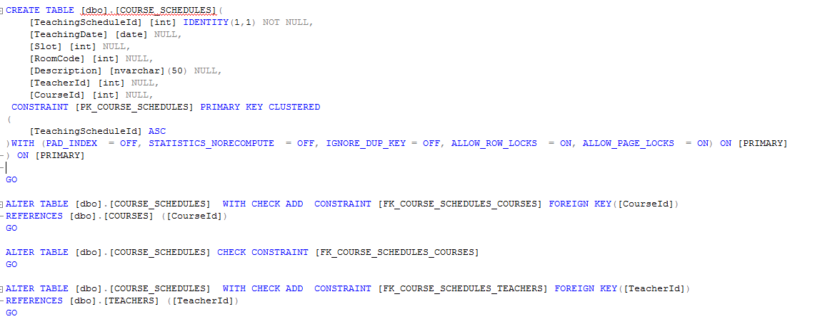

|  |  |
| --- | --- |
| Field | Description |
| TeachingScheduleId | Integer type, primary key , auto increment by 1, contains teaching schedule Id |
| TeachingDate | Date type, contains teaching date |
| Slot | Integer type, contains slot |
| RoomCode | Integer type, contains room code |
| Description | String type, contains description |
| TeacherId | Integer type, contains teacher Id |
| CourseId | Integer type, contains course Id |

**TERMS**

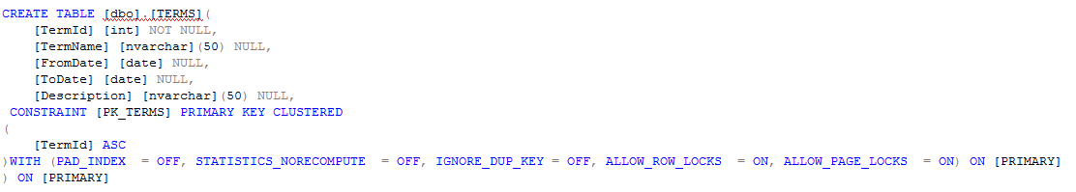

|  |  |
| --- | --- |
| **Field** | **Description** |
| **TermId** | **Integer type, primary key, contains term Id** |
| **TermName** | **String type, contains term name** |
| **FromDate** | **String type, contains term start date** |
| **ToDate** | **String type, contains term end date** |
| **Description** | **String type, contains description about term** |

**SUBJECTS**

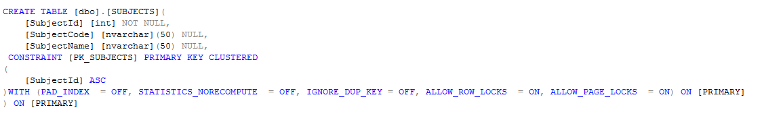

|  |  |
| --- | --- |
| **Field** | **Description** |
| **SubjectId** | **Integer type, primary key, contains subject Id** |
| **SubjectCode** | **String type, contains subject Code** |
| **SubjectName** | **String type, contains subject name** |

**STUDENT_ATTENDANCE**

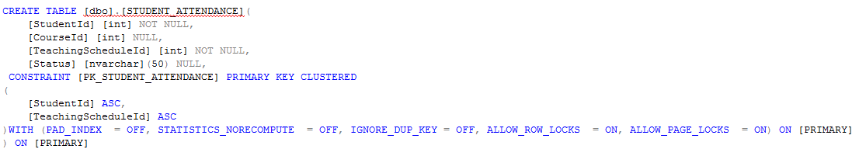

|  |  |
| --- | --- |
| **Field** | **Description** |
| **StudentId** | **Integer type, primary key, contains student Id** |
| **CourseId** | **Integer type, contains course Id** |
| **TeachingScheduleId** | **Integer type, primary key, contains teaching schedule Id** |
| **Status** | **String type , contains status** |

**STUDENT_COURSE**

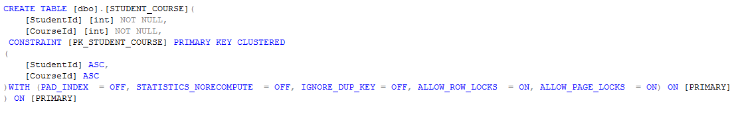

|  |  |
| --- | --- |
| **Field** | **Description** |
| **StudentId** | **Integer type, primary key , contains student ID** |
| **CourseId** | **Integer type, primary key, contains course Id** |

1. System Design

#### C:\Users\admin\Downloads\Blank Diagram - Page 1.jpeg

#### Screenshot

