Chris Lansing

12/8/2012

Database Systems Final

Problem 1:

a)

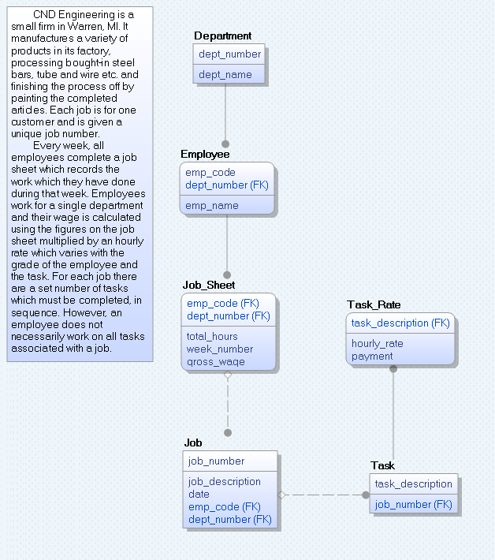

b)

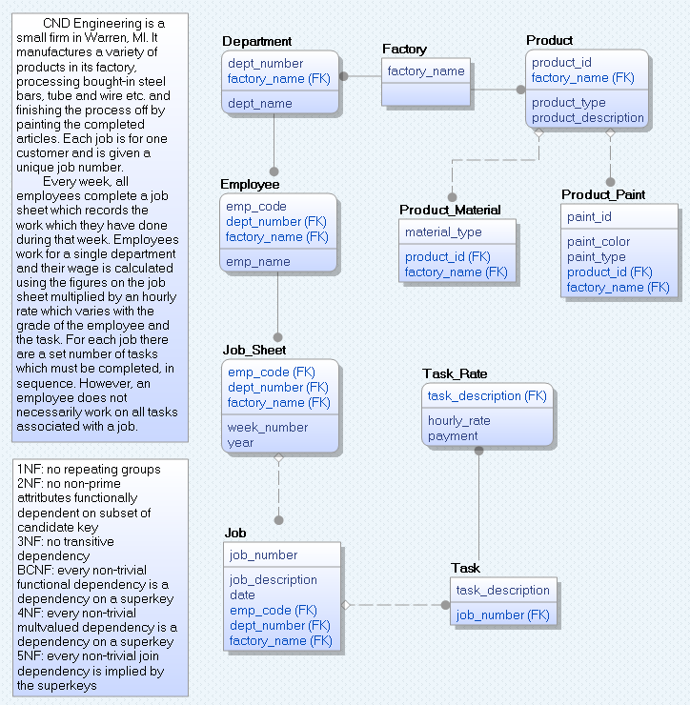

c)

|  |  |  |  |  |  |
| --- | --- | --- | --- | --- | --- |
| dept_number | emp_code | job_number | task_description | Model | Expert |
| 09 | 89 | 123 | Smoothing | Y | Y |
| X | 89 | 123 | Smoothing | Y | N |
| 09 | X | 123 | Smoothing | Y | Y |
| 09 | 89 | X | Smoothing | Y | Y |
| 09 | 89 | 123 | X | Y | Y |

d) Attached as Problem1.sql

e)

- Employees are only allowed to work a maximum amount of hours in a given time.

- Different Employees can only perform certain jobs or tasks.

- Employees have holidays and vacation days.

- New hourly rates must be created as different employees are hired.

- Departments may need to be expanded as company grows.

- Year should be added to date to avoid inaccurate dates.

Problem 2:

a)

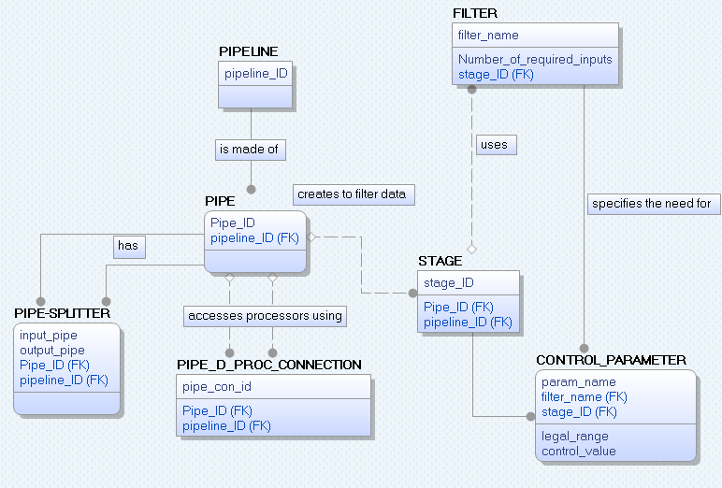

b)

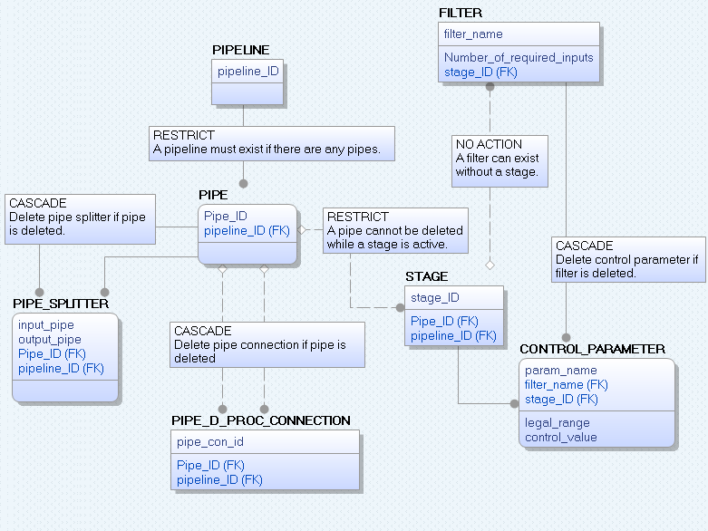

c) Attached as Problem2.sql

d)

Pipe accesses library of data processors:

PIPE -> STAGE -> FILTER

Data is processed and stored:

PIPELINE -> PIPE -> STAGE -> FILTER, CONTROL_PARAMETER

Select a frequency filter:

FILTER -> CONTROL_PARAMETER

Pipe is split and collected data transferred to different pipe.

PIPELINE -> PIPE -> PIPE-SPLITtER, PIPE -> STAGE, PIPE -> PIPE_D_PROC_CONNECTION

e)

Combine Tables:

The variables from CONTROL_PARAMETER (param_name and legal_range) can be added to FILTER since it is a one to one relationship.

Pre-joined Tables:

PIPE and PIPE_D_PROC_CONNECTION could possibly be pre-joined because they will use each other very frequently and have no redundant columns/contain only necessary columns.