Instructions for the strictly individual Final Exam Fall-2012

Problem 1[100 points]
- Create data model in IDEF1X notation for the CND Engineering Problem Statement and the form attached (use CA Erwin to draw data model).
- Normalize (verify/improve your data model) solution to comply with 5NF,
- Validate the final data model using simplified Sharp’s method.
- Create SQL DDL and insert minimal (to cover data provided) sample of records
- Specify business rules and domain restrictions that may reasonably be expected in situation like here.
- Using SQL (Views etc.) produce report with the content (not the format) shown in CND Sample Input Form [this one if for extra credit 10 points]

CDN Input Form
Y:2001 |  |  | C&D. (Engineering) Job Sheet |  |  | Week No. 17
Name:D.Streeter |  | Department: 09 |  |  | Employee code: 89
Day | Date | Job No. | Job Description | No. of hours | Task | For office use
 |  |  |  |  |  | Hourly rate | Payment($)
Mon | 23-Apr | 123 | Office table | 2 | Smoothing | A | 12.00
 |  |  |  | 2 | Welding | K | 10.00
Tues | 24-Apr | 66 | Computer table | 1 | Scraping | A | 6.00
 |  |  |  | 1 | Painting | A | 6.00
 |  |  |  | 1 | Finishing | A | 6.00
 |  | 67 | Hospital table | 1 | Loading | B | 4.50
 |  |  |  | 2 | Welding | K | 10.00
Wed | 25-Apr | 123 | Office table | 8 | Bending & Joining | C | 128.00
Thurs | 26-Apr | 67 | Hospital table | 2 | Painting | A | 12.00
 |  |  |  | 2 | Loading | B | 9.00
Fri | 27-Apr | 66 | Computer table | 3 | Welding | K | 15.00
 |  |  |  | 1 | Finishing | A | 6.00
 |  |  | Total Hours | 26 |  | Gross Wage | $224.50
CND Engineering is a small firm in Warren, MI. It manufactures a variety of products in its factory, processing bought-in steel bars, tube and wire etc. and finishing the process off by painting the completed articles. Each job is for one customer and is given a unique job number.
Every week, all employees complete a job sheet which records the work which they have done during that week. Employees work for a single department and their wage is calculated using the figures on the job sheet multiplied by an hourly rate which varies with the grade of the employee and the task. For each job there are a set number of tasks which must be completed, in sequence. However, an employee does not necessarily work on all tasks associated with a job.

Problem 2 [100 points]
- Revise the initial draft data model (IDEF1X diagram below); using descriptions and illustrations (application notes) below and minimal assumptions (TBD).
- Specify SQL referential integrity options on delete of the parent, for each foreign key, that best fits the problem as you understand it. In each case you opt for RESTRICT (NO ACTION) explain your reasons, as far as you can deduce or improvise from the information available (the only contextual information available to you is a description with a drawing used during the data model development shown as an attachment).
- define database schema (forward engineer in ERwin) i.e. produce DDL

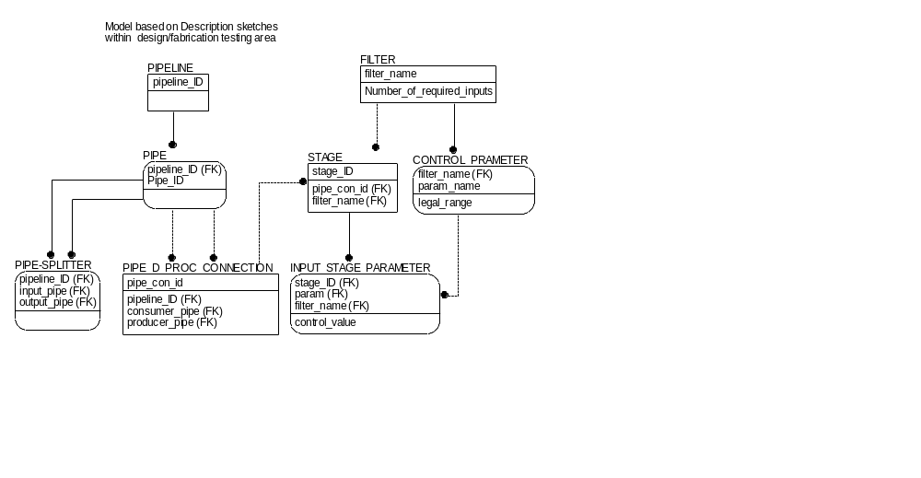

- Suggest minimal set of reasonable transactions and indicate their paths

- Suggest at least two de-normalization options of different ‘types’
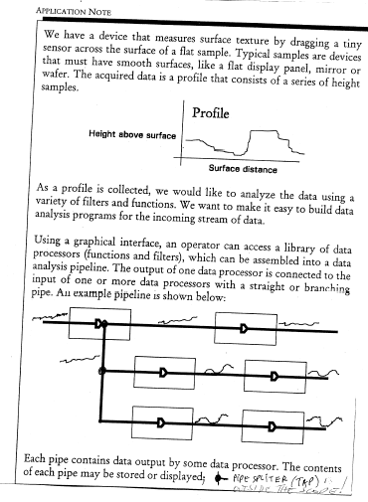
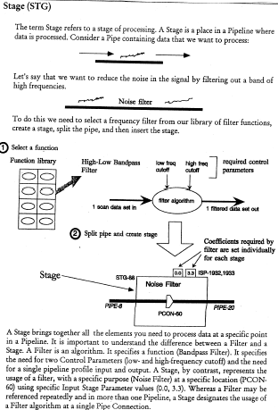

Title of document

You will type your report in Microsoft Word, using the required format of the course assignment release form as a cover page and embedding your data models and other diagrams, i.e. solution diagram from ERwin into the text to follow.

File naming convention for the assignment

Save your report in Word and use the following file naming convention:

M8_FinalExam _your_name.doc

How to hand in the assignment

When you have finished your report, you will e-mail me no later than Sunday 12.09.12 by 5PM i.e. the day before the final exam (Monday 12.10.12), for me to have sufficient time to review your work. Your obligation is to show for the final exam at designated time 5:30 PM in 3214 to explain your work if I have any questions.

Note:
Estimated effort on the final exam is about eight to ten hours (this does not include clarifying background and eventual remedial readings and practices related to the types of problems).

