HAIRHEALTH: A MOBILE APPLICATION FOR ALOPECIA AND PSORIASIS IDENTIFICATION USING IMAGE PROCESSING AND DATA MINING

[1]Catherine L. Pasadilla, [2]Jasmine Risha Signey, [3]]Joan Rubio

[1]*Pamantasan ng Lungsod ng Maynila,* [2] *Pamantasan ng Lungsod ng Maynila,* [3] *Pamantasan ng Lungsod ng Maynila*

[1]*[clpasadilla2020@plm.edu.ph,](mailto:jmantonino2020@plm.edu.ph)* [2]*jrlsigney2020@plm.edu.ph,* [3]*jrubio2020@plm.edu.ph*

***Abstract*— The HairHealth is a cutting-edge mobile app addressing alopecia and psoriasis challenges. It offers personalized care tips, identifies issues, and educates users on management strategies. It fosters a supportive community for sharing experiences and provides a user-friendly Chabot for assistance. Evaluated against ISO 25010 standards, it excels in functionality, performance, usability, and security. Overall, HairHealth is a holistic solution for managing hair and scalp health effectively.**

***Index Terms - HairHealth, Image Processing, Data Mining, Community Support, Diagnosis Support, Alopecia, Psoriasis, Convolutional Neural Networks (CNN)***

1. INTRODUCTION

H

AIR is a crucial and integral part of the human body,

making hair care essential for both men and women. Beyond enhancing appearance, hair care plays a significant role in overall hygiene. Maintaining healthy hair contributes to a more attractive and confident appearance. While hair care can be challenging, especially with time constraints, it is a manageable task [1]. For many individuals, hair serves as an expression of their personality, highlighting the importance of maintaining its health and vitality.

1. REVIEW OF RELATED LITERATURE
2. *Alopecia*

Alopecia is a condition that leads to hair loss from the head or other body parts where hair naturally grows. This distressing condition negatively impacts self-esteem and has psychological and social effects. Common types of alopecia include androgenic alopecia (common baldness), alopecia areata, and chemotherapy-induced alopecia. Various factors like stress, genetics, hormones, nutrition, illness, and certain medications, including those for cancer, can cause alopecia [2]. The etiology of pediatric alopecia can range from abnormalities in hair shafts or follicles to infectious and autoimmune disorders. A comprehensive patient history offers insights into the acuity and pattern of hair loss, potential comorbidities, and nutritional status. Physical examination aids in identifying signs of inflammation and assessing the extent of hair-bearing regions affected. [3].

1. *Androgenetic Alopecia*

Psoriasis is a chronic immune-mediated disease affecting around 125 million people globally. It is influenced by genetics and the environment, leading to distinct scaly plaques on the skin. Severe cases are linked to metabolic syndrome, cardiovascular disease, and depression, impacting patients' quality of life. Due to an incomplete understanding of its causes, finding a definitive cure for psoriasis remains a significant challenge [8]. It affects individuals of all ages and is prevalent globally, with approximately 125 million people worldwide experiencing psoriasis. The severity of psoriasis is assessed clinically, considering the affected areas and its impact on the individual's quality of life. Plaque psoriasis is the most common form, accounting for at least 80% of cases, characterized by red patches covered with a silvery white buildup of dead skin cells [9].

Psoriasis is highlighted as a prevalent immune-mediated disorder in humans. The estimated prevalence of psoriasis among adults in the Philippines varies from 0.22% to 2.4%. The disease follows a lifelong, unpredictable, and relapsing course. [10].

1. *Alopecia Areata*

Alopecia Areata (AA), a non-scaring hair loss resulting from T-cell-mediated autoimmune damage to hair follicles. The risk of AA in the general population is around 2%, with

varying incidence rates globally: 2.1% in the USA, 0.7% in India, and 3.8% in Singapore. AA has no gender preference and can affect all age groups, commonly presenting between ages 21 and 40. AA's pathogenesis involves factors like infections, endocrine issues, autoimmunity, genetics, and psychological factors [6]. Alopecia Areata (AA) was examined as an autoimmune disorder leading to non-scarring hair loss primarily on the scalp. The study focused on a 27-year-old Filipino male who displayed acute patchy hair loss on different scalp areas. AA is characterized by distinct patches that can spread and merge, potentially affecting other body parts. The autoimmune response disrupting normal hair growth underlies the development of AA. The unpredictable progression of this condition can have a significant impact on patients' well-being [7].

1. *Psoriasis*

Psoriasis is a chronic immune-mediated disease affecting around 125 million people globally. It is influenced by genetics and the environment, leading to distinct scaly plaques on the skin. Severe cases are linked to metabolic syndrome, cardiovascular disease, and depression, impacting patients' quality of life. Due to an incomplete understanding of its causes, finding a definitive cure for psoriasis remains a significant challenge [8]. It affects individuals of all ages and is prevalent globally, with approximately 125 million people worldwide experiencing psoriasis. The severity of psoriasis is assessed clinically, considering the affected areas and its impact on the individual's quality of life. Plaque psoriasis is the most common form, accounting for at least 80% of cases, characterized by red patches covered with a silvery white buildup of dead skin cells [9].

Psoriasis is highlighted as a prevalent immune-mediated disorder in humans. The estimated prevalence of psoriasis among adults in the Philippines varies from 0.22% to 2.4%. The disease follows a lifelong, unpredictable, and relapsing course. [10].

1. METHODOLOGY
2. *Research Design*

The proposed study used a mixed methods approach, combining both quantitative and qualitative research methods. The research begins with a thorough needs assessment to identify the specific challenges faced by small-scale greenhouse farming within urban areas in the Philippines regarding irrigation control. This involves gathering qualitative data through surveys, interviews, and field visits to understand their requirements and preferences. Based on the needs assessment, a literature review is conducted to explore

existing research and technologies related to IoT devices and smart irrigation systems. The research then moves into the design and development phase, where a low-cost IoT device and smart irrigation control system and water temperature control system are engineered and implemented. This process involves both quantitative evaluation, such as measuring data and system performance, and qualitative evaluation through user feedback and observations. The iterative refinement of the system is carried out based on the evaluation results and user input. Finally, the research assesses user acceptance and impact, gathering qualitative and quantitative data on system usability, perceived benefits, water conservation, crop yield, and overall crop health.

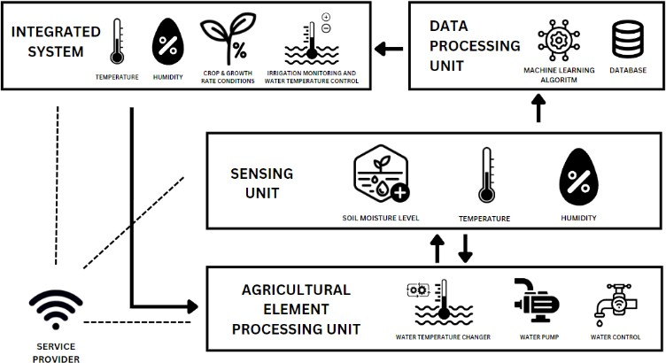

Fig 1. System Architecture of iSmartPH

The architectural design of the iSmartPH consists of four interconnected units and a service provider that facilitates communication between them. The first unit, called the agricultural element processing unit, receives data from the sensor unit and executes various functions. The sensing unit measures soil moisture level and triggers the water pump in the first unit if it falls below the required threshold. the irrigation process considers the temperature and humidity inside the structure, but the soil moisture level remains the primary indicator for watering. It also includes a water temperature sensor, ensuring the water is at the appropriate temperature for the specific plant by heating it or cooling it down through the agricultural element processing unit. The sensing unit senses agricultural elements, which are then processed by the processing unit before being transferred to the data processing unit. In this section, a machine learning algorithm analyzes the data to improve predictions and recognize patterns beneficial for greenhouse farms. All the collected data is stored in a database and presented on the integrated iSmartPH system. This system offers real-time temperature and humidity information, along with crop growth rate conditions predictions, providing easy access for users. Additionally, the integrated system includes a water temperature control feature, allowing users to set the specific water temperature requirement for a plant. The connection to the processing unit ensures the right temperature setup is processed as specified by the user.

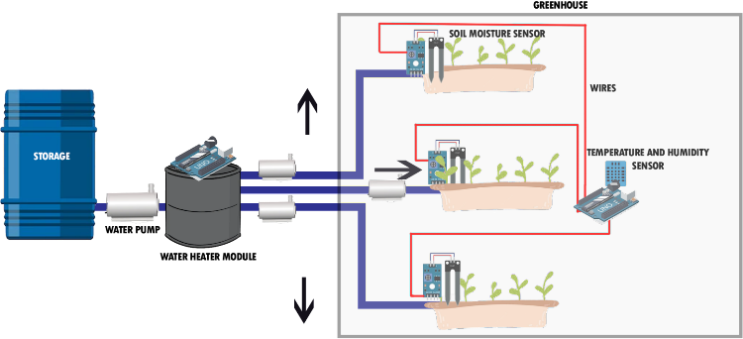

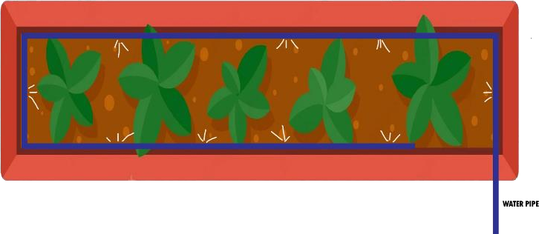

Fig 2. System Architecture of iSmartPH

Figure 2 illustrates a water flow setup comprising essential components: a water source, storage, pump, heater module, moisture sensors, and temperature/humidity sensors within a greenhouse farm. These sensors provide data on soil moisture, temperature, and humidity. Water temperature sensors and the heater module ensure optimal water temperature for irrigation. A water pump facilitates irrigation, with water sourced from a tank connected to a tap. This setup showcases iSmartPH's IoT integration for predicting crop growth conditions.

1. *Research Development Method*

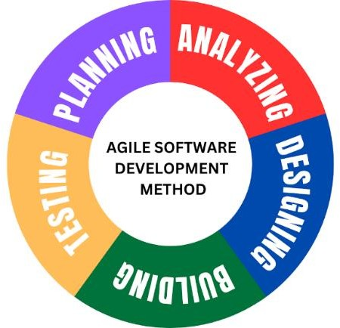

Fig 3. Research Development Method

The researchers opted for the Agile Software Development approach, which emphasizes collaboration and teamwork, prioritizing adaptability and flexibility. This choice was crucial as they needed to address the evolving needs and challenges of the small-scale greenhouse farm and the dynamic nature of agriculture. Agile's iterative process allows for frequent adjustments, enabling the team to incorporate new insights and adapt the system as needed. The methodology's focus on continuous improvement aligns well with the

research goal of developing an effective smart irrigation control system. Through regular reviews and refinements, the researchers could incrementally enhance the system's functionality, usability, and performance, ensuring it meets the requirements of all stakeholders.

1. *Data Collection*

Data collection is the method of methodically compiling information or data from multiple sources for analysis or research objectives. For the proposed study, data gathering is essential to getting pertinent and trustworthy information that guides the system's development and evaluation. Surveys, interviews, observations, and sensor data are just a few examples of the various approaches that can be used to collect data. To learn more about the irrigation techniques, difficulties, and desires of small-scale greenhouse farms, surveys and interviews might be done. Through observations, researchers can gather knowledge about the present irrigation methods in use by farmers. The iSmartPH system's sensor data, which includes measurements of soil moisture, water temperature, temperature, and humidity gives real-time feedback on the efficiency of the intelligent irrigation system and water temperature control system. With the help of these numerous data collection methods, researchers are better able to assess the iSmartPH system's performance, better understand the needs of small-scale greenhouse farms, and customize the system to meet the demands of the intended beneficiaries. The gathering of user opinions and experiences is an important component of data collection in the research of the iSmartPH. This can be accomplished using qualitative techniques like focus groups or interviews, when farmers are given the chance to express their opinions on the usability, functionality, and utility of the iSmartPH system.

1. *Sampling Technique and Instrumental*

The research proposed study employs the Stratified Sampling Method to gather data from the intended beneficiaries. This sampling technique involves selecting participants based on their group as the agriculture industry can be made just by anyone not just in a certain group such as farmers etc. In this particular study, the researchers have specifically named their respondents namely farmers, urban farmers, greenhouse owners, and the so called plantito’s and plantita’s. By opting for stratified sampling, the researchers can swiftly and conveniently collect data from this readily available subgroup proportional of participants.

1. RESULTS AND DISCUSSION

The study garnered results from 78 individuals, where 16 of them were Plantito/Plantita, 17 were Farmers, 33 were interested in plant care and 12 were IT Professionals. The results of the study conducted by the researchers thru Google Forms are as follows:

*A. ISO 25010 Product Quality Assessment*

The researchers conducted a survey in which the respondents will be responding thru a Likert Scale to assess the studies (1) Performance Efficiency, (2) Usability, (3) Functional Stability, (4) Compatibility and (5) Reliability.

**Table 1** Numerical Scale (Likert Scale)

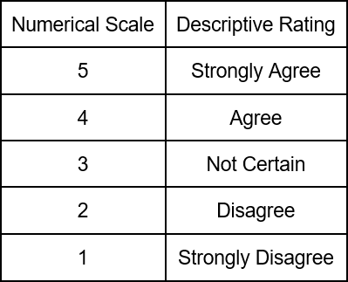

Table 1 shows the Likert Scale that was used in the survey-questionnaire. A Likert scale is a numerical scale used for assessing opinions or attitudes, where respondents choose from options like "Strongly Agree" (5), "Agree" (4), "Not Certain" (3), "Disagree" (2), and "Strongly Disagree" (1).

**Table 2** Numerical Scale (Mean Rating)

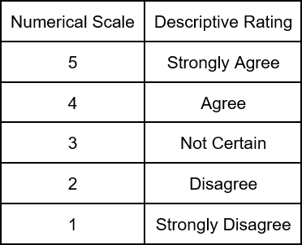

Table 2 demonstrates the numerical scale for the qualitative analysis that will be used to interpret the results obtained in the survey-questionnaire. The range for Excellent is 4.51 to 5.00, for Very Good it is 3.51 to 4.50, for Satisfactory it is 2.51 to 3.50, for Fair it is 1.51 to 2.50, and for Poor it is 1.00 to 1.50.

**Table 3** Summary of Results (Non-IT Respondents)

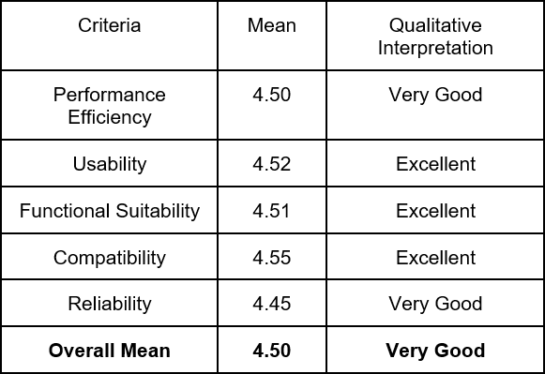

This study undergoes the ISO 25010 standard evaluation where it evaluates the project's first, second and third objective’s overall quality. The overall outcomes of the research first objective, second objective and third objective evaluation results using ISO 25010 are as follows:

1. The Performance Efficiency of the first, second, and third objective of the study based on the evaluation result, obtained a mean of 4.50, which means that in terms of Performance Efficiency, it has an very good quality based on the numerical rating scale;
2. The Usability of all objectives of study has a 4.52 mean, which means that in terms of the usability of the system, it has an excellent rating as per the respondents.
3. As for the Functional Suitability of the all objectives obtained 4.51 mean where it is classified as excellent when providing functions and it meets the stated and implied needs of the current user
4. For the Compatibility of the system’s objectives, 4.55 mean is obtained. This only means that the developed hardware and software system is excellent in exchanging information with other components or hardware or software systems.
5. Lastly, the ISO reliability of the system is affirmed by the respondents who rated it with a commendable mean score of 4.45, attesting to its robust and dependable performance.

The researchers conducted a survey to evaluate the quality of all stated objectives of project iSmartPH, this is specifically assessing the quality of Performance Efficiency, Usability, Functional Suitability, Compatibility and Reliability. The overall evaluation of project iSmartPH, utilizing the ISO standard 25010, resulted in an impressive mean average of 4.50, categorizing it as "Very Good" according to the mean rating scale.

**Table 4** Summary of Results (IT Respondents)

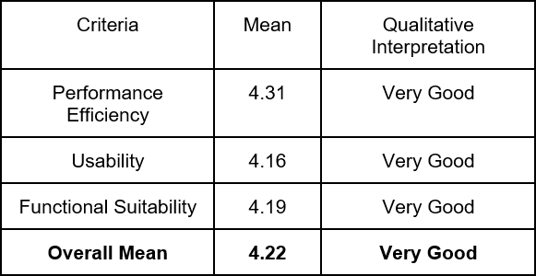

This study undergoes the ISO 25010 standard evaluation IT professionals respondents evaluate all project’s objectives quality. Following are the results of the evaluation using the ISO 25010:

* 1. The evaluation results for the project's objectives reveal a noteworthy mean of 4.31 in the Performance Efficiency criterion. The mean of 4.31 suggests a robust and effective performance in meeting the specified objectives related to efficiency, highlighting the project's success in optimizing its operational and computational capabilities.
  2. The usability assessment, with a mean score of 4.16, underscores the project's high level of user- friendliness, as perceived by IT professionals who participated in the evaluation. The significance of this result is paramount, as IT professionals bring a specialized perspective to the evaluation, emphasizing the system's practicality and ease of use within the context of their expertise.
  3. The Functional Suitability aspect, marked by a commendable mean of 4.19, is indicative of the project's capacity to provide functions that align closely with both stated and implied user needs. The IT professionals' insights bring a specialized lens to this evaluation, highlighting the project's aptness in functionality from a practical and user-oriented standpoint.

In summary, the project demonstrated impressive performance with a mean of 4.31 in Performance Efficiency, 4.16 in Usability, and 4.19 in Functional Suitability. The overall mean of 4.22 highlights the project's success in delivering a user-centric solution, acknowledged by IT professionals for its robust performance and high usability.

1. CONCLUSIONS

The researchers highlight the importance of diligent monitoring of crop conditions, facilitated by wireless network sensors and predictive software, to optimize growth rates by regulating environmental factors such as soil levels, temperature, and humidity.

The development of a cost-effective IoT device for smart irrigation control, integrating the KNN machine learning algorithm and tailored for small-scale greenhouse farming

in Metro Manila, offers a promising solution. This innovation addresses challenges in water optimization, enhancing crop productivity.

Recommendations for future enhancements, the researchers propose several key improvements. Firstly, they suggest integrating sensor and motor modules into a single unit to streamline functionality, potentially increasing efficiency and reducing complexity. Secondly, they advise exploring alternative data storage solutions capable of handling large datasets more efficiently, or adjusting data upload frequency to minimize storage costs, ensuring optimal use of resources. Additionally, they highlight the importance of improving information presentation by incorporating color-coded indicators for enhanced visual cues and addressing web page reloading issues during data loading to provide users with a smoother experience. Finally, they emphasize the need to enhance website functionality by introducing date filtering in reports and refining time display formats to align with industry standards, ultimately enhancing usability and user satisfaction.

REFERENCES

1. Vallejo-Gómez, David, et al. “Smart Irrigation Systems in Agriculture: A Systematic Review.” *Agronomy*, vol. 13, no. 2, Jan. 2023, p. 342. [https://doi.org/10.3390/agronomy13020342.](https://doi.org/10.3390/agronomy13020342)
2. [Shekhar, Y., Dagur, E., & Mishra, S. (2017). Intelligent IoT Based](https://www.ripublication.com/ijaer17/ijaerv12n18_33.pdf) [Automated Irrigation](https://www.ripublication.com/ijaer17/ijaerv12n18_33.pdf)

[System. Ripublication.](https://www.ripublication.com/ijaer17/ijaerv12n18_33.pdf)Rajendrakumar, Shiny, et al. “Automation of Irrigation System Through Embedded Computing Technology.” ResearchGate, Jan. 2019, [www.researchgate.net/publication/332392635_Automation_of_irrigatio](http://www.researchgate.net/publication/332392635_Automation_of_irrigation_system_through_embedded_computing_technology) [n_system_through_embedded_computing_technology](http://www.researchgate.net/publication/332392635_Automation_of_irrigation_system_through_embedded_computing_technology)

1. Kamaruddin, F. (2019). IoT-based intelligent irrigation management and monitoring

system using arduino[. https://www.semanticscholar.org/paper/IoT-](https://www.semanticscholar.org/paper/IoT-based-intelligent-irrigation-management-and-Kamaruddin-Malik/a8b0d4f78c583d784c48f99126296f58e6565b3b) [based-intelligent-irrigation-management-and-Kamaruddin-](https://www.semanticscholar.org/paper/IoT-based-intelligent-irrigation-management-and-Kamaruddin-Malik/a8b0d4f78c583d784c48f99126296f58e6565b3b) [Malik/a8b0d4f78c583d784c48f99126296f58e6565b3b](https://www.semanticscholar.org/paper/IoT-based-intelligent-irrigation-management-and-Kamaruddin-Malik/a8b0d4f78c583d784c48f99126296f58e6565b3b)SatishVarma, M. (2019). Smart irrigation system using IOT[.](https://www.semanticscholar.org/paper/Smart-Irrigation-System-Using-IOT-SatishVarma-Lakshmi/7466fd67ff3e691edd471b7a6f53d1fdee27d6c7) [https://www.semanticscholar.org/paper/Smart-Irrigation-System-Using-](https://www.semanticscholar.org/paper/Smart-Irrigation-System-Using-IOT-SatishVarma-Lakshmi/7466fd67ff3e691edd471b7a6f53d1fdee27d6c7) [IOT-SatishVarma-](https://www.semanticscholar.org/paper/Smart-Irrigation-System-Using-IOT-SatishVarma-Lakshmi/7466fd67ff3e691edd471b7a6f53d1fdee27d6c7) [Lakshmi/7466fd67ff3e691edd471b7a6f53d1fdee27d6c7](https://www.semanticscholar.org/paper/Smart-Irrigation-System-Using-IOT-SatishVarma-Lakshmi/7466fd67ff3e691edd471b7a6f53d1fdee27d6c7)Kamaruddin, F. (2019). IoT-based intelligent irrigation management and monitoring system using arduino[. https://www.semanticscholar.org/paper/IoT-](https://www.semanticscholar.org/paper/IoT-based-intelligent-irrigation-management-and-Kamaruddin-Malik/a8b0d4f78c583d784c48f99126296f58e6565b3b) [based-intelligent-irrigation-management-and-Kamaruddin-](https://www.semanticscholar.org/paper/IoT-based-intelligent-irrigation-management-and-Kamaruddin-Malik/a8b0d4f78c583d784c48f99126296f58e6565b3b)

[Malik/a8b0d4f78c583d784c48f99126296f58e6565b3b](https://www.semanticscholar.org/paper/IoT-based-intelligent-irrigation-management-and-Kamaruddin-Malik/a8b0d4f78c583d784c48f99126296f58e6565b3b)

1. [Obaideen, K., Yousef, B. A., AlMallahi, M. N., Tan, Y., Mahmoud, M.,](https://openaccess.city.ac.uk/id/eprint/28838/1/1-s2.0-S2772427122000791-main.pdf) [Jaber, H., & Ramadan, M. (2022). An overview of smart irrigation](https://openaccess.city.ac.uk/id/eprint/28838/1/1-s2.0-S2772427122000791-main.pdf) [systems using IoT. ScienceDirect, 7, 100124.](https://openaccess.city.ac.uk/id/eprint/28838/1/1-s2.0-S2772427122000791-main.pdf)

<https://doi.org/10.1016/j.nexus.2022.100124>Bhanu, et al. “IoT Based Smart System for Enhanced Irrigation in Agriculture.” *IEEE Conference Publication | IEEE Xplore*, 1 July 2020, ieeexplore.ieee.org/document/9156026.

1. (Handbook style) *Transmission Systems for Communications,* 3rd ed., Western Electric Co., Winston-Salem, NC, 1985, pp. 44–60.
2. *Motorola Semiconductor Data Manual,* Motorola Semiconductor Products Inc., Phoenix, AZ, 1989.
3. (Basic Book/Monograph Online Sources) J. K. Author. (year, month, day). *Title* (edition) [Type of medium]. Volume(issue). Available: http://www.(URL)
4. J. Jones. (1991, May 10). Networks (2nd ed.) [Online]. Available: [http://www.atm.com](http://www.atm.com/)

AUTHOR’S BIOGRAPHY

**Joshua M. Antonino** (M’76–SM’81–F’87) and the other authors may include biographies at the end of regular papers. Biographies are often not included in conference-related papers. This author became a Member (M) of IEEE in 1976, a Senior Member (SM) in 1981, and a Fellow (F) in 1987. The first paragraph may contain a place and/or date of birth (list place, then date). Next, the author’s educational background is listed. The degrees should be listed with type of degree in what field, which institution, city, state or country, and year degree was earned. The author’s major field of study should be lower- cased.

The second paragraph uses the pronoun of the person (he or she) and not the author’s last name. It lists military and work experience, including summer and fellowship jobs. Job titles are capitalized. The current job must have a location; previous positions may be listed without one. Information concerning previous publications may be included. Try not to list more than three books or published articles. The format for listing publishers of a book within the biography is: title of book (city, state: publisher name, year) similar to a reference. Current and previous research interests ends the paragraph.

The third paragraph begins with the author’s title and last name (e.g., Dr. Smith, Prof. Jones, Mr. Kajor, Ms. Hunter). List any memberships in professional societies other than the IEEE. Finally, list any awards and work for IEEE committees and publications. If a photograph is provided, the biography will be indented around it. The photograph is placed at the top left of the biography. Personal hobbies will be deleted from the biography.

**Joey E. Lauriaga** (M’76–SM’81–F’87) and the other authors may include biographies at the end of regular papers. Biographies are often not included in conference-related papers. This author became a Member (M) of IEEE in 1976, a Senior Member (SM) in 1981, and a Fellow (F) in 1987. The first paragraph may contain a place and/or date of birth (list place, then date). Next, the author’s educational background is listed. The degrees should be listed with type of degree in what field, which institution, city, state or country, and year degree was earned. The author’s major field of study should be lower- cased.

**Mary Angelie A. Maristela** (M’76–SM’81–F’87) and the other authors may include biographies at the end of regular papers. Biographies are often not included in conference-related papers. This author became a Member (M) of IEEE in 1976, a Senior Member (SM) in 1981, and a Fellow (F) in 1987. The first paragraph may contain a place and/or date of birth (list place, then date). Next, the author’s educational background is listed. The degrees should be listed with type of degree in what field, which institution, city, state or country, and year degree was earned. The author’s major field of study should be lower-cased.

**Michelle Andrea Reyes** (M’76–SM’81–F’87) and the other authors may include biographies at the end of regular papers. Biographies are often not included in conference-related papers. This author became a Member (M) of IEEE in 1976, a Senior Member (SM) in 1981, and a Fellow (F) in 1987. The first paragraph may contain a place and/or date of birth (list place, then date). Next, the author’s educational background is listed. The degrees should be listed with type of degree in what field, which institution, city, state or country, and year degree was earned. The author’s major field of study should be lower-cased.