CL’s Word Template
CL Roberts
2022-08-09
Table of Contents
Heading 1 1
Subheading 1 1
Subheading 2 2
Subsubheading 1 2
Subsubheading 2 2
Subsubheading 3 2
Subsubheading 4 2
Heading 2 3

Heading 1
This is the first section of my template. I will use this template to manually edit the styles of my Rmarkdown documents. Then using the reference_docx option in the YAML of .Rmd documents I can have all of my Rmarkdown documents look and feel a certain way.

Subheading 1
I just think the Rmarkdown defaults for word documents are so ugly. I want to change the blue headings to black, add page numbering, and center align figures and tables.
tab <- data.frame(output = c("PDF", "HTML", "Word"),
ugly_score = c(1, 4, 10))
knitr::kable(tab, caption = "Ugliness scores for the three output types of .rmd documents.")
Ugliness scores for the three output types of .rmd documents.
output | ugly_score
PDF | 1
HTML | 4
Word | 10

Subheading 2
There are several things I want to change about the default knit-to-word settings.

Subsubheading 1
I would like to change the blue headings to black.

Subsubheading 2
I would like to center-align tables and figures.
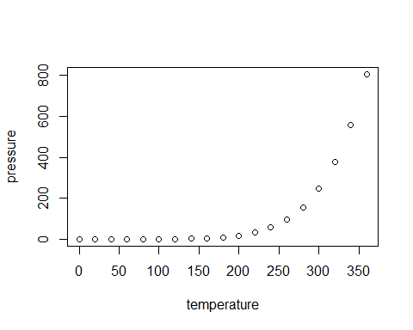
Caption to generic plot

Subsubheading 3
- perhaps
- change
- bullet
- styles

Subsubheading 4
I would like to add page numbers

Heading 2
It would be really cool if we could collectively put together a professional-looking word template that we all use. That way, with minimal effort we can all generate word documents from Rmarkdown that look like they came from the same organization; even informal analyses for internal use look nice and are consistent with each other. Furthermore, it would be a nice thing to give new employees or folks who are new to markdown something that looks good out of the box. link
Furthermore, we can do something similar with PDF and HTML output. Ideally, in the interest of reproducibility, we could have Rmarkdown documents which can be output to any format without any (or with few) further changes. Bonus points if PDF and Word documents look similar to each other.

$$\begin{aligned}{\left(x+a\right)}^{n}=\sum_{k=0}^{n}{\left({n \atop k}\right)x^{k}a^{n-k}}\#\left(1\right)\end{aligned}$$

References

McAllister, M. K., and J. N. Ianelli. 1997. Bayesian stock assessment using catch-age data and the sampling-importance resampling algorithm. Canadian Journal of Fisheries and Aquatic Sciences 54(2):284–300.

