CNN Application-Detecting Car Exterior Damage

Application of Convolutional neural networks (CNN) in Automated detection of car exterior damages and subsequent quantification (damage severity)

1. Extracting Regions of Interest(ROI)
   1. Image is passed to a ConvNet which returns the region of interests based on methods like selective search(RCNN) or RPN(Region Proposal N/W for Faster RCNN) and
   2. then RoI pooling layer on the extracted ROI to make sure all the regions are of the same size.
2. Classification
   1. Regions are passed on to a fully connected network which classifies them into different image classes. For instance, scratch(‘damage’) or background(car body without damage).
   2. 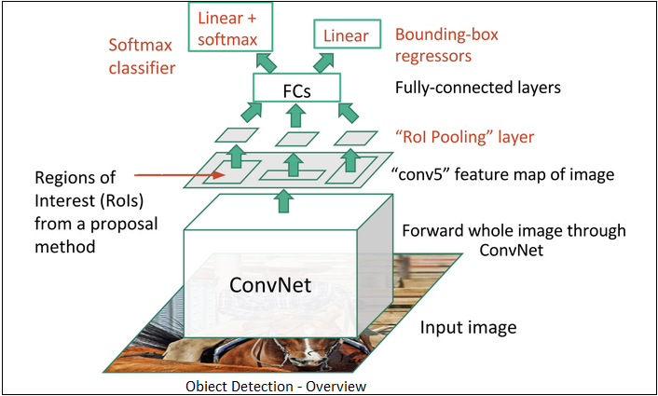
3. Regression
   1. bounding box(BB) regression is used to predict the bounding boxes for each identified region for tightening the bounding boxes(getting exact BB defining relative coordinates)
   2. to regress from either region proposals or fixed anchor boxes to nearby bounding boxes of a pre-defined target object classes
4. Need to identify the exact pixels location in the bounding box that correspond to the class(damage) to identify the location and quantify the damage accurately.
5. **Masked Region based CNN(Mask R-CNN)**
   1. Identifying pixel-wise delineation for object class of our interest
      1. BB based Object detection (uses ROI align to allow the pixel to pixel preserve of ROIs and prevent information loss)
      2. Semantic segmentation - segmenting individual objects at pixel within a scene, irrespective of the shapes (pixel-wise classification) (pixel-wise shading of the class of interest)
      3. 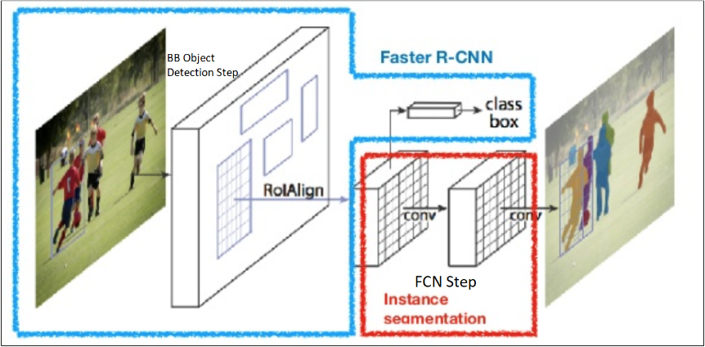
6. Loses at each phase Image for post
   1. **rpn_class_loss**
      1. 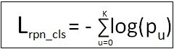
   2. **rpn_bbox_loss**
      1. 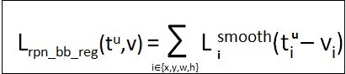

total network loss

* + 1. Image for post
  1. mrcnn_class_loss
     1. generated during Semantic segmentation task
  2. mrcnn_bbox_loss
     1. generated during Semantic segmentation task
  3. mrcnn_mask_loss
     1. generated during Semantic segmentation task